



Transition to Work

Final Evaluation Report

May 2021

Title

ISBN  
978-1-76114-112-6 [PDF]  
978-1-76114-164-5 [DOCX]



With the exception of the Commonwealth Coat of Arms, the Department’s logo, any material protected by a trade mark and where otherwise noted all material presented in this document is provided under a [Creative Commons Attribution 3.0 Australia](http://creativecommons.org/licenses/by/3.0/au/) licence.  
The details of the relevant licence conditions are available on the Creative Commons website (accessible using the links provided) as is the full legal code for the [CC BY 3.0 AU licence](http://creativecommons.org/licenses/by/3.0/au/legalcode).

The document must be attributed as the Transition to Work Final Evaluation Report, May 2021.

## Acknowledgements

This report was prepared by Robyn Henderson, Alison Reinhard, Mitchell Porter, Christina Jankovic, Wendy Elliott, Patricia Barber, Mai Pham, Simon Gonzales and Yingru Wu. Stephen Howe provided assistance with data construction of analysis datasets.

The department would also like to acknowledge the contribution to this report from commissioned research undertaken by the Social Research Centre.

Contents

Acknowledgements 3

Executive summary 13

About Transition to Work 13

Evaluation approach 13

Theory of change 14

Key findings 15

Did participation in TtW lead to improved work readiness, and employment and educational outcomes for participants? 15

Does TtW deliver cost-effective and time-effective outcomes? 16

What service elements are associated with improved outcomes; what works? 16

Does TtW deliver targeted and quality service to participants? 17

Conclusion 18

Departmental response to the Transition to Work Final Evaluation Report 19

Transition to Work context 19

Design principles and continuous improvement 19

Performance 20

About this report 24

Chapter 1 Introduction 26

1.1 Policy and program context 26

1.1.1 Transition of young people in Australia 26

1.1.2 Few work experience positions 27

1.1.3 Availability and affordability of education and training opportunities 28

1.1.4 Transition pathways 28

1.2 The Youth Employment Strategy and Youth Employment Package 29

1.3 The macroeconomic environment 29

1.4 The TtW service 30

1.4.1. TtW implementation 31

1.4.2 TtW services three main groups of young people 33

1.4.3 Indigenous participation 35

1.4.4 The TtW service pathway 35

1.4.5 The TtW funding model 35

1.4.7 Service Guarantee, Service Delivery Plans and Key Performance Indicators 38

1.5 Interactions of TtW with other employment programs 39

Chapter 2 Evaluation of the TtW service 41

2.1 Introduction 41

2.2 Theory of change 41

2.3 The human capability model 44

2.4 Stage one: formative evaluation 45

2.5 Stage two: summative evaluation 46

2.6 Key evaluation questions 46

2.7 Methods 46

2.8 Data sources 47

2.9 Study populations and their characteristics 47

2.9.1 TtW inflow population and matched sample profiles 48

2.10 Barriers to participation 50

2.10.1 Non-vocational (personal) barriers 51

2.10.2 Vocational barriers 53

2.11 Analytical methods 54

2.11.1 Impact analysis 55

2.11.2 Quantitative survey data 56

2.11.3 Qualitative data 57

Chapter 3 Referrals and commencements 58

3.1 Introduction 58

3.2 Referrals 58

3.3 Awareness and referrals 59

3.4 Commencements 62

3.4.1 Time from referral to commencement 65

3.5 Conclusion 67

Chapter 4 Service elements and provider practice – what works 68

4.1 Introduction 68

4.2 Service Delivery Plans 68

4.3 Flexibility 69

4.4 Upfront funding 70

4.5 Rewards and recognition as strategies for engagement 71

4.6 Benefits of smaller caseloads 72

4.7 Provider collaboration 73

4.8 Limited compliance requirements for participants 74

4.9 Provider strategies to assess participants 74

4.9.1 Assessment tools 75

4.9.2 Job plans 76

4.9.3 Dedicated case managers 78

4.9.4 Specialist staff 79

4.10 Impact of service elements 82

4.11 Conclusion 84

Chapter 5 Does participation in TtW lead to improved work readiness for participants? 86

5.1 Introduction 86

5.2 Activities to address barriers to participation 86

5.2.1 Vocational barriers 86

5.2.2 Non-vocational barriers 88

5.2.3 Support provided through upfront payments 90

5.3 Activities to address specific groups 91

5.3.1 CALD services 91

5.3.2 Indigenous services 91

5.3.3 Barriers to service access 92

5.4 Participation in education and training 93

5.5 Employment-related activities 93

5.6 Outcome achievement 94

5.6.1 Employment outcomes were the most common outcome 94

5.6.2 Pathway to sustainable outcome targets 97

5.7 Improvements in participants’ work readiness 98

5.8 Work experience 101

5.8.1 Youth Jobs PaTH 101

5.8.2 National Work Experience Programme 103

5.9 Development of participants’ human capability 104

5.10 Conclusion 105

Chapter 6 Impact of TtW on labour market attachment, study and receipt of income support 106

6.1 Introduction 106

6.2 Impact analysis methodology 106

6.3 The impact of TtW on labour market attachment, education and training 107

6.3.1 Labour market attachment 107

6.3.2 Engagement in education and training 109

6.3.3 Positive outcomes 110

6.4 TtW impacts for participants in different social groups 113

6.4.1 Gender 113

6.4.2 Indigenous young people 115

6.4.3 English proficiency 118

6.4.4 Residential location 121

6.5 Long-term income support status and sustainability 125

6.5.1 TtW participants exit income support later than jobactive participants 125

6.5.2 Sustainability of income support exits 127

6.5.3 Income support return destinations 128

6.5.4 Did TtW impact convictions? 129

6.6 Conclusion 132

Chapter 7 Cost and time efficiency associated with delivering TtW 133

7.1 Introduction 133

7.2 Time between commencements and the achievement of outcomes 133

7.3 Exits from TtW 136

7.4 Monitoring Outcome Performance Targets 137

7.5 TtW funding and expenditure 137

7.6 Cost per participant 139

7.7 Cost per outcome 140

7.8 Return on investment 141

7.9 Conclusion 141

Chapter 8 Does TtW deliver targeted and quality service? 142

8.1 Introduction 142

8.2 Participant expectations 142

8.3 Participant satisfaction 143

8.4 Post-placement support 146

8.5 Link between provider performance and participant satisfaction 147

8.6 Provider satisfaction 148

8.6.1 Satisfaction with departmental support 149

8.7 Employer views 150

8.7.1 Awareness of TtW 150

8.7.2 Appropriateness of TtW linked to employer satisfaction 152

8.7.3 Wage subsidies 154

8.7.4 Unpaid work experience 155

8.8 Conclusion 155

Chapter 9 The impact of TtW 156

9.1 Introduction 156

9.2 Effectiveness of TtW 156

9.3 Efficiency of TtW and cost-effectiveness of TtW 157

9.4 Appropriateness of TtW 158

9.5 TtW compared with jobactive 158

9.6 What were the gaps? 159

9.7 What are the trade-offs? 160

9.8 Longer term effects 160

Appendix A: Interim Report key findings 162

Early implementation and operation of the TtW service 162

Engagement and retention of participants in TtW 162

Early education, employment and LMA outcomes 163

Conclusion 164

Appendix B: Exit and suspension reasons 166

Compliance exit reasons 166

Participants may exit from TtW for a range of reasons 166

Exits happen automatically (effective exit) 166

Some exits can be actioned by providers (provider exit) 167

ParentsNext participants 167

Providers should inform participants requesting to exit of implications 168

A suspension affects services to participants 168

Participants may be suspended for a range of reasons 168

Group One, Group Three and activity-tested Group Two participants 168

Non-activity-tested Group Two participants 168

ParentsNext participants 168

Who applies a suspension 169

Group One, Group Three and activity-tested Group Two participants 169

Non-activity-tested Group Two participants 169

ParentsNext participants 170

Appendix C: Employment regions 171

Appendix D: TtW outcomes and definitions of outcome types 172

Appendix E: Data sources 175

Data Source 1: Departmental administrative data 175

Data Source 2: Research and Evaluation Database (RED) 175

Data Source 3: 2016 TtW Provider Survey 175

Data Source 4: 2017 TtW Provider Survey 177

Data Source 5: 2017 JSEES Survey 178

Data Source 6: 2017 Employer Survey 181

Data Source 7: 2017–2018 PPM Survey 183

Data Source 8: Qualitative research – Wave 1 184

Data Source 9: Qualitative research – Wave 2 186

Appendix F: The study population methodology and demographics 188

Construction of study population 188

Matched TtW and jobactive samples construction 188

Demographics 189

JSCI score distribution 194

Appendix G: Range of activity types in TtW 195

Appendix H: Detailed discussion of impact analysis 197

The impact of TtW on labour market attachment, sustainability and income support reductions 197

Methodology 197

Interpreting the logistic regression tables 199

Labour market attachment 200

Study outcomes 204

Positive outcomes 207

How the impact of TtW varied by gender 210

How the impact of TtW varied by Indigenous status 213

How the impact of TtW varied by English proficiency 216

How the impact of TtW varied by residential location 219

Provider practices and achieving LMA 225

Provider practices and achieving study outcomes 227

Provider practices and achieving employment outcomes 228

Income support exits and reductions 230

Bibliography 236

List of tables 241

List of figures 246

List of short forms 250

Glossary 252

# Executive summary

## About Transition to Work

Transition to Work (TtW) provides up to 12 months intensive pre-employment support for young people at risk of long-term unemployment. A voluntary, demand-driven service and an integral component of the Youth Employment Strategy, TtW focuses on practical support and work experience to build the skills, confidence and work readiness of early school leavers aged between 15 and 21[1] and young people who have experienced difficulty transitioning from education to employment.

Rolled out in four phases in 51 employment regions between February 2016 and May 2016, the TtW provider contracts, originally in place until 26 June 2020, were extended in the 2019–20 Budget to 30 June 2022. The current budget allocation for the forward estimates is $730 million as at Budget 2020–21 to 2023–24.

## Evaluation approach

The Department of Education, Skills and Employment (the department) – formerly the Department of Employment, Skills, Small and Family Business – has completed an evaluation of the Transition to Work (TtW) service. A systematic and objective assessment of the performance of TtW was conducted in two phases, formative and summative.

The results of the *formative* evaluation, captured in the Interim Report, examined the design and implementation of TtW and followed the progress of participants who commenced in the program by 31 August 2016 (Department of Employment, Skills, Small and Family Business, 2018A).

The *summative* stage, the subject of this report, provides an in-depth assessment of the overall performance of TtW to early 2018.

The TtW evaluation team adopted a mixed-methods approach. It involved collecting and analysing quantitative and qualitative data. Data sources included:

* income support administrative data from the Department of Human Services (DHS) (now Services Australia) captured in the department’s Research and Evaluation Dataset
* employment services administrative data from the department
* provider survey data from censuses of all TtW providers conducted by the department in 2016 and 2017
* qualitative data collected from research with stakeholders undertaken by the Social Research Centre (SRC) on behalf of the department in 2016 and 2018.

Statistical methods used to analyse quantitative data included descriptive statistics and logistic regression modelling. The main study populations were matched inflow populations of young people referred to TtW and jobactive. The evaluation tracked the matched populations who commenced between 1 April 2016 and 31 March 2017 for at least 12 months to assess their study and labour market outcomes.

Caution needs to be exercised when comparing TtW results with jobactive results. As the jobactive comparison cohort constitutes a small proportion of overall jobactive caseload, jobactive results presented in this report should not be interpreted as representing overall jobactive performance.

Four key evaluation questions were examined as part of the evaluation:

* Does participation in TtW lead to improved work readiness, and employment and educational outcomes for participants?
* Does TtW deliver cost-effective and time-effective outcomes?
* What service elements are associated with improved education and employment outcomes and from which providers?
* Does TtW deliver targeted and quality service to participants?

The evaluation of TtW overall reported against five key indicators: effectiveness, efficiency, quality, equity and appropriateness.

## Theory of change

The theory of change underpinning the final evaluation of TtW is that, when operating within a capability framework consisting of a combination of tailored assistance, genuine engagement and appropriate feedback (Perales et al, 2018), participants can build their competence to set relevant goals for the future.

By developing a young person’s human capability – that is, their capacity to improve their health, wealth and knowledge – and by providing appropriate services to reduce the risks that any vocational and non-vocational barriers pose, TtW participants would be better positioned to achieve these training and employment goals and to become a more productive and contributing member of the society.

## Key findings

### Did participation in TtW lead to improved work readiness, and employment and educational outcomes for participants?

TtW provided a pathway for disadvantaged young people not in employment, education and training towards full or partial participation. Not only did around three-quarters of participants (**73%**) think their work readiness improved, as evidenced in the 2017–2018 Post Program Monitoring (PPM) Survey, but also almost all providers (**97%**) surveyed in the 2017 TtW Provider Survey agreed.

Overall, participants across TtW and jobactive had a similar probability of achieving positive outcomes, either labour market attachment (LMA) or a study outcome over their service period. However, TtW participants (**47%**) were less likely to achieve LMA in their first year after referral than were jobactive participants (**52%**), largely due to more LMA achieved at an early stage by jobactive participants (by 4 percentage points at six weeks post-referral). This is unlikely due to a jobactive program effect; it is more likely a ‘deterrence effect’ of its strong compliance framework.

A higher proportion of jobactive participants (**73%**) exited income support during the two years from commencement than TtW participants (**68%**) and this was also largely due to a higher proportion of jobactive participants exiting early. TtW had a higher proportion of participants exiting income support during the second year than jobactive. This delayed effect of TtW indicates that it has a larger lock-in effect.

TtW had higher rates of study outcomes than jobactive. In fact, it achieved almost double the number of study outcomes for its participants than did jobactive over 12 months and was more effective than jobactive at encouraging female participants to study.

There were indications that TtW delivered wider social benefits than just employment and education outcomes. TtW was more effective than jobactive at helping participants avoid renewed contact with the criminal justice system. In the matched samples, **3%** of TtW participants who left prison claimed crisis payments up to two years after referral, compared with over **4%** of jobactive participants. Participants in the matched samples were more likely to go to prison two or more times if they were in jobactive (around **2%**) than if they were in TtW **(1%**).

These findings reaffirm that TtW has a strong effect on building participants’ vocational and other human capabilities. This approach inevitably led to a stronger lock-in effect and delayed labour market outcomes.

Overall, TtW meets its objectives. At the program level, providers achieved above the outcome target for nearly all quarters over the two financial years July 2016 to June 2018. The proportion of annual performance targets achieved increased from 110% of the target in 2016–17 to 125% in 2017–18.

### Does TtW deliver cost-effective and time-effective outcomes?

More than three-quarters (**77%**) of all young people referred to TtW commenced in services, and the proportion of referrals leading to commencements increased over time. Moreover, TtW providers had more success in commencing young people in services during the first 30 days (**93%**) than did jobactive providers (**83%**). Despite the voluntary nature of TtW, its referral and commencement processes are more efficient.

A little over half of TtW participants exited to jobactive at the end of the study period. Of those who did so, around three-quarters commenced within 91 days of exiting TtW.

TtW was found to be more expensive than jobactive. In fact, the unit cost for a TtW participant over a 12-month period was 2.8 times as much as that of a jobactive participant. Similarly, TtW positive outcomes cost 2.9 times as much as jobactive. It is important to note however, that the analysis was based on the matched cohorts for a specific time period and, consequently, the results should not be interpreted as representing total program unit cost, especially for jobactive. The outcome measures used in the evaluation are specific evaluation constructs and the cost associated with these outcomes should not be compared with other cost per outcome measures.

The emerging evidence from this evaluation indicates that TtW program settings enabled participants to develop their confidence, wellbeing, motivation, work readiness and community connectedness within a capability framework. Such development together with the vocational skills gained through the program, while difficult to monetise, may translate to more productive years to the economy and contributions to the society. The return on investment for TtW may take time to be realised.

### What service elements are associated with improved outcomes; what works?

Social and economic disadvantage may all contribute to a young person being neither in employment nor in education or training (NEET) (Perales et al., 2018).[2] Understanding this was paramount to TtW providers delivering an appropriate service for this cohort of young people.

Provider feedback strongly indicates that TtW program settings enable them to fully engage with participants – understanding their needs and desires and providing genuinely tailored assistance. The smaller caseload allows caseworkers to adopt a participant-centred service delivery based on participant feedback and participant-led servicing. Upfront payment gives providers opportunities to help young people to access courses and licences, pay for interview clothing and work uniforms, and supplement travel costs etc. The flexibility of delivery, inherent in the service design, not only allows for a personalised approach to helping participants, but also encourages innovations in service delivery, e.g. rewards and recognition as strategies to engage participants. The program also likely obviated competition and encouraged collaboration between providers

Provider service strategies evolved with time. While the use of a broad range of assessment tools and dedicated case managers remains consistent and widespread, the employment of specialist staff has increased over time. These specialist staff included youth worker, training/education specialist, and Indigenous mentor.

In terms of what service elements are associated with participant labour market outcomes, this evaluation confirms that engaging in education and training activities (accredited or non-accredited) and paid work experience improves participants’ labour market outcomes. Increased service intensity was also associated with better labour market outcomes for participants.

### Does TtW deliver targeted and quality service to participants?

The satisfaction of participants and employers with the TtW service is a useful measure of how targeted and appropriate the service had proven to be.

An overwhelming proportion of TtW participants (**90%**) in the 2017 Job Seeker Experiences of Employment Services (JSEES) Survey were satisfied or very satisfied with the service their TtW provider gave them, compared with **64%** of jobactive respondents. Compared with jobactive participants, TtW participants reported a greater willingness to work and were more positive about their job prospects. Almost **98%** of TtW participants surveyed either strongly agreed or agreed that their providers treated them with respect, compared with just over **88%** of jobactive respondents.

Well over **90%** of participants thought providers had their interests at heart, understood their needs and wanted to find them a job.

They’re really supportive … younger staff, more quality, friendlier, gentler. They are aiming towards the goal that you have and providing as much time as they can for you. (Participant Focus Group 2)

TtW was successful at meeting the needs of different cohorts of TtW participants. Indigenous TtW participants were 5.6 percentage points more likely to achieve study outcomes after 52 weeks than were Indigenous jobactive participants.

While there was no gender-related difference in labour market attachment in TtW, the service was more effective at encouraging female participants to study than it was for male participants.

Employers’ awareness of the TtW program was moderate but those who had used TtW service were more satisfied than those who used jobactive. Employers surveyed between March and April 2017 indicated a high level of satisfaction with TtW providers. Four in five employers using TtW were satisfied with the service (**81%**) compared with two in three employers using the jobactive program (**65%**).

### Conclusion

Consensus among providers and participants was that the tailored and intensive support provided through TtW increased the target groups’ work readiness and contributed to their achievement of study and employment outcomes. Employers’ high level of satisfaction with the TtW service was a good measure of its appropriateness to meet employer needs.

TtW provided a targeted and high-quality early intervention service to participants. Unsurprisingly, the human capital investment associated with the program may have increased the program’s cost and the duration participants spent in it. The flexibility of the service delivery model, however, allowed participants to engage with their consultants in ways that enabled them to address both vocational and non-vocational barriers by various means including referrals to specialist services, individual appointments or group sessions.

Positive short-term outcomes for TtW participants, such as practical skills to get job ready and personal improvement skills to reduce levels of anxiety, also increased their social connectedness and improved their communication skills. Positive long-term impacts on participants included increased self-confidence and motivation to find and retain employment.

In addition to building the human capital necessary to compete in the jobs market, heightened individual human capability may have broader consequences for society, including reduced recidivism. The extent to which the development of human capability might lead to a future reduction in lifetime welfare dependency and potentially intergenerational welfare, for example, needs to be the subject of future longitudinal studies. The results of this may be seen not only in increased economic participation and productivity but also in social and civic participation. Testing this hypothesis will need to be the focus of further research.

# Departmental response to the Transition to Work Final Evaluation Report

## Transition to Work context

The Transition to Work (TtW) service is a complementary youth employment service that operates alongside the Department of Education, Skills and Employment (DESE) mainstream employment service, jobactive. TtW focuses on personalised case management, providing equal weight to education and employment outcomes.

TtW targets early school leavers and young people who have had trouble transitioning from education to employment, who are at risk of long-term unemployment and poor labour market attachment. The broad consensus among youth stakeholders is that young people differ from other job seeker cohorts. Young people are still in their formative stages, developing their attitudes and behaviours and the skills and experiences needed to make good choices with long-term effects. This results from both temporal factors (a lack of opportunity to develop experience and skills) and biological factors (ongoing brain development).

## Design principles and continuous improvement

Consistent with the Australian Government’s Priority Investment Approach the TtW service has evolved and been refined to best meet the needs of young Australians and in response to economic trends. This evolution has been based on feedback from a range of stakeholders including providers, peak bodies and young people; the TtW Interim Evaluation Report; and general program performance.

Policy changes made to date include:

* expanding eligibility to include
  + young people aged 22 to 24 years
  + Indigenous young people (aged 15 to 21 and later 22 to 24) with Year 12 Certificate or Certificate III
* a more flexible demand-driven funding model
* extending the program duration for participants from up to 12 months to up to 18 months
* reducing the 13-week waiting period for disengaged young people not receiving activity-tested income support.

In facilitating the ongoing improvement of TtW and building on the TtW Interim Report and Final Evaluation Report, the department has expanded its evaluation of TtW. Phase III of the evaluation will examine the short-term and long-term benefits of the program in building human capability and wellbeing, the impact of extending the program from up to 12 months to up to 18 months, and the longer term (two to four years) outcomes achieved by young people participating in TtW.

Departmental responses to high-level findings are provided in the following table.

## Performance

This TtW Evaluation Report evaluated program performance against five criteria. High-level results against each are provided in the table below.

| Criteria | Program design elements | Key findings and government response |
| --- | --- | --- |
| **Effectiveness** | TtW is primarily an early intervention program designed explicitly to assist eligible young people through intensive support to develop practical skills to get a job, re-engage with education or training, or connect with services that assist them to overcome barriers preventing their connection with the labour market. | **Improved work readiness** results in the evaluation point to the success of the program in this area. That TtW participants achieved slightly lower **labour market attachment** than similar jobactive participants may be a reflection of the jobactive ‘work first’ approach compared to the intensive pre-employment design of TtW services.  The government’s new Youth Advisory Sessions (YAS), which commenced on 8 March 2021, are intended to leverage the success of TtW in improving work readiness. They provide young people in online/digital employment services with some access to TtW providers to help them maintain their work readiness and connection with the labour market.  The evaluation’s findings that young people in **TtW were more likely to achieve study outcomes** than their jobactive counterparts are welcome. TtW service settings give equal weight to education and employment outcomes, given that a person’s level of education is a key factor in their future job prospects and strength of connection with the labour market.  The department notes the evaluation’s findings that **many young people referred to TtW had little knowledge of the service** and that **a majority of young people reported receiving little information about the program at the point of referral**.  The department will continue to look for opportunities to promote the TtW service. |
| **Efficiency** | TtW is focused on engaging young people in services as soon as possible to reduce the risk of them becoming disengaged from school or employment for long periods. TtW is a time-limited service that provides intensive early interventions.  To ensure young people receive timely access to services, TtW providers are assessed against 3 Key Performance Indicators including efficiency in commencing TtW participants in a timely manner. | The evaluation notes that TtW providers were **highly successful in commencing** young people in services during the first 30 days, indicating that TtW is an efficient service.  The evaluation also found the average program cost for TtW participants is significantly more expensive when compared with jobactive. In this regard the department notes the following:   * The evaluation’s analysis was based on the matched cohorts for a specific time period; as such, the results should not be interpreted as representing total program unit cost, especially for jobactive. The outcome measures used in the evaluation are specific evaluation constructs, and the cost associated with the outcomes should not be compared with other cost per outcome measures. * TtW expenditure is in line with the government’s Priority Investment Approach to Welfare. TtW is an early investment in young people that removes barriers to employment and promotes higher workforce participation. It is likely to reduce fiscal pressures associated with providing welfare support, improve participation in society and generate gains in gross domestic product and income growth. The development of human capital of eligible young people is highlighted throughout the evaluation, and the average program cost for TtW participants should be viewed in this context.   The department also notes that a number of TtW’s key design elements have resulted in a number of program efficiencies. The removal of competition between providers has resulted in a number of provider-led collaborations aimed at developing best practice. |
| **Quality** | TtW has smaller caseloads than mainstream employment services to enable intensive servicing and encourage individualised support and tailoring. | The department notes the TtW service and its providers have a reputation for quality and this has been supported by the evaluation’s findings.  The evaluation identified that **4 in 5 or 81% of employers using TtW were satisfied with the service, compared with 2 in 3 or 65% of employers using the jobactive program**. Of the employers surveyed, **74% confirmed that they would be ‘likely’ or ‘very likely’ to use a TtW provider again to hire staff**.  The department notes the evaluation’s findings that smaller caseload sizes and flexible service delivery were critical to the success of TtW in delivering quality services to participants and employers. In this regard, the TtW caseload doubled as a result of COVID‑19, resulting in sudden and significant increases to provider caseloads and the need for providers to expand their businesses to meet this demand. The department will continue to monitor the impact of these changes on the quality of services provided. |
| **Equity** | TtW’s service settings are designed to support flexibility to give providers the scope to provide an individualised service that addresses each participant’s needs. | TtW’s service settings have allowed providers to adjust their service delivery as program eligibility settings have expanded. The expansion of TtW’s eligibility criteria resulted in TtW having a high Indigenous caseload. Flexible program settings supported providers to shift their service delivery strategies to implement culturally competent strategies to appropriately service these participants, leading to good performance results for the Indigenous cohort.  The department notes the evaluation’s findings that participation in TtW was more effective than participation in jobactive at helping ex-offender participants avoid further contact with the justice system, likely due to TtW’s activity-intensive nature, tailored service and lighter compliance measures. This is an unintended, but welcome, outcome of the program settings.  TtW providers were chosen to deliver YAS to young people in online and digital employment services due to their achievements in equity of outcome across multiple cohorts, tailored servicing and expertise in working with young people. |
| **Appropriateness** | TtW’s focus on individualised tailored assistance and higher upfront payments supports young people to access community and other services, including training, to build capacity and improve their labour market attachment. | The department notes the evaluation found TtW to be an appropriate program for its intended cohort. The way providers have **tailored service delivery** to meet individual participants’ needs is likely a key contributing factor to this finding.  TtW providers are delivering an appropriate service and this is reflected in the evaluation’s findings that almost 98% of TtW participants surveyed either strongly agreed or agreed that their providers treated them with respect, compared to just over 88% of jobactive respondents. |
| **Funding model** | The TtW funding model is deliberately different from that used for mainstream employment services. Higher upfront payments provide flexibility for TtW providers to invest in human capability development and help to facilitate the individual tailoring of services to the specific needs of each eligible young person. | The change from a capped funding model to a demand-driven funding model in July 2018 provided TtW with flexibility to meet changes in the labour market. This meant the service was able to quickly respond to the significant increase in eligible young people needing assistance caused by COVID 19. The payment model is also helping to ensure providers have sufficient funding available to help disadvantaged eligible young people access opportunities as the economy continues to recover. |

The evaluation found that TtW provides a high-quality service to eligible young people. The flexibility of service delivery allowed young people to develop practical skills. Young people reported reduced levels of anxiety, and increased confidence, social connectedness and motivation to find and keep a job. Increased workforce participation has widespread benefits not only for young people and their community but also for Australia’s economy and society.

The findings of this evaluation are being used to inform program, policy and design for employment services for eligible young people beyond 30 June 2022.

# About this report

This report covers the summative evaluation of the TtW service. Conducted approximately two years after the implementation of the TtW service, it focuses on assessing the effectiveness, efficiency and quality of the service and identifying good practice. It raises key issues for consideration in future program development.

Chapter 1 commences with the position young people occupy in the Australian labour market and identifies several key issues that young people face in transitioning from education and training to employment. Issues that inform the policy context and program settings for the TtW service are canvassed. The human capability model is explored to explain how an individual participant’s broad human capabilities develop within an economic, cultural and community context.

How the concept of a virtuous circle can be used to study the chain of events leading to improvements in work readiness, motivation, aspirations and skills development, participation in education and training and ultimately workforce participation, is explored.

There is a description of the eligibility criteria for the TtW program, the funding model, and the employment and education outcomes and Key Performance Indicators. The interaction of TtW with other employment services is noted.

Chapter 2 contains an outline of the evaluation framework and links this report with the formative evaluation covered in the Interim Report **(Appendix A)**.Quarterly outcome performance, reported up to the end of March 2017, and suggestions for improvement made in the earlier evaluation are included along with actions the department took in response (Department of Employment, Skills, Small and Family Business, 2018B). An outline of the evaluation questions, the methodology for the current evaluation and the data sources and characteristics of the participants (the TtW inflow population and matched TtW group and jobactive group) is provided.

In Chapter 3, the referral and commencement process is reviewed and the time between referral and commencement for each of the participant groups is examined. The awareness of providers, stakeholders and participants and their views about the efficiency of the commencement process are noted. Possible explanations for why providers found some referrals to TtW inappropriate appear here.

A discussion of the service elements of TtW occurs in Chapter 4. An examination of service plans, specialised staff and individualised activities for participants with vocational and non-vocational barriers follows, and the impact of various service elements on participants is noted.

Chapter 5 traverses the pathway of TtW participants as they proceeded to attain education and employment outcomes on the back of self-identified improved work readiness. It includes a discussion of the extent to which providers met the objectives of TtW, measuring performance using the number of outcomes achieved by participants.

Chapter 6 contains a further examination of the effectiveness of TtW by reviewing the impact of TtW. A comparison is made of the different pathways to work of matched TtW participants and their relative achievements compared with matched jobactive participants, using measures such as LMA and income support status. There is also a focus on equity issues including accessibility of services; the program impact on different groups such as women, Indigenous participants and culturally and linguistically diverse (CALD) participants; the effect of geographic location and proximity to labour markets; and the impact of TtW on recidivism.

Chapter 7 examines the efficiency of the delivery of TtW and probes the degree to which TtW provides cost-effective and time-effective education and employment outcomes. Measures used to assess these include the time between referral and commencement of participants in the matched samples, time between commencements and the achievement of outcomes, time between exiting from TtW and commencing in jobactive, and cost per outcome.

Chapter 8 discusses the extent to which TtW achieves Outcome Performance Targets and delivers a quality service to participants and employers. It canvasses how service elements are linked to participant satisfaction, and the views of providers and employers about the appropriateness and quality of the service overall.

Chapter 9 consists of an examination of how successful TtW has been in meeting its key objectives to date, and what gaps remain. This is followed by a discussion of the importance of pre-employment support, work experience and specialist services in improving the work readiness and developing the human capability of participants.

Finally, an assessment is made of the trade-offs associated with the continuation of the TtW program. A number of conclusions drawn from the research are considered for the value they add to informing the future development of employment services policies for young people.

# Chapter 1 Introduction

## 1.1 Policy and program context

As noted in the Interim Report, enabling young people to graduate from the education system with job-relevant skills (Kluve, 2014) is a persistent challenge worldwide. In a study involving nine countries (Brazil, Germany, India, Mexico, Morocco, Saudi Arabia, Turkey, the UK and the USA), Mourshed and colleagues (2013) found 43% of employers surveyed could not find enough skilled entry-level workers. The study concluded that the journey from education to employment is complicated, with many different routes, resulting in too many young people getting lost along the way.

In most developed countries the transition period from education to employment starts when young people become eligible for employment, generally at 15 years, and ends when they have finished education, usually around 24 years (dandolopartners, 2012). During this transition, young people experience rapid biological, psychological and physical changes, as well as changes in social and economic circumstances as they begin to take on the responsibilities of adulthood (Liu and Nguyen, 2011).

### 1.1.1 Transition of young people in Australia

Transitioning from education to employment is an important phase in a person’s life and can be a challenging time for some young people. Those who do not make this transition successfully are more than likely to face long periods of unemployment. When young people are NEET, they risk becoming disengaged.

The OECD report *Society at a Glance 2016* (2016A) revealed that in 2015 a significant number of young people in Australia were NEET, at a rate of 11.8%. Although this rate was below the OECD estimated average of 14.6%, it was still higher than the Netherlands (7.8%), Switzerland (8.6%) and Germany (8.8%).

Furthermore, the youth unemployment rate in Australia (**Figure 1.1**) has remained stubbornly high over the past 10 years since a low of 8.8% in 2008.[3]

Figure 1.1: Unemployment rate – persons aged 15–24 years, Australia, 1978 to 2018

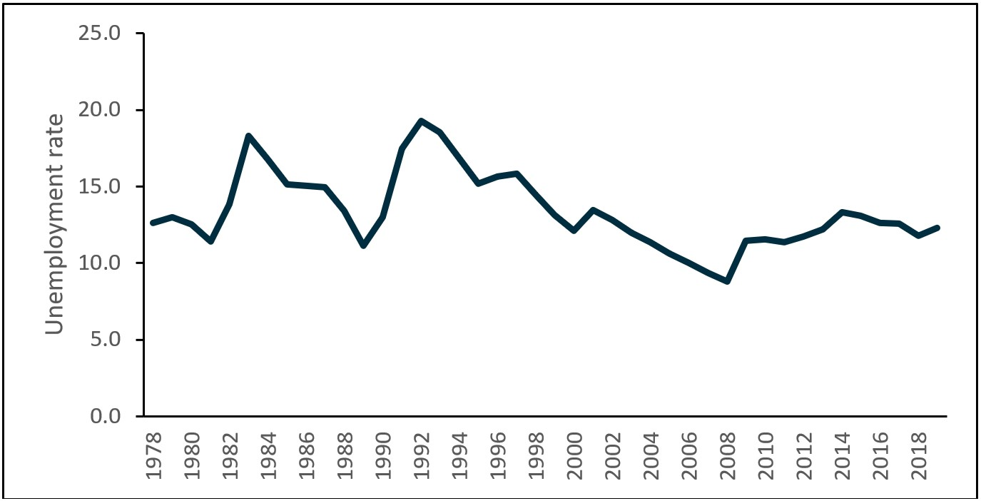

Source: Australian Bureau of Statistics, Labour Force, Australia, Detailed – Electronic Delivery, May 2019

The OECD report *Connecting People with Jobs: Key Issues for Raising Labour Market Participation in Australia* (OECD, 2017) focused on strategies to encourage greater labour market participation of disadvantaged groups in Australia. The report identified young people who were NEET as one of these disadvantaged groups and concluded that employment services interventions alone were insufficient to address multiple barriers often faced by disadvantaged individuals. Barriers to participation varied, with some young people experiencing several barriers at the same time, the most common being limited work experience, low skills and poor health.

In addition, the NEET rate is gender related (OECD, 2017):

… across the OECD, NEET rates exhibit a clear gender pattern, with women having persistently higher NEET rates than men. In Australia, the gender gap is particularly high: NEET rates are 36 per cent higher for women than for men across the OECD – in Australia, the gap in NEET rates is 51 per cent.

Australian research (Social Ventures Australia, 2016) further explored risk factors associated with youth transitioning from education to work. It showed that young people without Year 12 attainment are more likely to experience unemployment and for longer periods than their peers. Barriers such as risky behaviour (drug and alcohol abuse or criminal behaviour), a family background of joblessness, unstable housing or limited access to education reduce the likelihood of a young person completing their education and successfully transitioning to employment without additional support.

### 1.1.2 Few work experience positions

Surveys of employers, conducted regularly by the department, have shown a critical link between core foundation skills and a young person’s job prospects (Department of Employment, 2015). Around 13% of employers indicated that work experience would help young people understand expectations in the workplace and build practical skills. Finding work experience is a big challenge for many young people in disadvantaged locations with high unemployment. These young people often find themselves competing with other young people who have completed higher education (tertiary education leading to an academic degree). In some locations, the underlying relationships between family, neighbourhood and youth need addressing to improve employment outcomes for disadvantaged youth (Lewis, 2003).

### 1.1.3 Availability and affordability of education and training opportunities

Young people with low levels of educational attainment are most at risk of becoming long-term unemployed. The fact that 40% of all NEET young people in Australia (OECD, 2016B) have not completed Year 12 is of significant social and economic concern. Young people from low socioeconomic backgrounds and remote areas, particularly Indigenous youth, are especially at risk of not completing Year 12. They also perform substantially worse in literacy and numeracy tests (OECD, 2016B).

Training and further education help young people improve their employment prospects by giving them work-specific skills and qualifications, with higher education TAFE courses, apprenticeships and traineeships being the most viable pathways. Education and training opportunities are not always available or are booked out, particularly in some regional and rural locations. In many instances, the cost of education and training is prohibitive for young people from disadvantaged backgrounds (Considine et al, 2005). Similarly, a lack of transport options, caused by financial barriers, geographic barriers and age requirements for licensing drivers, can add to this ‘cumulative disadvantage’ and prevent or deter young people from participating in training.

### 1.1.4 Transition pathways

The OECD (2016) classifies two-thirds of all young NEET people in Australia as ‘inactive’. These young people are not looking for work, due mainly to multiple barriers to education and employment. It identifies this group’s risk factors as being ill health, social problems and migrant backgrounds. They require additional support to address multiple barriers before being able to engage in education and employment. The role of TtW is to help address these issues.

Recent Australian research based on longitudinal surveys undertaken by the National Centre for Vocational Education Research (NCVER), *School-to-Work Pathways*, profiles five pathways taken by young Australians between the ages of 16 and 25 years as they transition from school to work. They note that while most young people follow a simple school-to-work pathway, others experience ‘complex post-school pathways, with frequent switching between higher education and vocational education and training (VET) activities, episodes of part-time work and repeatedly moving in and out of the labour market’. In particular, the NCVER pathway, which involves multiple and repeated labour market movements and disengagement, ‘is associated with the highest share of young people with poor work outcomes at the age of 25 years, with 53.1% unemployed or not in the labour force’.

Disadvantaged young people and their parents are often unaware of services that are available in their community or how to access them to help overcome any personal barriers they may experience (NSW Family and Community Services, 2011). Young people participating in the roundtables conducted by the NSW Office of Communities Commission for Children and Young People (2013) agreed:

Young people raised issues in relation to availability and awareness of local facilities and services, barriers including cost and location and problems with boredom where there is a lack of suitable activities. Not all youth get access to opportunities in different areas. One area is different to another area – schools, sports and jobs especially.

## 1.2 The Youth Employment Strategy and Youth Employment Package

In recognition of the significant issues confronting young NEET people in Australia, the federal government announced a $322 million Youth Employment Strategy under the Growing Jobs and Small Business Package (The Treasury, 2015) in the 2015–16 Commonwealth Budget. The TtW service was an integral component of the Youth Employment Strategy. In addition, the government announced a Youth Employment Package in the 2016–17 Budget that included Youth Jobs PaTH (Prepare–Trial–Hire) and measures to encourage young people to start a business and create their own job. TtW participants were eligible for the Trial and Hire components of Youth Jobs PaTH.[4]

## 1.3 The macroeconomic environment

During the study period, the Australian economy was growing and transforming, resulting in changes to the jobs in which Australians work, with many occupations and industries expanding while others contracted. Future employment services need to help Australians adapt to these changes. Following almost three decades of uninterrupted growth, the economy has moved away from agriculture, manufacturing, mining and related industries towards more broadly-based growth, particularly in the more labour-intensive services sectors.

This structural shift has led to many benefits for the Australian economy as some cities and regions experience growth in investment and employment. Changes have not been uniform, however: job losses in other areas as local, some major, employers disappear are resulting in some groups – such as youth, the long-term unemployed, mature-aged people, lone-parent families and jobless families – becoming marginalised as a result.

During the study period of this evaluation of the TtW program, labour market conditions in Australia have strengthened considerably, with the level of employment increasing at around 2.3% per year. Further, the unemployment rate has decreased significantly, from 6.2% in July 2015 to 4.8% in December 2018, among the lowest rates recorded since June 2011 (ABS, May 2019).

The long-term unemployment number also fell by 25,700 (or 32.2%), while very long-term unemployment[5] decreased by 2,900 (or 3.1%) (ABS, March 2019). The youth unemployment rate fell from 12.3% to 11.3% in the year to December 2018 (ABS, April 2019).

The Indigenous unemployment rate stood at 18.2% in August 2016 (ABS, 2016), well above the 5.0% recorded for all persons in December 2018, while the Indigenous participation rate stood at 51.9% in August 2016, well below the 65.6% recorded for all persons in December 2018 (ABS, 2018).

## 1.4 The TtW service

TtW is a voluntary service that aims to provide targeted support to address the barriers faced by young people at risk of long-term unemployment to help them develop the attitudes and behaviours sought by employers.

A targeted 12-month intensive service,[6] TtW includes pre-employment activities hosted by the provider, education and training courses, activities to address non-vocational barriers, and regular appointments with providers.

The program design of TtW allows providers to work with individual participants in ways that are most helpful to them, creating a service tailored to each participant’s needs. TtW service providers, having been first selected through a competitive process, operate in one or more employment regions (ERs) and are either for-profit or not-for-profit organisations with links to educational organisations and local employment markets.

TtW providers work with local employers and with community and education organisations that offer complementary services to support young people to overcome barriers such as homelessness, mental health issues or substance abuse so that they can achieve their employment and education outcomes.

Unlike jobactive participants, TtW participants are not subject to a suspension of their income support payment for failure to attend activities or contact appointments with their provider; however, they will be exited from TtW to jobactive if they fail to participate adequately, albeit with a ‘warm hand-over’ (see **Appendix** **B**).

TtW operates independently of jobactive and other targeted employment services such as Disability Employment Services and the Community Development Programme, although TtW participants are referred from and to jobactive and may be eligible for PaTH and the National Work Experience Programme (NWEP) (see **Section 5.8.2**). ParentsNext participants may also participate in TtW under certain conditions.

### 1.4.1. TtW implementation

The TtW service rolled out in four phases in 51 ERs between February 2016 and May 2016; a map of ERs is at Appendix C. TtW provider contracts were originally in place until 26 June 2020. Various changes to the TtW program have occurred since its commencement in 2016 (**Figure 1.2).**

From 1 January 2018, the eligibility criteria of TtW expanded to include all Indigenous youth aged 21 years or under, including those who have completed Year 12 or a Certificate III. From 1 July 2018, funding for TtW became demand driven with uncapped funding (announced in the 2018–19 Budget).

Figure 1.2: Changes to the TtW program between February 2016 and January 2020

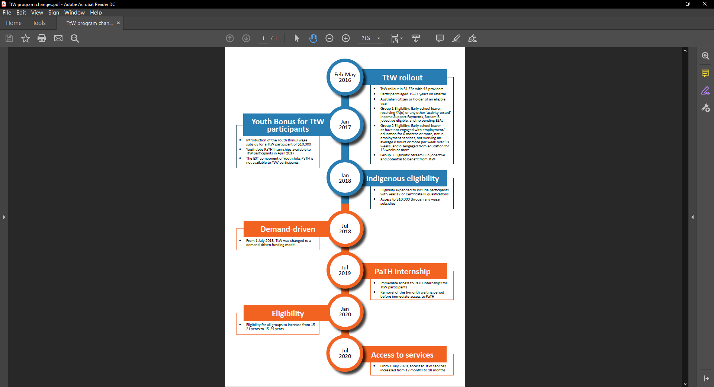

Note: The area of blue shading represents the study period and the orange represents the post-evaluation period.

* For July 2018, if a TtW Group One referral subject to RapidConnect fails to comply with the requirement to attend the initial interview and does not have a reasonable excuse, commencement of their income support payment is delayed until the participant attends an initial interview, if one can be made within a reasonable timeframe.

In April 2019, the government announced an extension of contracts and a future expansion of the eligibility criteria to include disadvantaged young people aged 22 to 24 years from 1 January 2020.

### 1.4.2 TtW services three main groups of young people

The TtW service supports three groups of young people aged 15 to 21 years considered most at risk of disengagement or disadvantage in their transition to work. The eligibility requirements for each of the three groups vary. At the time of the evaluation, the overarching eligibility requirements were for a young person to:

* be aged 15–21 years[7] on commencement in the service
* be an Australian citizen or the holder of a
  + permanent visa or
  + New Zealand Special Category Visa (protected or non-protected) or
  + nominated visa (including Temporary Protection Visa or Safe Haven Visa).

Participants must live in a postcode where the TtW service is delivered.

In addition to the core TtW eligibility requirements, young people referred to TtW through the different pathways during the evaluation period, as shown in **Table 1.1**, reflect the different eligibility circumstances of each of the three groups.

Table 1.1: TtW target groups before 1 January 2018 – eligibility, referral process and caseload profile

| **Group** | **Referral process** | **Caseload** |
| --- | --- | --- |
| Group One – early school leavers referred from the Department of Human Services  These are young people who:   * have not been awarded a Year 12 certificate or a Certificate III or higher * are receiving Youth Allowance (Other) or any other activity-tested income support payment * are eligible for Stream B in jobactive but do not have a pending employment services assessment (ESAt). | * DHS (Centrelink) refers eligible young people to their local TtW service when they first claim income support. The start date with TtW is within 2 business days from referral if subject to RapidConnect. * Participants in this group may opt out and elect to participate in jobactive instead. * TtW providers attempt to engage young people in this group within 4 weeks from referral, before exiting them or referring them back to jobactive if they are uncontactable or unsuitable for TtW. | Participants in Group One have priority access to TtW and were projected to make up approximately 70% of Annual Funded Places. |
| **Group Two – disengaged young people**  These are young people who:   * have not been awarded a Year 12 certificate or a Certificate III or higher * are not already participating in employment services * for the last 13 weeks have not been working an average of 8 hours or more per week * have not attended secondary education for 13 weeks, are not enrolled in secondary education and have an approved exemption from legal requirements to attend school * are not receiving income support or are receiving non-activity-tested income support such as Parenting Payment. | * Eligible young people can register directly with a provider. * Providers undertake activities to attract disengaged young people to the service and encourage them to participate in it fully. | * Participants in Group Two were projected to make up around 20% of Annual Funded Places. * Group Two includes young people who are not receiving income support or who are receiving non-activity-tested income support such as a Parenting Payment where their youngest child is under 6 years of age. |
| **Group Three – referrals from a jobactive provider**  These are young people who:   * are in Stream C in jobactive * are identified by their jobactive provider as having capacity to benefit from TtW (e.g. young people with one or more particular types of disadvantage, such as unstable housing). | jobactive providers can directly refer young people in this category to TtW providers. | Participants in Group Three are subject to a cap on places, which was set at 10% of the total Annual Funded Places allocated (except during the initial commencement stage). |

### 1.4.3 Indigenous participation

In January 2018, under the Closing the Gap Agreement, Indigenous young people (aged 15–21 years) who had completed Year 12 or a Certificate III became eligible for the intensive pre-employment assistance provided by TtW.[8]

### 1.4.4 The TtW service pathway

TtW providers deliver more intensive support than is available through employment services in existence at the time of the study, to help young people develop the attitudes and behaviours sought by employers. Under TtW, a participant has commenced once they have attended their initial appointment. As part of the initial phase in TtW, providers determine and agree on the appropriate mix of individual, group and self-directed activities with each participant to meet a 25 hours per week participation requirement, where applicable. This can include employment, activities hosted by the provider, education and training courses, activities to address non-vocational barriers, and appointments. These activities should be revisited as participants progress through the service.

### 1.4.5 The TtW funding model

The TtW funding model differs from the funding models for other employment services, such as jobactive. jobactive provides a six-monthly administration fee and regular outcome payments. jobactive providers also have access to an Employment Fund allocation, not available to TtW providers, for goods and services that genuinely support and assist job seekers to gain the tools, skills and experience they need to get and keep a job. TtW providers purchase these goods and services out of their much higher upfront payments, as well as any bonus outcome and sustainability outcome payments.

The TtW funding model includes a quarterly upfront payment based on the funded places allocated, a quarterly Outcome Performance Target and bonus outcome payments to drive high performance. The three main elements currently are:

* an upfront payment of $1,370[9] per quarter for each funded place
* a bonus outcome payment of $3,619 for every non-sustainability outcome above a quarterly Outcome Performance Target, paid as outcomes are claimed
* a sustainability outcome payment of $3,619 for every sustainability (26-week) outcome achieved, paid as outcomes are claimed.

The upfront payment allows providers to fund services or activities that will help a participant gain employment, participate in education and increase their work readiness.

TtW providers can seek reimbursement from the department for the following wage subsidies:

* Youth Bonus Wage Subsidy
* Parents Wage Subsidy
* Long-Term Unemployed Wage Subsidy
* Indigenous Wage Subsidy.[10]

In line with receiving upfront payments for each funded place, providers are expected to achieve an agreed number of non-sustainability outcomes each quarter (Outcome Performance Targets). These targets are set at 25% above the average 12-week employment outcome rates achieved by mainstream employment services (Job Services Australia[11] and jobactive) in each ER over three years.

The Outcome Performance Targets, calculated separately for each ER,[12] take into account regional variations in labour market conditions. In the first year of the service, these targets were set using three-year average outcome rates from Job Services Australia.

In the first year of operation, quarterly Outcome Performance Targets were discounted to account for the lag between commencing participants and achieving outcomes, resulting in lower outcome targets for that year than those of subsequent years. All funded places were expected to be filled by the end of the first year.

Wage subsidies (up to $10,000)[13] are also available to employers who hire a TtW participant in a sustainable, ongoing position with an average of 20 hours per week over at least six months. These provide a financial incentive to employers to hire eligible recipients in ongoing jobs by contributing to the initial costs of hiring and training a new employee.

#### 1.4.6 The TtW service focuses on both employment and education outcomes

Providers can claim outcomes for young people who participate in work, education or a combination of the two. The requirements for achieving an outcome depend on the participant’s income support status and Mutual Obligation Requirements (MORs) as presented in **Table D.1,** **Appendix D**.

#### 1.4.6.1 Employment outcomes

A 12-week employment outcome is for 12 cumulative weeks of:

* employment confirmed and tracked during a participant’s period of service (this can comprise multiple job placements and employers) or
* unsubsidised (not on income support) self-employment or
* an apprenticeship or traineeship (if not claimed as a hybrid outcome).

The achievement of 14 weeks of consecutive employment following a 12-week outcome results in a 26-week employment sustainability outcome.

#### 1.4.6.2 Education outcomes

An education outcome is for 26 consecutive weeks of full-time participation in, or attainment of:

* a Certificate III or higher course (this includes a Certificate IV, diploma, advanced diploma, associate degree or bachelor degree; it does not include university bridging or preparation courses), or
* secondary education leading to Year 12 (attainment may only be claimed for completing Year 12), or
* the Skills for Education and Employment (SEE) program or Adult Migrant English Program (AMEP). SEE and AMEP can only track towards a participation outcome, not an attainment outcome.

Providers can claim either an education attainment outcome or an education participation outcome but not both for the same course.

#### 1.4.6.3 Hybrid outcomes

A 12-week hybrid outcome is claimable for 12 consecutive weeks of participation in any combination of education and employment for no fewer than 25 hours (on average) per week for participants with full-time requirements, as long as placements run concurrently. A 26-week hybrid outcome occurs when a participant meets the 12-week hybrid or 12-week employment outcome requirements, then the hybrid outcome requirements for 14 consecutive weeks after the 12-week outcome.

### 1.4.7 Service Guarantee, Service Delivery Plans and Key Performance Indicators

The Service Guarantee for TtW[14] sets out the standard of service delivery that participants and employers can expect from a provider. This is complemented by Service Delivery Plans (SDPs) outlining the agreed suite of services to be delivered by the TtW provider, including highly flexible strategies that are tailored to the needs of individual participants.

The department uses the following Key Performance Indicators (KPIs) set out in the TtW Deed to assess the effectiveness, efficiency and quality of a provider’s service delivery (Department of Employment, Skills, Small and Family Business, 2016). The KPIs are:

* **KPI 1 (Effectiveness)** – the extent to which the provider meets the objectives of TtW. Measurement is based on:
  + the number of outcomes (excluding sustainability outcomes) achieved for participants, relative to the Outcome Performance Target
  + from 1 July 2017, the degree of improvement in each participant’s work readiness from their start date to their exit date
  + achieving outcomes that result in participants moving fully off income support payments
* **KPI 2 (Efficiency)** – Measurement is based on the amount of time between referral and commencement of participants
* **KPI 3 (Quality)** – Measurement is based on the department’s assessment of quality and assurance, including delivery against the Service Guarantee for TtW and the SDPs.

Some providers are contracted to deliver a service in a single ER, while others operate in multiple ERs. Providers receive ‘bonus’ outcomes for every 12-week employment, hybrid or education outcome they claim above their quarterly allocated target.

The department reviews service delivery on a continuous basis and undertakes regular service assurance meetings with providers via formal performance reviews, conducted annually. The department also gathers information on provider performance from a variety of other sources such as post-program monitoring surveys of participants, informal provider visits and assurance activities.

Indigenous young people and other disadvantaged groups are a priority for the TtW service. Changes to the TtW eligibility criteria to include all Indigenous youth who met the age criteria from January 2018 reflect this priority. Providers, or their staff, must demonstrate experience working with disengaged and disadvantaged young people, as well as having strong links with employers, community services and schools in their local community on selection. Although there are no specific targets for Indigenous participants and other highly vulnerable participants in TtW, the department monitors outcomes for these groups. Up to 30% of TtW participants are Indigenous, although this varies across ERs.

## 1.5 Interactions of TtW with other employment programs

Activities in TtW include participation in a range of other government programs. The specific programs have changed over the period of operation of TtW with new rules and activities. They include SEE, Vocational, Training and Employment Centres, Empowering YOUth Initiatives and the Australian Apprenticeship Support Network (**Appendix G**). Following the commencement of TtW in 2016, the government introduced the Youth Jobs PaTH program in April 2017. Youth Jobs PaTH covers three elements – Prepare, Trial and Hire[15] – to encourage employers to hire young people by enhancing their employability through targeted training and real work experience, supported by incentives for employers to employ them and support them as they transition to employment. TtW participants are eligible for the Trial and Hire elements of Youth Jobs PaTH.[16] TtW participants who are 18 years or older can also undertake work experience job placements under the NWEP.[17] Participants in ParentsNext may concurrently participate in TtW.

# Chapter 2 Evaluation of the TtW service

## 2.1 Introduction

This chapter describes the evaluation of the TtW service. Program evaluation contributes to the Australian Government’s transparency and accountability agenda, informing policy development and driving continuous improvement and innovation.

In line with the *Public Governance, Performance and Accountability Act 2013* (PGPA Act), evaluations – described as systematic and objective assessments of an ongoing or completed project, activity or policy – are undertaken to (a) improve the performance of existing interventions or policies, (b) assess their effects and impacts, and (c) inform decisions about future programming.

Evaluations are formal analytical endeavours involving systematic collection and analysis of qualitative and quantitative information. Evidence derived from them contributes to performance reporting in annual performance statements. The TtW evaluation focuses on supporting continuous improvement of the service by assessing how effectively and efficiently the service is meeting its objectives. It includes both formative and summative evaluation components, as outlined in the TtW Evaluation Strategy (Department of Employment, 2017B).

In the following sections, a summary and then results of the formative component – the first phase of the evaluation, which appeared in the Interim Report – are presented. The second stage of the evaluation, the summative component, is the focus of this report. The approach is elaborated on, including the use of mixed methods.

The main study population comprises TtW participants who commenced in the program between 1 April 2016 and 31 March 2017 and were followed for 12 months or longer. A profile of the characteristics of the population appears in this chapter. A clarification of the numerous data sources that contribute to the evaluation and an overview of each are provided, including details of the population size, its profile and how it is different compared to the main study population.

## 2.2 Theory of change

Participants entering the TtW inflow population do so at different stages of their transition from education to work, despite the almost universal commonality of not having a Year 12 certificate or Certificate III or higher[18] and not being in employment. Despite some being ESLs, some participants are more work ready and face fewer vocational and non-vocational barriers than do other participants.

The majority of the young people participating in TtW, however, are likely to follow one or two of the five possible pathways identified by NCVER in 2019 as those taken by young Australians between the ages of 16 and 25 years transitioning from school to work (Appendix F).

These two pathways were repeated disengagement and/or working part-time (**Table 2.1**). Generally, participants in these pathways experienced multiple and repeated labour market movements, disengagements, and relatively early entry into the labour market. The jobs they obtained were likely to be short term and low level. For ease of discussion, these pathways are termed ‘tenuous’ transitions.

Table 2.1: Pathways from school to employment – mixed and repeatedly disengaged or mostly working part time

| Mixed and repeatedly disengaged | Mostly working part time |
| --- | --- |
| This pathway is characterised by multiple and repeated labour market movements and disengagement, indicating tenuous LMA (5% of the NCVER longitudinal sample). | This represents the smallest group (4% of the NCVER longitudinal sample), a group characterised by relatively early entry to the labour market and mostly part-time employment over the 10 years. |
| This represents the most complex pathway and contains the highest proportion of young people experiencing more than 10 transitions between the ages of 16 and 25 years. | Youth in this pathway spend the most time in part-time employment between the ages of 16 and 25 years. |
| Young people in this pathway spend the highest average number of months disengaged from the labour market (16.2 months) or unemployed (41.2 months), with 53.1% not working at age 25 years. | They hold the least qualifications of all the pathways (with the highest share, at 17.9%, holding a Certificate III), and 50.9% have no post-school qualifications at the age of 25 years. They also spend the least amount of time in post-school education. |
| This pathway has the highest proportions of vulnerable youth, indicated by the higher incidence of teenage marriages or parenting, disability, ESLs and youth from the lowest socioeconomic stratum. | At the age of 25 years, young people in this pathway are primarily employed in community and personal services (26.8%), sales (18.8%) and clerical and administrative occupations (12.5%). |

Source: NCVER research report *School-to-Work Pathways* (Ranasinghe et al., 2019)

While activation programs may improve employment prospects and participants’ earnings, they can also divert participants’ time and effort away from job search when undertaking education and training. Based on the objective of this evaluation, a theory of change that explains this type of diversion has been proposed. It takes participants through a series of virtuous circles along their path to skills development and employment. Key to a virtuous circle is a combination of tailored assistance, genuine engagement, achievable and relevant goals, appropriate feedback leading to improved performance, and increased competence. This results in heightened confidence and leads to a willingness to set more challenging goals. It is an ongoing and ultimately self-perpetuating spiral of self-improvement that leads to improved self-confidence, self-efficacy and ultimately agency or human capital (Department of Education, Skills and Employment, 2020).

The human capital generated by this model is generally ‘defined in terms of the number of productive years they (participants) could contribute that skill to the economy, and how, as their skill develops over time, their contribution to economic productivity increases’ (Perales et al., 2018).

The individual participants’ vocational and non-vocational barriers, work readiness, motivation, aspirations and job skills determine the initial circle in which they participate. TtW participants with significant vocational and non-vocational barriers are likely to follow a cycle of improvement set out in **Figure 2.1**.

Figure 2.1: Participants’ capability development

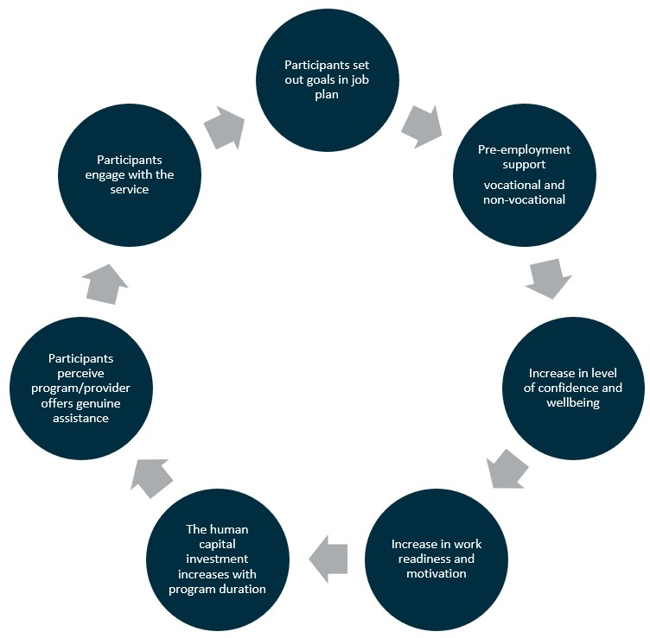

Participation in TtW provides young people with support as they move along a pathway of self-improvement to gain additional training and qualifications and/or work experience. The acquisition of these skills, work readiness, increased levels of confidence and human capital should enable participants to transition to one of two other NCVER pathways that have more secure employment outcomes for the future – that is, ‘sustained transition’ (**Table 2.2**).

Table 2.2: Pathways from school to employment – early entry to full-time work and a mix of higher education and VET

| Early entry to full-time work | Mix of higher education and VET |
| --- | --- |
| This is an ‘express pathway’ to employment and includes apprenticeships and traineeships. This pathway comprises a relatively short spell (14.3 months on average) of post-school education or training, leading to full-time work (23% of the sample). For many respondents, however, it is likely that training jointly in combination with full-time work extends beyond early post-school years, as part of an apprenticeship or traineeship. | This pathway comprises an extended period of higher education and VET activity, eventually leading to more stable employment or further VET activity (8% of the sample). |
| Young people in this pathway have the fastest entry to employment and spend the longest time in work. | Youth in this pathway have a relatively complex trajectory, with frequent switching between university and VET activities. |
| This is a predominantly male pathway, with a high proportion undertaking vocational subjects in secondary school; almost half had undertaken apprenticeship/traineeships by the age of 25 years. | This is a predominantly female pathway, with a high proportion engaged in VET activities after the age of 20 years; they also spend the highest average number of months (35.2) in post-school VET activities and hold the most VET qualifications by age 25 years. At this age, 26.8% held a bachelor’s degree as their highest qualification, while a further 25.6% held an advanced diploma / diploma qualification and 15.4% held a Certificate IV. |
| This pathway contains the highest proportion of young people who were married by the age of 25 years, and the highest proportion in technical and trades occupations at the age of 25 years. | The highest proportions of these young people are working as professionals (20.1%) and community and personal service workers (22.8%), and in clerical and administrative occupations (16.5%) at age 25 years. |

Source: NCVER research report *School-to-Work Pathways* (Ranasinghe et al., 2019)

## 2.3 The human capability model

In addition to the development of human capital described above, the evaluation applies a human capability concept to test if TtW has the potential to enhance the contribution participants make to their broader community (Perales et al., 2018):

[This] human capability concept also takes into consideration the broader set of talents, skills and resources that people have that not only allow them to choose a profession and change jobs through the life course, but also to contribute to their families, for example through parenting and the development of their children, and to their communities through activities outside of the workplace …

[The] role of human capabilities, as distinct from human capital, is through their direct influence on well-being and freedom. The results of this are not just seen in increases in economic participation and productivity, but are also seen in increases in social and civic participation as well …

## 2.4 Stage one: formative evaluation

The formative evaluation focused on the implementation and early operations of TtW, underpinned by initial participant and provider views on the service’s design, commencement, implementation and operational processes, and on the initial stage of participant engagement. It also included a preliminary assessment of progress towards defined outcomes using administrative data. This stage covered the inflow period for referrals to TtW from the start of the service in February 2016 until 31 July 2016. It followed the progress of participants who commenced by 31 August 2016 for up to six months and included quarterly outcome performances reported up to the end of March 2017.

The findings of the formative evaluation were presented in the TtW Interim Evaluation Report (Department of Employment, Skills, Small and Family Business, 2018A). The research found that the TtW service was well received by all stakeholders, namely participants, providers, DHS staff, peak body representatives and employers. Stakeholders agreed that the service was targeted, flexible and of a high quality.

Most providers encountered implementation issues in the first few months of operations. For example, the rapid rollout of the service made it challenging for providers to secure premises and recruit and train staff in time. Furthermore, there were issues with the early referrals where contact details were inaccurate or referrals unsuitable. Providers attributed these issues to a lack of awareness and understanding of TtW among participants, DHS staff and employers. Feedback from stakeholders included the following suggestions for improvements:

* extending the service delivery time beyond 12 months
* extending the upper age limit from 21 to 25 years[19]
* increasing compliance requirements for participants during the early weeks of engagement[20]
* reducing the waiting times for disengaged youth (Group Two)
* increasing incentives to encourage more Stream C referrals from jobactive (Group Three)
* more ESS Web training for providers
* more regular feedback from the department to providers on their performance
* increasing interactions between the department, providers and DHS.

Most of these issues have now been resolved and providers are generally satisfied with the service and support received from the department.

The key findings from the formative stage of the evaluation appear in **Appendix A**.

## 2.5 Stage two: summative evaluation

This summative evaluation, conducted approximately two years after the TtW service commenced, focuses on TtW participants who commenced in the program between 1 April 2016 and 31 March 2017 and were followed for 12 months or more. It assesses the effectiveness, efficiency, equity and quality of the service, and identifies what works in servicing disadvantaged young people.

## 2.6 Key evaluation questions

This evaluation report addresses the following evaluation questions outlined in the TtW Evaluation Strategy (Department of Employment, 2017B):

* Does participation in TtW lead to improved work readiness, and employment and educational outcomes for participants?
* Does TtW deliver cost-effective and time-effective outcomes?
* What service elements are associated with improved education and employment outcomes and from which providers?
* Does TtW deliver targeted and quality service to participants?

## 2.7 Methods

This evaluation adopted a mixed-methods approach, applying complementary quantitative and qualitative methods to assess the impact of TtW on youth employment and educational outcomes, and the cost-effectiveness and service quality of the program. The department undertakes these mixed-methods evaluations of many of its programs on a regular basis and considers that this approach offers many advantages over single-method approaches that apply purely quantitative or purely qualitative study designs.

In the case of the TtW service, these advantages include improving the accuracy, consistency and general credibility of the findings by cross-validating results from different evaluation phases. The mixed-methods approach also increases the comprehensiveness and utility of the overall findings by enhancing explanation and interpretation, while synthesising results gleaned from different data sources.

## 2.8 Data sources

This evaluation used a variety of quantitative and qualitative data sources including surveys, qualitative fieldwork and departmental administrative data (used to derive the participant study populations). The data sources included:

* administrative data from the department’s ESS database, which captures participant, provider, employer and other program transactional information
* the department’s Research and Evaluation Database, which contains information related to income support payments and recipients based on DHS administrative data
* 2016 TtW Provider Survey
* 2017 TtW Provider Survey
* 2017 JSEES Survey
* 2017 Employer Project (known as 2017 Employer Survey)
* 2017–2018 PPM Survey
* 2016 qualitative research (Wave 1) with participants, providers, employers and other stakeholders
* 2018 qualitative research (Wave 2) with participants, providers, employers and other stakeholders.

A full description of each data source appears in **Appendix E**.

## 2.9 Study populations and their characteristics

The final evaluation utilised several participant study populations to compare TtW and jobactive participants. The participant study populations included information on periods of assistance TtW and jobactive participants received, beginning on the date of the participant’s referral to TtW or jobactive and ending when they exited TtW or jobactive for more than 91 days.[21]

Participants may have had more than one period of assistance; however, since a significant amount of time elapsed between participants ending a period of assistance and starting a new one, a participant’s labour market situation and personal characteristics may have differed significantly from one period of assistance to the next. The evaluation therefore treated each of a participant’s periods of assistance as separate cases, rather than combining them and treating each participant as a single case. For ease of reporting, reference is made to ‘periods of assistance’ as ‘participants’ throughout the report.

The main participant study population for the final evaluation, drawn from departmental administrative data, was the inflow population of 27,241 periods of assistance (26,994 unique participants) with referrals to TtW that occurred between 1 April 2016 and 31 March 2017. It included participants who:

* commenced in the service
* exited TtW before 12 months, or
* completed 12 months or more of TtW (noting their destinations).

### 2.9.1 TtW inflow population and matched sample profiles

For comparison purposes TtW participants in the main study population were matched with similar aged jobactive participants using case-control matching, based on Job Seeker Classification Instrument (JSCI) score grouping and completion, or not, of Year 12.

Sixty per cent of the TtW inflow population were male and a high percentage were aged 18 years and older. Young people who reported as being Indigenous accounted for 17.4% of the study population, while 8% identified as ex-offenders.

The jobactive population used for the matching process was restricted to Stream B jobactive participants aged under 22 years at referral who had not been in TtW in the 91 days prior to referral. Matching resulted in 12,105 periods of assistance in each of the respective TtW and jobactive matched samples. This consisted of 12,040 unique participants in the TtW matched sample and 12,023 unique participants in the jobactive matched sample.

The characteristics of the TtW inflow study population and the matched TtW and jobactive samples are summarised in **Table 2.3**. Further details of study population methodology and demographics are included at **Appendix F**.

Table 2.3: Demographic characteristics of TtW inflow population and matched samples

| Factor/Level | TtW inflow population n=27,241  (No) | TtW inflow population  (%) | TtW matched sample n=12,105  (No) | TtW matched sample  (%) | jobactive matched sample n=12,105  (No) | jobactive matched sample (%) |
| --- | --- | --- | --- | --- | --- | --- |
| **Age (years)** | – | – | – | – | – | – |
| 15 to 17 | 9,131 | 33.5 | 4,078 | 33.7 | 3,032 | 25.0 |
| 18 to 20 | 15,075 | 55.4 | 6,638 | 54.8 | 7,235 | 59.8 |
| 21 to 22* | 3,035 | 11.1 | 1,389 | 11.5 | 1,838 | 15.2 |
| **Gender** | – | – | – | – | – | – |
| Female | 10,963 | 40.2 | 5,374 | 44.4 | 5,631 | 46.5 |
| Male | 16,277 | 59.8 | 6,730 | 55.6 | 6,474 | 53.5 |
| Unknown | 1 | 0.0 | 1 | 0.0 | 0 | 0.0 |
| **Indigenous status** | – | – | – | – | – | – |
| Does not identify as Indigenous | 21,148 | 77.6 | 8,832 | 73.0 | 9,022 | 74.5 |
| Declined to answer | 558 | 2.0 | 258 | 2.1 | 365 | 3.0 |
| Identifies as Indigenous | 4,739 | 17.4 | 2,619 | 21.6 | 2,322 | 19.2 |
| Unknown | 796 | 2.9 | 396 | 3.3 | 396 | 3.3 |
| **Income support history: duration** | – | – | – | – | – | – |
| Less than 12 months | 4,282 | 15.7 | 2,003 | 16.5 | 2,972 | 24.6 |
| 12 to 23 months | 1,312 | 4.8 | 736 | 6.1 | 1,190 | 9.8 |
| 24 to 35 months | 616 | 2.3 | 390 | 3.2 | 628 | 5.2 |
| 36 to 47 months | 309 | 1.1 | 207 | 1.7 | 332 | 2.7 |
| 48 to 59 months | 161 | 0.6 | 124 | 1.0 | 130 | 1.1 |
| 60 months or more | 197 | 0.7 | 132 | 1.1 | 257 | 2.1 |
| Not currently on income support | 19,568 | 71.8 | 8,117 | 67.1 | 6,200 | 51.2 |
| Unknown | 796 | 2.9 | 396 | 3.3 | 396 | 3.3 |
| **TtW group** | – | – | – | – | – | – |
| Group One | 24,041 | 88.3 | 10,282 | 84.9 | n/a | n/a |
| Group Two | 2,439 | 9.0 | 1,271 | 10.5 | n/a | n/a |
| Group Three | 759 | 2.8 | 551 | 4.6 | n/a | n/a |
| Unknown | 2 | 0.0 | 1 | 0.0 | n/a | n/a |

* One participant was aged 23 years.

Note: Demographics are as at a participant’s JSCI assessment date, using the JSCI assessment that was closest to their commencement date. Some participants may have been yet to start on income support at this date.

Source: Department of Education, Skills and Employment administrative data – study populations

In the TtW matched sample, **21.6%** of TtW participants identified as Indigenous compared with **19.2%** of those in the jobactive matched sample. Indigenous young people were overrepresented in TtW compared to the wider population, with **4.3%** of 15–22 year olds in the 2016 Census reported as Indigenous. There were slightly fewer female participants in TtW (**44.4%**) compared to jobactive (**46.5%**) in the matched sample.

There was a higher proportion of participants in the TtW matched sample aged under 18 years (**33.7%**) (**Table 2.3**) compared with the jobactive matched sample (**25.0%**). Approximately **55%** of the TtW matched sample were aged between 18 and 20 years, compared with approximately **60%** of the jobactive matched sample. Differences between the matched samples, such as age, were statistically controlled in the program impact analyses.

## 2.10 Barriers to participation

In the 2017 TtW JSEES Survey, when asked about their perceived barriers to finding ongoing, sustainable employment, participants mentioned a range of vocational and non-vocational barriers, while approximately a third (**35%**) reported they had no barriers to finding work (**Figure 2.2**). The most common barriers cited were physical or mental health concerns (**14%**), a lack of work experience (**13%**) and no suitable jobs available in the area (**11%**). Transport, either no driver’s licence or lack of access, impacted **14%** of participants.

Figure 2.2: Perceived barriers to ongoing and sustainable work identified by TtW participants

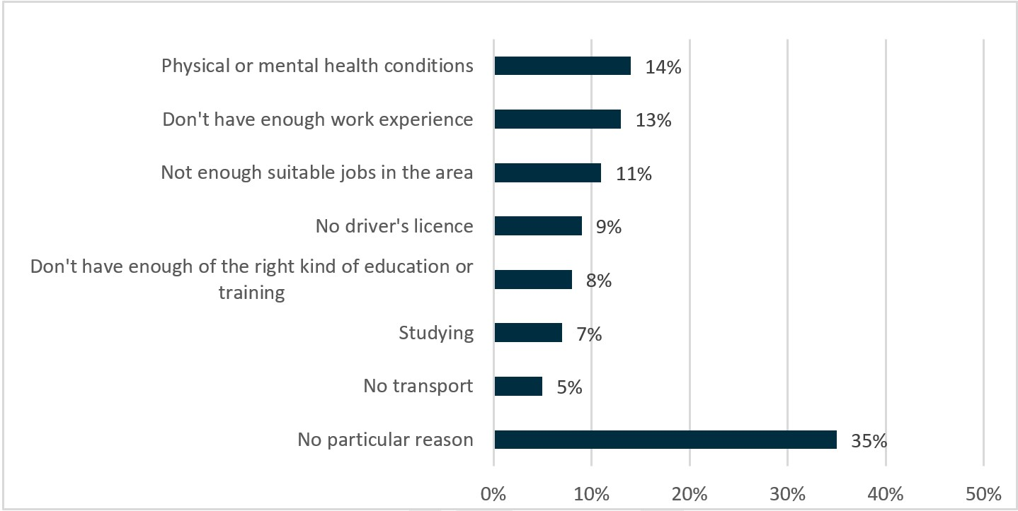

Base: all participants not currently working (n=356)

Question: Are there any reasons that make it difficult for you to find ongoing work?

Source: 2017 TtW JSEES Survey

Other barriers mentioned but not included in Figure 2.2 were:

* employers thinking job seekers are too young (3%)
* a lack of confidence (3%)
* living in a remote/isolated area (3%)
* having caring responsibilities for another person (2%)
* a lack of skills in writing job applications and interviewing (2%).

### 2.10.1 Non-vocational (personal) barriers

According to JSCI data, **89%** of young people in the TtW inflow population reported having no personal factors[22] affecting their ability to work, and **88%** reported being in stable housing (**Table 2.4**). Similarly, **86%** of the TtW and **89%** of the jobactive matched samples reported no impact from personal factors.

Most young people with complex barriers who were referred for an ESAt and thus not eligible for TtW were placed in Stream C in jobactive. jobactive providers may have then referred them to TtW, however, if they felt they would benefit from TtW services.

The demographics of the TtW inflow population showed that for TtW participants:

* **55%** relied on public transport while **6%** had no transport available
* **5%** had one or more disabilities (compared to **2%** of 15–22 year olds in the 2016 Census who needed assistance with core activities)
* **88%** had stable housing.

While the matched TtW and jobactive samples had similar proportions of participants who were male, identified as Indigenous, reported not having a disability and had stable housing, TtW participants were less likely to have their own transport (**20%**) than were jobactive participants (**25%**) (**Table 2.4**), perhaps unsurprisingly given their age group.

Table 2.4: Non-vocational barriers of TtW inflow population and matched samples

| Factor/Level | TtW inflow population n=27,241  (No) | TtW inflow population  (%) | TtW matched sample n=12,105  (No) | TtW matched sample  (%) | jobactive matched sample n=12,105  (No) | jobactive matched sample  (%) |
| --- | --- | --- | --- | --- | --- | --- |
| **Transport** | – | – | – | – | – | – |
| Own transport | 6,005 | 22.0 | 2,387 | 19.7 | 3,024 | 25.0 |
| Other private transport | 4,047 | 14.9 | 1,829 | 15.1 | 1,678 | 13.9 |
| Public transport | 14,878 | 54.6 | 6,739 | 55.7 | 6,122 | 50.6 |
| No transport | 1,515 | 5.6 | 754 | 6.2 | 885 | 7.3 |
| Unknown | 796 | 2.9 | 396 | 3.3 | 396 | 3.3 |
| **Disability** | – | – | – | – | – | – |
| No disabilities | 24,831 | 91.2 | 10,681 | 88.2 | 10,630 | 87.8 |
| Declined to answer | 172 | 0.6 | 86 | 0.7 | 176 | 1.5 |
| Has one or more disabilities | 1,442 | 5.3 | 942 | 8.5 | 903 | 7.5 |
| Unknown | 796 | 2.9 | 396 | 3.3 | 396 | 3.3 |
| **Housing** | – | – | – | – | – | – |
| Stable residence | 23,859 | 87.6 | 10,278 | 84.9 | 10,093 | 83.4 |
| Primary unstable residence | 121 | 0.4 | 62 | 0.5 | 87 | 0.7 |
| Secondary unstable residence | 2,465 | 9.0 | 1,369 | 11.3 | 1,529 | 12.6 |
| Unknown | 796 | 2.9 | 396 | 3.3 | 396 | 3.3 |
| **Personal factorsa** | – | – | – | – | – | – |
| No impact | 24,280 | 89.1 | 10,231 | 84.5 | 10,785 | 89.1 |
| Some impact | 2,165 | 7.9 | 1,478 | 12.2 | 918 | 7.6 |
| Unknown | 796 | 2.9 | 396 | 3.3 | 402 | 3.3 |

(a) Such as jobless family background, anger issues/temper/violence, caring responsibilities, domestic violence, criminal court action pending or in drug treatment program

Note: Demographics are as at a participant’s JSCI assessment date, using the JSCI assessment that was closest to their commencement date.

Source: Department of Education, Skills and Employment administrative data – study populations

Also, unsurprisingly, the number of TtW participants who had access to private transport increased with age. However, fewer than half of participants aged 21 years had access to private transport (**Figure 2.3**).

Figure 2.3: TtW inflow study population, mode of transport by age

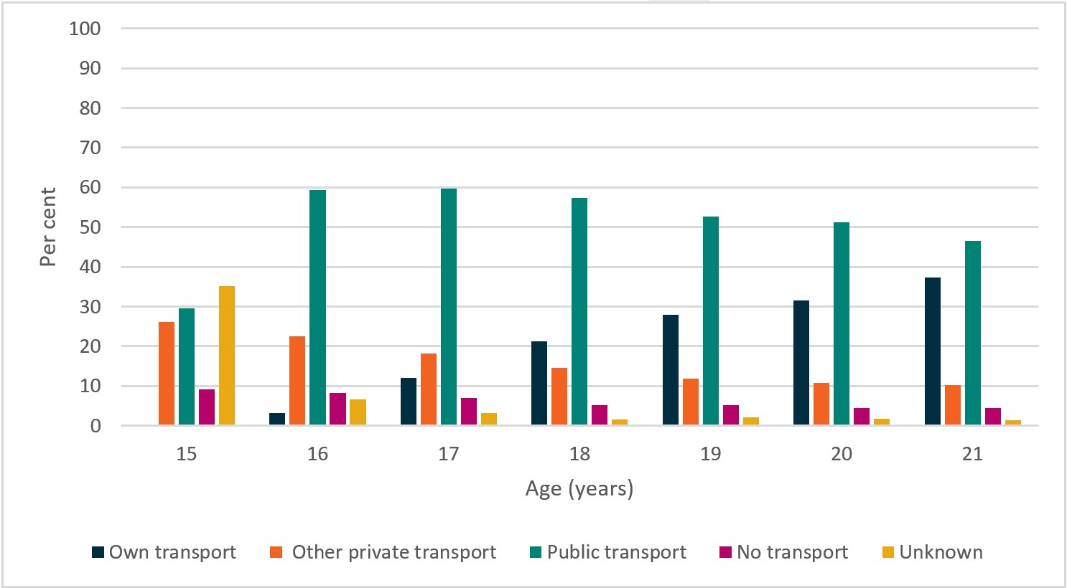

Base: TtW inflow population (n=27,241)

Source: Department of Education, Skills and Employment administrative data

### 2.10.2 Vocational barriers

As noted in the 2017 TtW JSEES Survey, when participants were asked about their difficulties in finding ongoing employment, they identified several vocational barriers: a lack of work experience, not having the right kind of education and training, and no jobs in their local area.

Within the inflow population, **82%** of TtW participants had not completed Year 12 or an equivalent qualification (compared to **51%** of 15–22 year olds in the 2016 Census) (**Table 2.5**)and:

* **69%** had completed Year 10/11 as their highest year of schooling (compared to **32%** of 2016 Census 15–22 year olds)
* **13%** had completed less than Year 10 as their highest year of schooling (compared to **12%** of 2016 Census 15–22 year olds)
* almost none had any tertiary qualifications such as diplomas or trades qualifications (compared to **17%** of 2016 Census 15–22 year olds)
* **92%** had good English skills (compared to **93%** of 2016 Census 15–22 year olds who reported they spoke English very well or well or that the question was not applicable because they spoke only English at home).

As shown in **Table 2.5**, the matching process resulted in the TtW sample having a reduced proportion of participants who had not completed Year 12 compared to the TtW inflow population, from **82%** to **63%**. However, the matched jobactive sample had a similar proportion of participants who had not completed Year 12 to the matched TtW sample (**62%**).

Table 2.5: Vocational barriers of TtW inflow population and matched samples

| Factor/Level | TtW inflow population n=27,241  (No) | TtW inflow population  (%) | TtW matched sample n=12,105  (No) | TtW matched sample  (%) | jobactive matched sample n=12,105  (No) | jobactive matched sample  (%) |
| --- | --- | --- | --- | --- | --- | --- |
| **Education** | – | – | – | – | – | – |
| Less than Year 10 | 3,428 | 12.6 | 1,553 | 12.8 | 1,742 | 14.4 |
| Year 10/Year 11 | 18,900 | 69.4 | 6,039 | 49.9 | 5,850 | 48.3 |
| Year 12/13 or above**(a)** | 4,116 | 15.1 | 4,116 | 34.0 | 4,116 | 34.0 |
| Unknown | 797 | 2.9 | 397 | 3.3 | 397 | 3.3 |
| **English** | – | – | – | – | – | – |
| Good | 25,129 | 92.2 | 10,971 | 90.6 | 10,480 | 86.6 |
| Combination of good and poor | 888 | 3.3 | 504 | 4.2 | 645 | 5.3 |
| Poor | 428 | 1.6 | 234 | 1.9 | 584 | 4.8 |
| Unknown | 796 | 2.9 | 396 | 3.3 | 396 | 3.3 |
| **Offender status** | – | – | – | – | – | – |
| Not an ex-offender | 23,741 | 87.2 | 10,364 | 85.6 | 10,271 | 84.8 |
| Declined to answer | 487 | 1.8 | 232 | 1.9 | 356 | 2.9 |
| Ex-offender | 2,217 | 8.1 | 1,113 | 9.2 | 1,082 | 8.9 |
| Unknown | 796 | 2.9 | 396 | 3.3 | 396 | 3.3 |

* One participant was aged 23 years.

(a) To be eligible for Group One and Group Two of TtW, young people must not have been awarded a Year 12 Certificate or a Certificate III or higher. This requirement does not apply to Group Three. The matching process resulted in an increased proportion of TtW participants with a Year 12 Certificate or a Certificate III or higher in the TtW matched sample compared to the TtW inflow population. However, the proportion of these participants was the same as in the jobactive matched sample.

Source: Department of Education, Skills and Employment administrative data – study populations

## 2.11 Analytical methods

Where feasible, descriptive statistics for different groups of interest, reported at a whole-of-service level, were disaggregated into category counts and percentages.

The evaluation also utilised logistic regression modelling where necessary to control for observable participant characteristics, providing a more robust estimate of the effects of TtW. The confidence level for statistical significance for this report was set at 95%.

### 2.11.1 Impact analysis

The main impact analyses involved the comparison of TtW and jobactive participants in the matched samples. After adjusting for participants’ levels of disadvantage, the matched TtW and jobactive participants were compared using multiple regression techniques that attempt to isolate the overall impact of TtW from the effects of participants’ demographic and socioeconomic characteristics.[23]

Finally, the impact on the probability of the average participant achieving an outcome after TtW was estimated. In technical terms, the analyses reported the ‘average marginal effect’ of TtW on each outcome.

In all cases, the analyses excluded from consideration outcomes that participants achieved less than one month after referral. This was because such outcomes were probably attributable mostly to the participant’s own efforts, rather than provider assistance. Outcomes achieved shortly after referral may have reflected pre-existing employment or study.

In order to compare performance between TtW and jobactive, three measures were constructed: an LMA indicator, a study outcome indicator and a positive outcome indicator. TtW participants referred from jobactive as part of the initial start-up caseload were excluded from the TtW inflow population. This allowed for greater comparability between the TtW and jobactive study populations and the isolation of the effect of TtW on participant outcomes.

#### Constructing the labour market attachment measure

The LMA indicator utilised the following factors:

* reported earnings to DHS
* received no income support payment for at least one fortnight
* received an income support payment below their base rate of income support
* recorded part-time or casual employment as an activity in the department’s IT system
* confirmed job placement recorded in the department’s IT system.

Each factor for each participant was tracked across the study period each fortnight. If any one of the factors applied during the tracking period, a participant was identified as engaged in some paid work and their LMA indicator was set to 1. If there was no evidence of paid work in any fortnight across all the criteria, the LMA indicator was set to zero.[24]

#### Constructing the study outcome measure

The study outcome measure is a concept used specifically in this report and is distinct from education outcomes in TtW and jobactive. This report defines ‘achieving a study outcome’ as the placement (recorded in the department’s IT system) of a TtW or jobactive participant in an education or training activity that could qualify for an education outcome payment.

#### Constructing the positive outcome measure

The positive outcome measure combines both the LMA and study outcome indicators. A participant achieves a positive outcome over a period if they achieve either an LMA or a study outcome.

### 2.11.2 Quantitative survey data

Provider surveys, conducted as a census of all TtW service providers in October to November 2016 and November to December 2017, collected providers’ feedback on their experiences and perspectives about the implementation and operations of the service. In 2016, providers completed surveys for 242 sites from a total survey population of 264 sites. This represented a response rate of 91.7%. In 2017, 216 providers completed surveys from a total survey population of 277, giving a response rate of 78%.

The 2017 JSEES Survey, conducted in August and September 2017, explored the views and experiences of TtW and jobactive participants. For TtW participants the survey focused on their referral to TtW, assistance received from providers and barriers to finding and maintaining work. Responses were collected from 600 TtW participants and 3,000 jobactive participants via Computer Assisted Telephone Interviewing (CATI).

The PPM survey was used to monitor participants’ education and employment status and improvement in soft skills while, or after, participating in TtW. The survey was conducted across 2017 and 2018, on TtW participants who either had exited TtW or were on the TtW caseload between 1 July 2017 and 30 June 2018. Over a quarter (28.0%) of all surveyed participants (23,319) responded.

### 2.11.3 Qualitative data

In 2016 and 2018, the department commissioned qualitative research using:

* in-depth interviews with:
  + TtW providers
  + DHS staff
  + employers who had recently hired TtW participants
  + peak bodies (Jobs Australia and the National Employment Services Association (NESA))
  + focus group discussions with TtW participants.

# Chapter 3 Referrals and commencements

## 3.1 Introduction

In this section of the report, the referral and commencement process is reviewed and the time between referral and commencement for each of the participant groups examined. This enables assessment of the efficiency of the commencement process. Provider, stakeholder and participant levels of awareness of TtW and views about the efficiency of the commencement process are canvassed and the reasons why providers find some referrals to TtW inappropriate are explored.

## 3.2 Referrals

As stated earlier in this report, TtW targets three groups of young people aged 15 to 21 years. Each of these groups has a different pathway into the service (**Table 3.1**).[25] DHS staff referred Group One participants directly when they were flagged in the DHS system.

Table 3.1: Referral paths of the three target groups

| Group | Description |
| --- | --- |
| Group One | **DHS referrals**  DHS referred eligible participants to TtW when they first claimed income support. Participants generally commenced within 2 business days. |
| Group Two | **Disengaged youth**  TtW providers recruited participants directly and participants typically commenced on the day of referral. |
| Group Three | **jobactive Stream C referrals**  jobactive providers referred these participants to TtW. Participants generally commenced within 2 business days. |

As noted during the qualitative research and in the Interim Report, early problems with referrals to providers included incorrect contact details and a shortage of appointment times that, once rectified, resulted in an increase in the number of Group One referrals. However, a few providers participating in the Wave 2 qualitative research (conducted in March and May 2018) mentioned that, despite the initial boost in referrals, a slow-down in the number of Group One referrals was occurring.[26] This may have been due in part to a slow-down in the number of young people entering youth allowances/employment services.

We’ve certainly seen a drop in referrals for group 1s … (Area 10 TtW provider)

We’ve had a lot of issues with the Centrelink referrals … we’re not getting the referrals through. (Area 13 TtW provider)

## 3.3 Awareness and referrals

Despite the favourable perceptions of TtW among stakeholders, many young people referred to TtW had little knowledge of the service, although some were aware that it was a service targeted at them and ESLs. Wave 2 qualitative research showed a low level of awareness and understanding of TtW among participants at referral. A majority of them reported receiving little information about the program at the point of referral, although they were often told that the TtW providers would ‘help them out’ in getting a job. Providers supported these findings and noted that participants’ understanding of TtW was low at referral but grew over time.

I reckon Centrelink could have given us a heads-up and been like ‘this is what this does, this is what this does’ and like ‘okay, all good, I’m going’. Then instead of ‘you need to go to a job provider; you’re going to this one, you’ve got to be at this appointment, a text message will come through and that’s it, you have to go or you don’t get paid’. I was like ‘oh, okay, whatever, bye’ [laughter] and walked out. (Focus Group 3, Wave 2)

Initially they were a bit sceptical and didn’t really know, they just thought it was another job provider, just like jobactive or anything like that, but now they been sort of educated about it. (Area 2 TtW provider, Wave 2)

Participants referred through a youth worker or health organisation appeared to be better informed.

[My youth worker] was saying that it was an organisation that would help you focus more on career. And they’ve got 12 months’ work with you and are not just going to chuck you into a job like any other job provider. And they’ll actually work towards something you like and your interests and stuff to try and seek out something that you’ll actually enjoy and be more long time – more long-term. (Focus Group 1, Wave 2)

Most participants were unaware that participation in the TtW service was voluntary; however, when asked if they would have participated had they known, many indicated that they would have attended the appointments and meetings with their TtW provider anyway because they enjoyed the interaction.

They want to actually get to know me and understand what your life goals are, as opposed to just getting you a job to just get you off Centrelink for now. So you know you can actually have better prospects. (Area 4 focus group)

It was evident from both participants and providers interviewed during the qualitative research that Group One TtW participants were initially almost universally unaware that their referral was to the TtW service when they attended their first appointment at the provider’s offices, although most young people recalled receiving a letter detailing their appointment time and location.

No explanation. Just said, ‘You have to go to this, this is the location and that’s your meeting time’. (Area 8 focus group)

I got this mail in the mail and they said I’ve got to go to an appointment at [Provider] on this date, so I did and it was with [Caseworker 1] and he asked me everything that I needed to be asked. (Area 8 focus group)

Group Two participants were difficult to engage and unfamiliar with the program. Disengaged youth were encouraged to walk in off the street into a youth-friendly environment created by some providers.

We’ve got this great space young people can walk into, they don’t need to be a client, they can just chill out here, they can come in with their friends, charge their phone, watch TV, whatever, so I think that’s a lot to do with [our high referrals]. (Area 11 TtW provider)

Providers contacted a range of community organisations and attracted participants through word of mouth. In some instances, young people brought friends in to sign up or parents came in with their children, wanting them to engage in something.

There was a big group in reception and I said what’s going on? They said, these are my friends. They want to register. They just finished their course over at TAFE … That’s what it’s about – really empowering the young people to then bring their friends back and to then say, ‘these guys were amazing. You should link in with them.’ (Area 1 TtW provider)

To be eligible for referral to TtW as a Group Two participant, young people must have been disengaged from school for a period of at least 13 weeks. Providers highlighted this during the qualitative research as one of the main reasons for the low uptake of Group Two referrals. At 13 weeks of being disengaged from school, young people faced significant barriers to work and lacked the motivation to engage in TtW.

If we could meet with that person … explain TtW to them. We get them straight in, start working with them straight away rather than having this three month gap. You know it doesn’t make much sense to me to be honest. They’re just going to start to fall into the welfare system, develop that welfare mentality, get used to sleeping in everyday and not getting up, not having that routine. That’s I think a big issue. (Area 2 TtW provider)

As Group Three participants came via jobactive providers, the provider’s awareness of TtW was critical to the numbers of participants they referred. Without exception, all providers interviewed stated that the lack of referrals from jobactive providers was an issue and had been since the commencement of their contract. In addition to a lack of knowledge and understanding of TtW, jobactive providers had no contractual obligation to identify and refer this group of participants.

I don’t really feel that I know too much. I know the basics. I know what they do. We don’t have a contract for – and then not having a contract, not running it, don’t need the details. I mean I know the basics. I haven’t had too much dealings to be honest with that. (jobactive Provider 1)

Despite the fact that providers were required to provide activities to their clients to assist them to become more work ready, including mental and physical health interventions, some providers surveyed during the 2017 TtW Provider Survey thought some Group One and Group Three participants were unsuitable for the TtW program (**Figure 3.1**).

In both groups, the three most common reasons were that the participants:

* were not interested in engaging in a program that required 25 hours per week participation (Group One: **60%**, Group Three: **75%**)
* had non-vocational barriers (other than physical or mental health) (Group One: **52%**, Group Three: **61%**)
* had physical or mental health barriers (**44%** for both Group One and Group Three).

Figure 3.1: Reasons why Group One and Group Three referrals were unsuitable

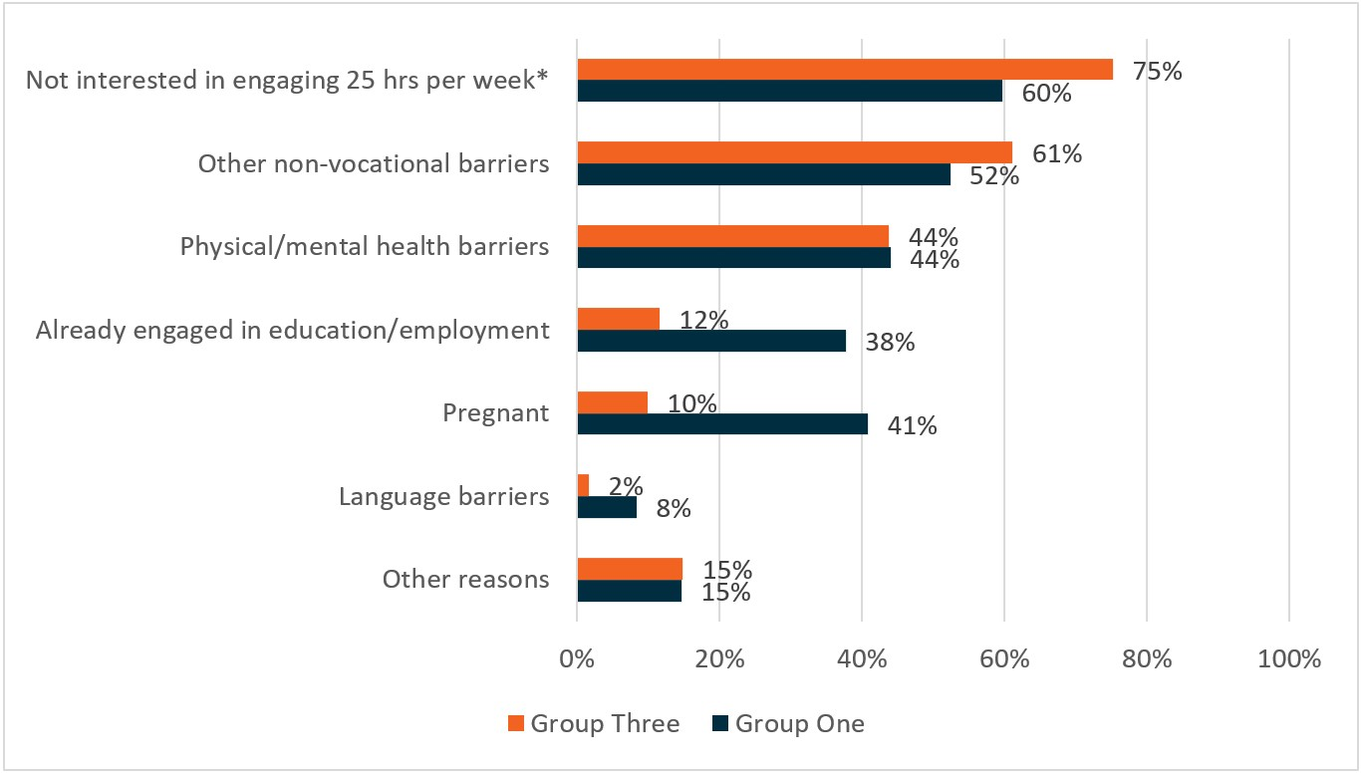

Base: sites that identify as having unsuitable referrals, either Group One from Centrelink (n=191) or Group Three from jobactive (n=121)

* Not interested in engaging in a service with 25 hours a week participation.

QB3 – In what ways have you found Group One participants referred from Centrelink to be unsuitable? QB6 – In what ways have you found Group Three participants referred from jobactive to be unsuitable?

Source: 2017 TtW Provider Survey

Overall, while staff at provider sites usually perceived Group One referrals to be suitable, many often perceived Group Three referrals as unsuitable (**Figure 3.2**). Of the staff who responded to the 2017 Provider Survey, **86%** stated that all, or almost all, of their Group One referrals were suitable for participation. By contrast, only **48%** of them perceived that all, or almost all, of their Group Three referrals were suitable.

Figure 3.2: Referrals who are suitable for TtW

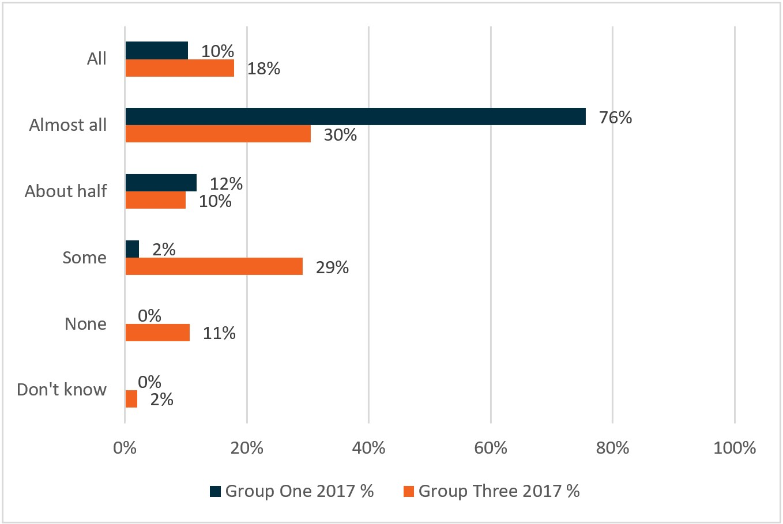

Base: all respondents (2017: 213)

2017: QB2 – Thinking about the Group One participants who are referred to the [site name] site from Centrelink, about what proportion are suitable for participation? 2017: QB5 – Thinking about Group Three participants who are referred to the [site name] site from jobactive, about what proportion are suitable for participation?

Source: 2017 TtW Provider Survey

## 3.4 Commencements

As noted previously, referral, commencement and participation in TtW varied slightly from group to group. **Figure 3.3** describes the pathway for Group One.

Group One and Group Three participants were generally expected to commence in TtW within two business days of referral, depending on their RapidConnect status. Most participants who attended an initial appointment commenced in TtW, although there were circumstances when some young people elected to exit or were referred to another program. For a number of them, the intensive activity-based servicing in TtW was not suitable; others returned to full-time study or secured employment. Group Two participants generally started on the day they were referred.

Figure 3.3: TtW pathway to commencement for Group One

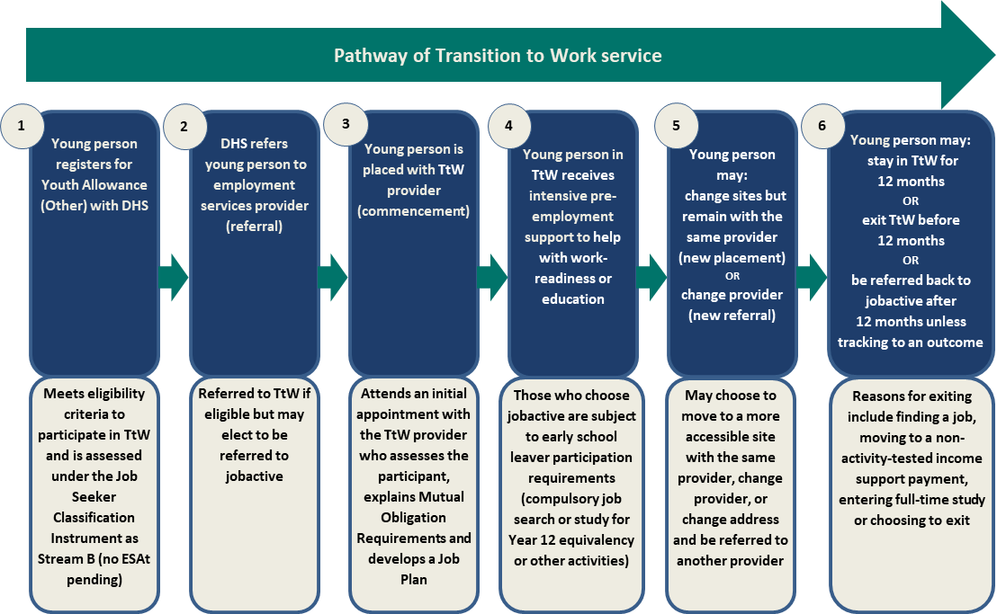

While most of the young people referred to TtW commenced in TtW, a significant minority did not. This was most likely due to the voluntary nature of the service; young people who received TtW referrals may have chosen not to attend appointments. Some may not have been suitable, as indicated in **Figure 3.2**, and others may not have signed up for income support.

As **Figure 3.4** shows, **23%** of referrals to TtW that occurred between 1 April 2016 and 31 March 2017 did not lead to program commencements. However, the finding that most TtW referrals in the inflow period led to commencements suggested that the TtW commencement process was efficient overall.

Figure 3.4: Referrals to TtW by commencement status (per cent)

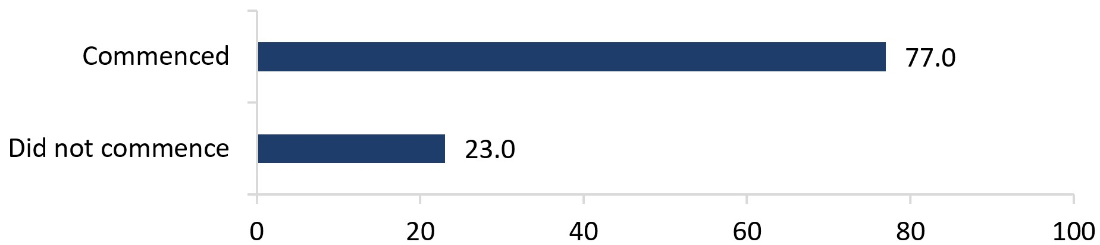

Base: TtW inflow population (including participants who did not commence in TtW) (n=35,397)

Note: The analyses define referrals to and commencements in TtW as ‘initial’ referrals and commencements to TtW. A TtW participant has ‘been initially referred to’ or ‘initially commenced in’ TtW if it is the first time the participant has been referred to or has commenced in TtW in a ‘period of assistance’. A period of assistance for a participant begins when the participant is referred to TtW and ends when they have exited TtW for more than 91 days. The analyses use data on TtW participants who were initially referred to TtW between 1 April 2016 and 31 March 2017.

Source: Department of Education, Skills and Employment administrative data

From February 2016 to June 2019, the number of young people referred to TtW declined while the number of young people who commenced in TtW was comparatively steady (**Figure 3.5)**. This finding corroborated the view, expressed by providers interviewed in the qualitative fieldwork, that as the program rolled out referrals to TtW became less frequent (see **Section 3.2**).

Figure 3.5: Referrals to and commencements in TtW by month, February 2016 to June 2019

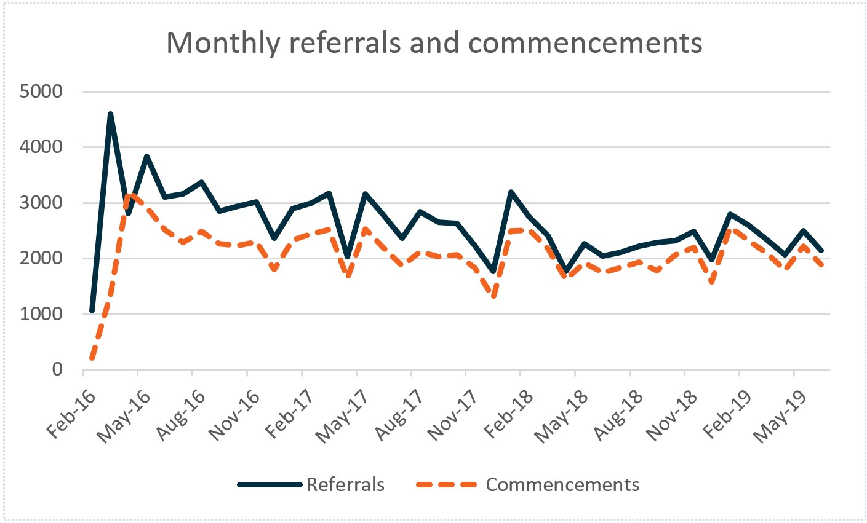

Base: TtW referrals February 2016 – June 2019 (n=106,903)

Note: The analyses define referrals to and commencements in TtW as ‘initial’ referrals to and commencements in TtW. A TtW participant has ‘been initially referred to’ or ‘initially commenced in’ TtW if it is the first time the participant has been referred to or has commenced in TtW in a ‘period of assistance’. A period of assistance for a participant begins when the participant is referred to TtW and ends when they have exited TtW for more than 91 days. The analyses use data on TtW participants who were initially referred to TtW on or before 30 June 2019.

Source: Department of Education, Skills and Employment administrative data (as at 31 July 2019)

As a result, as **Figure 3.6** shows, the proportion of TtW referrals that led to commencements increased from February 2016 to June 2019.[27] The average increase in the commencement rate, using a trend line (excluding the last data point), shows that the ‘expected’ commencement rate at each point in time increased from **70%** in February 2016 to **85%** in June 2019. The effectiveness of the commencement process therefore appears to have improved over time, possibly because with the maturing of the program, providers improved their advocacy.

Figure 3.6: TtW referrals who commenced in TtW between February 2016 and June 2019 (per cent)

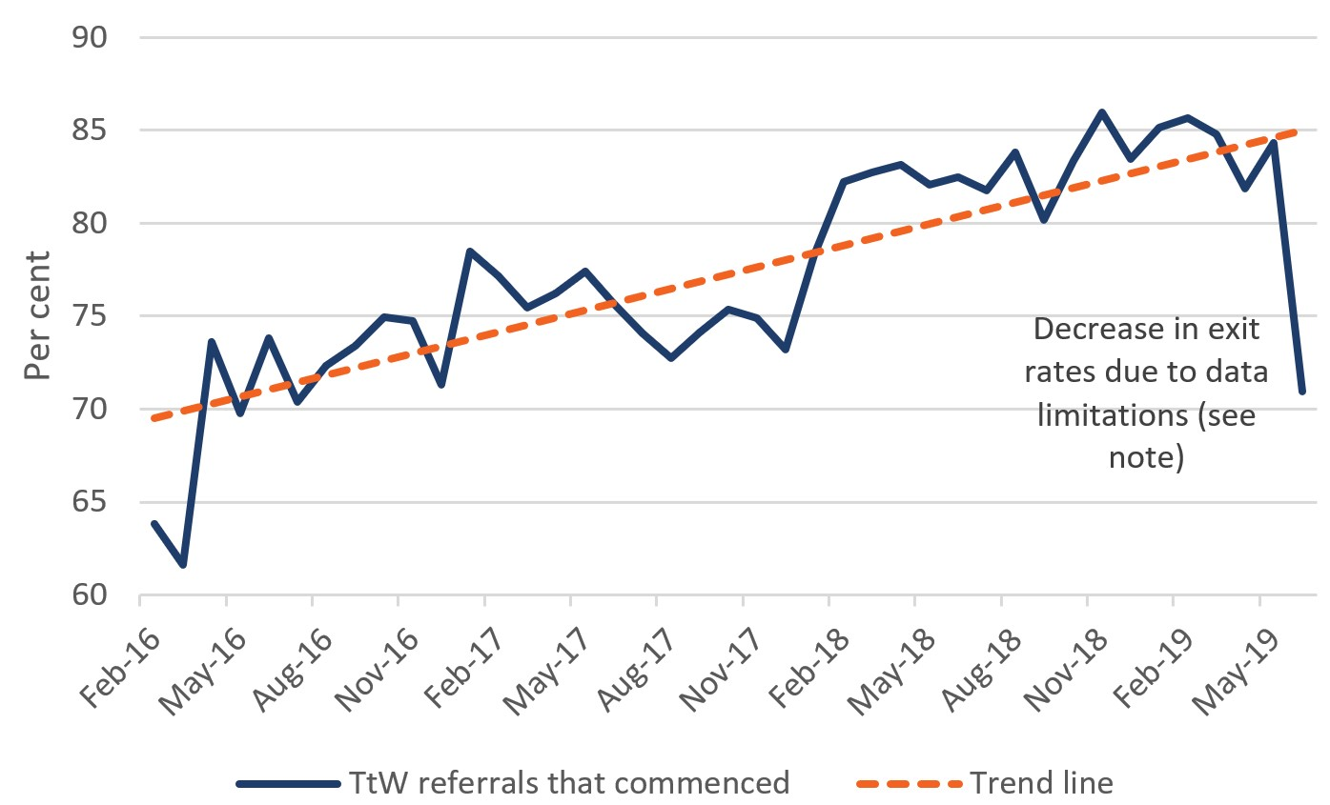

Base: TtW referrals February 2016 – June 2019 (n=106,903)

Notes:

The analyses define referrals to and commencements in TtW as ‘initial’ referrals to and commencements in TtW. A TtW participant has been ‘initially referred to’ TtW if it is the first time the participant has been referred to or has commenced in TtW in a period of assistance. The analyses use data on TtW participants who were initially referred to TtW on or before 30 June 2019.

There is a significant drop in the proportion of TtW referrals who had commenced in services in June 2019 when the analyses were conducted. This is because the analyses use data on TtW participants who were referred to TtW on or before 30 June 2019. Many TtW participants who were referred in June 2019 would commence in later months.

Source: Department of Education, Skills and Employment administrative data (as at 31 July 2019)

### 3.4.1 Time from referral to commencement

Participants commenced in TtW sooner after referral than did participants who commenced in jobactive, suggesting that TtW was more efficient than jobactive in ensuring that participants commenced in services in a timely fashion. As **Figure 3.7** and **Table 3.2** show, **93%** of TtW participants in the commenced inflow population started within 30 days from referral, compared with **85%** of jobactive participants in the inflow population. There was a similar pattern in the matched samples. Almost all of the matched TtW participants (**92%**) commenced within 30 days, compared with only **81%** of the matched jobactive participants, suggesting that different program settings may have resulted in different provider or participant behaviours.

It is possible that this result was influenced to some extent by the presence of Group Two participants in the TtW inflow population and matched sample. As these participants may register directly with a provider, they may be more likely to commence sooner than other participants.

Figure 3.7: Time taken for commenced TtW and jobactive participants to commence in services, inflow population and matched samples (cumulative per cent)

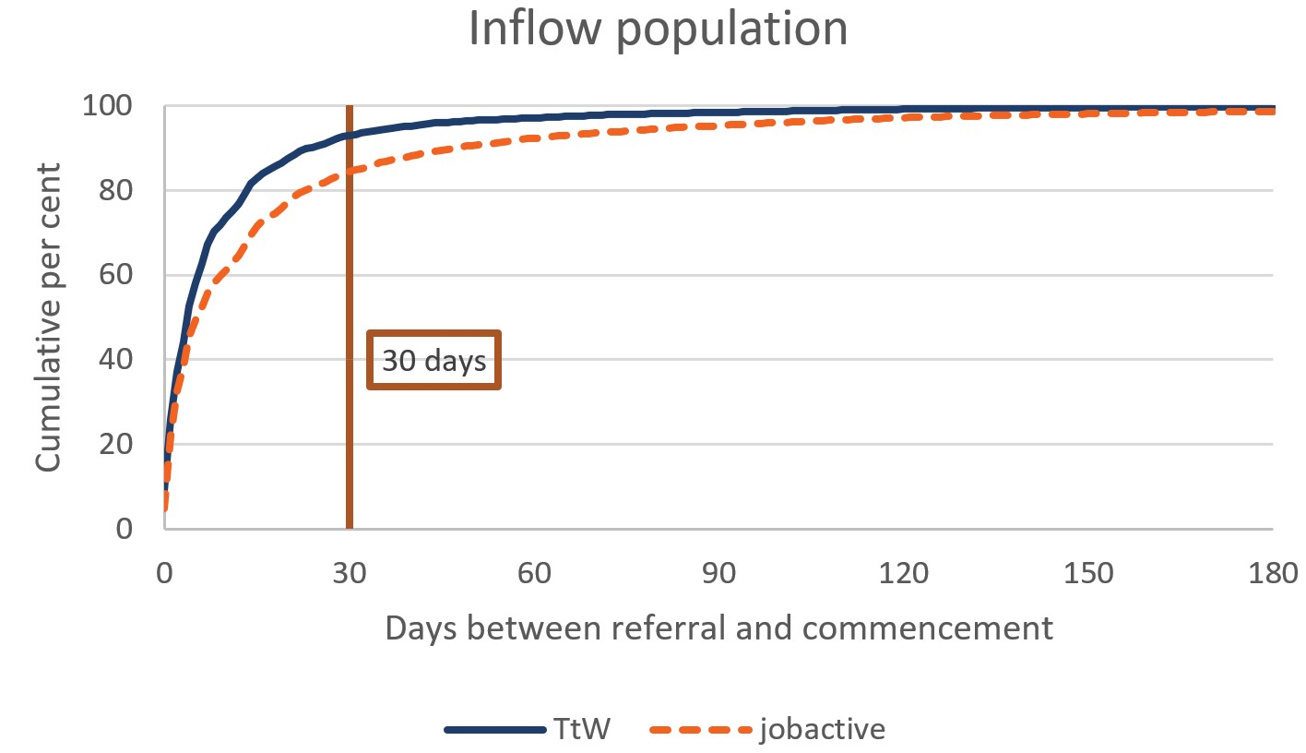

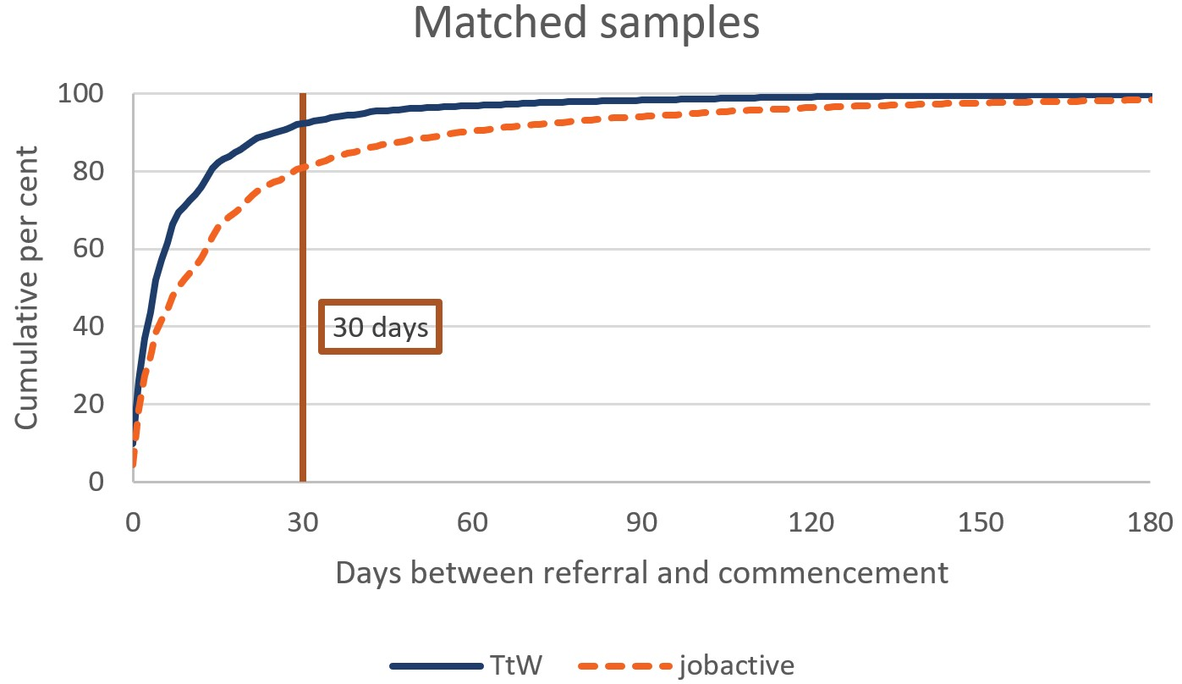

Base: inflow populations (n=51,275) and matched samples (TtW: n=12,105, jobactive: n=12,105)

Note: The analyses define referrals to and commencements in services as ‘initial’ referrals to and commencements in services. An employment services participant has been ‘initially referred to’ services if it is the first time the participant is referred to or commenced in services in a period of assistance. For reasons of presentation, the charts display cumulative percentages for referrals that took up to 180 days to commence in services. Less than 2% of TtW and jobactive referrals took more than 180 days to commence.

Source: Department of Education, Skills and Employment administrative data

Table 3.2: Time taken from referral to commencement, inflow population and matched samples (cumulative per cent)

| Time | TtW (inflow) | jobactive (inflow) | TtW (matched) | jobactive (matched) |
| --- | --- | --- | --- | --- |
| Within 2 days | 37.3 | 32.5 | 37.0 | 27.4 |
| Within 30 days | 93.0 | 84.5 | 92.3 | 81.0 |
| Within 60 days | 97.1 | 92.2 | 96.9 | 90.3 |
| Within 90 days | 98.4 | 95.3 | 98.3 | 94.0 |
| Total | 100.0 | 100.0 | 100.0 | 100.0 |

Base: inflow populations (n=51,275) and matched samples (TtW: n=12,105, jobactive: n=12,105)

Note: The analyses define referrals to and commencements in services as ‘initial’ referrals to and commencements in services. An employment services participant has been ‘initially referred to’ services if it is the first time the participant has been referred to or has commenced in services in a period of assistance.

Source: Department of Education, Skills and Employment administrative data

## 3.5 Conclusion

Responses from TtW participants and providers in the qualitative research indicated that participants had low awareness of the program at referral, especially when Centrelink (rather than a youth worker or health organisation) referred them to the service. Despite the initial low awareness, participants and other stakeholders started to perceive TtW as a ‘career-forging’ rather than a ‘work first’ program.

TtW providers typically (**86%**) thought that most Group One referrals to TtW were suitable. Fewer than half of them (**48%**) perceived that all, or almost all, of their Group Three referrals were suitable.

More than three-quarters of all young people (**77%**) referred to the service commenced and the proportion of referrals that led to commencements increased over time. The average commencement rate increased from **70%** in February 2016 to **85%** in June 2019. Participants commenced in TtW more quickly than did participants in jobactive, with **92%** of TtW referrals commencing within 30 days, compared with **81%** of jobactive referrals. In spite of the voluntary nature of TtW, its commencement process is more efficient.

# Chapter 4 Service elements and provider practice – what works

## 4.1 Introduction

This chapter aims to explore which program elements, provider practices and characteristics are associated with participants gaining education and employment outcomes. As noted throughout this report, a key feature of the TtW service model is the flexibility it offers providers to develop services tailored to the specific training and non-vocational needs of participants (The Treasury, 2015). There is a discussion of service plans, specialised staff and individualised activities for participants with vocational and non-vocational barriers. The success or otherwise of these service elements lies at the heart of identifying what works in TtW program settings and what constitutes good practice in service delivery and its success in preparing participants to navigate the labour market into the future.

Stakeholder feedback was sought through either qualitative research or surveys to gather their insights as to what works. A regression analysis sheds light on what service practices are associated with improved labour market outcomes for participants.

## 4.2 Service Delivery Plans

Central to a flexible and effective TtW service is the SDP[28] of each provider. The SDP outlines flexible strategies tailored to the needs of individual participants, employers and other stakeholders.

As part of this evaluation, SDPs from 42 provider sites were analysed. This analysis identified a broad range of service offerings:

* individualised and tailored support
* assessment tools and job plans
* specialised staff and designated single consultants
* financial assistance
* activities and workshops
* work experience
* linkages to other support services.

The SDPs, prominently displayed in provider sites and available online, complement the Service Guarantee (discussed in the Interim Report), which sets out the government’s expectations of TtW providers and the standard of service delivery that participants, and employers, could expect from them. **Figure 4.1** outlines how these service offerings are designed to realise the objective of delivering flexible and intensive servicing.

Figure 4.1: The range of service activities within the TtW service model

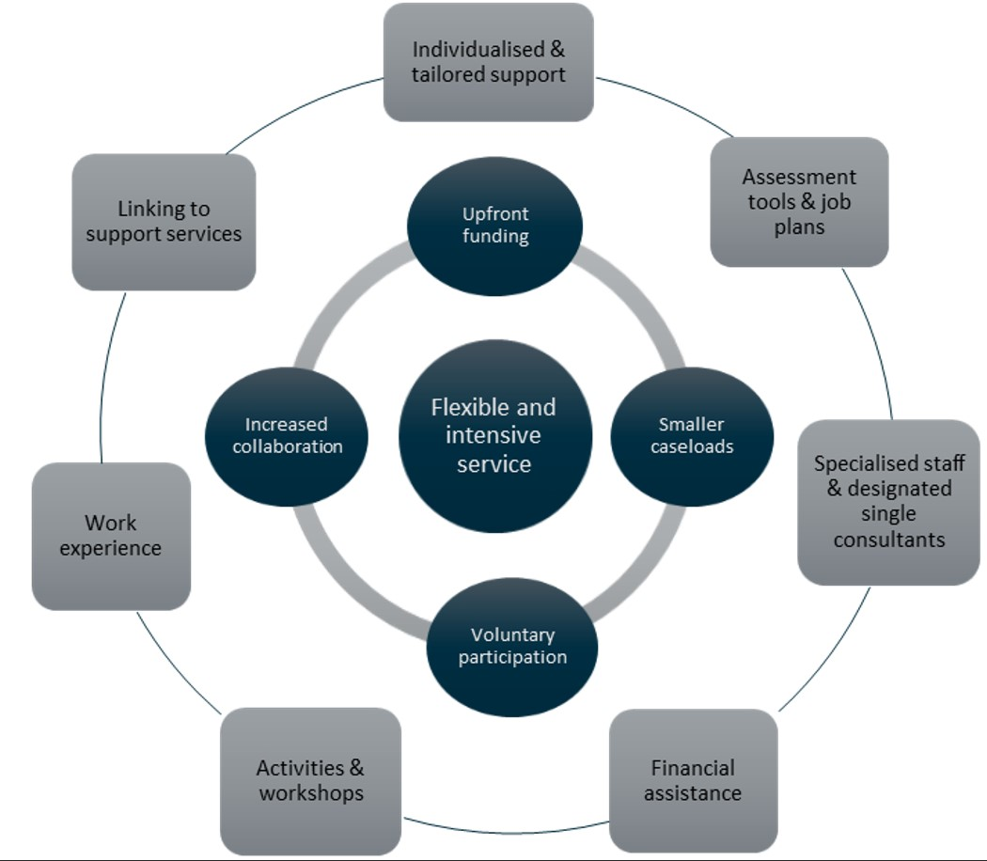

## 4.3 Flexibility

During the Wave 1 qualitative research, most providers agreed that the current TtW service model offered them considerable scope to adapt their service delivery practices to the needs of participants. The flexibility of delivery, inherent in the service design, allowed for a personalised approach to helping participants.

A lot of flexibility to be able to support a little bit closer and address some of the significant challenges that we’re facing. And some of the challenges that come with new migrants; post-traumatic stress and mental health challenges around that. (Provider 4 Interview 1, Wave 1)

Providers delivered a mix of vocational and non-vocational support, such as help to obtain a driver’s licence, referral to counselling services, and the purchase of work clothing or specific training for job roles.

Even just get little things like getting their licence, working with them to get their licence, that’s massive for them, that’s huge in their life, and that sort of thing. So, it’s really rewarding and participants are loving all that, all the support, which is good. (Area 10 provider)

In the Wave 2 qualitative research, providers again noted that the flexibility of the TtW service gave them the autonomy to be innovative in their service delivery.

I suppose the team was – it wasn’t really working back then. So it was all about we created expectations for the young people, we wanted to create environment and a culture here. Like I said it was – back then it was very bland and jobactivish. A lot’s changed since then, a lot. What we have today is completely different to what we had back then, and this is what’s working. So different environment, our team is half – we’ve got a couple of people that were here from the beginning, [Name] and [Name], and we’ve got some new people. Just the mindset about why we’re here, there’s a reason why we’re here. It’s not about numbers or KPIs, it’s the language you use too. (Area 6 TtW provider)

We ask the young people – the consultant who runs that asks them, ‘Write down what you want from this on a bit of paper’ on the first session, he’ll take that away and then revamp the activity-based on what they want to get from it. So, we’ve got lots of different ideas of course of pre-employment stuff, résumés, speaking to employers, but we’ll let them dictate the direction it’s going to go. So, it feels like they have a part to play in that, which helps with the engagement as well. (Area 11 TtW provider)

Overall, providers considered the main strengths of the TtW service model to be:

* the flexibility to develop new relationships with external organisations to better service specific groups of participants, such as Indigenous young people
* the capacity to employ staff who spoke the first languages of CALD young people, and recruiting consultants with special skills such as youth workers
* resources to run additional workshops to ensure all participants are able to attend
* an expectation that their offices are more youth friendly
* participant feedback on the types of support they would like to help them become more work ready.

## 4.4 Upfront funding

Under the TtW funding model, upfront payments, paid quarterly as lump sums, enable providers to fund activities, training or education at their discretion. During the Wave 2 qualitative research, many providers indicated that they used upfront payments to assist participants with essential purchases.

Providers agreed it was important they have a specific fund to help young people to access courses and licences, pay for interview clothing and work uniforms, and supplement travel costs. Some providers said they had set up the equivalent of the Employment Fund (used in jobactive). The funding came from a proportion of their upfront or outcome payments and went towards a range of employment or education related activities and items.

The 2017 Provider Survey data showed that at one-third (**34%**) of responding sites ‘all or nearly all’ participants received support from the providers through their upfront payments. Another third (**32%**) of sites reported ‘about half’ of their participants needed it. The types of support that upfront payments were used for were broad, with **56%** of providers using them to pay for accredited training, **49%** for clothing purchases, **48%** to pay for transport and **42%** for work-related licences. In addition, upfront payments helped with the purchase of trade tools and driving lessons. As one provider explained:

We will fund interview clothes, work uniforms, some basic tools, phone credit. There’s been a couple of times where we’ve, in combination with a couple of other providers, funded taxi trips for a month for a person to get to work, so we will cover a certain percentage of that. Public transport fees. We pay for driving lessons. We pay for people to go for their probationary licence test. We do fund quite a bit up to a certain point. (Area 14 Provider 14, Wave 2)

When asked during the qualitative research if the removal of the upfront payments would affect their ability to run the TtW service, most providers agreed that it would have the potential to affect their planning and delivery of the service. A few acknowledged that this might be particularly difficult if the provider was a small organisation, as they would not have the ability to absorb the costs required to obtain outcomes.

## 4.5 Rewards and recognition as strategies for engagement

While the lack of targeted compliance arrangements was a source of frustration for some providers, others implemented rewards-based strategies to engage young participants and encourage them to achieve their education or employment outcomes. The following comments made during the qualitative research describe two such approaches:

We have a reward-based system. So, depending on how well they engage, what they’re willing to do outside of the appointments, they can earn rewards and things like that from us. It’s nothing major, it might be just that we’ll give them $10 or something in credit and you say get a job and the more they’re willing to help themselves they’ll buy into that. (Area 14 TtW provider, Wave 2)

Once a month having a sit down with them and say, ‘These were the standouts for the month. These were …’ So we are looking at rewarding those standout participants, at the end of each month … We also reward them at week 13 and week 26 of employment, with vouchers. Just to congratulate them. (Area 4 TtW provider, Wave 2)

## 4.6 Benefits of smaller caseloads

TtW has smaller caseloads than other mainstream employment services. TtW consultants had between 30 and 50 active participants on their individual caseloads generally (jobactive has between 160 and 180 on average). The purpose of smaller caseloads was to enable intensive servicing and encourage providers to offer individualised and tailored services to participants. Providers agreed during the qualitative research that regular face-to-face meetings with participants were critical for building relationships and monitoring participants’ progress. Furthermore, they provided an opportunity to assess participants’ level of satisfaction with TtW activities. This appeared to have benefits for both providers and participants:

We’re not meeting with them one-on-one just to update a job plan, we’re meeting them just to talk to them, and see how they’re going in the facilitation, what are they like about it, what they don’t. Are they learning? What would they like to see? So we’re just re-evaluating. And really opening their mind to different things. (Area 3 TtW provider, Wave 2)

… we have the ability to provide more intensive support means that we can get feedback from the clients on what they actually want to get from the service and what they actually want from activities, and then direct our servicing around that. (Area 11 Provider 11, Wave 2)

Generally, providers interviewed in the Wave 2 qualitative research had smaller active caseloads than those in Wave 1. In a few instances, consultants had larger caseloads because the majority of those on their caseloads were engaged in an education or employment activity.

We originally wanted us, the work mentors, just to have 50 on their caseload and really focused. Unfortunately, the girls here want more so they’ve 80 or 90 each because they wanted it that way and it keeps them busy. Because a lot of ours are engaged in employment and education. (Area 6 TtW provider)

Respondents to the 2017 TtW Provider Survey were less likely to perceive their overall caseload size as being ‘just right’ in 2017 (**51%**) than they had been in 2016 (**58%**), and more likely to perceive it as being ‘too small’ in 2017 (**46%**) than in 2016 (**39%**).

The trend in the TtW caseload over the period January 2017 to June 2019 appears in **Figure 4.2**. The caseload peaked in March 2017 at around 18,500 participants but declined subsequently to around 14,500 in June 2018. While not directly correlated, this fall could be due in part to a reduction in the youth unemployment rate (11.8% in 2018 compared with 12.6% in 2016 and 2017, when it remained stable) resulting in a reduced demand for TtW places.

Figure 4.2: TtW commenced caseload compared with unemployment rate for 15–24 year olds

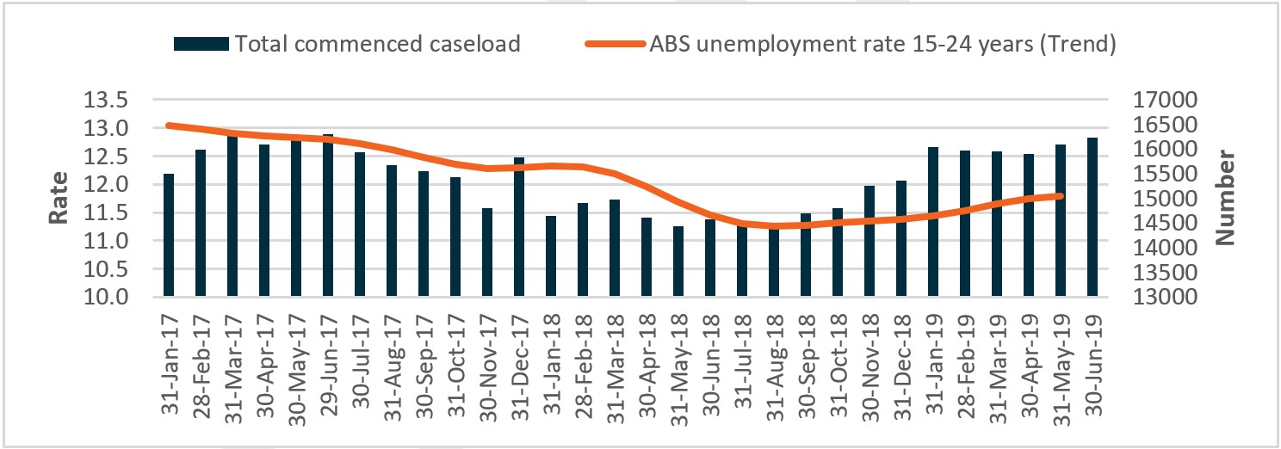

Source: Department of Education, Skills and Employment administrative data; ABS, Labour Force, Australia (Cat. no. 6202.0), Table 13, Labour force status for 15–24 year olds by sex – trend, seasonally adjusted and original, May 2019

## 4.7 Provider collaboration

The program settings of TtW, based on identified regions, likely reduced competition between TtW providers. Most providers indicated that their focus was on collaboration rather than competition. During Wave 1 and 2 qualitative research, providers agreed generally that the TtW service arrangements encouraged them to collaborate, exchange ideas with other providers and improve their own strategies and approaches. This focus on collaboration rather than competition was emphasised in the following comments from providers interviewed during the qualitative research:

(The TtW Deed) is very open in the sense in that it gives providers that flexibility to deliver and achieve the results that we need to. The best thing about it is there’s no competition so when you talk to other providers you can share good ideas and good strategies because there’s no competition. (Provider 10, Wave 1)

Because we don’t have that star rating, it’s not that competitive push. There is no other TtW provider in [Place] so we don’t have to compete. It’s a really good point, [Respondent 1], because that is – it’s made a really good positive culture for the TtW as a whole. We haven’t had a meeting for a while, but all the TtW providers in New South Wales, we used to get together every quarter and have a meeting, and just say, ‘What is working for you?’ ‘What are you doing?’ because we are not competing against each other and we could share our tools and we could share our ideas. (Area 4 Provider 3, focus group, Wave 2)

Providers who responded to the 2017 TtW Provider Survey, however, were less likely to collaborate with other TtW providers than they had been in 2016 (2017: 31%, 2016: 50%). Similarly, they were less likely to collaborate with jobactive providers (2017: 55%, 2016: 71%). It may be that as the program matured, service delivery entered into a ‘cruising mode’ as best practice, and developed business models emerged based on what worked best for the provider.

## 4.8 Limited compliance requirements for participants

Most providers contacted in the qualitative research reported that TtW’s flexibility encouraged participants to develop and maintain a positive attitude toward them. Peak body representatives were of a similar view. They felt that TtW had led to a positive shift in the way participants perceived employment services.

… all the research shows if you offer people choice and use motivational opportunities, it’s far better than compliance. If you tell people they have to, they try to start working out how they can get around it. If you tell them they’ve got options and you work out how it might help them meet their goals, you actually get better participation and uptake. (Peak Body 2, Wave 1)

Not all providers believed that the absence of a strong compliance lever was positive. Some thought TtW would benefit from having mandatory attendance at appointments. These providers felt that the lack of compliance measures prevented them from engaging participants in TtW quickly.[29]

Other providers recommended an even stronger approach to disengaged participants, suggesting suspension of their payments for non-attendance at initial appointments. These providers felt that it was a necessity to address the problem of poor attendance upfront.

There should be a compliance framework on initial appointments … and not to use it as a big stick approach that it perhaps was seen as in the other contracts, but purely as a tool to get them in the door … It would make all the difference. (Area 13 TtW provider, Wave 2)

… if we had compliance we probably could have assisted even more. I think that if we had the ability to cut the benefits and re-engage – if we had that potential to re-engage young people into our service, because we know once they are engaged we are successful with them, we could actually do even better work. (Area 4 TtW provider, Wave 2)

Providers used initial appointments to explain the benefits of TtW, differentiating it from jobactive. Despite this, some providers thought that participants had not really understood the differences between the two programs and regarded having to exit participants into jobactive without further discussion as unfortunate.

## 4.9 Provider strategies to assess participants

TtW providers employed a variety of approaches to assess the employment and training needs of participants. These approaches varied depending on the group from which participants had come. The TtW Deed describes work readiness as ‘possessing the core skills and behaviours required by employers includ[ing] skills and behaviours relating to teamwork, communication, a positive attitude and work ethic’. To quantify changes to work readiness, a variety of survey tools were used by providers to report on participant and provider attitudes.

The department, through the PPM Survey, which reports on the labour market status of job seekers after assistance in employment services, as well as satisfaction with the services received, now measures work readiness of TtW participants.

### 4.9.1 Assessment tools

There were no requirements for TtW providers to use specific assessment processes, although providers could choose to use commercial or in-house tools to assess the vocational and non-vocational service options for participants. Most providers interviewed in the qualitative research used a combination of psychological and work readiness / skills assessment tools to identify participants’ needs and match participants to suitable careers. The following comments illustrate the different approaches taken by providers to assessing needs.

We have an initial assessment where we ask a set of questions, but youth workers have additional questions, where we start talking about where they will need further assistance from us for one-on-one’s along the way, maybe wrap servicing, counselling appointments, all that sort of things, any mental health plans that need to be set up, safety plans. It’s all rolled into that interview. (Area 3 TtW provider, Wave 2)

In the Wave 1 and Wave 2 qualitative research, providers reported that they assessed vocational and non-vocational barriers through external assessment tools[30] to identify gaps in work readiness and Sokanu’s[31] tools to help match participants with their ideal careers.

At the first appointment, we do job readiness questionnaire, which is basically getting to know them and asking about barriers, mental health, drug and alcohol, a range of issues. Seeing whether they actually have any idea what they want. (Area 4 TtW provider, Wave 2)

The 2017 TtW Provider Survey identified the range of formal assessment tools providers used to determine the needs of participants (**Table 4.1**).

Table 4.1: Type of participant assessments used by TtW providers

| Types of assessment tools used | Proportion of providers (%) |
| --- | --- |
| Skills assessment | 68.1 |
| Strengths and weaknesses | 62.6 |
| Non-vocational needs | 57.7 |
| Work readiness | 54.9 |
| Literacy/numeracy | 46.7 |
| Health assessment (e.g. mental, physical or alcohol and other drugs) | 27.5 |
| Readiness for change[32] | 25.3 |

Base: providers who indicated they used an assessment tool (n=182)

QC1b – What type of participant assessment tools does the [site name] site use, if any? [multiple choice]

Source: 2017 TtW Provider Survey

Roughly two-thirds of providers who used assessments reported using a skills assessment tool, while more than half used a work readiness tool. One in four providers stated that they used various health assessment tools to gauge the physical and mental health needs of participants.

We’ve got non-vocational activities and we’ve got our [program] which is six sessions over three weeks which is a blend of pre-employment stuff. Really it’s a focus for those young people who are not ready to work, or who are really unsure of what their strengths and skills are, what career direction they might want to take, they don't know how to get there. (Area 11 TtW provider, Wave 2)

### 4.9.2 Job plans

After attending an initial appointment, participants commenced a 28-day initial phase during which the provider explained their services and ensured the participant understood the participation requirements and the consequences of not participating appropriately.

During this initial phase, the participant and the provider agreed on an employment pathway and a job plan[33] setting out the steps the participant would take to improve work readiness and maximise their chances of securing a job.

The job plan provided an ‘employment pathway plan’ and a ‘participation plan’ that recorded the activities participants had agreed to undertake to meet their participation requirements for TtW. Providers and participants updated these plans regularly, in line with the individual participant’s circumstances. Group One and Group Three participants were required to have a job plan to meet their MORs under Social Security law.

During the qualitative research, some providers indicated that they did not find the prescriptive job plan format useful because the tailored approach to servicing TtW participants individually demanded more flexibility. Many providers felt the job plan was administratively burdensome and suggested a change to the format to make it more practical and useful:

[The job plan is] too formal, I think, for these young people. They don’t read it. They sign it, we go through it with them, we give it to them and I can guarantee it probably never leaves the car or the bin once it goes. So, yeah, if it was an online thing that they could respond to and tick things off or something as they were doing it, I can see that – if we could gamify it in a way, I think that would be amazing. (Area 14 TtW provider)

Providers explained that the job plan was less relevant to TtW than to jobactive as many of the activities undertaken by TtW participants did not appear as options within it. One provider said that they made use of the free text option regularly to complete job plans as it provided an opportunity to describe varied and innovative approaches not captured in the departmental administrative data.

We do use a lot of the free text options in the job plan, because there a lot of things that we do that don’t fit which are in the job plan, because we have to try and think outside the box for a lot of our kids to get them doing things. (Area 14 TtW provider)

From the 2017 TtW JSEES Survey, however, it was clear that assisting participants with their job plans was a major function of providers (Figure 4.3).

Figure 4.3: Types of support discussed with TtW provider

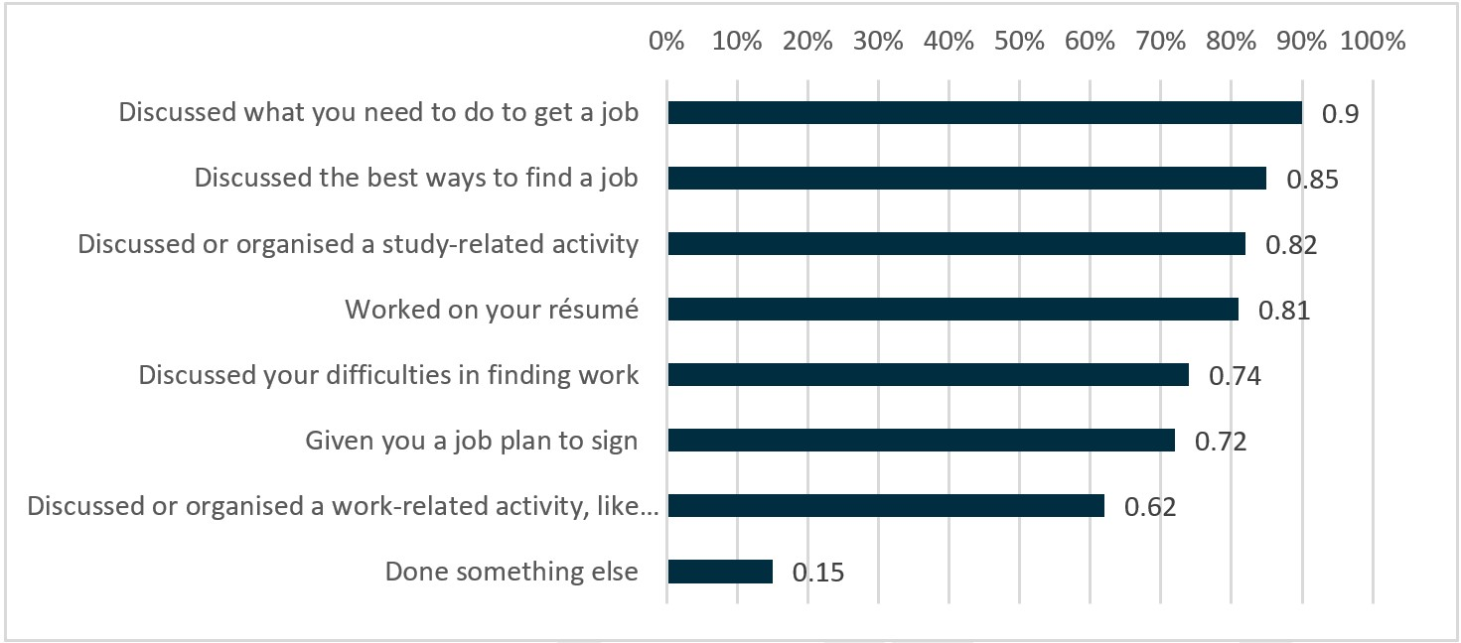

Base: all respondents (n=600)

QTTA7 – In the last six months, has <provider> … ?

Source: 2017 TtW JSEES Survey

Participants who mentioned the importance of goal setting and pursuing a specific career pathway as a key outcome of the TtW service also described providers nurturing them along the pathway to their goal and being supportive of that end goal.

At times you can – as a person, you can be quite vague in what you want and how you want it. But they do understand that, because they don’t – they understand the direction that you’re coming from and, say, that’s your first time going there, they’ll understand and, say, nurture to your goal. And then help you achieve it. They’re not going to just shut you out full-on. Which a lot of other places I’ve heard can do, but they don’t understand that they’re doing it, to say. (Focus Group 1)

They’re really supportive … younger staff, more quality, friendlier, gentler. They are aiming towards the goal that you have and providing as much time as they can for you. (Focus Group 2)

### 4.9.3 Dedicated case managers

As part of the tailored approach, providers assigned most participants a dedicated case manager with whom they met weekly or fortnightly. As found during the qualitative research, case management approaches varied depending on the provider’s service delivery model. Some participants were allocated a consultant with whom they dealt for the entirety of their TtW service, while others saw multiple consultants who had different roles within service delivery to match the participant pathway to employment and education.

In the 2017 TtW JSEES Survey, just over three-quarters (78%) of participants indicated that they were having face-to-face contact on a fortnightly or more frequent basis. On a monthly basis, 92% were in face-to-face contact. Participants also expressed a preference for having a dedicated case manager as it provided an opportunity to discuss their personal needs and circumstances and was less intimidating than group discussions.

As shown in **Figure 4.4**, respondents to the 2017 TtW Provider Survey who used consultants reported that either ‘most of the time’ or ‘some of the time’ their participants dealt:

* individually with the same consultant (100%)
* individually with consultants specialised in dealing with job seekers who have specific barriers (81%)
* individually with any available consultant (39%).

However, as noted in the qualitative research, high staff turnover at some sites caused major disruption of service delivery and negatively impacted their outcomes.

[High staff turnover] has an enormous impact, not only on consistency and performance but also the time that that takes away from operational matters to HR matters. I mean the recruitment process, the induction process, all sort of takes time. (Area 10, TtW provider, Wave 2)

The other workers pick up the caseloads and so, therefore, their time spent on giving attention to their own caseloads obviously has to suffer somewhere in there. So, yeah, I think it’s – and it’s not good for morale either. (Area 5, TtW provider, Wave 2)

Figure 4.4: Servicing approaches using consultants

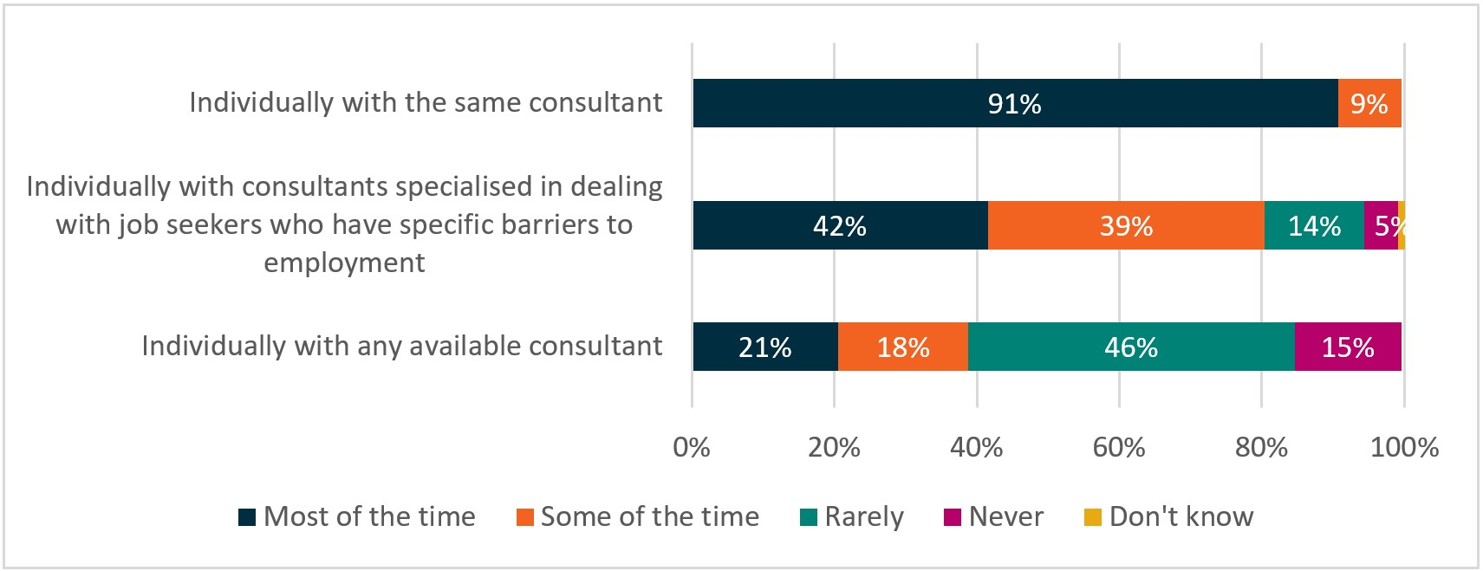

Base: all respondents (n=213)

QC3a – Please select how frequently each of the following servicing approaches are used with TtW participants at the site.

Source: 2017 TtW Provider Survey

Other approaches to servicing participants that providers reported using either ‘most of the time’ or ‘some of the time’ were:

* group servicing by cohort (68%)
* telephone/teleconference (60%)
* self-service (27%).

### 4.9.4 Specialist staff

Based on the results of provider surveys, the majority of survey respondents had many years of experience in the employment services sector. In 2017, around a quarter of respondents (26%) had worked in the sector for 10 years or more and a similar proportion (25%) for five to 10 years.

Around a third (30%) of respondents had five or more years of experience in the youth services sector, with half (50%) having less than two years of experience (**Figure 4.5**). In the 2016 Provider Survey, 60% of respondents indicated that they had experience delivering services under jobactive.

Figure 4.5: Employment services and youth services sector experience

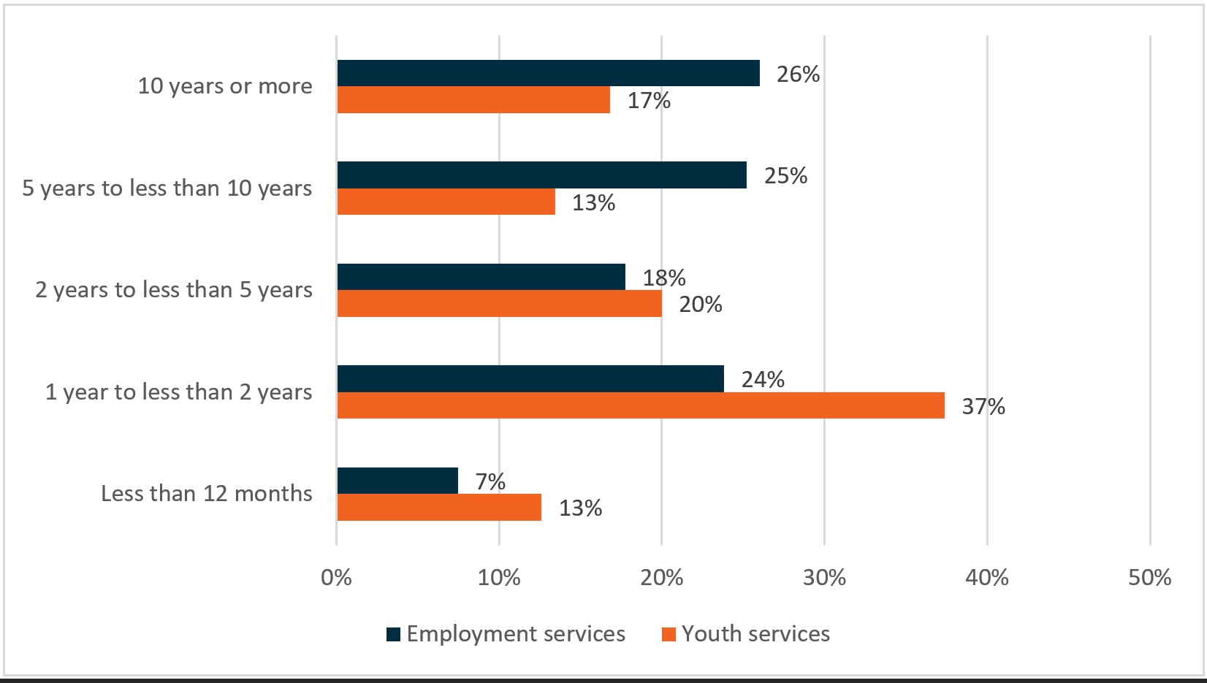

Base: all respondents (n=216)

QA3 – How long have you worked in the …

Source: 2017 TtW Provider Survey

Most TtW providers employed specialist consultants and/or case managers to address the various needs of disadvantaged participants. These included youth workers, Indigenous workers, and health and disability specialists, among others (**Figure 4.6**). The employment of specialist staff working on TtW increased from **77%** in 2016 to **83%** in 2017. The most common type of specialist role was youth worker (2017: **75%**, 2016: **71%**).[34]

Figure 4.6: Specialist staff roles among providers increased between 2016 and 2017

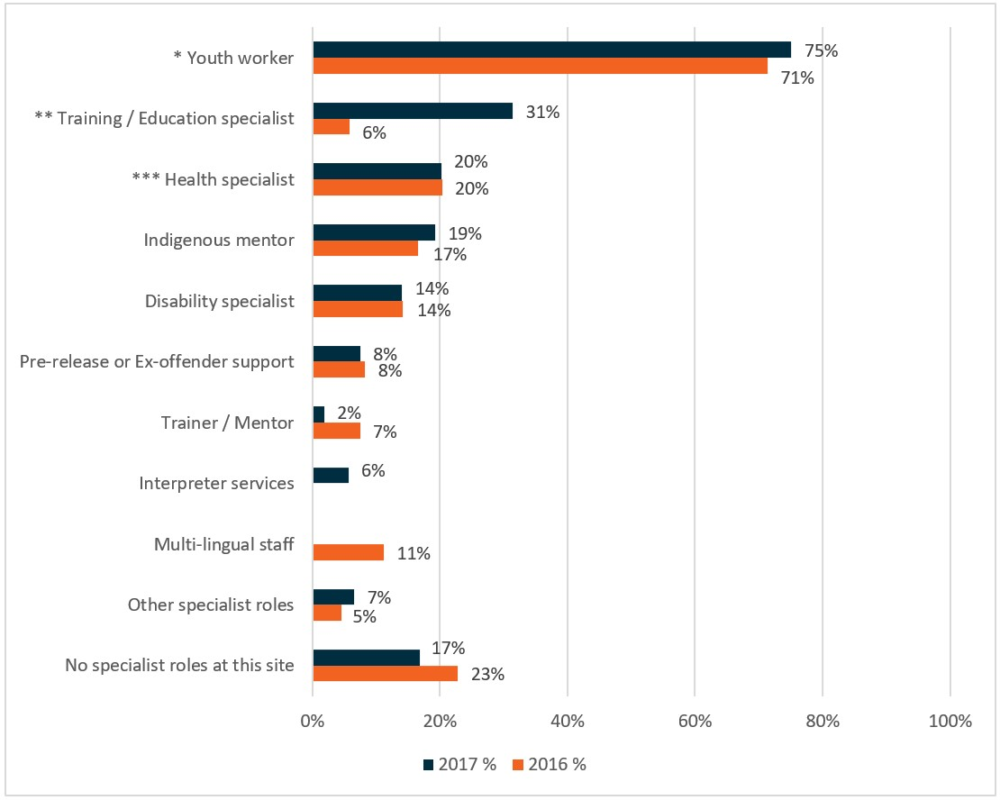

Base: all respondents (2016: n=241; 2017: n=213)

QA8 – Thinking about staff roles, are there any of the following specialist roles at [site name]? Select all that apply.

* Youth worker / staff experienced in working with disengaged young people

** Extracted from ‘Other (please specify)’ responses in 2016

*** Mental health specialist / Allied health specialist / Psychologist

Source: 2016 and 2017 TtW Provider Surveys

In 2017, the proportion of responding sites that employed Indigenous staff increased from 2016, in terms of both employing any Indigenous staff and employing more than one full-time equivalent (FTE) Indigenous staff member. Twenty per cent of responding sites employed Indigenous staff in 2017, up from 14% in 2016 (**Figure 4.7**).

Figure 4.7: Employment of Indigenous staff

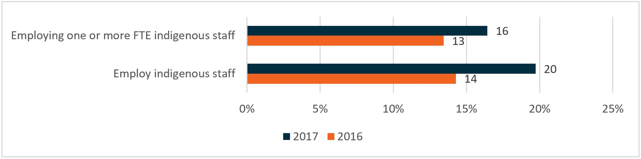

Base: all respondents (2016: n=238, 2017: n=214)

2016: QA6 – How many of these staff (FTE) are Indigenous? Again, please include contractors and those on long-term leave (e.g. maternity or unpaid leave)?

2017: QA6 – How many of the [QA5 response] FTE staff at the [site name] site, if any, are Indigenous?

Source: 2016 and 2017 TtW Provider Surveys

In 2017, survey participants, when asked about their employment of multilingual staff, said that one-quarter (**25%**) of sites employed multilingual staff and almost one-quarter (**22%**) employed at least one FTE multilingual staff member (**Figure 4.8**).

Figure 4.8: Employment of multilingual staff

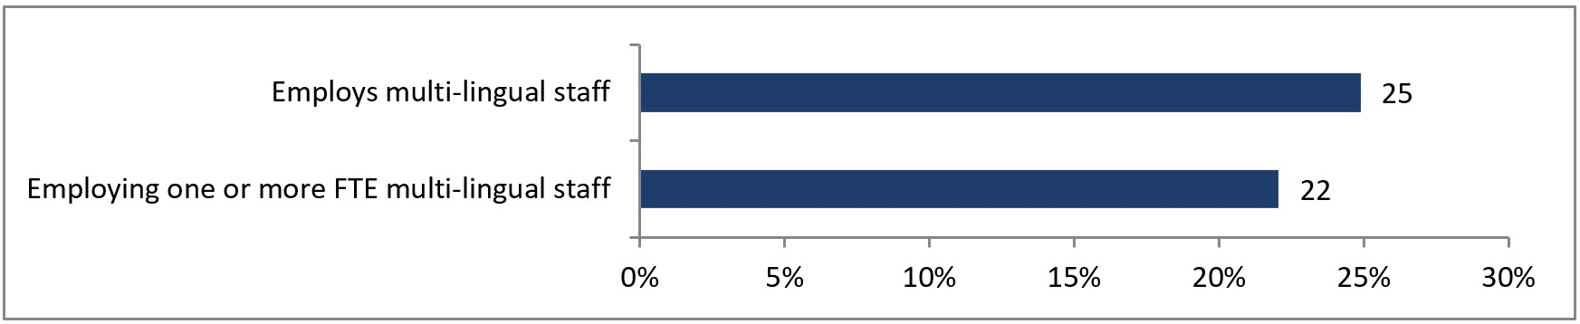

Base: all respondents (n=214)

QA7 – How many of these [QA5 response] FTE staff, are multilingual?

Source: 2017 TtW Provider Survey

## 4.10 Impact of service elements

As indicated in **Section 2.9**, a participant achieved LMA when the income support and job placement information on the department’s IT system suggested they had secured some form of employment.

This section examines whether, and to what extent, service elements or provider practice impacted participants’ LMA outcomes. Unsurprisingly, some services offered by providers had a distinct effect on participants’ LMA.

Results of the logistic regression modelling (Table 4.2) showed participants who undertook paid work experience were 11.3 percentage points more likely to achieve LMA compared with those who did not.[35]

Table 4.2: Impact of servicing characteristics on the probability of the typical TtW participant achieving labour market outcomes: percentage points

| Servicing characteristic | Labour market attachment (n=15,935)* |
| --- | --- |
| Participant undertaking paid work experience  (vs Not undertaking paid work experience) | 11.3 |
| Participant undertaking accredited education and training  (vs Not undertaking accredited education and training) | 7.3 |
| Participant undertaking non-accredited education and training  (vs Not undertaking non-accredited education and training) | 6.2 |
| Increasing average number of appointments with provider per fortnight by one | 5.3 |
| Site assisting participants with job preparation (vs Not assisting with job preparation) | 3.3 |
| Site assisting participants to find education opportunities  (vs Not assisting with finding education opportunities) | 2.6 |
| Site having contact with employers every day  (vs Less frequent / No response) | 2.0 |
| Increasing FTE staff at site by one | 0.8 |
| Increasing caseload at site by one | -0.05 |
| Indigenous staff being present at site  (vs None) | -1.9 |
| Survey respondent from site having worked in youth services for 5 years or more  (vs Less than 5 years) | -2.1 |
| Site assisting participants to find education opportunities  (vs Not assisting with finding education opportunities) | – |
| Site keeping participants found to be unsuitable for TtW on its caseload  (vs Not keeping them on its caseload) | – |
| Site using assessment tools to assess participant needs  (vs Not using assessment tools / Don’t know) | – |
| More than half of participants on site caseload needing support from upfront payments  (vs Up to half of participants at site needing support from upfront payments) | – |
| Survey respondent from site believing TtW is effective  (vs Not effective) | – |
| Staff at site spending 40% or more of their time on administration  (vs Less than 40% of time) | – |

Base: TtW inflow population (n=27,241); see table columns for number of observations used in each analysis

Notes:

* The sample size used in the model.

‘–’ Denotes variables that were excluded from the model as they were determined to be non-significant in the stepwise regression variable selection method.

The difference in numbers between n=15,935 (in table) and n=27,241 (in notes) is because some participants could not be linked to the survey data since their provider did not respond to the provider survey.

Source: Department of Education, Skills and Employment administrative data

Participants who increased fortnightly appointments with their provider by one and who had assistance with job preparation were more likely to have increased labour market participation, by **5.3 percentage points** and **3.3 percentage points** respectively.

Participants undertaking accredited education/training and non-accredited training were more likely to have increased LMA, by **7.2 percentage points** and **6.2** **percentage points** respectively.

It is possible that the negative effects associated with the presence of Indigenous staff or caseworkers who had worked in youth services for over five years in the regression analysis indicated that these sites had a stronger focus on addressing labour market barriers faced by their participants than on labour market outcomes.

## 4.11 Conclusion

Provider feedback strongly indicates that TtW program settings enable them to fully engage with participants – understanding their needs and desires and providing genuinely tailored assistance. The smaller caseload allows caseworkers to adopt a participant-centred service delivery approach (participant feedback and participant-led servicing). Upfront payment gives providers opportunities to help young people to access courses and licences, pay for interview clothing and work uniforms, and supplement travel costs etc. The flexibility of delivery, inherent in the service design, not only allows for a personalised approach to helping participants but also encourages innovations in service delivery, e.g. rewards and recognition as strategies to engage participants. The program also likely obviated competition and encouraged collaboration between providers

Provider service strategies evolved with time. While the use of a broad range of assessment tools and the use of dedicated case managers remained consistent and widespread, the employment of specialist staff increased over time. These specialist staff included youth workers, training/education specialists, and Indigenous mentors.

This analysis confirms that education and training activities (accredited or non-accredited) and paid work experience are service elements that improve participants’ labour market outcomes. Increased service intensity was also associated with better labour market outcomes for participants.

# Chapter 5 Does participation in TtW lead to improved work readiness for participants?

## 5.1 Introduction

This chapter explores the effectiveness of TtW by determining the extent to which the providers meet the objectives of the program. It outlines how providers worked with TtW participants to develop an individual job plan and detail the activities that they would participate in for 25 hours per week for up to 12 months. Included is an examination of the number of outcomes participants achieved relative to providers’ performance targets, and the pathways they took to attain and achieve these outcomes.

An assessment is made of the appropriateness of the activities that providers designed to address equity issues associated with the special needs of particular cohorts, including Indigenous people, CALD participants and women, and the impact of geographic location is discussed. The degree of improvement in a participants’ work readiness from their start date to their exit date, and the extent to which achieving outcomes resulted in participants moving off income support payments fully, are examined.

Once placed with a TtW provider, participants undertook a range of activities (**Appendix G**). In the first four weeks, the provider described their services and explained to the participant the consequences of not participating appropriately in the program. For participants receiving an activity-tested income support payment (Group One and Group Three participants), the provider explained how fully participating in TtW required participants to meet any applicable MORs.

TtW providers ensured participants fulfilled their MORs of 25 hours of activities per week to improve their chances of getting a job. Ultimately the role of providers was to encourage young people to undertake activities and progress along a pathway that would enable them to both meet their MORs and improve their work readiness.

As noted in the Interim Report, TtW aims to give providers more flexibility to work with young people, primarily ESLs, to improve their work readiness through an intensive 12-month pre-employment support service. The activities undertaken by participants included a wide range of non-accredited education and training; preparatory education; non-vocational assistance to overcome barriers such as mental health, substance use and homelessness; and vocational work-like activities such as volunteering, work experience and employment.

## 5.2 Activities to address barriers to participation

### 5.2.1 Vocational barriers

As reported in **Section 2.10** some participants faced vocational barriers including limited educational attainment and/or skills development. Results from the 2017 TtW JSEES showed that the activities participants undertook to address these barriers included mentoring and coaching sessions, preparing résumés and job applications, practising for interviews, searching for jobs and submitting job applications (**Figure 5.1**).

Figure 5.1: Types of vocational support activities undertaken by TtW participants

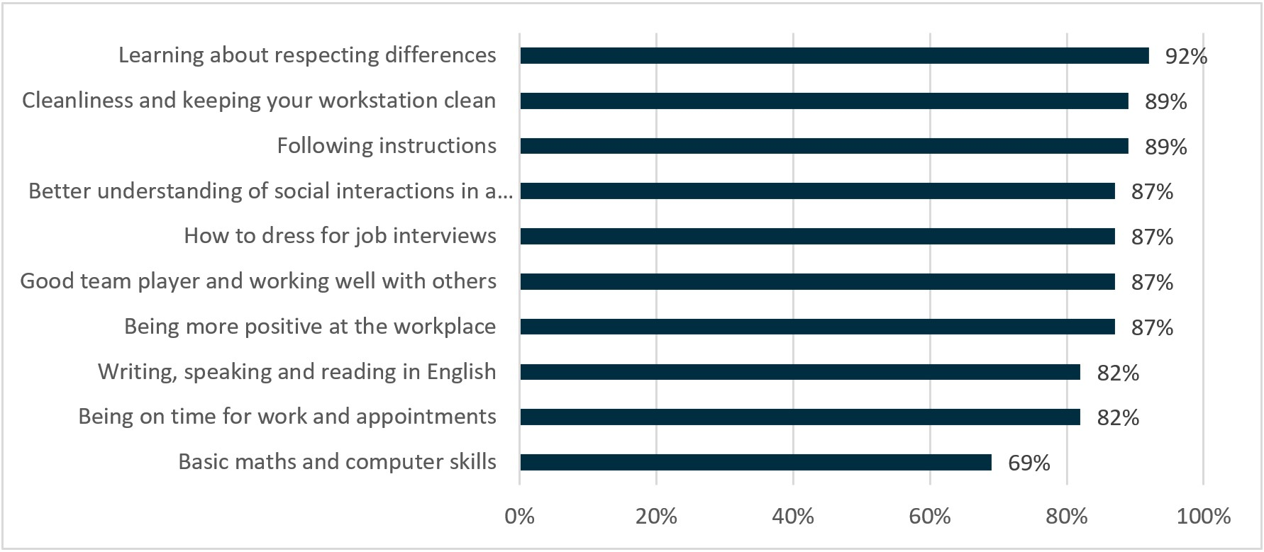

Base: those that selected each support type in the previous question: QTTB2 – When you started seeing <Site Name> did you want any support in the following areas? (QTTB2 base: all respondents, n=600)

QTTB3 – And since you started seeing <Site Name> did they provide you with any support in the following (area/areas)?

Source: 2017 TtW JSEES

Participants noted the benefits of some of these activities, particularly interview practice, during the qualitative research:

I've seen the bigger picture of what an interview is meant to be like. I was not really taught or knew what you were meant to do in an interview. I just thought you were meant to … answer the questions truthfully. But they told me a strategy to overcome your anxious and stressing and your – pretty much everything that you do in an interview, he told me to go through these steps. (Area 2 TtW Focus Group 4, Wave 2)

The practice interview helped me with my confidence, it got me asking the right questions. They taught me how to breathe and how to leave and make a good impression … They also encouraged me to smile as well, which I wouldn’t have thought to do. (Area 5 TtW Focus Group 3, Wave 2)

This activity enabled participants to improve their presentation skills and behaviour, develop coping mechanisms, establish peer support from other participants and undertake mentoring opportunities with guest speakers.

Guest speakers are definitely a big drawcard. St Kilda Football Club – we went there last week. That was a big drawcard. Connecting with other young people is huge for them – they’ll speak to another one and say, what's the next session you’re coming to? Can you look at my résumé? How come my résumé looks like that? So, quite often it can just be about connecting with other young people who are in the same space as them, so yeah, I don’t think anything works better than the next thing. (Area 1 Provider 1, staff group discussion, Wave 2)

### 5.2.2 Non-vocational barriers

While **89%** of young people in the study population were reported in their JSCI assessment as having no personal barriers,[36] providers participating in the qualitative research identified several non-vocational barriers faced by their participants. These included drug and alcohol problems, and mental and physical health issues (**Figure 5.2**).

Providers identified some young people with barriers stemming from households with intergenerational unemployment, a lack of social supports, poor role models, early parenthood and associated parenting issues.

There’s a lot of generational barriers, so a lot of our participants are second, third, fourth generation welfare. So a lot of them just don't have any peers or relatives, mums, dads, uncles, aunts that have worked. (Area 12 provider)

Figure 5.2: Forms of non-vocational assistance provided to participants[37]

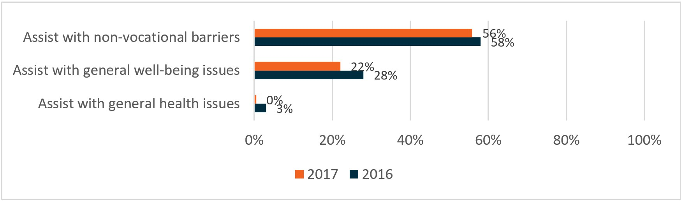

Base: all respondents (2017: n=213, 2016: n=240)

QC4 – Thinking about the interactions staff at the [site name] site have with the TtW participants, please select up to three most common forms of assistance that case workers/consultants provide to participants.

Source: 2016 and 2017 TtW Provider Surveys

During the qualitative research, providers reported mental health as a substantial barrier for young people. Depression and anxiety appeared to be common issues for TtW participants, and it often seemed that these mental health issues went undiagnosed at the time of their initial referral. Furthermore, in some individual cases, other circumstances exacerbated mental health issues, such as being involved in an abusive relationship or being a refugee.

I have a lot of mental health issues because I hadn’t worked for so long. Not a sob story but I had an abusive ex, I wasn’t allowed to do a lot of things. For two years, I wasn’t allowed to work. I tried, got in trouble, yep, whatever. And so because I didn’t have a job for so long, I was feeling so down and so washed out. (Area 1 focus group)

Undiagnosed medical condition, illness, of the youth is very common. Developmental and social stigma, bipolar, anxiety, depression. I will say that actually my clients they are asylum seekers and [for] a lot of migrants PTSD is also [an issue]. (Area 4 provider)

When participants were asked during the 2017 TtW JSEES about their perceived barriers to finding ongoing, sustainable employment, approximately a third (**35%**) reported they had no barriers to finding work. For those who had barriers, the most common were physical or mental health concerns (**14%**).

Some young people who encountered physical health barriers to employment indicated that these resulted from an injury at work or from an accident outside of work, such as a car accident, that had put them out of work.

Providers often had local links to headspace,[38] and during the focus groups some TtW participants mentioned accessing this type of support or counselling. A few providers also had access to a psychologist (as a ‘bought-in’ service) who visited their offices regularly on an appointment basis.

Yeah. I had some family stuff going on and [case worker] was really supportive through that, and got me connected with headspace. And then, obviously, that helps you actually be in a better place to start working. (Area 4 focus group)

In a few instances, providers mentioned difficulties in accessing such services due to waiting lists or oversubscribed services, most prevalent in regional areas where services were limited or scarce.

Mental health, there are some towns where it’s very hard to get into mental health, particularly those ones that don't have a headspace, they only have a headspace outreach service. It’s very hard to get mental health in those ones. (Area 14, TtW provider)

Young people did not raise drug and alcohol use/misuse as a common barrier during the qualitative research, although some providers said that the local area was known for having a prominent drug culture. Furthermore, some young people indicated that they had had difficulties in the past with finding employment, completing school et cetera due to a prior history of drug and/or alcohol use.

There’s quite a large drug culture in [Location]. (Area 11 provider)

I’d only gone to school for a year – before I was on drugs and … (Area 4 focus group)

Assistance given by providers to address other non-vocational and general wellbeing barriers included addressing transport issues (Figure 5.3).

Figure 5.3: Other types of non-vocational support given by providers

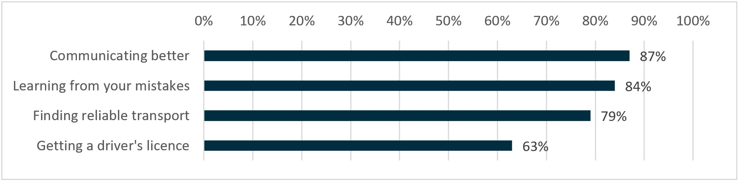

Base: those that selected each support type in the previous question, QTTB2 – When you started seeing <Site Name> did you want any support in the following areas? (QTTB2 base: all respondents, n=600)

QTTB3 – And since you started seeing <Site Name> did they provide you with any support in the following (area/areas)?

Source: 2017 TtW JSEES

### 5.2.3 Support provided through upfront payments

As noted earlier in this report, in the 2017 TtW Provider Survey, providers indicated that the use of upfront payments was to provide support to address vocational and non-vocational barriers. **Figure 5.4** below shows nine different types of support provided through upfront payments, with accredited training being the most common at over half (**56%**) of sites.

Figure 5.4: Use of upfront payments

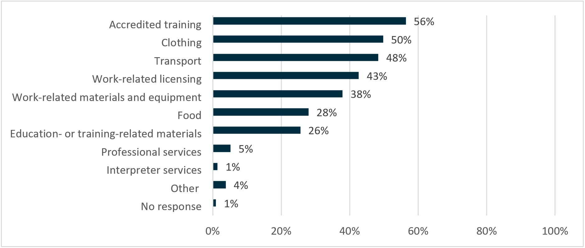

Base: all respondents (n=213)

QC6 – Which three types of direct support

Source: 2017 TtW Provider Survey

The least used types of support were professional services (**5%**) and interpreter services (**1%**).

TtW providers did not have access to the Employment Fund available to jobactive providers. It is worth noting, however, that at the end of June 2019 expenditure from the Employment Fund followed a similar pattern to expenditure from upfront payments, including accredited training, wage subsidies, clothing, and work-related expenses.

## 5.3 Activities to address specific groups

### 5.3.1 CALD services

Many providers interviewed during the qualitative research indicated that they developed their own strategies to engage effectively with young people from CALD backgrounds. As noted in **Section 4.9.4**, this often took the form of specialist staff.

… the transitions coach we have here has an understanding of Arabic and is working on developing their Arabic language skills … we shift the way we do things … they may need to translate those text messages, so instead of calling we’ll text them in the morning so they can translate that and get back to us. We’ve brainstormed ways to keep them engaged and make sure that they know that we’re here to support them. (Area 11 TtW provider, Wave 2)

Mental health was particularly challenging for CALD participants according to the providers interviewed during the qualitative research. A few providers noted that CALD participants presented with trauma. Furthermore, mental health was not widely recognised in some cultures and a few providers indicated that this was an added barrier to helping these participants.

Based on the trauma that they’ve experienced … It can take five years before they are ready to get into employment and sustain that employment. So that’s a really long time and here we’re talking 12 months, and it’s just not long enough. (Area 2 TtW provider, Wave 2)

### 5.3.2 Indigenous services

Providers with Indigenous participants implemented culturally competent strategies such as hiring Indigenous staff, working with Indigenous communities and elders, supporting Indigenous-specific facilitation groups and activities and assisting Indigenous participants to access Indigenous-specific initiatives.

Our Indigenous caseload here is 30 percent of the caseload … We’ve got elders, we’ve got community – very Indigenous-specific. We’re running our own separate facilitation groups for them as well, to talk about – because there’s different initiatives for them. It’s really about giving them opportunities and finding out what’s out there for them. There is a lot more actually out there for them than our mainstream clients. (Area 3 TtW provider, Wave 2)

Strong connections with local Indigenous organisations and between Indigenous elders and Indigenous participants developed.

We’ve developed Yarn Up where we get community elders and mentors together … once the stress of the initial period is out of the way, the first things we do for our Indigenous cohort is book them in for a Yarn Up session. And that’s about inclusion, it’s about the elders and the communities being part of the journey. And we softly, softly talk a little bit about the provider and about what our role is in the journey. And then we call each of them up and say ‘Which way?’ which we call Which way yarns. So which way do they want to go. (Area 10 TtW provider, Wave 2)

### 5.3.3 Barriers to service access

Providers delivered or referred TtW participants to a wide range of activities designed to assist the young person to get closer to education and work. As can be seen from Figure 5.5, the most commonly reported problem faced by providers in both the 2017 and 2016 Provider Surveys was that suitable training courses were unavailable in the local area (65% in 2017, down from 83% in 2016).

Figure 5.5: Reasons for being unable to refer participants to training courses

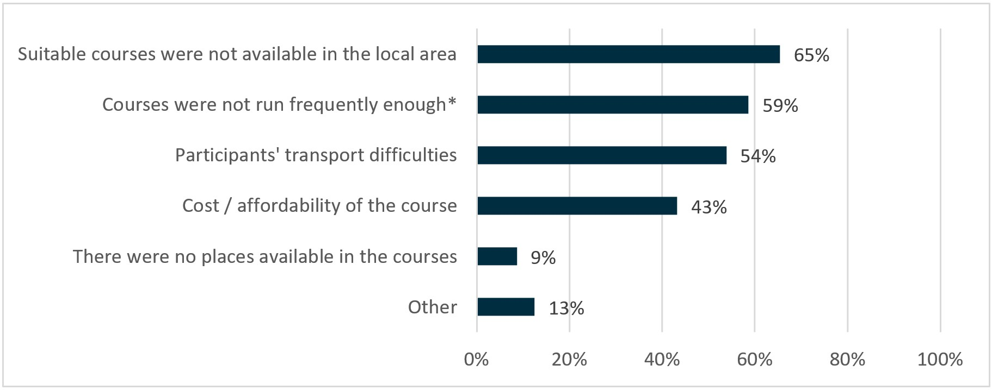

Base: respondents identifying as having been unable to refer participants to training courses (n=94)

QC8 – Why were you unable to refer participants to training courses? Please select up to three reasons that were most common.

* Courses were not run frequently enough or at the time needed.

Source: 2016 and 2017 TtW Provider Surveys

However, providers reported difficulties accessing certain services. As noted earlier in this report, a shortage of youth mental health places meant that some participants did not receive the support they needed. This problem was particularly severe in regional locations, where the limited services that were available were often oversubscribed.

I’ve got a young client here today who’s been on our books for nearly a year. And it’s only been in the last three months we’ve been able to get him to a counselling appointment. And be diagnosed with Asperger’s. That’s taken a lot of time and youth workers’ time, to actually get him there, take him to GP appointments, he did a GP mental health plan. Now he goes to an external counsellor. We were able to get that extended for him. His mother’s extremely grateful, because she’s been trying for years. (Area 4 Provider 2, manager, Wave 2)

## 5.4 Participation in education and training

While provider surveys and qualitative research informed us about the assistance delivered, and challenges encountered, by providers, program administrative data provides insights into participants’ engagement in education and training activities. Around half (**49%**) of participants in the TtW inflow population engaged in at least one recorded activity. Education and training represented the vast majority of the activities (**46%** of the inflow population). Similar proportions of participants were placed in accredited (**30%**) and non-accredited (**29%**) education and training respectively. Around a quarter of participants engaged in a course that was eligible for an education outcome (**Table 5.1**).

Table 5.1: Participation in education and training by young people in the TtW inflow population over a 12-month period*

| Education and training activity type(a) | No. of participants placed in activity (n=27,241) | % of participants placed in activity |
| --- | --- | --- |
| Accredited education and training | 8,062 | 29.6 |
| Non-accredited education and training | 7,794 | 28.6 |
| Other government programs | 842 | 3.1 |
| Education outcome – qualifying course | 7,112 | 26.1 |
| Participants with at least one activity placement | 13,412 | 49.2 |

* Or until the TtW participant exited services

(a) Participants can be placed in multiple types of activities and activity types are not mutually exclusive. For example, a Certificate III is both a type of accredited education and training, and an education outcome-qualifying course.

Source: Department of Education, Skills and Employment administrative data – TtW inflow population

Many young people enrolled in preparatory courses (such as Certificate I and II) that met the eligibility requirements for the courses that qualified for a study outcome should they choose to continue.

A small number of participants placed in other government programs received assistance to address specific labour market barriers prior to engaging in other education and training. Some participants engaged in more than one activity both within and across activity types.

## 5.5 Employment-related activities

During the 2017 TtW Provider Survey, providers reported preparing participants for work and interviews as their main vocational assistance. Most providers preferred courses that incorporated an element of work experience and implemented services to assist job-ready participants with their job searches (**Figure 5.6**) or referred them to a job.

Preparing participants for interviews was considered less important by providers over time (**36%** in the 2017 TtW Provider Survey,down from **45%** in the 2016 TtW Provider Survey).

Figure 5.6: Forms of assistance provided to participants

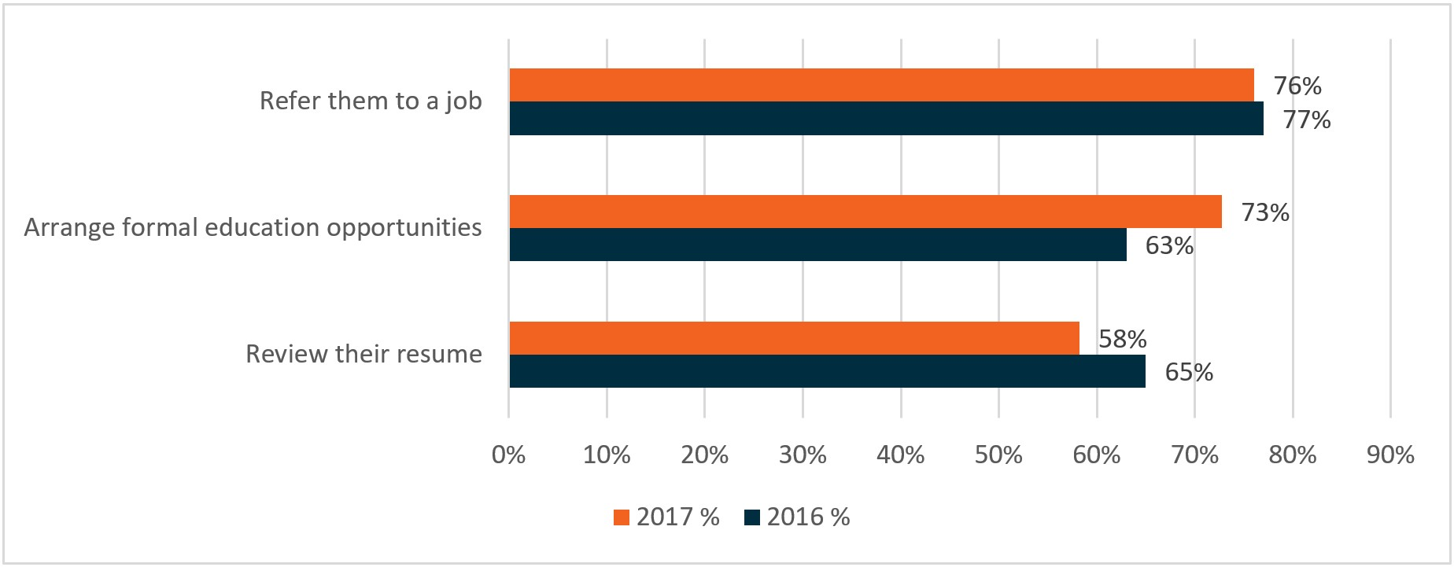

Base: all respondents (2017: n=213, 2016: n=240)

QC4 – Thinking about the interactions staff at the [site name] site have with the TtW participants, please select up to three most common forms of assistance that case workers/consultants provide to participants.

Source: 2016 and 2017 TtW Provider Surveys

## 5.6 Outcome achievement

### 5.6.1 Employment outcomes were the most common outcome

As TtW participants were only eligible for 12 months of services, providers had a finite time in which to achieve outcomes or work towards achieving them. The departmental administrative data showed that providers continued to achieve positive results for the entire 12 months after referral. Given the average length of time required to achieve an education outcome, it was perhaps unsurprising that based on the whole TtW population (not just the evaluation inflow population), 12-week employment outcomes were the most common outcomes achieved over a two-year period (**Figure 5.7**).

Figure 5.7: TtW employment and education outcome achievement, raw data, July 2016 to June 2018

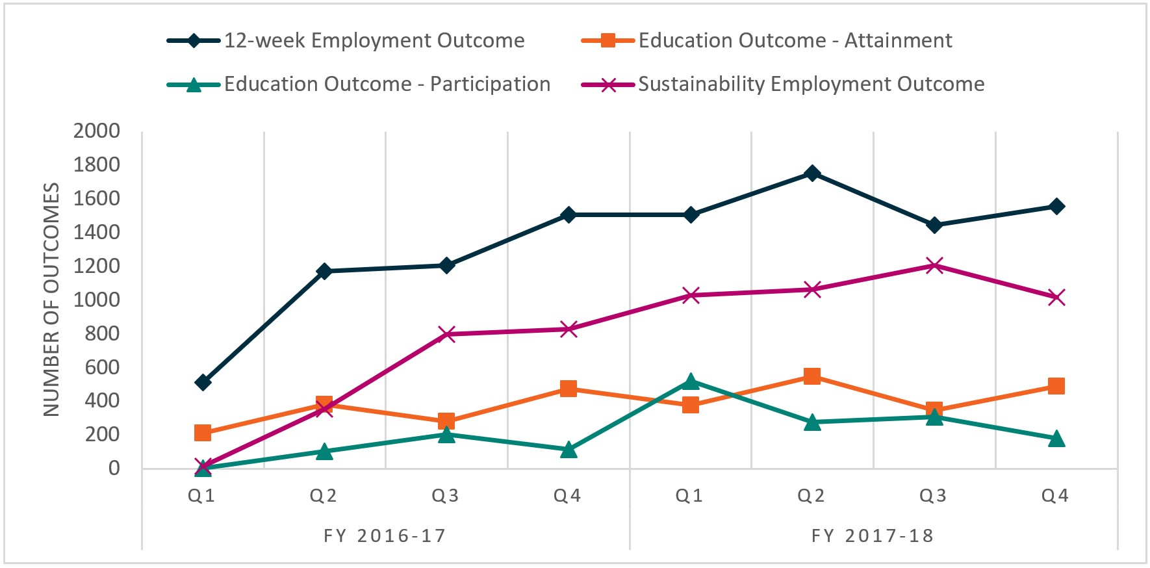

Note: As the TtW caseload was still building at the start of 2016–17, the outcome achievement is lower. Sustainability outcomes take 26 weeks to achieve, which is why there are so few at the start of the program.

Source: Department of Education, Skills and Employment administrative data

Table 5.2: Outcomes achieved in TtW, 2016–17 and 2017–18 (whole TtW population)

|  |  |  |  |  |
| --- | --- | --- | --- | --- |
| Type of outcome | Outcomes achieved  2016–17 (no) | Outcomes achieved  2016–17 (%) | Outcomes achieved  2017–18 (no) | Outcomes achieved  2017–18 (%) |
| 12-week employment outcome | 4,388 | 53.4 | 6,255 | 45.4 |
| 12-week hybrid outcome | 63 | 0.8 | 131 | 1.0 |
| Education outcome – attainment | 1,345 | 16.4 | 1,752 | 12.7 |
| Education outcome – participation | 427 | 5.2 | 1,281 | 9.3 |
| Sustainability employment outcome | 1,994 | 24.2 | 4,310 | 31.3 |
| Sustainability hybrid outcome | 7 | 0.1 | 42 | 0.3 |
| Total | 8,224 | 100.0 | 13,771 | 100.0 |

Source: Department of Education, Skills and Employment administrative data

The increase in outcomes achieved in 2017–18 (**Table 5.2**) could be explained by a number of factors. It could be due to improved service efficiency, the longer timeframe available to participants in which to achieve outcomes in 2017–18 because of their prior experience in jobactive, or the changes in the eligibility criteria for Indigenous participants. For example, some providers noted during the qualitative research that their number of funded places and performance targets increased from January 2018, possibly because of the expanded eligibility for Indigenous youth or as part of the annual review of funded places. This meant that providers received larger upfront payments but were required to achieve more 12-week employment outcomes and 12-week hybrid and education outcomes before receiving bonus outcome payments.

Another possible reason may have been that providers focused on an employment placement. Most TtW providers interviewed during Wave 2 of the qualitative research appeared reluctant to enrol participants in training as a first port of call. Rather, they highlighted employment outcomes or jobs for participants as their first priority within the 12 months of the service.

Entering a participant into education, in order to obtain an education outcome, was a secondary focus. A few providers interviewed during the TtW Wave 2 qualitative research stated that enrolling a participant into a course was not an effective use of TtW time, unless avenues of employment were already exhausted. However, some providers placed participants in training initially to address perceived skills deficits. As participants approached the completion of their 12 months of services (and possible exit from TtW to jobactive), providers became more incentivised to place participants in employment or further study to enable them to track to an outcome.[39]

We don’t usually go down the education for the first three to six months … If [after that], we tried to get you a job, it hasn’t been successful, let’s get you into some study to build those skills so you’re more employable in three or four months’ time. (Area 14 TtW provider)

We use education as an intervention to employment. So, obviously, employment is our end outcome, and education is used as an intervention if they need it. (Area 4 TtW provider)

From the qualitative research, it was apparent that providers became more incentivised to place participants in employment or further study, thereby qualifying for an outcome, as participants completed their 12 months of services (and faced exits from TtW to jobactive). Providers thought it particularly important to inform the participant that otherwise they would enter into the Work for the Dole phase in jobactive immediately once they commenced with their jobactive provider.[40]

We make them aware that they’re going straight into Work for the Dole phase which is – we give them some ideas on how they can perhaps go across into that and manage that. (Area 13 TtW provider)

The number of hybrid outcomes claimed was low generally. This was due to the difficulty in meeting the requirements to undertake 25 hours of study and work over 26 consecutive weeks and the reluctance of providers to claim hybrid outcomes. Hybrid outcomes required providers to submit additional evidence that was sometimes difficult to obtain, such as payslips or course completion sign-off from registered training organisations (RTOs).

As one provider observed during the qualitative research:

With hybrid claims, you need a signed declaration from the RTO. I know that the department tried to make it easier with hybrid claims for apprenticeships and traineeships because there is that education component to that employment. But getting an RTO declaration for someone at trade school is way harder sometimes ... Sometimes their schooling dates don’t align with their employment dates and it’s just a nightmare. (Area 13 TtW provider, Wave 2)

Approximately 30% of TtW participants achieved at least one outcome during their TtW period of service; some participants achieved multiple outcomes. Of the participants who first achieved an education attainment outcome, more than a quarter (**27.4%**) went on to obtain a 12-week employment or hybrid outcome. Almost one-fifth (**19.4%**) of those first achieving the education attainment outcome also achieved a 26-week employment/hybrid outcome. For participants whose first outcome was a 12-week employment or hybrid outcome, **71.8%** later achieved a 26-week employment or hybrid outcome.

Achieving education or 12-week employment outcomes most likely reflected the work readiness of the achievers, with those who gained 12-week employment outcomes being the most work ready. As noted in Chapter 6, the conversion rates to 26-week outcomes among these three groups confirmed this.

### 5.6.2 Pathway to sustainable outcome targets

As noted earlier in this report, Outcome Performance Targets are the benchmark for provider performance in TtW, with the TtW service agreement requiring each provider contract to achieve a specified number of outcomes (excluding Youth Jobs PaTH Internship outcomes and sustainability outcomes). The Outcome Performance Targets include 12-week outcomes (employment and hybrid) and education (26-week participation towards or attainment of a qualification in a qualifying course).

The targets were set at contract level at 25% above the performance of mainstream employment services (Job Services Australia and jobactive) for a similar cohort in the corresponding ER. This annual Outcome Performance Target was distributed across the four quarters of the financial year, with providers’ performance assessed each quarter against their quarterly allocation. The provider received a bonus outcome payment for every outcome achieved above the quarterly target.

Despite some underperforming providers, at the program level, providers achieved above the outcome target for nearly all quarters over the two financial years July 2016 to June 2018 (**Figure 5.8**). The proportion of annual performance targets achieved increased from 109.8% of the target in 2016–17 to 124.6% in 2017–18.

Figure 5.8: TtW outcomes achieved compared to targets, quarterly

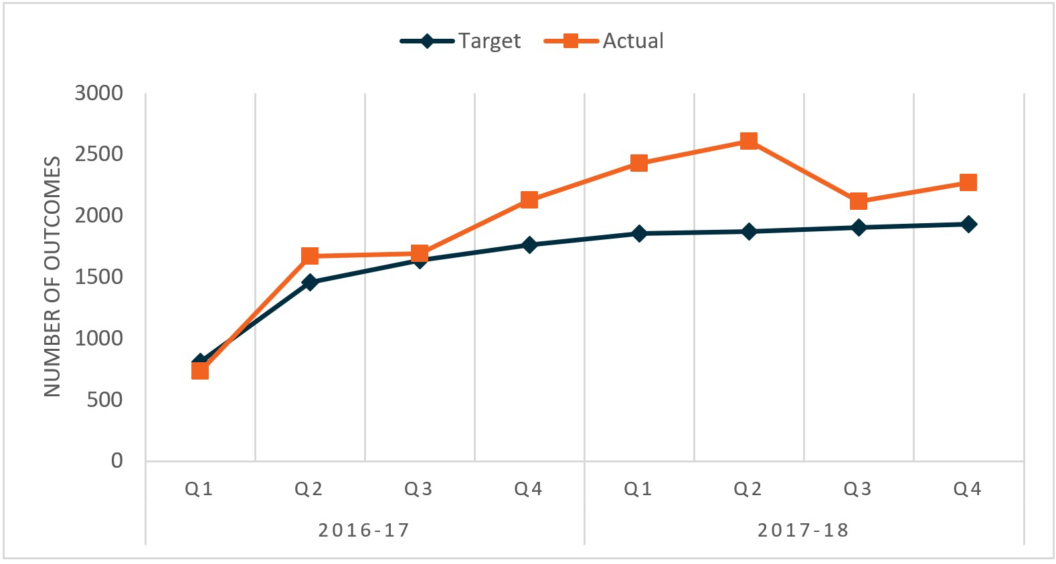

Notes: (1) Outcomes are counted when they are achieved, not when claims are made. (2) Providers can continue to claim outcomes after the end of a financial quarter for outcomes achieved in that quarter. (3) Outcomes tracked against outcome targets exclude sustainability outcomes. (4) There are 619 special claims which are not included in the count of outcomes by quarter.

Source: Department of Education, Skills and Employment administrative data as at 28 February 2019

## 5.7 Improvements in participants’ work readiness

One of the aims of the TtW service was to improve the work readiness of young people who failed to complete secondary education. Earlier in this report, it was noted that the TtW Deed described work readiness[41] as ‘possessing the core skills and behaviours required by employers includ[ing] skills and behaviours relating to teamwork, communication, a positive attitude and work ethic’. Almost all providers (**97%**) who responded to the 2017 TtW Provider Survey reported that the TtW service improved participant work readiness.

In **Section 4.9.1**, it was noted that providers used various tools to assess and monitor work readiness. During the qualitative research, there was a broad consensus among employers and providers that work readiness was a critical attribute for young job seekers. Employers participating in in-depth discussions during the qualitative research and 2017 Employer Survey highlighted the importance of reliability, interpersonal skills, a positive work attitude, a willingness to work and self-motivation when recruiting staff. The following comments illustrate the employee characteristics employers sought:

We’re not after rocket scientists … It’s a hard day’s work for a good day’s pay type thing. (TtW Employer 1, Wave 2)

No-one’s born with Excel spreadsheet skills are they? You need to learn it … It comes down to experience, knowledge, attitude … (TtW Employer 3, Wave 2)

A willing to work, a willing to have drive, a willing to have ambitions … they’ve got to have ambitions, they’ve got to have goals and not to just go on day by day. (Employer (car retailer), Wave 1)

During the 2017 JSEES Survey, TtW participants reported improvement in key components of their work readiness and work skills because of participating in TtW. The majority of those who completed, enrolled in or commenced study and training felt it had improved their chances of getting a job, improved their work skills and increased their desire to find ongoing work (**Figure 5.9**).

Figure 5.9: Perceived impact on soft skills from study and training

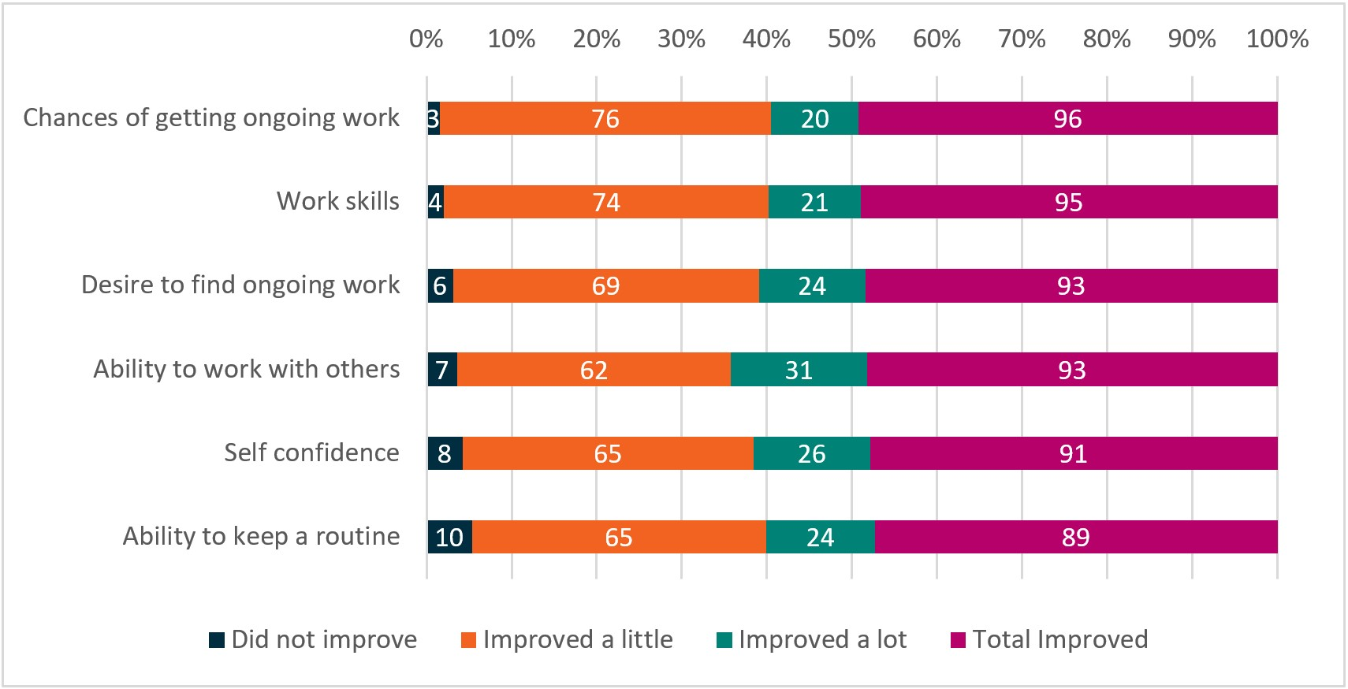

Base: respondents who have completed or are currently undertaking study/training or enrolled to study (n=345)

QTJE5 – Do you think that your training or course has improved / will improve? Completed, currently undertaking study or training, or enrolled to study.

Source: 2017 TtW JSEES Survey Analytical Report

Compared with jobactive participants, TtW participants reported a greater willingness to work and were more positive about their job prospects. Responding to questions during the 2017 JSEES Survey, **90%** of TtW participants thought that having almost any job was better than being unemployed, compared with **77%** of jobactive participants. Participants in TtW were also slightly more positive about their chances of finding employment. Moreover, **15%** of jobactive participants stated that no employer would be willing to employ them, compared with **11%** of TtW participants (**Figure 5.10**).

Figure 5.10: TtW and jobactive participants’ attitudes to work (per cent)

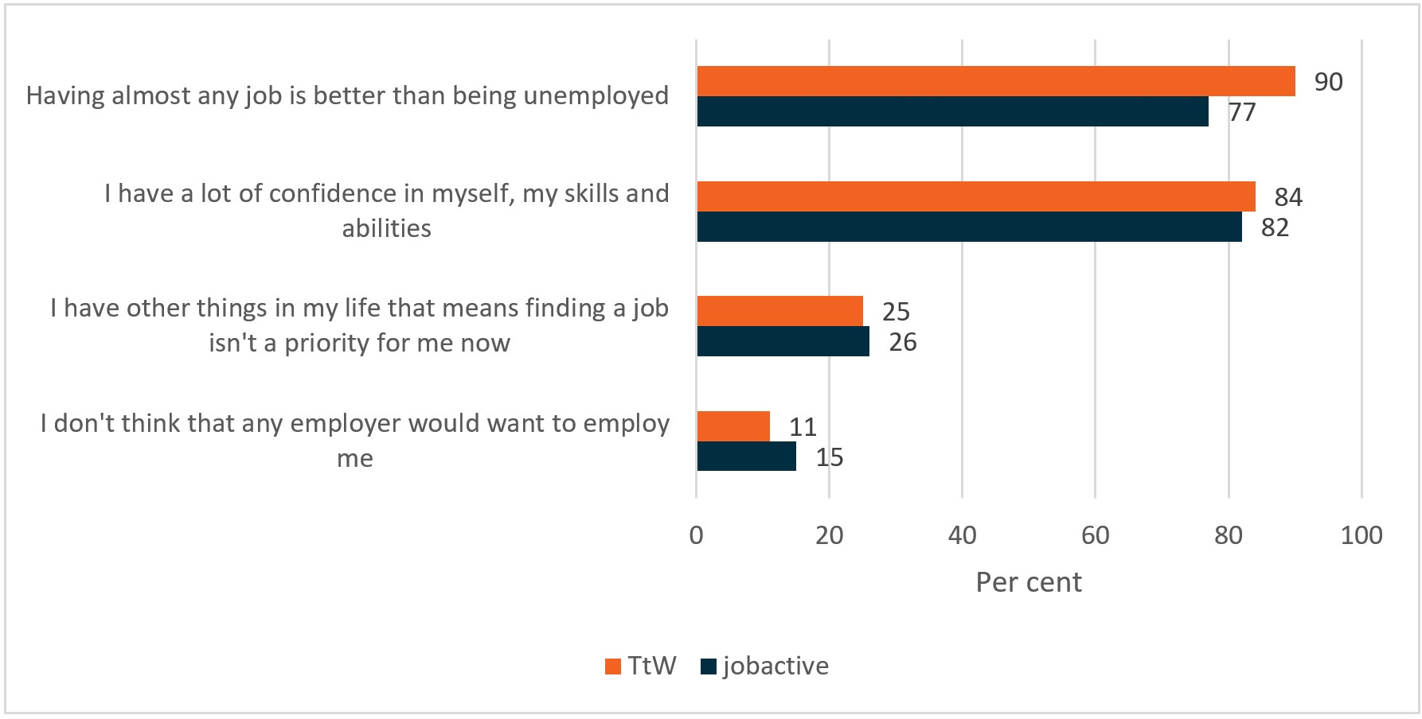

Base: all participants (TtW: n=600, jobactive: n=3,000)

QTTD1 – I am going to read some statements about looking for work and I would like you to tell me how much you agree or disagree with each one.

Source: 2017 TtW and jobactive JSEES Survey

In addition, the department’s 2017–2018 PPM Survey (**Figure 5.11**) showed that around three-quarters (**73%**) of participants felt their level of work readiness had improved because of working with their TtW provider. Participants undertaking the survey also reported improvements in their communication skills (**69%**), organisation skills (**66%**) and desire to find a job (**71%**).

Figure 5.11: Proportion of TtW participants stating their participation in TtW improved selected soft skills ‘a little’ or ‘a lot’ three months after exiting

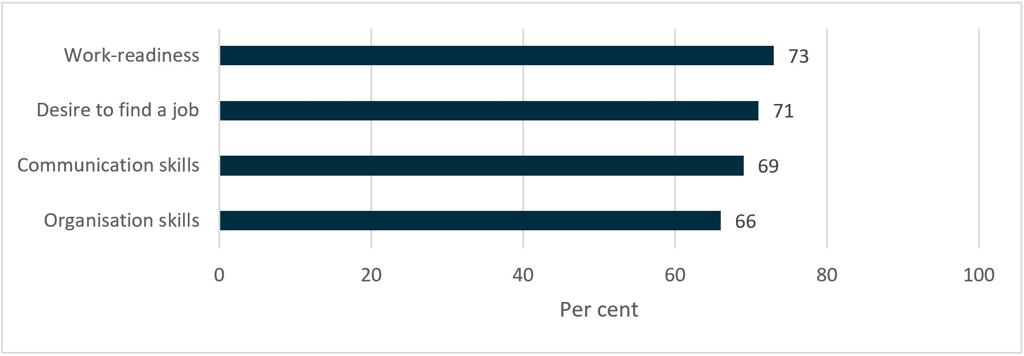

Base: n=6,523

Question – Has working with [TtW provider] improved [your]: …

Source: TtW PPM Survey between June 2017 and July 2018[42]

## 5.8 Work experience

Work experience was an ideal opportunity for young people to develop work readiness while improving their work skills and developing a job-related network. The TtW participants gained work experience opportunities through PaTH and the NWEP and other opportunities arranged by their provider.

### 5.8.1 Youth Jobs PaTH

During the Wave 2 qualitative research, TtW providers noted that work experience was a good way for participants to add experience to their résumés, while exposing them to industries in which they may have a future work interest. With the commencement of Youth Jobs PaTH Internships (the ‘trial’ element of the program) in April 2017, TtW providers were able to use them for eligible TtW participants, such as those aged 17 years or older who had served in TtW continuously for at least six months (Department of Employment, 2017A).[43]

As at 31 March 2018, departmental administrative data showed that 4,284 TtW participants were eligible for PaTH Internships, representing about 5% of all eligible people. For the 1,596 young people under TtW who participated in PaTH, the top three ways were:

* 1,162 (**73%**) had a job placement supported by a Youth Bonus Wage Subsidy only
* 254 (**16%**) started an internship only
* 122 (**8%**) started an internship first and then began a job with a Youth Bonus Wage Subsidy.

As noted in **Section 8.7.4**, a minority of employers offered unpaid work experience, because many felt it was somewhat exploitative. However, employers were pleased that they could trial a young person in a role, as participants received an incentive payment of $200 per fortnight, in addition to their income support, and employers received a $1,000 incentive payment. A few providers interviewed during the qualitative research felt that the PaTH Internship process was onerous, with long waiting periods and a heavy administrative burden.

The steps that you need to do in order to put a young person into a PaTH Internship is quite lengthy. The risk assessments that need to be done and the paperwork that needs to be signed by the employer, the jobseeker, and us. It’s easier for us to give the employer the option to just take them on with the wage subsidy. (Area 7 TtW provider)

The 2017 TtW Provider Survey respondents, when asked about their attitudes on a range of issues relating to PaTH Internships, expressed agreement that PaTH Internships (**Figure 5.12**):

* gave participants vocational skills (**86%** agreed / strongly agreed)
* were actively promoted to participants (**84%** agreed / strongly agreed)
* helped participants improve their chances of getting a job (**78%** agreed / strongly agreed).

Figure 5.12: Attitudes towards PaTH

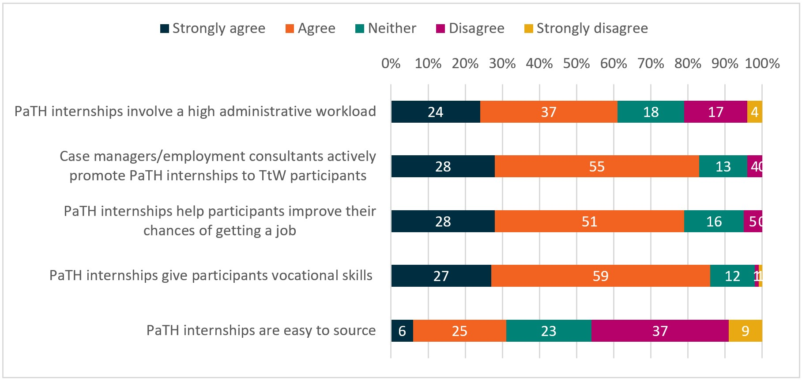

Base: all respondents (n=213)

QG2 – How much do you agree or disagree with the following statements?

Source: 2017 TtW Provider Survey

However, consistent with qualitative research findings, many respondents also reported that they found PaTH Internships involved a high administrative workload (**61%** agreed / strongly agreed) and were not easy to source (**45%**).

### 5.8.2 National Work Experience Programme

Few TtW providers used NWEP[44] during the evaluation period. During the qualitative research, a few providers explained that they felt the NWEP age limit (18 years and over[45]) restricted the use of the program within the TtW service.

Providers complained that the administrative burden and the lack of monetary incentives for participants in NWEP was negatively affecting completion of placements. By March 2018, there had been 245 unique TtW participants in NWEP.[46]

This changed under PaTH Internships, however, with $200 per fortnight provided to participants to complete their internship.

When I first came here I used [the NWEP] but again people were falling out and not going. That’s why internships when a young person feels they’re getting something, even if it’s $200 a fortnight it’s like I’m working for it. It’s like I'm going, I’m getting up, I’m working for it, I’m working for that extra $200 and it changes that whole perception. (Area 6 TtW provider)

For many TtW providers, the main work experience option for participants aged 15 and 16 years was volunteer work, although it was not popular with them. One provider developed their own paid work trial program for participants in this age group to allow them to gain valuable work experience and provide a monetary incentive for participating employers.

We’ve developed our own – a work trial within [provider]. And that comes out of our bottom line and from our service fees that we get for the program. So, we basically have our own policies. (Area 6 TtW provider)

## 5.9 Development of participants’ human capability

As noted earlier in this report, research suggests that broad human capabilities (psychological, physical, cognitive, economic, social and political) are developed progressively over an individual’s life course and defined by culture and relations between households, communities, the state and the market (Perales et al., 2018). Relevant to this development are important factors such as access to, and utilisation of, childcare; parental background; socioeconomic achievement; the quality and availability of education; income inequality; cultural background; and macroeconomic factors such as economic growth and the availability of jobs.

Utilising the concept of human capability,[47] the impact of education and employment interventions, such as TtW, can be viewed in a broader frame than that of the purely economic benefits of increased productivity. The development of ‘a broader set of talents, skills and resources that people have that not only allow them to choose a profession and change jobs through the life course, but also to contribute to their families, for example through parenting and the development of their children, and to their communities through activities outside of the workplace’ (Perales et al., 2018) can be explored.

In **Figure 5.2**, it was noted that around a quarter of TtW providers assisted participants in addressing general wellbeing issues, resulting in increases in their self-confidence, capacity to work with others (**Figure 5.9**) and communication skills (**Figure 5.11**). Findings from the Wave 2 qualitative research showed the increase in confidence and self-esteem, a positive sense of self and renewed motivation participants experienced as a result of taking part in TtW was impactful.

I wasn’t doing anything. And when you're not doing anything, you just feel like nothing is going to happen and you just floating through life. But if you're actually trying to get out and try new things, even if you don’t like it, that's cool. That’s one more thing you know you’re not going to want to do in the future. It cancels them out and it focuses you down a little bit more. (Participant focus group 1)

Providers agreed with this feedback.

It brings back that routine but it gives them a purpose to their life. It sounds ridiculous but for some of these kids if they haven’t had somewhere to go or the expectation that if they’re not there – they’re relied on too like if they’re not there that job doesn’t get done. So it really gives them that purpose of getting up, going to work, being in that routine. I find overall their mental health is better, their wellbeing is better. (Area 6 TtW provider)

## 5.10 Conclusion

Overall, TtW providers were effective in meeting the objectives of the program. At the program level, providers achieved above the outcome target for nearly all quarters over the two financial years July 2016 to June 2018. The proportion of annual performance targets achieved increased from 110% of the target in 2016–17 to 125% in 2017–18.

Providers delivered or referred participants to a wide range of activities essential to addressing their non-vocational barriers and improving their wellbeing and human capabilities. Many were time consuming and often difficult, such as developing a mental health plan. Providers reported that poor mental health and substance abuse were among the most common non-vocational barriers that they addressed.

Mentoring and coaching sessions, job search assistance and advice about undertaking interviews helped participants to achieve education, training and employment outcomes and an improvement in their motivation and work readiness.

# Chapter 6 Impact of TtW on labour market attachment, study and receipt of income support

## 6.1 Introduction

This chapter examines the relative impact of TtW on young people when matched with similar jobactive participants, extending the analysis of the effectiveness of the program covered in Chapter 5. Using outcome measures that were comparable between TtW and jobactive, the relative program impact over at last 12 months was analysed. These outcome measures, described in **Section 2.11** were:

* LMA, which occurs when the department’s income support and job placement information indicates a participant has secured employment
* study outcomes, which occur when a participant engages in an education or training activity that could qualify for an outcome payment
* positive outcomes, which occur when a participant achieves either LMA or a study outcome.

A discussion of whether the LMA and study outcomes varied in line with participant characteristics looks at whether TtW had different impacts based on a participant’s gender, Indigenous status, English proficiency and residential location.

The longer term impacts of TtW on participants’ reliance on income support is examined. The income support analysis, which followed participants for two years from their initial referral to TtW, tests whether TtW participants were more likely to exit income support, or exit income support for longer, compared with similar jobactive participants. Using income support data, the impact of TtW on the likelihood that participants would re-enter the criminal justice system, compared with the impact of jobactive, was also reviewed.

## 6.2 Impact analysis methodology

The impact analysis first compared the outcomes of all TtW and jobactive participants in the matched samples, taken from the inflow population of TtW and jobactive participants referred to services between 1 April 2016 and 31 March 2017 (see **Appendix F**). The jobactive inflow population consisted of Stream B participants aged under 22 at referral who were not in TtW in the 91 days prior to referral.

This was followed by a regression analysis of the matched TtW and jobactive samples, which isolated the impact of TtW from the effects of participants’ demographic and socioeconomic characteristics for each outcome measure. The impact of TtW was estimated by calculating the probability of the average participant achieving a study or employment outcome – that is, the ‘average marginal effect’ of TtW on each outcome.

While providers may have assisted participants to develop their résumés, search for jobs and undertake interview practice, outcomes achieved less than four weeks after program referral were excluded from the analysis, as it was likely that they resulted from participants’ own efforts rather than any program effect. For example, outcomes achieved during this initial period may have reflected pre-existing employment or study activities.

For detailed descriptions of the regression analysis, as well as a more detailed discussion of the outcome measures, see **Appendix H**.

## 6.3 The impact of TtW on labour market attachment, education and training

### 6.3.1 Labour market attachment

For the matched cohorts, the TtW cohort appeared to have lower LMA throughout the analysis period. **Figure 6.1** shows that **47%** of matched TtW participants achieved LMA up to a year after referral, compared with **52%** of jobactive participants. This percentage difference was largely present from the beginning of the analysis period and, as a result, it is unlikely to be due to the effect of program servicing.

The program servicing effect is reflected in the increase in the difference in LMA during the analysis period. In this case, the increase in LMA was 29.8 percentage points for TtW, and 30.7 percentage points for jobactive, representing a **0.9 percentage point** increase in the difference between jobactive and TtW after four weeks post-referral.

Figure 6.1: Cumulative percentage of TtW and jobactive participants achieving LMA*

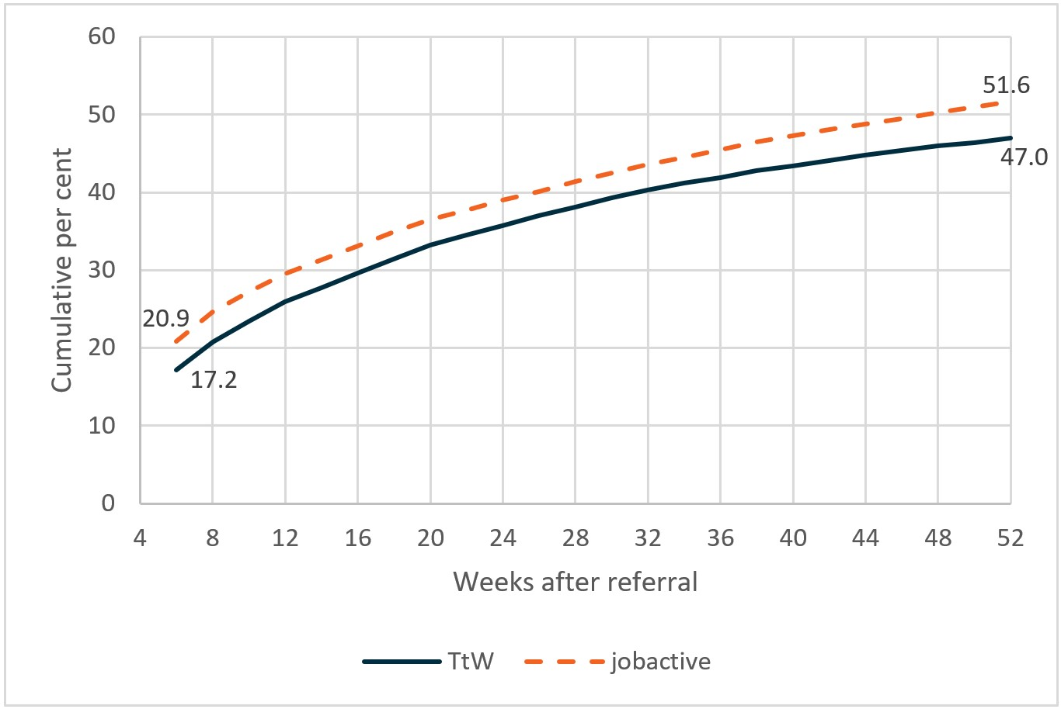

Base: matched samples (TtW: n=12,105, jobactive: n=12,105)

* A participant achieves LMA when the department’s income support and job placement information indicates they have secured employment. LMA outcomes achieved within four weeks of referral are excluded, as it is unlikely these outcomes resulted from TtW or jobactive servicing.

Source: Department of Education, Skills and Employment administrative data

After adjusting for participant characteristic through regression analysis, TtW does not achieve the same rate of LMA as jobactive. **Table 6.1** shows that for the average young person the probability of achieving LMA between four and 52 weeks after referral was **3.4 percentage points** lower than in jobactive.

Table 6.1: Average change1 in probability of achieving LMA2 in TtW compared to jobactive, by period after referral

| Period after referral  (number of weeks) | Average change in probability of achieving LMA in TtW compared to jobactive2  (percentage points) |
| --- | --- |
| 4 to 26 | -1.4 |
| 4 to 38 | -2.3 |
| 4 to 52 | -3.4 |

Base: matched samples (TtW: n=12,105, jobactive: n=12,105)

1. The ‘average change’ is the difference in probability of the average participant achieving LMA in TtW compared to jobactive, adjusted for participant characteristics – that is, the ‘average marginal effect’ of TtW compared to jobactive.

2. A participant achieves LMA when the department’s income support and job placement information indicates they have secured employment. LMA outcomes achieved within four weeks of referral are excluded, as it is unlikely these outcomes resulted from TtW or jobactive servicing.

The presence of a difference in LMA status at the beginning of the study period likely reflects motivational/preferential differences between the two matched cohorts. It may also indicate the difference in the deterring effect of the two programs. The fact that TtW is regarded by stakeholders as ‘career-forging’ suggests that TtW may have a ‘lock-in’ effect on participants due to its activity-intensive nature and participants’ higher level engagement in education/training.

Due to differences in program design, this lock-in effect is likely to have been larger in TtW than it was in jobactive, as TtW focused on pre-employment activities such as education and training and addressing other barriers to employment in addition to attempting to achieve labour market outcomes. This likely restricted TtW participants’ ability to find a job or undertake enough work to exit income support, compared with jobactive participants. The higher LMA rate for jobactive participants at four weeks post-referral is unlikely due to program effect. Rather, jobactive’s ‘work-first’ approach may encourage participants to undertake some paid work as soon as possible rather than remaining in service and improving their work readiness. The compliance mechanisms in jobactive may also cause a stronger ‘deterrence effect’ for participation in the program, which may motivate jobactive participants to look for work with greater urgency.

International research has also found that participants in certain pre-employment labour market programs are less likely to exit to employment than are comparable non-participants (Wunsch, 2016). This is partly because job seekers who participate in these activities have less time in which to look for or undertake paid work.

### 6.3.2 Engagement in education and training

Perhaps unsurprisingly, TtW was much more effective than jobactive in encouraging participants to undertake education and training. **Figure 6.2** shows that, in the matched samples, **21.8%** of TtW participants achieved study outcomes up to a year after referral, compared with only **12%** of jobactive participants.

Figure 6.2: Cumulative percentage of TtW and jobactive participants achieving study outcome*

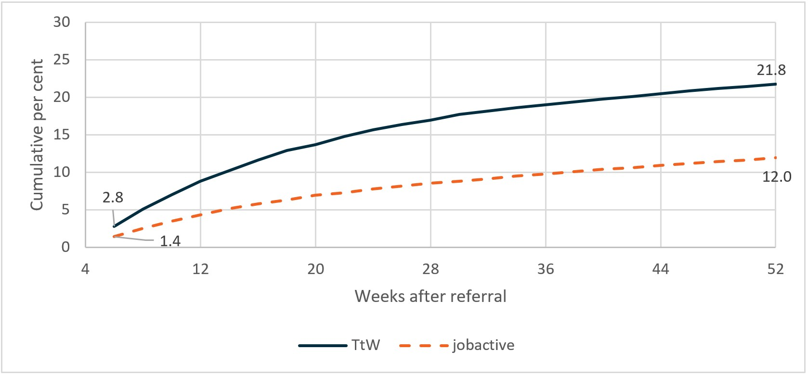

Base: matched samples (TtW: n=12,105, jobactive: n=12,105)

* A participant achieves a ‘study outcome’ when they participate in an education or training activity that qualifies for an outcome payment. Study outcomes achieved within one month of referral are excluded, as it is unlikely these outcomes resulted from TtW or jobactive servicing.

Source: Department of Education, Skills and Employment administrative data – matched samples

After adjusting for participant characteristics through regression analysis, TtW was more effective than jobactive at encouraging participants to engage in education and training that may have a long-term impact on LMA. As **Table 6.2** shows, the typical participant was **10.6 percentage points** more likely to achieve a study outcome up to a year after referral if they were in TtW than if they were in jobactive.

Table 6.2: Average change1 in probability of achieving study outcomes2 in TtW compared to jobactive, by period after referral

| Period after referral (number of weeks) | Average change in probability of achieving study outcome in TtW compared with jobactive (percentage points) |
| --- | --- |
| 4 to 26 | 8.8 |
| 4 to 38 | 10.0 |
| 4 to 52 | 10.6 |

Base: matched samples (TtW: n=12,105, jobactive: n=12,105)

1. The ‘average change’ is the difference in probability of the average participant achieving study outcomes in TtW compared to jobactive, adjusted for participant characteristics – that is, the ‘average marginal effect’ of TtW compared to jobactive.

2. A participant achieves study outcomes when they participate in an education or training activity that could qualify for an outcome payment. Study outcomes achieved within four weeks of referral are excluded, as it is unlikely these outcomes resulted from TtW or jobactive servicing.

Source: Department of Education, Skills and Employment administrative data

That TtW was more effective than jobactive in encouraging participants to study is consistent with the differences in the programs’ intent and fee structures. As discussed in **Section 1.4.6**, the TtW funding model focused on both employment and education outcomes. In contrast, employment outcomes in jobactive usually attract higher payments, have higher weighting in performance monitoring and are quicker to attain than are education outcomes. Compared with jobactive, TtW also has a stronger focus on pre-employment activities.

### 6.3.3 Positive outcomes

The TtW service had a similar impact to jobactive on the probability of participants achieving positive outcomes – that is, achieving either LMA or a study outcome (see **Section 6.1** and **Appendix H** for further discussion of these measures). As **Figure 6.3** shows, **57.7%** of TtW participants and **58.3%** of jobactive participants achieved positive outcomes in their first year of servicing.

Figure 6.3: Cumulative percentage of TtW and jobactive participants achieving positive outcomes*

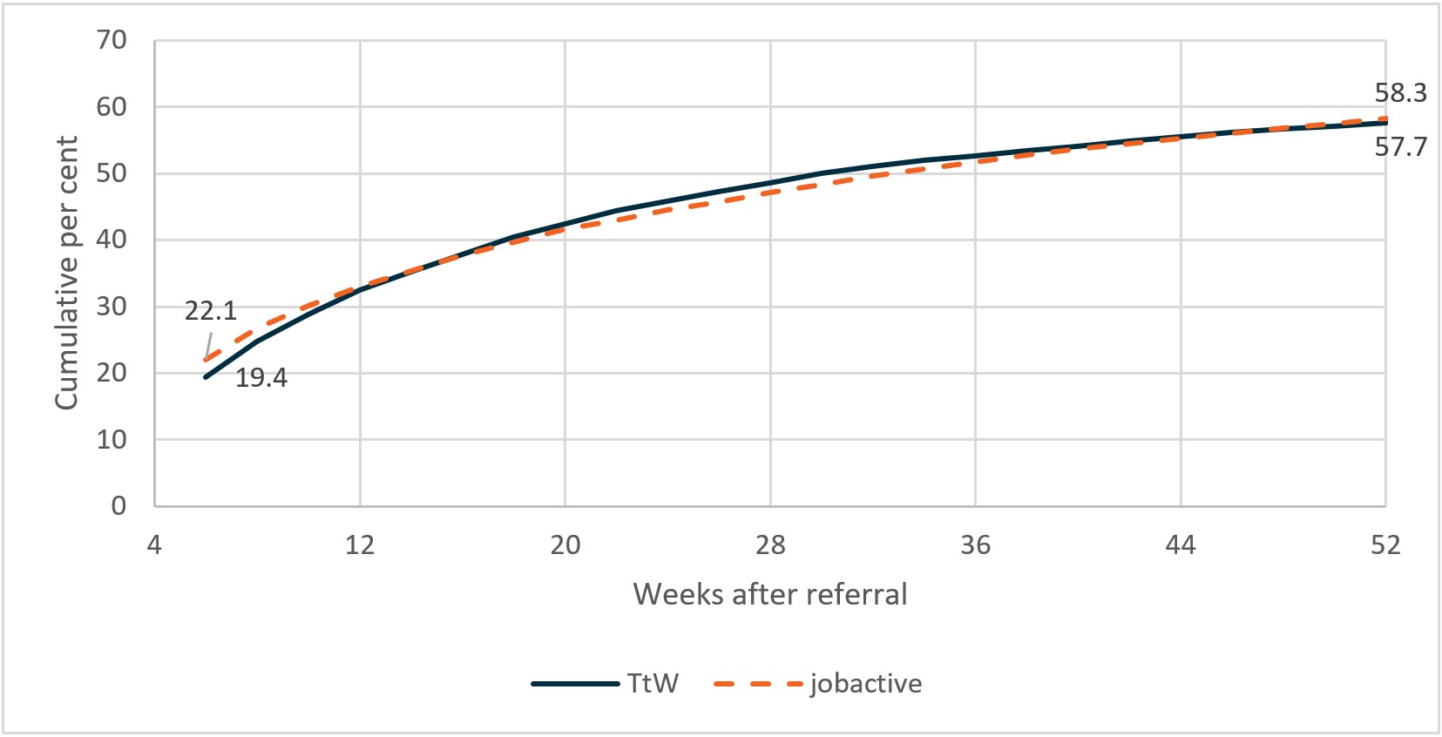

Base: matched samples (TtW: n=12,105, jobactive: n=12,105)

* A participant achieves a ‘positive outcome’ when they achieve either LMA or a study outcome. Positive outcomes achieved within four weeks of referral are excluded, as it is unlikely these outcomes resulted from any TtW or jobactive servicing.

Source: Department of Education, Skills and Employment administrative data

After adjusting for participant characteristics through regression analysis, TtW performed slightly better than jobactive in achieving positive outcomes initially, although this difference becomes insignificant over time. As **Figure 6.3** shows, high proportions of participants in both TtW (**57.7%**) and jobactive (**58.3%**) achieved positive outcomes during the follow-up period. During this period there was a small increased probability (**2 to 3 percentage points**) of TtW achieving a positive outcome (**Table 6.3**).

Table 6.3: Average change1 in probability of positive outcomes2 in TtW compared to jobactive, by period after referral

| Period after referral (number of weeks) | Average change in probability of achieving positive outcome in TtW compared with jobactive (percentage points) |
| --- | --- |
| 4 to 26 | 3.3 |
| 4 to 38 | 2.2 |
| 4 to 52 | Not statistically significant3 |

Base: matched samples (TtW: n=12,105, jobactive: n=12,105)

1. The ‘average change’ is the difference in probability of the average participant achieving positive outcomes in TtW compared to jobactive, adjusted for participant characteristics – that is, the ‘average marginal effect’ of TtW compared to jobactive.

2. A participant achieves a ‘positive outcome’ when they achieve either LMA or a study outcome. Positive outcomes achieved within four weeks of referral are excluded, as it is unlikely these outcomes resulted from any TtW servicing.

3. Effects that are not statistically significant are not reported as they are excluded from the regression model (Appendix H).

Source: Department of Education, Skills and Employment administrative data

Moreover, by 12 months, TtW had no statistically significant effect on achieving positive outcomes compared to jobactive. The finding that TtW and jobactive had a similar impact on positive outcome rates after 52 weeks might seem counterintuitive. As discussed in **Sections 6.2** and **6.3**, compared with jobactive participants, TtW participants had a much higher probability of achieving study outcomes and a similar probability of achieving LMA. Therefore, it might be expected that TtW participants would have a higher positive outcome rate than jobactive participants, since the positive outcome measure combines the LMA and study outcome measures.

The proportions of participants who achieved an LMA outcome or a study outcome, or both outcomes, are further examined. As **Table 6.4** shows, the quantum of LMA outcomes was substantially higher than either that of study outcomes or that of both, thus representing the major contribution to the positive outcome. Secondly, TtW participants were more likely to achieve both LMA and study outcomes compared with jobactive participants. However, participants who achieved both LMA and study outcomes were treated as having achieved only one positive outcome, even though they achieved two types of outcomes over their service periods.

This result indicates that by emphasising both employment and education outcomes in its performance framework, TtW encouraged participants to both work and improve their work readiness through study.

Table 6.4: Percentage of TtW and jobactive participants achieving LMA1 and study outcomes2

| Outcomes achieved (4 to 52 weeks after referral) | TtW (%) | jobactive (%) | Difference (percentage points) |
| --- | --- | --- | --- |
| LMA only | 36.0 | 46.3 | -10.3 |
| Study outcome only | 10.7 | 6.7 | 4.0 |
| Both LMA and study outcome | 11.0 | 5.3 | 5.8 |
| Neither LMA nor study outcome | 42.3 | 41.7 | 0.6 |
| Total | 100.0 | 100.0 | – |

Base: matched samples (TtW: n=12,105, jobactive: n=12,105)

1. A participant achieves LMA when the department’s income support and job placement information indicates they have secured employment. LMA outcomes achieved within four weeks of referral are excluded, as it is unlikely these outcomes resulted from TtW or jobactive servicing.

2. A participant achieves study outcomes when they participate in an education or training activity that could qualify for an outcome payment. Study outcomes achieved within four weeks of referral are excluded, as it is unlikely these outcomes resulted from TtW or jobactive servicing.

Source: Department of Education, Skills and Employment administrative data

The finding that TtW and jobactive participants have similar positive outcome rates differs from the findings in the TtW interim report. The interim report found that TtW was more effective than jobactive in helping participants to achieve both LMA and study outcomes.

One reason the findings differed may be that the TtW participants investigated in the Interim Report included the initial transitioned caseload who were jobactive participants prior to the transfer. As TtW was a new program, the inflow cohort was of limited quantum. The transitioned caseload constituted 32% of TtW inflow population and 28% of the matched sample for the interim evaluation. The analyses in this report included the new TtW inflow population only. TtW participants transferred from jobactive had a longer period of service and might have carried over the ‘work first’ mindset. The inclusion of this cohort of participants in the interim analysis likely explains the higher LMA outcome and consequently the better positive outcome.

It is worth speculating further on the cause of these differences. On the one hand, motivational differences between the two cohorts cannot be ruled out. On the other, and more likely, is the different focus of the two programs. jobactive, with its strong focus on job searches and a structured compliance regime, fosters a ‘work first’ mindset and associated behaviours. TtW by contrast, with a stronger focus on pre-employment assistance and an enabling funding model, encourages participants both to engage with the labour market and, at the same time, to improve their human capital by engaging in study and training.

## 6.4 TtW impacts for participants in different social groups

In this section, the relative effectiveness of TtW compared with jobactive for different demographic cohorts was further explored. The LMA and study outcome rates of the matched cohorts were compared over the study period. Regression analysis was then used to quantify the marginal effect at 52 weeks.

### 6.4.1 Gender

It appears there is no significant gender-related effect of TtW on LMA (**Figure 6.4** and **Table 6.5**).

Figure 6.4: Cumulative percentage of TtW and jobactive participants achieving LMA*, by gender

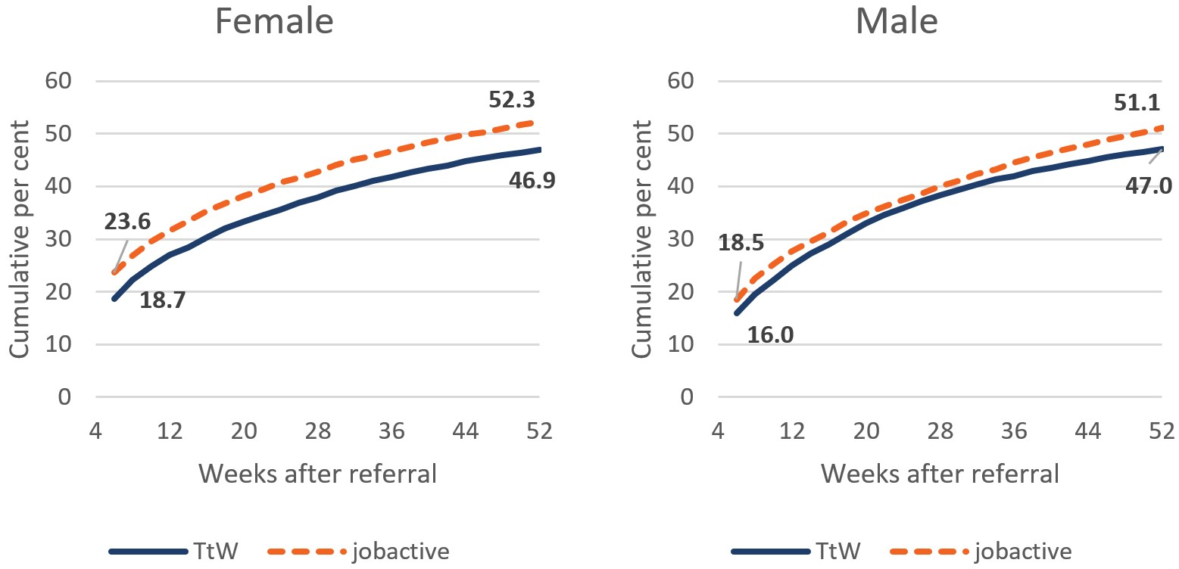

Base: matched samples (female participants: n=11,005, male participants: n=13,204)

* A participant achieves LMA when the department’s income support and job placement information indicates they have secured employment. LMA outcomes achieved within four weeks of referral are excluded, as it is unlikely these outcomes resulted from TtW or jobactive servicing.

Source: Department of Education, Skills and Employment administrative data

However, the differences in study outcome rates between TtW and jobactive were substantially greater among female participants than among male participants (**Figure 6.5**). For female participants, the TtW study outcome rate after 52 weeks was **13.9 percentage points** above the jobactive rate, and for male participants the TtW study outcome rate was **6.6 percentage points** above the jobactive rate.

Figure 6.5: Cumulative percentage of TtW and jobactive participants achieving study outcomes*, by gender

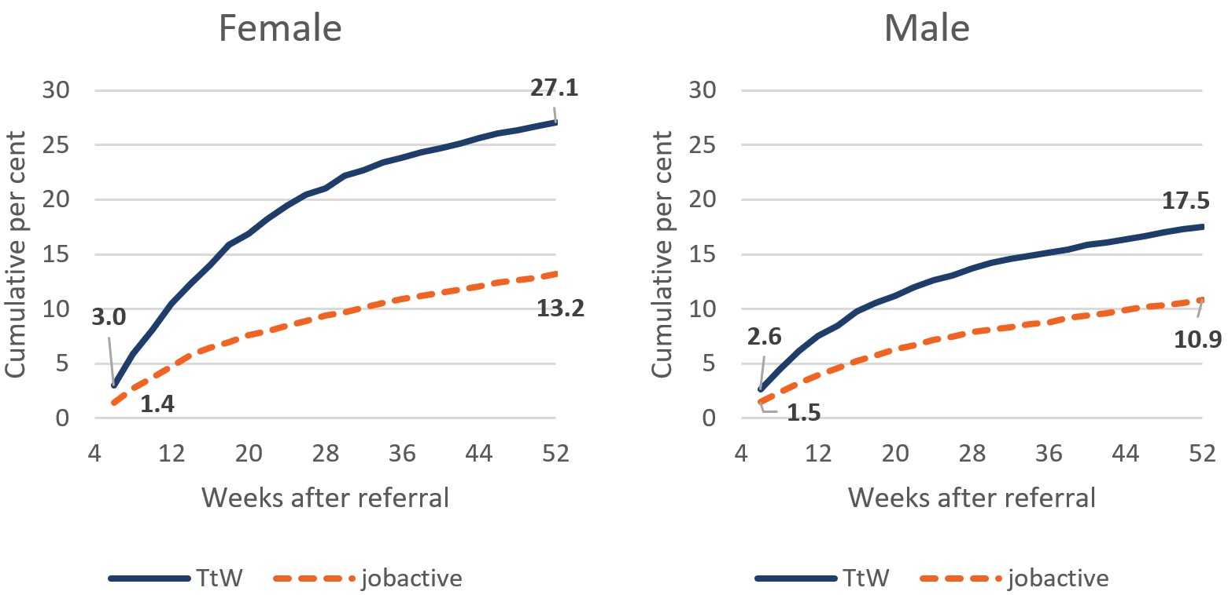

Base: matched samples (female participants: n=11,005, male participants: n=13,204)

* A participant achieves study outcomes when they participate in an education or training activity that could qualify for an outcome payment. Study outcomes achieved within four weeks of referral are excluded, as it is unlikely these outcomes resulted from TtW or jobactive servicing.

Source: Department of Education, Skills and Employment administrative data

After adjusting for participant characteristics, regression analysis supported the finding that TtW was more effective at encouraging participants of both genders to study than jobactive, and that the impact on female participants was much greater than the impact on male participants. As shown in **Table 6.5**, the impact of TtW compared to jobactive on study outcomes was more than 6 percentage points higher for the average female participant than for the average male participant.

Table 6.5: Average change1 in probability of achieving LMA2 and study outcomes3 in TtW compared to jobactive, by gender

| Gender | Average change in probability of achieving LMA 4 to 52 weeks after referral (percentage points) | Average change in probability of achieving study outcomes 4 to 52 weeks after referral (percentage points) |
| --- | --- | --- |
| Female | -2.5 | 13.6 |
| Male | -4.1 | 7.3 |

Base: matched samples (female participants: n=11,005, male participants: n=13,204)

1. The ‘average change’ is the difference in probability of the average participant achieving outcomes in TtW compared to jobactive, adjusted for participant characteristics – that is, the ‘average marginal effect’ of TtW compared to jobactive.

2. A participant achieves LMA when the department’s income support and job placement information indicates they have secured employment. LMA outcomes achieved within four weeks of referral are excluded, as it is unlikely these outcomes resulted from TtW or jobactive servicing.

3. A participant achieves study outcomes when they participate in an education or training activity that could qualify for an outcome payment. Study outcomes achieved within four weeks of referral are excluded, as it is unlikely these outcomes resulted from TtW or jobactive servicing.

Source: Department of Education, Skills and Employment administrative data

The finding that TtW had a greater effect on women’s study outcomes than it had on LMA is consistent with research on young Australians’ transitions from school to work. The NCVER’s *School-to-Work Pathways* report identified the main pathways by which young people transitioned to the labour market after completing their schooling (Ranasinghe et al., 2019). The research found that, after leaving school, women were more likely to engage in a mix of higher education and VET. Female school leavers were also more likely to disengage repeatedly from the labour market, moving into short spells of work and education. This was supported by the regression findings in this research. As **Tables H.5**, **H.6** and **H.7** in **Appendix H** show, female participants were consistently more likely to achieve study outcomes over the analysis period than were male participants. Since young women have a higher propensity to engage in short spells of study, they may require fewer incentives to undertake education and training (Ranasinghe et al, 2019).

### 6.4.2 Indigenous young people

Overall, Indigenous participants achieved fewer LMA outcomes than non-Indigenous participants in both TtW and jobactive. After 52 weeks the TtW LMA rate was lower than the jobactive LMA rate for both Indigenous and non-Indigenous participants (**Figure 6.6**),but this difference was smaller among Indigenous participants (**2.1 percentage points**) than among non-Indigenous participants (**5.4 percentage points**). It should be noted that the difference between the TtW and jobactive LMA rates was also smaller at the start of the analysis period for Indigenous participants (**1.2 percentage points**) compared to non-Indigenous participants (**5.1 percentage points**).

Results from the 2017 TtW JSEES Survey showed that the percentages of TtW participants currently working were **44%** for non-Indigenous participants and **24%** for Indigenous participants. Some providers interviewed for the qualitative research indicated that confidence and social skills were common barriers across Indigenous cohorts. This was linked to cultural norms of communication within Indigenous cultures.

With some of our Indigenous clients that we work with, you know, their way of communicating is – sometimes they’re more quiet in how they come across, which can be perceived as not confident when applying [for jobs]. (Area 8, TtW Provider, Wave 2)

Figure 6.6: Cumulative percentage of TtW and jobactive participants achieving LMA*, by Indigenous status

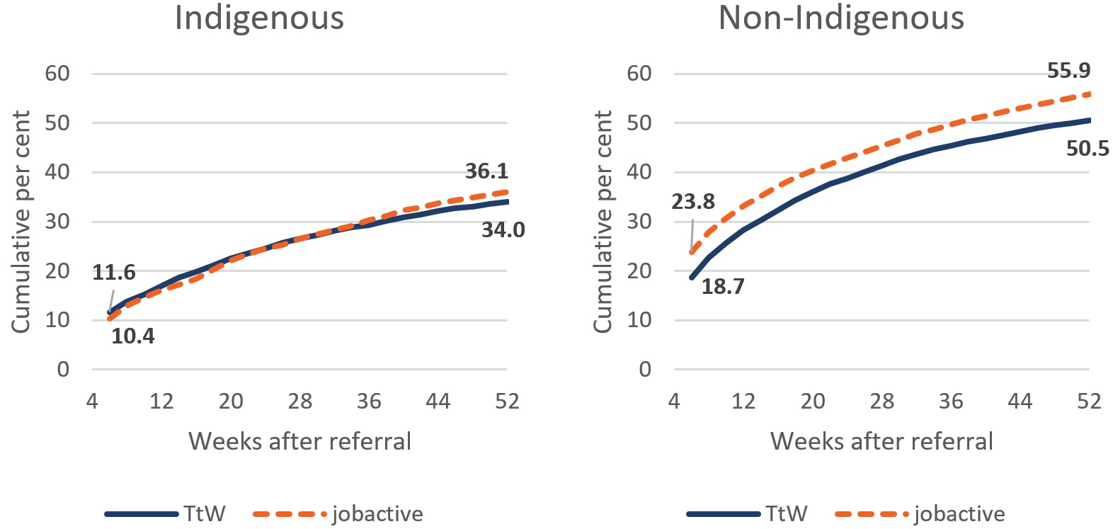

Base: Indigenous participants (n=5,223), non-Indigenous participants (n=18,986); matched samples

* A participant achieves LMA when the department’s income support and job placement information indicates they have secured employment. LMA outcomes achieved within four weeks of referral are excluded, as it is unlikely these outcomes resulted from TtW or jobactive servicing.

Source: Department of Education, Skills and Employment administrative data

**Figure 6.7** shows that, compared to jobactive, TtW servicing had a positive impact on achieving study outcomes for both Indigenous participants and non-Indigenous participants. After 52 weeks, Indigenous TtW participants were **5.6 percentage points** more likely to achieve study outcomes than Indigenous jobactive participants. The impact of TtW was relatively greater among non-Indigenous participants, with the TtW study outcome rate **11 percentage points** higher than the jobactive rate. This difference in impact between Indigenous and non-Indigenous participants reflects differing interactions between each of these groups and the programs.

After 52 weeks, the TtW study outcome rate was higher for non-Indigenous participants (**23%**) than Indigenous participants (**19%**). For jobactive, the opposite was true, with a higher study outcome rate for Indigenous participants (**13%**) compared to non-Indigenous participants (**12%**).

Figure 6.7: Cumulative percentage of TtW and jobactive participants achieving study outcomes*, by Indigenous status

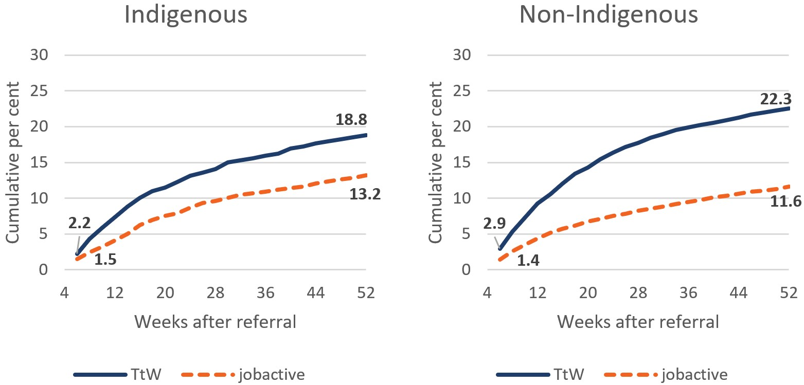

Base: Indigenous participants (n=5,223), non-Indigenous participants (n=18,986); matched samples

* A participant achieves study outcomes when they participate in an education or training activity that could qualify for an outcome payment. Study outcomes achieved within four weeks of referral are excluded, as it is unlikely these outcomes resulted from TtW or jobactive servicing.

Source: Department of Education, Skills and Employment administrative data

After adjusting for participant characteristics through regression analysis, the impact of TtW on achieving LMA remained negative compared to that of jobactive for both Indigenous and non-Indigenous participants (**Table 6.6**). By contrast, TtW had a positive impact on achieving study outcomes, although the impact was greater for non-Indigenous participants (**12 percentage points**) than for Indigenous participants (**6 percentage points**).

Table 6.6: Average change1 in probability of achieving LMA2 and study outcomes3 in TtW compared to jobactive, by Indigenous status

| Indigenous status | Average change in probability of achieving LMA 4 to 52 weeks after referral (percentage points) | Average change in probability of achieving study outcomes 4 to 52 weeks after referral (percentage points) |
| --- | --- | --- |
| Indigenous | -3.9 | 5.6 |
| Non-Indigenous | -3.3 | 11.6 |

Base: Indigenous participants (n=5,223), non-Indigenous participants (n=18,986); matched samples

1. The ‘average change’ is the difference in probability of the average participant achieving outcomes in TtW compared to jobactive, adjusted for participant characteristics – that is, the ‘average marginal effect’ of TtW compared to jobactive.

2. A participant achieves LMA when the department’s income support and job placement information indicates they have secured employment. LMA outcomes achieved within four weeks of referral are excluded, as it is unlikely these outcomes resulted from TtW or jobactive servicing.

3. A participant achieves study outcomes when they participate in an education or training activity that could qualify for an outcome payment. Study outcomes achieved within four weeks of referral are excluded, as it is unlikely these outcomes resulted from TtW or jobactive servicing.

Source: Department of Education, Skills and Employment administrative data

Indigenous participants appear to have benefited less in terms of study outcomes than did non-Indigenous participants (**Tables H.5**, **H.6** and **H.7** in **Appendix H**).

One reason may have been a lack of confidence in their competence to succeed in education and training among some Indigenous participants.

We certainly see that [Indigenous participants] can be less aware of the skills and abilities that they have and their belief to get into something. We felt maybe that’s because they interpret that as a barrier even though most of the time, and through our experience and our time in working with Indigenous clients, that’s not necessarily the case. (Area 11, TtW Provider, Wave 2)

### 6.4.3 English proficiency

The impact of TtW on labour market and study outcomes did not vary significantly based on participants’ levels of English proficiency. As **Figure 6.8**shows, the impacts of TtW up to 52 weeks after referral on achieving LMA were similar for participants with varying levels of English proficiency. Participants in jobactive with good English proficiency achieved slightly better LMA outcomes compared to TtW over the 52 weeks from referral.

Figure 6.8: Cumulative percentage of TtW and jobactive participants achieving LMA*, by English proficiency

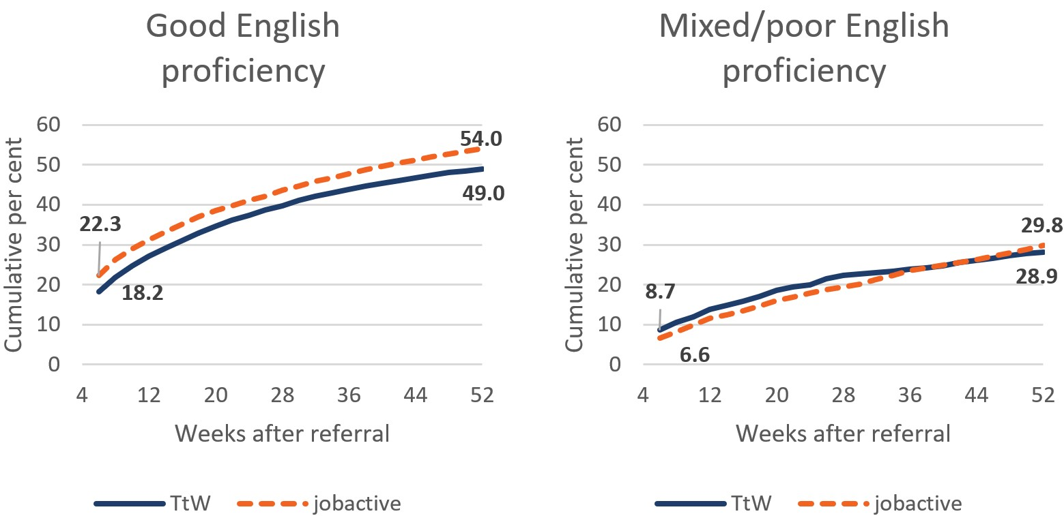

Base: selected participants reporting that they have good English skills (n=21,451) and participants reporting that they have poor or mixed English skills (n=1,966); matched samples

* A participant achieves LMA when the department’s income support and job placement information indicates they have secured employment. LMA outcomes achieved within four weeks of referral are excluded, as it is unlikely these outcomes resulted from TtW or jobactive servicing.

Source: Department of Education, Skills and Employment administrative data

The analysis also examined whether the impact of TtW compared to jobactive varied for participants with limited English skills in terms of achieving study outcomes over 52 weeks from referral. **Figure 6.9** shows that, consistent with broader results, TtW and jobactive individually had similar impacts on participants with varying levels of English proficiency achieving study outcomes. Consistent with broader results comparing TtW and jobactive, TtW participants exceeded jobactive participants in achieving study outcomes, with little variation based on English proficiency.

Figure 6.9: Cumulative percentage of TtW and jobactive participants achieving study outcomes*, by English proficiency

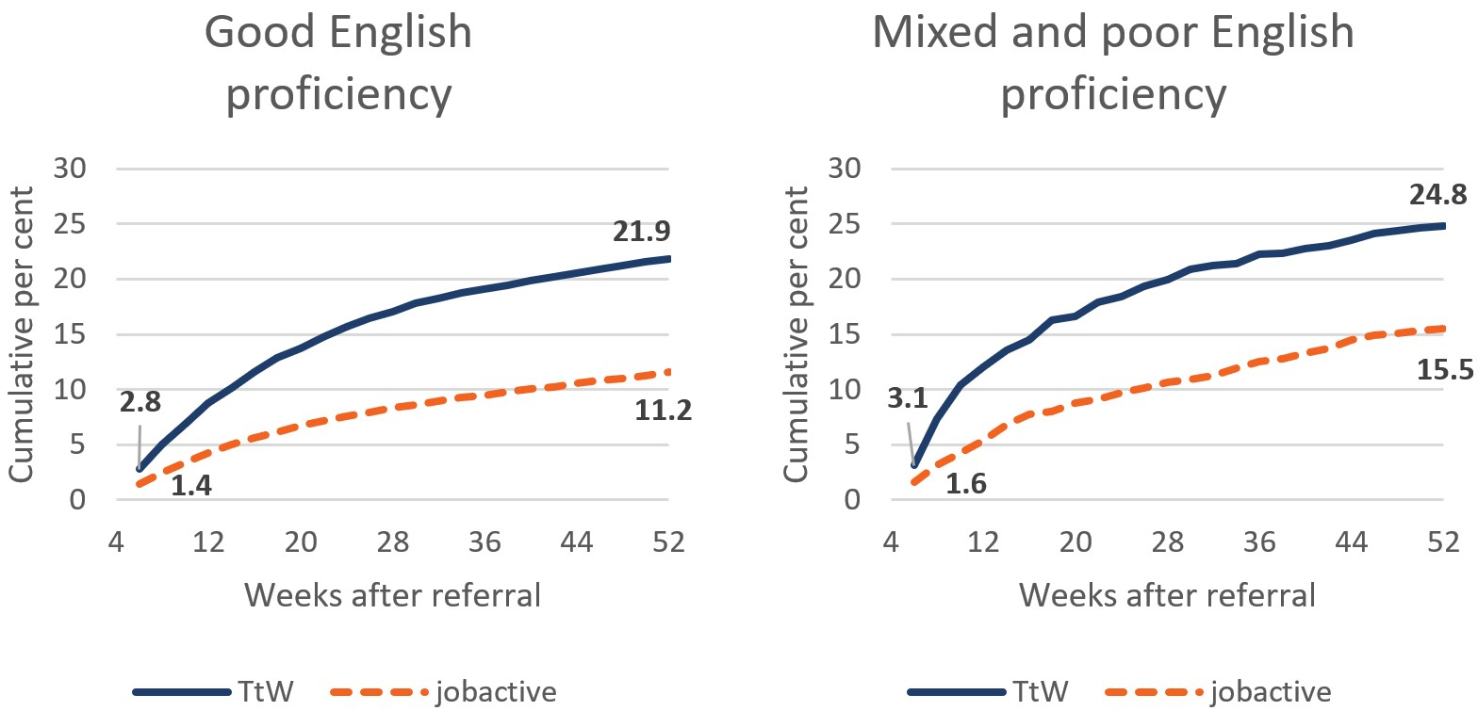

Base: selected participants reporting that they have good English skills (n=21,451) and participants reporting that they have poor or mixed English skills (n=1,966); matched samples

* A participant achieves study outcomes when they participate in an education or training activity that could qualify for an outcome payment. Study outcomes achieved within four weeks of referral are excluded, as it is unlikely these outcomes resulted from TtW or jobactive servicing.

Source: Department of Education, Skills and Employment administrative data

After adjusting for participant characteristics, regression analysis results support the finding that English proficiency was not associated with achieving study outcomes in TtW compared with jobactive (**Table 6.7**).

Table 6.7: Average change1 in probability of achieving LMA2 and study outcomes3 in TtW compared to jobactive, by English proficiency

| English proficiency | Average change in probability of achieving LMA (percentage points) | Average change in probability of achieving study outcomes (percentage points) |
| --- | --- | --- |
| Good | -3.5 | 10.2 |
| Poor or mixed | Not statistically significant4 | 10.0 |

Base: selected participants reporting that they have good English skills (n=21,451) and participants reporting that they have poor or mixed English skills (n=1,966); matched samples

1. The ‘average change’ is the difference in probability of the average participant achieving outcomes in TtW compared to jobactive, adjusted for participant characteristics – that is, the ‘average marginal effect’ of TtW compared to jobactive.

2. A participant achieves LMA when the department’s income support and job placement information indicates they have secured employment. LMA outcomes achieved within four weeks of referral are excluded, as it is unlikely these outcomes resulted from TtW or jobactive servicing.

3. A participant achieves study outcomes when they participate in an education or training activity that could qualify for an outcome payment. Study outcomes achieved within four weeks of referral are excluded, as it is unlikely these outcomes resulted from TtW or jobactive servicing.

4. Statistically insignificant effects are not reported as they are excluded from the statistical model these findings are based on (see Appendix H for further discussion).

Source: Department of Education, Skills and Employment administrative data

### 6.4.4 Residential location

Regional disadvantage is a complex result of regional labour market conditions, job seeker characteristics, provider performance, and other factors. Analysis was undertaken using the participant’s residential address to identify their location in terms of remoteness. The analysis categorised participants using the Australian Bureau of Statistics adaptation of the Accessibility/Remoteness Index of Australia (ARIA+). Overall, the difference in LMA rates between TtW and jobactive over four to 52 weeks from referral were small and did not vary greatly for participants living in major cities, inner regional and remote areas. As **Figure 6.10** shows, TtW participants achieved slightly lower LMA rates after 52 weeks no matter where they lived, except in outer regions, where TtW participants achieved similar LMA rates to jobactive.

Figure 6.10: Cumulative percentage of TtW and jobactive participants achieving LMA*, by residential location

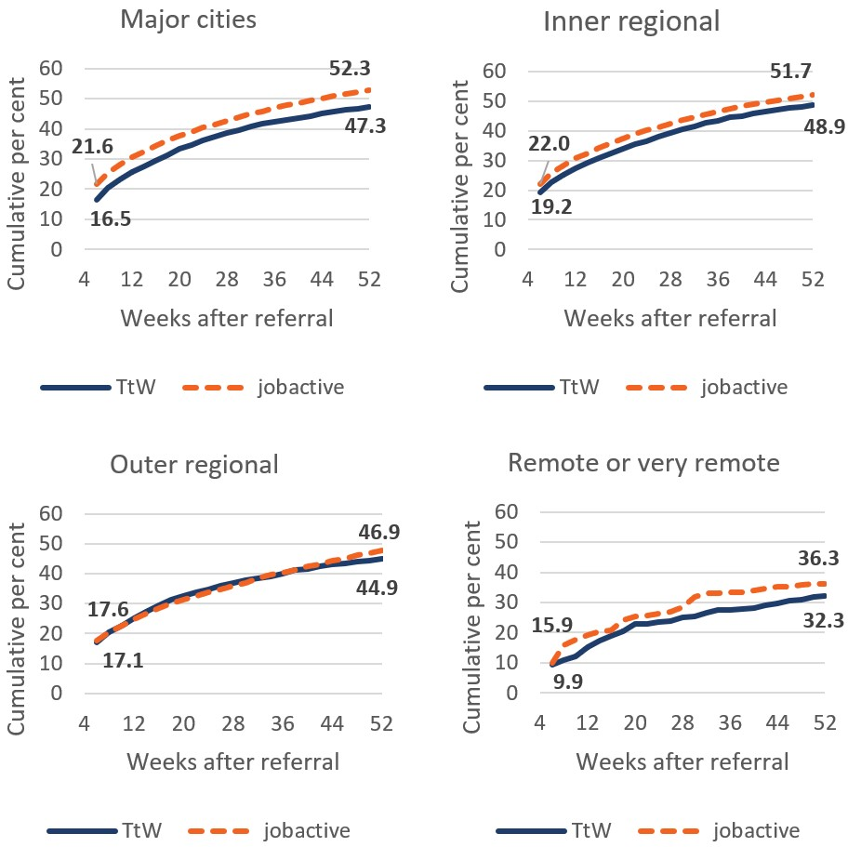

Base: participants in major cities (n=13,168), inner regional Australia (n=6,826), outer regional Australia (n=3,703) and remote or very remote Australia (n=430); matched samples

* A participant achieves LMA when the department’s income support and job placement information indicates they have secured employment. LMA outcomes achieved within four weeks of referral are excluded, as it is unlikely these outcomes resulted from TtW or jobactive servicing.

Source: Department of Education, Skills and Employment administrative data

However, the regression analysis indicated that jobactive participants achieve better LMA outcomes except in remote or very remote regions (**Table 6.8**).

Table 6.8: Average change1 in probability of achieving LMA2 and study outcomes3 in TtW compared to jobactive, by residential location4

| Residential location | Average change in probability of achieving LMA (percentage points) | Average change in probability of achieving study outcomes (percentage points) |
| --- | --- | --- |
| Major cities | -3.9 | 12.2 |
| Inner regional | -2.4 | 9.7 |
| Outer regional | -5.1 | 4.6 |
| Remote or very remote | Not statistically significant5 | Not statistically significant5 |

Base: participants in major cities (n=13,168), inner regional Australia (n=6,826), outer regional Australia (n=3,703) and remote or very remote Australia (n=430); matched samples

1. The ‘average change’ is the difference in probability of the average participant achieving LMA or study outcomes in TtW compared to jobactive, adjusted for participant characteristics – that is, the ‘average marginal effect’ of TtW compared to jobactive.

2. A participant achieves LMA when the department’s income support and job placement information indicates they have secured employment. LMA outcomes achieved within four weeks of referral are excluded, as it is unlikely these outcomes resulted from TtW or jobactive servicing.

3. A participant achieves study outcomes when they participate in an education or training activity that could qualify for an outcome payment. Study outcomes achieved within four weeks of referral are excluded, as it is unlikely these outcomes resulted from TtW or jobactive servicing.

4. The residential location measure uses the same categories as the ABS Accessibility/Remoteness Index of Australia.

5. Effects which are not statistically significant are not reported as they are excluded from the statistical model used in this analysis (see Appendix H).

Source: Department of Education, Skills and Employment administrative data

The relationship between locations and study outcome rates was somewhat similar for participants living in major cities and inner regional areas of Australia. **Figure 6.11** shows that matched TtW participants in major cities and inner regional locations had higher study outcome rates than their jobactive counterparts.

Figure 6.11: Cumulative percentage of TtW and jobactive participants achieving study outcomes*, by residential location

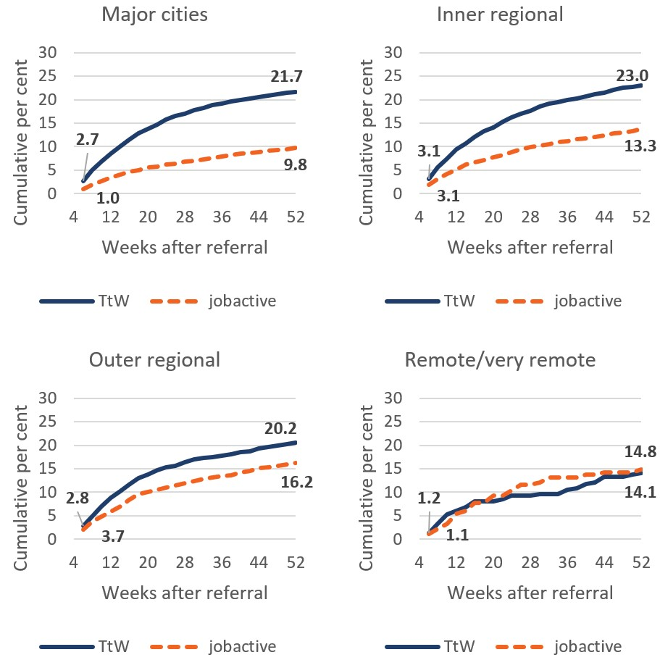

Base: participants in major cities (n=13,168), inner regional Australia (n=6,826), outer regional Australia (n=3,703) and remote or very remote Australia (n=430); matched samples

* A participant achieves study outcomes when they participate in an education or training activity that could qualify for an outcome payment. Study outcomes achieved within four weeks of referral are excluded, as it is unlikely these outcomes resulted from TtW or jobactive servicing.

Source: Department of Education, Skills and Employment administrative data

TtW participants had slightly higher study outcome rates than their jobactive counterparts in outer regions, while the participants in these two programs in remote areas had similar study outcome rates. Results of the regression analysis confirmed the pattern of these findings (**Table 6.8**). It appears that remoteness affects TtW study outcomes more than it affects jobactive study outcomes.

## 6.5 Long-term income support status and sustainability

In previous sections, TtW participants were followed for 12 months to track their employment and study related outcomes. As the TtW service is capped at 12 months, it was of interest to examine longer term outcomes of TtW participants after they completed TtW.

### 6.5.1 TtW participants exit income support later than jobactive participants

TtW participants’ income support status provides an insight into their labour market and study status. Participants in the TtW and jobactive matched samples were followed for two years from commencement to identify changes in their income support status. These findings are preliminary, as a more comprehensive assessment of destination from income support exits would require an extended observation period.

The analyses of income support exits differ from the other impact analyses in that they track participants after they commence in services, rather than after referral. This approach recognises that some participants received their first income support payments a significant amount of time after referral to services. For example, 15% of participants in the matched samples did not receive an income support payment within six weeks of referral. Tracking participants from commencement in services means that more participants had time to commence income support by the time tracking began. Matched sample participants were included in this analysis if they had received income support by their third fortnight from commencement in services. For the purpose of this analysis, an income support exit occurred when a participant’s income support rate became zero at the end of one fortnight.

A higher proportion of jobactive participants (**73%**) exited income support during the two years from commencement than TtW participants (**68%**), and this was largely due to a higher proportion of jobactive participants exiting early. For participants who exited income support during the two years from commencement, **Figures 6.12** and **6.13** show the distribution of exits across the first and second years respectively. Participants in both TtW and jobactive were more likely to first exit income support in the first year following their commencement than in the second year. However, a higher proportion of jobactive first-time exits from income support occurred in the first year after commencement (**73%**) compared to TtW (**67%**). Accordingly, TtW participants tended to first-time exit income support later than jobactive participants. Around a third (**34%**) of TtW first-time exits occurred during the second year after commencement, compared to **25%** of jobactive first-time exits.

Figure 6.12: Cumulative percentage of TtW and jobactive participants exiting income support for the first time, in the year after commencement

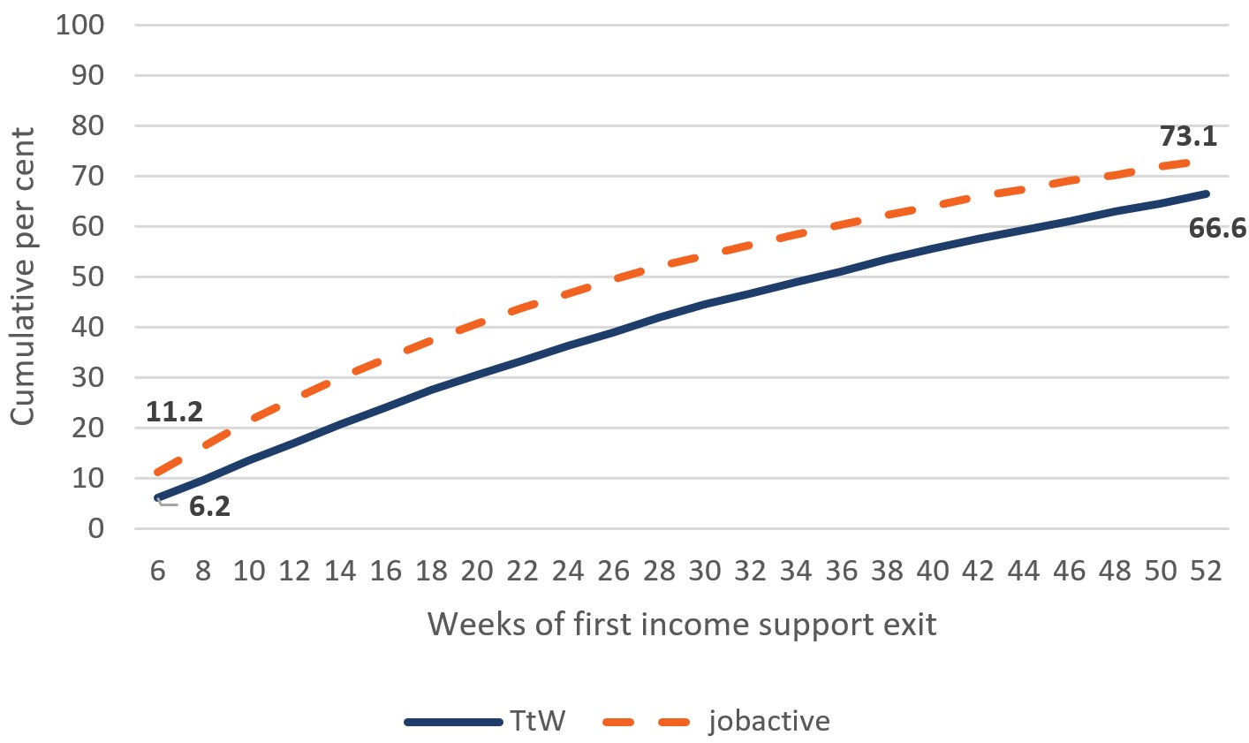

Base: participants who exited income support during the first year after commencement (TtW: n=4,305, jobactive: n=5,848), of participants in the matched samples who were on income support by six weeks from commencement in services and first exited income support within the following two years (TtW: n=6,466, jobactive: n=7,993)

Figure 6.13: Cumulative percentage of TtW and jobactive participants exiting income support for the first time, in the second year after commencement

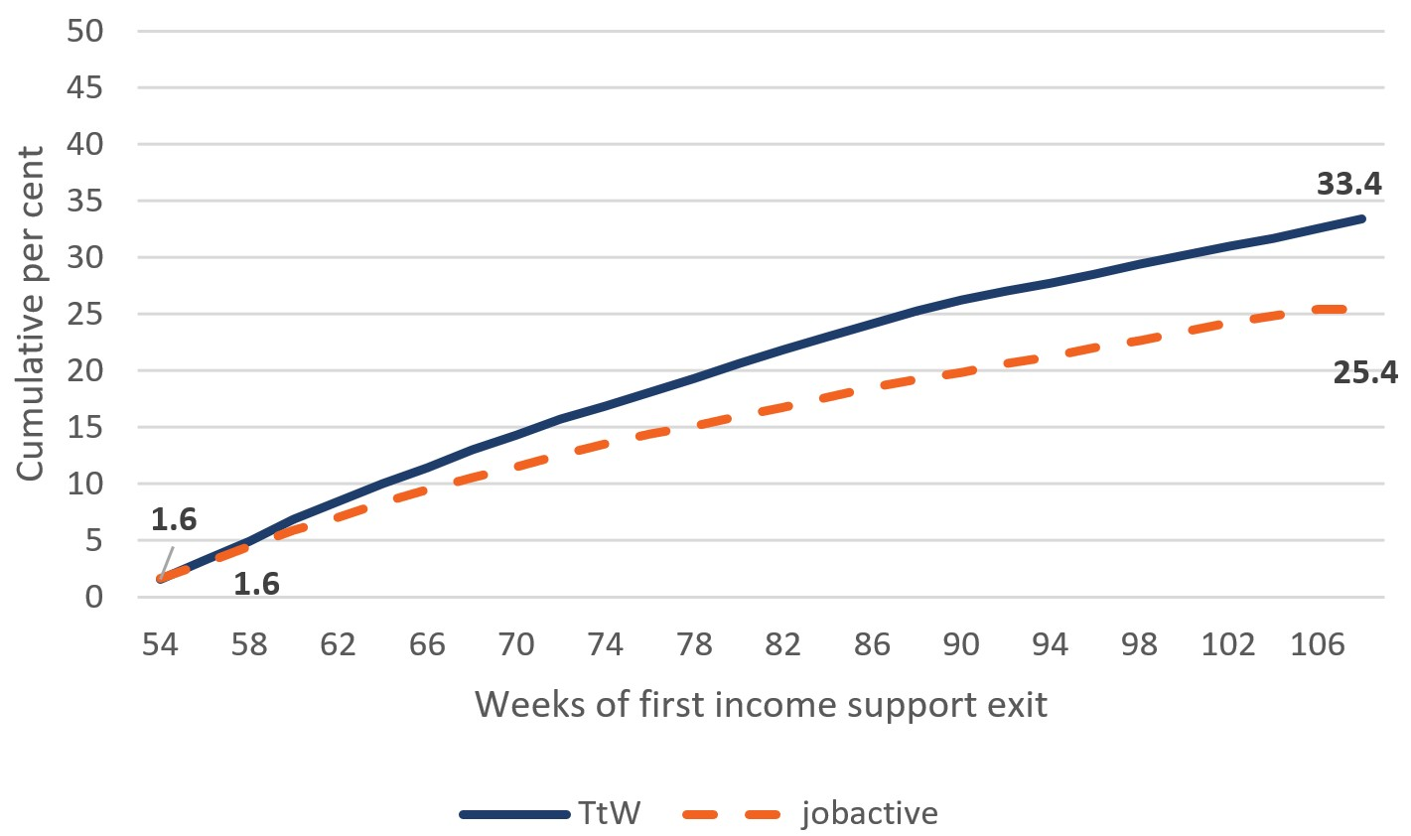

Base: participants who exited income support during the second year after commencement (TtW: n=2,161, jobactive: n=2,145), of participants in the matched samples who were on income support by six weeks from commencement in services and first exited income support within the following two years (TtW: n=6,466, jobactive: n=7,993)

Source: Department of Education, Skills and Employment administrative data

Differences in the timing of participants’ first exit from income support further reflect the different focus and services provided by TtW and jobactive. For example, as noted earlier in this report, the intensive activity focus of TtW may create an attachment effect for the participants in their first year, as they become ‘locked in’ to education and training activities to improve their skills and work readiness. This delayed effect of TtW likely reflects its dual focus on both LMA and increasing human capital.

### 6.5.2 Sustainability of income support exits

To provide an indication of the sustainability of income support exits for TtW participants, this analysis compared the probability of TtW and jobactive participants remaining off income support following the first income support exit during the two-year observation period. A Cox proportional hazards model was used, which estimates the probability of an event occurring at points in time. In this case, the event of interest is a return to income support, and the results are presented in terms of the probability that a participant continues to remain off income support beyond each time point. The time points correspond to the number of weeks spent off income support.

Two separate models analysed participants who first exited income support in the first year following commencement, and participants who first exited income support in the second year. The regression models included control variables to increase the robustness of comparison between the TtW and jobactive matched samples (see **Appendix H**).

**Figure 6.14** shows that TtW participants first exiting income support in the first year after commencement have a decreased probability of remaining off income support compared to jobactive participants. Accordingly, the hazard ratio, which compares the probability of remaining off income support between TtW and jobactive over time, was **0.91** and significant, meaning that TtW participants had a higher likelihood of returning to income support after exiting income support in the first year.

Figure 6.14: Estimated probability of remaining off income support after first income support exit occurs in the first year from commencement

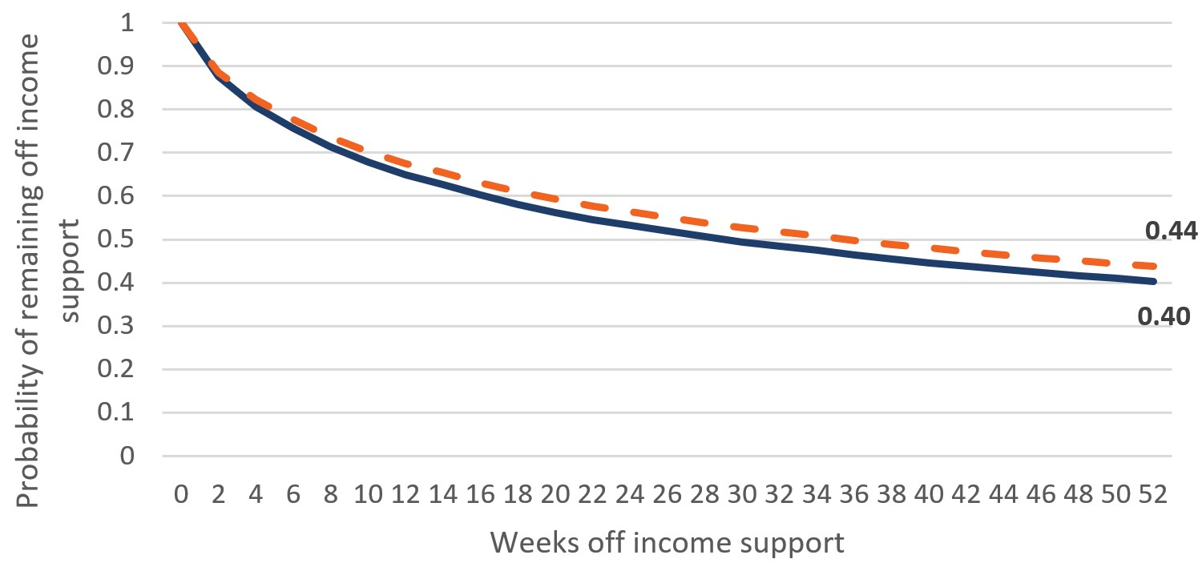

Base: participants in TtW (n=4,305) and jobactive (n=5,848) who were on income support within six weeks of commencement and first exited income support within a year of commencement; matched samples

* This chart presents the estimated probabilities of participants remaining off payment given how long they have been off payment to date and their characteristics. Some participants would not have returned to income support by the end of the follow-up period. Given that it is unknown how long these participants would ultimately remain off income support, it was necessary to use an estimation model, taking into account personal characteristics.

Source: Department of Education, Skills and Employment administrative data

For participants first exiting income support in the second year after commencement, the probability of remaining off income support was slightly higher in TtW than in jobactive but the difference was not statistically significant (**Figure 6.15**). In this case, the hazard ratio was **1.04**.

Figure 6.15: Estimated probability of remaining off income support after first income support exit occurs in the second year from commencement

Base: participants in TtW (n=2,161) and jobactive (n=2,145) who were on income support within six weeks of commencement and first exited income support 12 to 24 months after commencement; matched samples

* This chart presents the estimated probabilities of participants remaining off payment given how long they have been off payment to date and their characteristics. Some participants would not have returned to income support by the end of the follow-up period. Given that it is unknown how long these participants would ultimately remain off income support, it was necessary to use an estimation model, taking into account personal characteristics.

Source: Department of Education, Skills and Employment administrative data

### 6.5.3 Income support return destinations

Of the participants who exited income support in the two years following commencement, a slightly higher proportion of TtW participants (**62%**) returned to income support during the two years than jobactive participants (**61%**). Of the returning participants, **Figure 6.16** shows that TtW participants were more likely to return to Youth Allowance (Other) or Newstart Allowance (**91%**) compared to jobactive participants (**87%**). A higher proportion of jobactive participants returned to Youth Allowance (Student) or Youth Allowance (Australian Apprenticeship) (**10%**) than TtW participants (**6%**).

Figure 6.16: Type of income support of participants who returned to income support

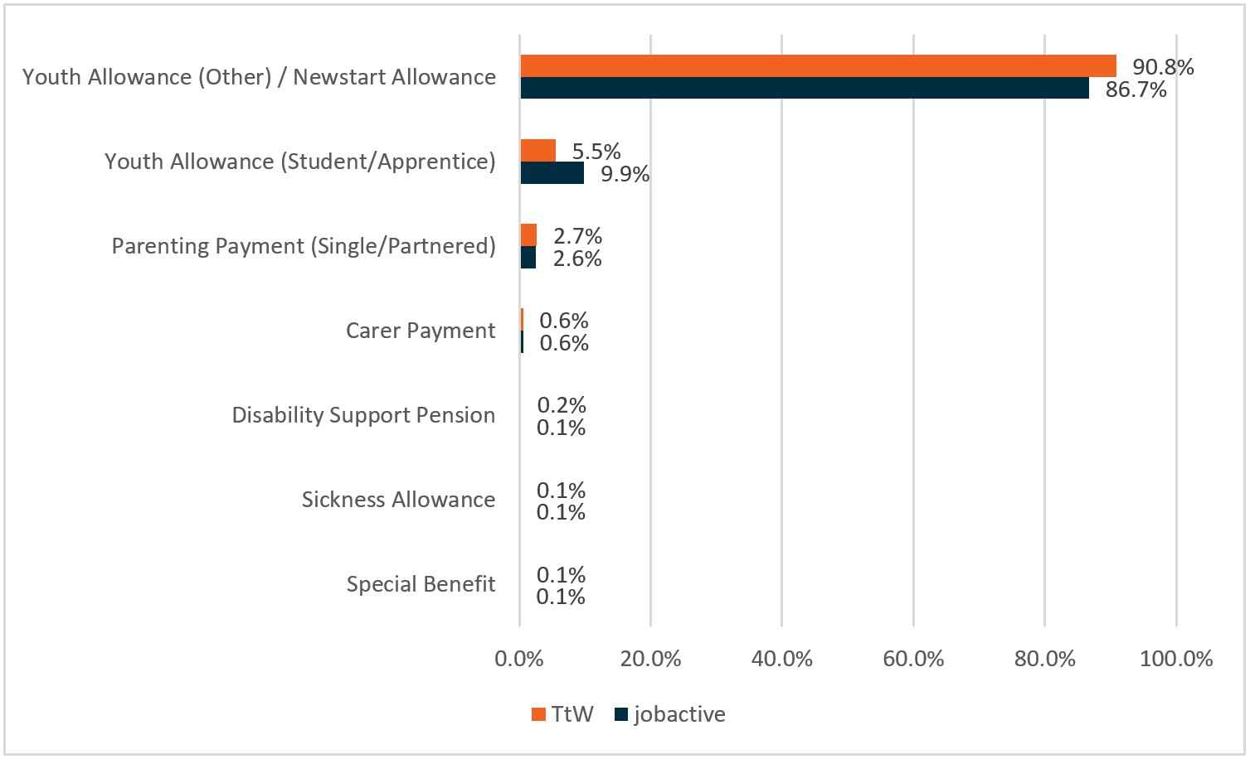

Base: participants in TtW (n=4,027) and jobactive (n=4,885) who were on income support within six weeks of commencement, first exited income support in the two years following commencement, and returned within the two years following commencement; matched samples

Source: Department of Education, Skills and Employment administrative data

This analysis also indicated that more TtW participants returned to activity-tested income support than did jobactive participants. It is possible that jobactive more strongly motivates participants to exit employment services, as suggested by the results in **Section 6.5.1**, which indicated that more jobactive participants exited income support in their first year after commencement than did TtW participants.

### 6.5.4 Did TtW impact convictions?

Providers interviewed for the qualitative research indicated that the flexibility of the service gave them the opportunity to offer participants appointments that were not office-based but could be held in public locations such as a park, café or shopping centre. This was highlighted as being particularly important for young people who had anxiety or were ex-offenders and needed to be eased into the service.

For us it’s probably the ex-criminals, the ones with criminal history. They’ve been the hardest for us to work with, and engage as well, because a lot of ours have been through juvenile justice and have completely come out disengaged with severe mental health issues. So, they’re the ones that have probably been the hardest for us to work with … Yes, a lot of that is you have to see them offsite, so not in the office. They don’t like coming into the office. And it’s all about just linking them with places like Headspace or mental health services and things like that, as well, and taking it slowly, especially if they’ve just freshly come out of juvenile justice where they’ve been, taking it slowly and trying to reintegrate them into the community. (Area 14, TtW provider, Wave 2)

Analysis of income support data (prison exit related crisis payments) within a year of the income support exit date shows that TtW was more effective than jobactive at helping participants avoid contact with the justice system.

**Figure 6.17** shows the proportion of matched TtW and jobactive participants who left prison and claimed a prison exit crisis payment[48] up to two years after referral to employment services. In the matched samples, **3.0%** of TtW participants left prison and claimed crisis payments up to two years after referral, compared with **4.4%** of jobactive participants, suggesting TtW participants were less likely to go to prison, other things being equal, than were jobactive participants.

Figure 6.17: Cumulative percentage of matched TtW and jobactive participants leaving prison and claiming crisis payments, by number of weeks between referral and first prison exit

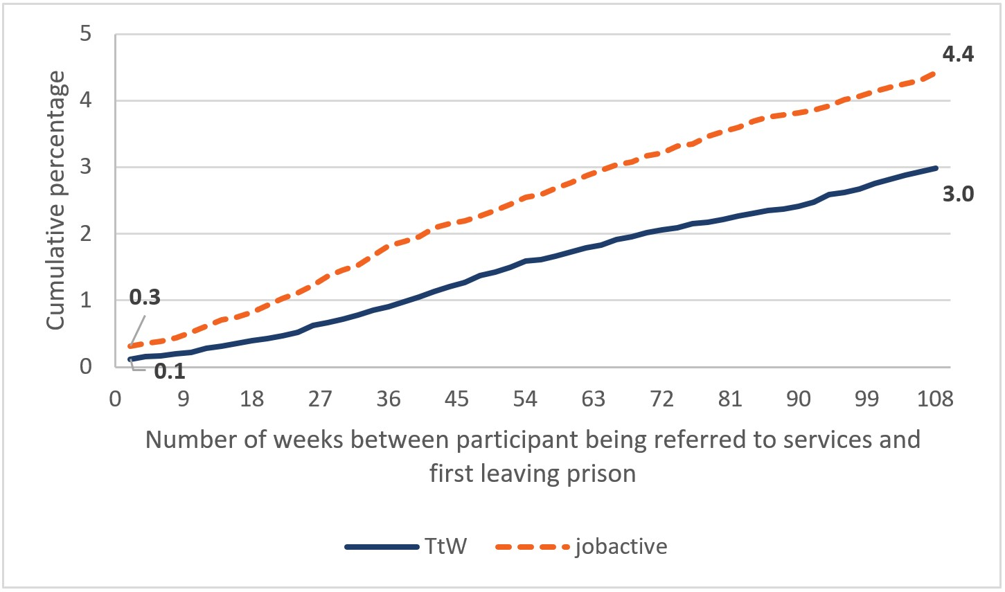

Base: matched samples (TtW: n=12,105, jobactive: n=12,105)

Source: Department of Education, Skills and Employment administrative data

It also appeared that TtW participants were less likely to go to prison multiple times than were jobactive participants.

Figure 6.18: Number of times matched TtW and jobactive participants left prison and claimed crisis payments up to two years after referral

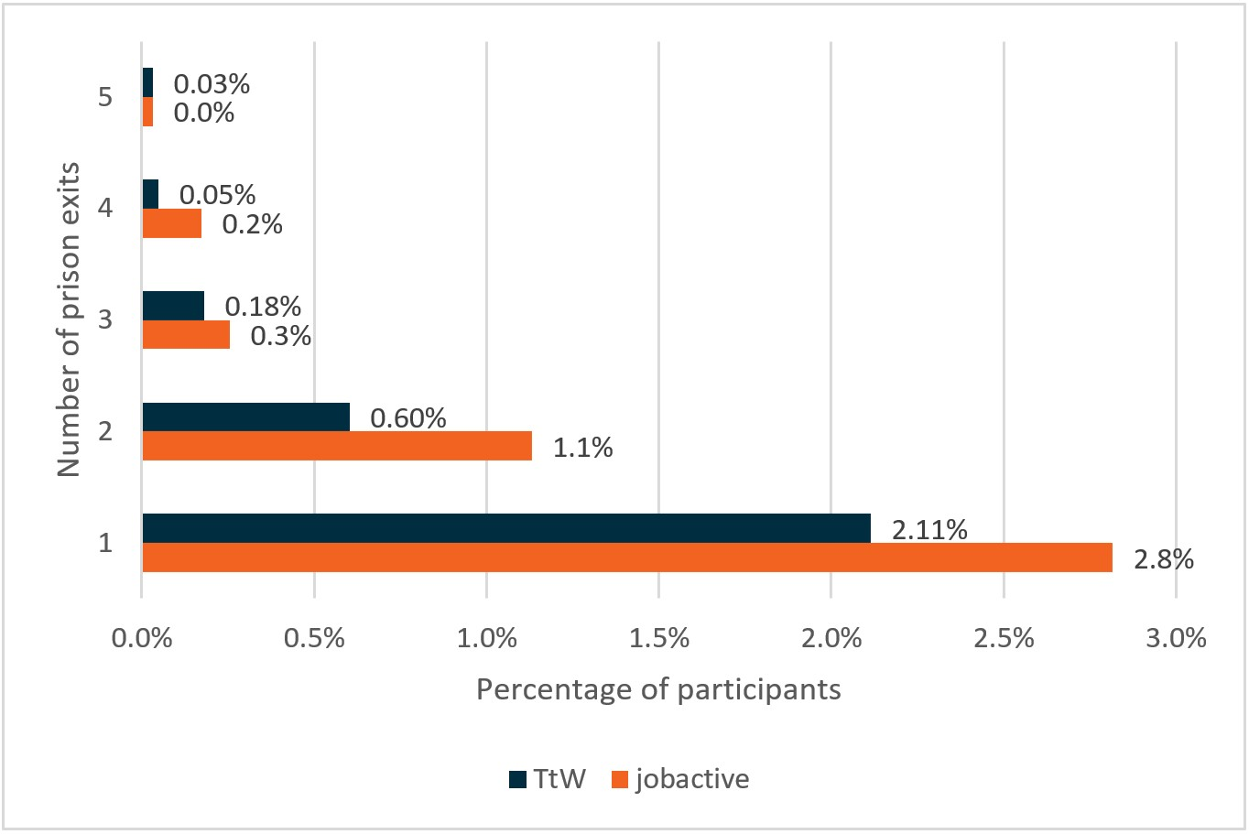

**Base: matched samples (TtW: n=12,105, jobactive: n=12,105)**

Source: Department of Education, Skills and Employment administrative data

As **Figure 6.18** shows, some participants in the matched samples left prison and claimed crisis payments[49] more than once over the two-year follow-up period. Participants in the matched samples were more likely to go to prison two or more times if they were in jobactive (**1.6%**) than if they were in TtW (**0.9%**).

An alternative explanation for these findings is that TtW and jobactive participants are equally likely to go to prison and that jobactive participants are imprisoned for shorter periods of time than are TtW participants.

The policy differences between TtW and jobactive cast doubt on this explanation. The main difference between TtW and jobactive is that TtW is a more activity-intensive, tailored service with lighter compliance measures. If TtW reduces crime rates among participants, it probably achieves this by reducing the amount of strain that participants are put under, increasing the amount of time that participants spend in structured activities and providing personalised support to participants at risk of imprisonment. Young people who have lower levels of stress and have less unstructured leisure time are less likely to commit crimes in the first instance, since they are not psychologically predisposed to do so (Caldwell and Smith, 2006). As TtW case managers are focused on supporting their clients in a structured environment, the reason TtW participants had lower prison exit rates than jobactive participants was probably because they were less likely to go to prison in the first place.

## 6.6 Conclusion

The analyses of participant LMA and study outcomes reaffirm that TtW has a stronger effect than jobactive in building human capital and capabilities. It achieved almost double the number of study outcomes for its participants than did jobactive over 12 months and was more effective than jobactive at encouraging female participants to study. Although jobactive has the slight edge over TtW on LMA outcome, this is largely due to LMA achieved at an early stage of program participation (at four weeks post-referral or earlier). This is unlikely due to a jobactive program effect but more a ‘deterrence effect’ of the strong compliance framework.

When examining longer program effect over a 24-month period using income support status as a proxy, it was found that TtW participants were less likely to exit income support than were jobactive participants over the first 12 months after commencement. However, TtW had a higher proportion of participants exiting income support during the second year than jobactive. The sustainability of the off income support outcome was also better during the second year for TtW. This delayed effect of TtW confirms that due to the intensity of the program TtW had a larger lock-in effect.

In addition to increasing participants’ education and employment potential, TtW had an unintended, but perhaps unsurprising, social impact. The research found that TtW participants were less likely to go to or return to prison.

# Chapter 7 Cost and time efficiency associated with delivering TtW

## 7.1 Introduction

In Chapter 3, it was noted that participants commenced in TtW sooner after referral than did participants who commenced in jobactive, suggesting that TtW was more efficient than jobactive in ensuring that participants commenced in services in a timely fashion (**Section 3.4.1**).

In this chapter, a further examination of the efficiency of the delivery of TtW and the degree to which TtW provides time-effective service and cost-effective education and employment outcomes is undertaken.

Measures used to assess this include time between commencements and the achievement of outcomes, time between the exit of TtW participants from TtW and their commencement in jobactive, cost per outcome, and participants’ progress over 12 months. The efficiency of TtW is reviewed, measured against the established program performance targets where possible.

## 7.2 Time between commencements and the achievement of outcomes

Of participants who had a recorded outcome, over a third (**36%**) achieved their first education and employment outcomes in the first six months after commencement (**Table 7.1**). Some participants were in servicing for a substantial amount of time before they achieved an outcome, with **16%** of participants taking more than a year to achieve their first study and employment outcomes.

Table 7.1: Time taken for TtW participants to achieve their first outcome

| Time taken to achieve first outcome from commencement | Number of participants | Per cent |
| --- | --- | --- |
| Less than 6 months | 2,821 | 36.2 |
| 6 to 12 months | 3,749 | 48.2 |
| More than 12 months* | 1,216 | 15.6 |
| Total | 7,786 | 100.00 |

Base: TtW inflow population (TtW participants who achieved an outcome: n=7,786)

Note: For the purposes of this analysis, outcomes may include both education and employment outcomes and wage subsidy payments. A participant’s first outcome could be a wage subsidy payment or an employment/education/hybrid outcome. The evaluation calculates the amount of time it took for each TtW participant to have their first outcome approved using calendar days, not periods of service (i.e. the calculations include suspensions and allowable breaks).

* Outcomes can be achieved after 12 calendar months from commencement if TtW participants have had their TtW service periods paused due to servicing suspensions and allowable breaks or if the activity is underway when TtW participants reach the 12-month TtW time limit.

Source: Department of Education, Skills and Employment administrative data

Of participants who had a recorded outcome, a majority (**64%**) achieved their first outcomes six months or more after commencing in TtW.

**Figure 7.1** shows the timing and proportion of outcomes achieved over the observation period. Participants were likely to achieve a first outcome of 12-week employment or an educational attainment in the early part of their time in TtW. Achievement of hybrid outcomes remained steadily low.[50]

Figure 7.1: Time taken for TtW participants who achieved outcomes to have their first outcomes approved, by type of first outcome

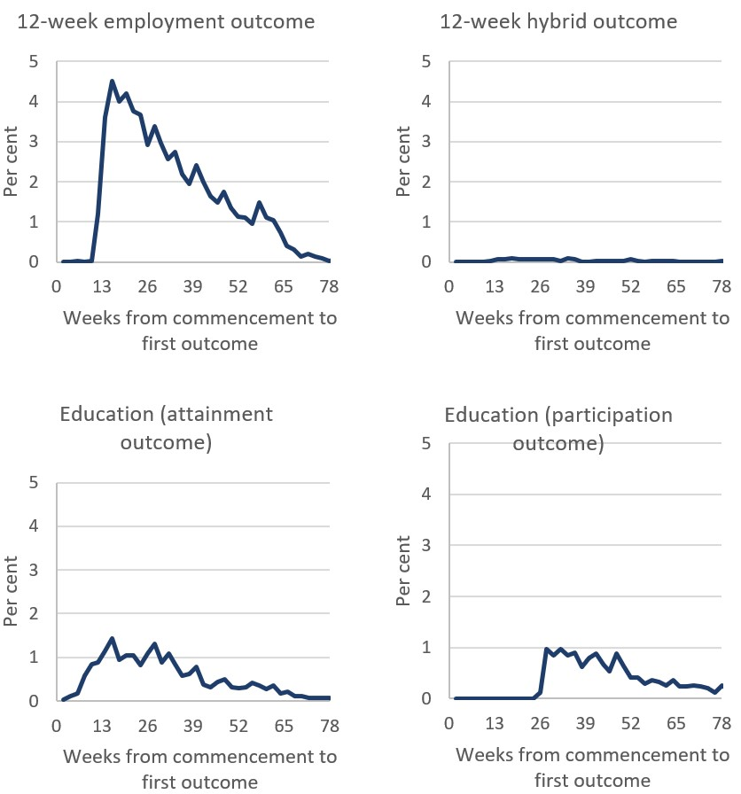

Base: participants who achieved an outcome (after commencement in service) (n=7,786); TtW inflow population

Note: For the purposes of this analysis, outcomes may include both education and employment outcomes and wage subsidy payments. A participant’s first outcome could be a wage subsidy payment or an employment/education/hybrid outcome. The evaluation calculates the amount of time it took for each TtW participant to have their first outcome approved using calendar days, not service periods. This means the calculations do not exclude servicing suspensions and allowable breaks. For reasons of presentation, the charts do not display outcome rates for participants who had their first outcomes more than 18 months after commencement. These participants constitute only 1.3% of the total study population.

Source: Department of Education, Skills and Employment administrative data

## 7.3 Exits from TtW

More than half of the TtW participants in the inflow population (**58%**) ultimately exited to jobactive (**Figure 7.2**). Once participants reached 12 months in the TtW service, they were referred to jobactive unless they were tracking towards outcomes.

Most of the TtW participants who exited to jobactive commenced in that program shortly after leaving TtW. Of the TtW participants who commenced in jobactive at a later stage, **78%** commenced within 91 days of exiting TtW or receiving their jobactive referral.

Figure 7.2: TtW inflow population (including referrals) by status in TtW (as at 11 October 2018)

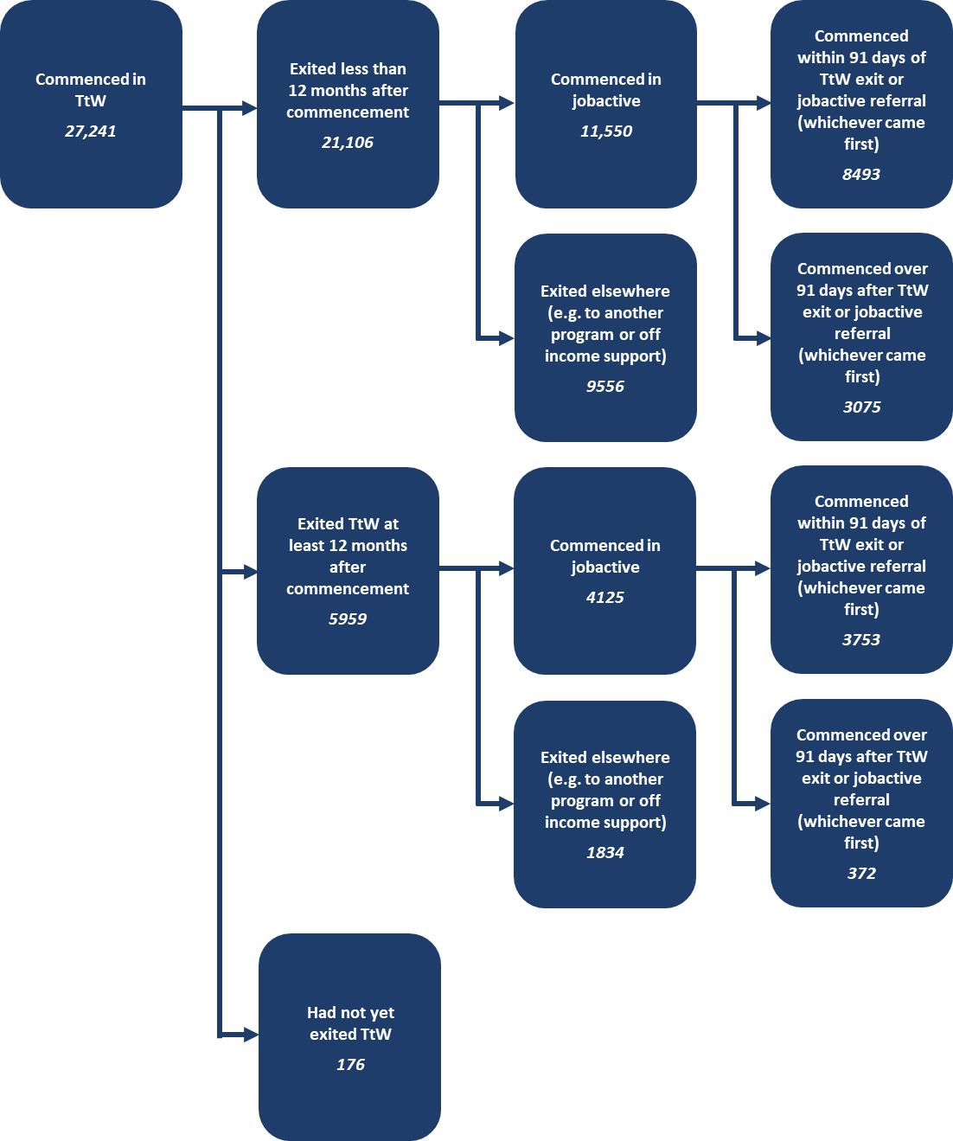

Base: TtW inflow population (n=27,241)

Source: Department of Education, Skills and Employment administrative data

A significant proportion of TtW participants (**42%**) in the inflow population who exited TtW services did not commence in jobactive at all. These participants may have moved to another employment program or had a change of circumstances, such as a change in their income support type or exiting income support, removing the requirement to participate in employment services.

## 7.4 Monitoring Outcome Performance Targets

As noted in Chapter 5, Outcome Performance Targets are the benchmark for measuring provider performance and efficiency. The provider receives a bonus outcome payment for every outcome achieved above the quarterly target. Departmental administrative data at 30 June 2019 showed that overall TtW exceeded Outcome Performance Targets (set at 25% above historical mainstream outcome rates).

In each quarter of the financial years 2016–17 and 2017–18, except the first quarter, over 50% of contracts met their Outcome Performance Targets (**Figure 7.3**). For the financial year 2017–18, 58 out of 82 contracts, or 71%, met or exceeded their targets. Nationally, the annual Outcome Performance Targets were set at 5,667 in 2016–17 (109.8% achieved) and 7,564 in 2017–18 (124.6% achieved).

Figure 7.3: Outcome performance across all TtW contracts for 2016–17 and 2017–18

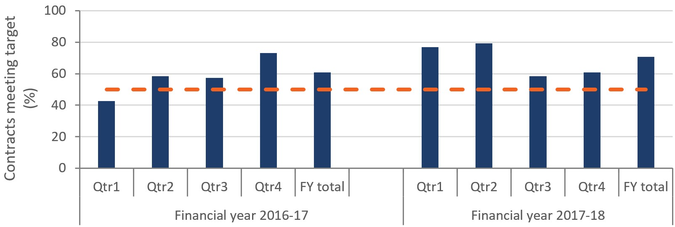

Source: Department of Education, Skills and Employment administrative data

## 7.5 TtW funding and expenditure

Three main types of payments are available to TtW providers: upfront payments, outcome payments, and other payments (for example, wage subsidy payments). jobactive has a larger range of payments: administration payments, Work for the Dole payments, outcome payments, wage subsidies, and Employment Fund payments.

As noted earlier in this report, the funding structure of TtW differed from mainstream employment services. At the time of the evaluation, an upfront payment of $5,300 per place per annum (GST exclusive) made to providers on a quarterly basis[51] represented the majority of their funding, with each funded place estimated to support around two participants annually. There was an expectation that the upfront payment would fund any activities, training and support services that could assist a participant to achieve an outcome.

The relatively high upfront payments in TtW provided flexibility for TtW providers to tailor the services to the specific needs of each participant. Each payment recorded by the department was attributed to one or more participants (i.e. bulk payments were pro-rated over the relevant group of participants) with an appropriate payment date. Using the matched TtW inflow and jobactive samples, the average costs for each participant and the costs of each participant’s LMA and positive outcome for the two programs over a 12-month period, were measured.

Prior to analysing how cost-effective TtW was, it was important to gain an initial understanding of the total expenditure of TtW. The two financial years from the start of TtW, 1 July 2016 to 30 June 2017 (FY17) and 1 July 2017 to 30 June 2018 (FY18), were examined. **Table 7.2** shows that upfront payments and outcome payments increased between FY17 and FY18. This included:

* an increase of upfront payments resulting from more funded places across the program
* the doubling of 26-week sustainability outcome payments
* the doubling of bonus outcome payments, driven by more outcomes achieved above providers’ performance targets.

As the upfront payments to providers allowed greater autonomy over spending, more itemised financial information showing provider spending was unavailable. However, the 2017 TtW Provider Survey indicated that training, clothing, transport and licensing were the most common uses of the funding.

Table 7.2: Breakdown of TtW expenditure from July 2016 to June 2018

| Expenditure component | FY17 | FY18 | Change (+/-) |
| --- | --- | --- | --- |
| Upfront payments | $79,922,655.58 | $84,185,200.00 | 5.3% |
| Sustainability outcome payments | $7,309,272.00 | $15,536,790.00 | 112.6% |
| Bonus outcome payments | $4,395,267.00 | $9,365,164.00 | 113.1% |
| Other costs (consultant fees, contractor fees) | – | $233,439.90 | n/a |
| Total | $91,627,194.58 | $109,320,593.90 | 19.31% |

Source: Department of Education, Skills and Employment administrative data

Increased expenditure on TtW alone was not a sufficient indicator of performance or cost-effectiveness. It can be inferred, however, that performance broadly improved as sustainability outcome payments and bonus outcome payments increased from a combined figure of around $12 million in FY17 to around $25 million in FY18.

## 7.6 Cost per participant

Although a comparison is made of participants flowing into jobactive and TtW, participants in each population could spend time in both programs. Consequently, the average duration in each program (and costs associated with that) were included in the evaluation analysis. **Table 7.3** shows the percentage of time participants in the TtW and jobactive matched samples spent in each program on average, within a 12-month period.

Participants in both populations spent about 60% (on average) of the following year in the programs in which they commenced. Participants entering TtW spent a significant amount of time in jobactive (**13%** on average) and spent less time outside employment services (**25%**) compared with jobactive participants (**37.5%**). In contrast, participants starting in jobactive spent little time in TtW (**2.0%** on average) and more time outside employment services (**37.5%**).

Table 7.3: Percentage of year spent in different employment service programs

| Program | jobactive (%) | TtW (%) | None (%) | Other services (%) |
| --- | --- | --- | --- | --- |
| jobactive | 59.0 | 2.0 | 37.5 | 1.6 |
| TtW | 13.1 | 60.5 | 25.4 | 1.1 |

Base: matched samples (TtW: n=12,105, jobactive: n=12,105)

Source: Department of Education, Skills and Employment administrative data

As a result, consideration is given to both jobactive and TtW costs for both analysis populations. **Table 7.4** gives the average program costs for the jobactive and TtW matched samples. Significantly more was spent (on average) on TtW participants than on jobactive participants.[52]

Table 7.4: Average program costs for jobactive and TtW participants

| Program | jobactive costs ($) | TtW costs ($) | Total costs ($) |
| --- | --- | --- | --- |
| jobactive | 1,654 | 148 | 1,801 |
| TtW | 357 | 4,686 | 5,043 |

Base: matched samples (TtW: n=12,105, jobactive: n=12,105)

Source: Department of Education, Skills and Employment administrative data

TtW was found to be more expensive than jobactive for any expenditure components similar to those discussed in **Section 7.5**. In fact, the unit cost for a TtW participant over a 12-month period was 2.8 times as much as that of a jobactive participant. This is not surprising given the fundamental differences between TtW and jobactive in terms of policy intent, duration of service, outcome requirements, compliance arrangements and payment structures.

## 7.7 Cost per outcome

The evaluation determined an average cost for participants to achieve one of a range of LMA indicators, an average cost per study outcome and an average cost per positive outcome. **Table 7.5** shows that the average cost of TtW labour market outcomes was 3.1 times that of jobactive, while the average cost of TtW study outcomes was 1.6 times that of jobactive. On average, TtW positive outcomes cost 2.9 times as much as jobactive positive outcomes.

Table 7.5: Average cost per labour market attachment, study outcome and positive outcome for TtW and jobactive

| Program | Total cost commencing program only ($) | LMA outcomes (no) | LMA unit cost ($) | Study outcomes (no) | Study outcome unit cost ($) | Positive outcomes (no) | Positive outcome unit cost ($) |
| --- | --- | --- | --- | --- | --- | --- | --- |
| jobactive | 20,010,170.25 | 6,251 | 3,201 | 1,449 | 13,810 | 7,056 | 2,836 |
| TtW | 56,729,719.35 | 5,687 | 9,975 | 2,633 | 21,546 | 6,982 | 8,125 |

Base: matched samples (TtW: n=12,105, jobactive: n=12,105)

Source: Department of Education, Skills and Employment administrative data

## 7.8 Return on investment

As noted earlier in this report, the flexibility of the program enabled participants to develop their confidence, wellbeing, motivation, work readiness and community connectedness within a capability framework. In addition, the human capital generated by TtW, as equated to the number of productive years in which participants can contribute the skills they develop through the program to the economy, develops over time.

For some participants these skills take longer to grow than for others. As a result, the return on investment (ROI) of such a program may take many years to be realised and is unlikely to be apparent within the study period of this evaluation.

## 7.9 Conclusion

Perhaps not surprisingly, a majority (64%) of participants who had a recorded outcome achieved their first outcomes six months or more after commencing in TtW, given the intensive and flexible nature of TtW.

The ‘career-forging’ and human capital building focus of TtW meant it was more expensive to service this cohort of young people in TtW than in jobactive in the short term.

A little over half of TtW participants exited to jobactive at the end of the study period. Of those who did so, around three-quarters commenced in jobactive within 91 days of exiting TtW.

Another measure of the efficiency of TtW was the speed with which providers reached their established program performance targets. Almost three-quarters of TtW providers either met or exceeded their targets in the 2017–18 financial year.

# Chapter 8 Does TtW deliver targeted and quality service?

## 8.1 Introduction

This chapter discusses the extent to which TtW delivered an appropriate and quality service to participants and employers. It explores participants’ level of satisfaction with the quality of the service of TtW providers and the extent to which this service extended to post-placement support. The satisfaction of providers and the benefits they delivered to the three groups of TtW participants are noted, and the effort providers made to link participants with employers is explored.

## 8.2 Participant expectations

When asked during the 2017 TtW JSEES Survey what sort of support they were seeking from their providers, TtW participants indicated they wanted to improve their interpersonal skills and work readiness:

* learning from mistakes (**55%**)
* being more positive in the workplace (**45%**)
* understanding social interactions in the workplace (**54%**)
* improving communication (**54%**)
* being a team player (**40%**).

In most cases, when participants wanted specific support, providers delivered it around **80%** of the time (**Table 8.1**). Functional skills such as getting a driver’s licence (**47%**) or basic maths and computing skills (**36%**) were selected by fewer participants and provided less frequently than were other supports (**63%** and **69%** respectively).

Table 8.1: Support wanted by TtW participants compared with support provided

| Type of support | Support wanted (%) | Support provided* (%) |
| --- | --- | --- |
| Learning from your mistakes | 55 | 84 |
| Better understanding of social interactions in a workplace or study environment | 54 | 87 |
| Communicating better | 54 | 87 |
| Getting a driver’s licence | 47 | 63 |
| Being more positive at the workplace | 45 | 87 |
| Being a good team player and working well with others | 40 | 87 |
| How to dress for job interviews | 37 | 87 |
| Learning about respecting others’ differences in a workplace or study environment | 37 | 92 |
| Following instructions | 37 | 89 |
| Basic maths and computer skills | 36 | 69 |
| Finding reliable transport | 33 | 79 |
| Being on time for work and appointments | 32 | 82 |
| Cleanliness and keeping your workstation clean | 25 | 89 |
| Writing, speaking and reading in English | 21 | 82 |
| Any other area | 9 | 72 |

Base: all respondents (n=600). Base for support provided is those that selected each support type wanted.

QTTB2 – When you started seeing <SITE_NAME>, did you want any support in the following areas?

QTTB3 – And since you started seeing <SITE_NAME> did they provide you with any support in the following (area/areas)?

Source: 2017 TtW JSEES Survey

## 8.3 Participant satisfaction

Findings from the 2017 TtW JSEES Survey confirmed the positive perceptions that TtW participants had of their providers (see **Figure 8.1**). The survey showed that a large majority of them felt that their provider treated them with respect (**98%**), cared about them (**95%**), understood their needs (**92%**) and wanted to help them find a job (**95%**) and help with their problems (**87%**).

Figure 8.1: TtW participants’ perceptions of their providers (per cent)

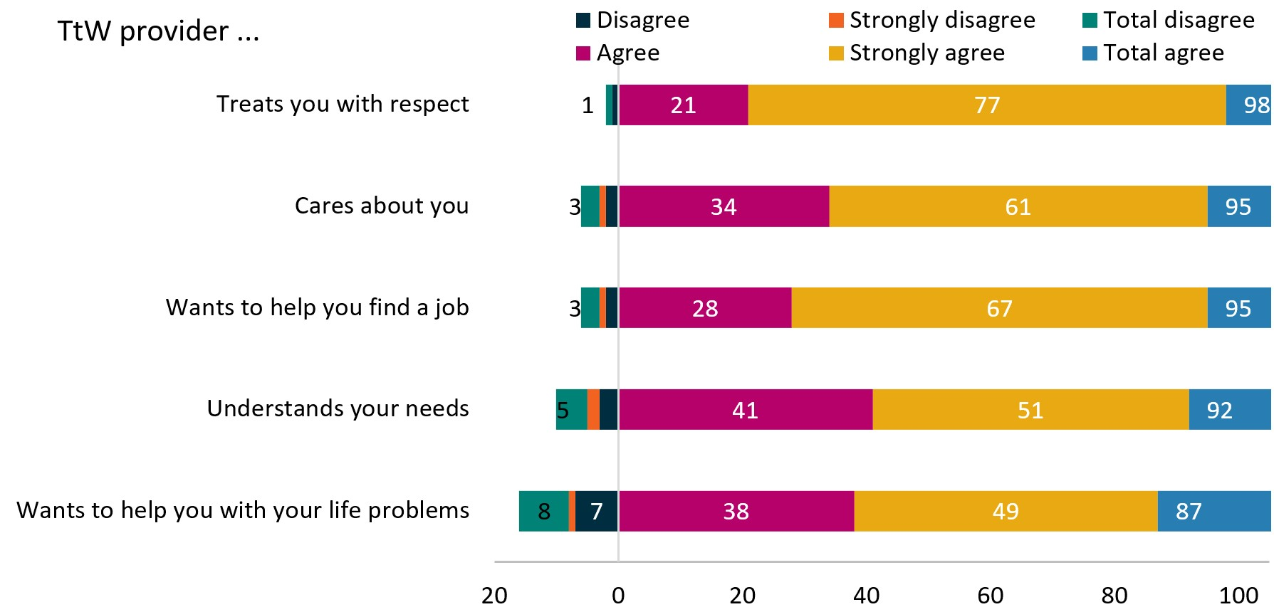

Base: all respondents (n=600)

TTA6 – Do you agree or disagree with the following statements?

Source: 2017 JSEES Survey

While it is important to note these were not matched samples, participants in TtW were also more satisfied with their providers than were jobactive participants with theirs. As **Figure 8.2** shows, **90%** of TtW respondents to the 2017 JSEES Survey were satisfied or very satisfied with the service their provider gave them, compared with **64%** of jobactive respondents.

Figure 8.2: TtW and jobactive participants’ overall satisfaction with their providers

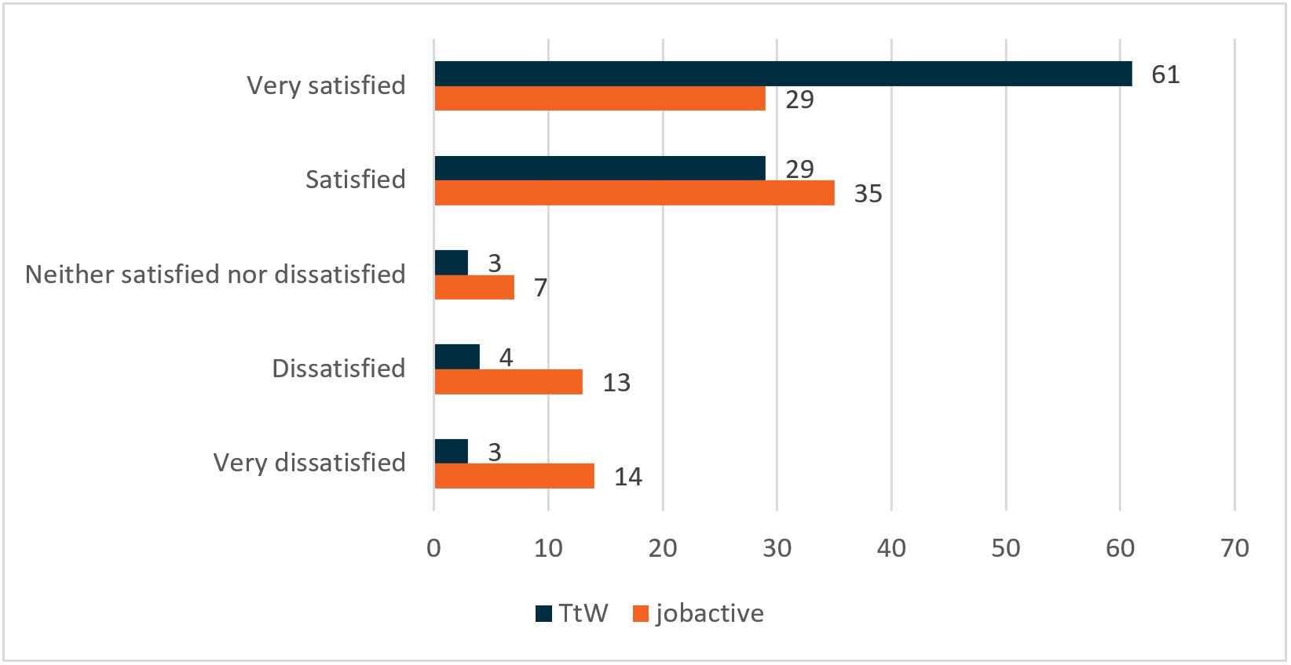

Base: all respondents (TtW: n=600, jobactive: n=3,000)

QTJB5 – And overall, how satisfied or dissatisfied are you with the service provided by your provider?

Source: 2017 JSEES Survey

Compared with jobactive participants, TtW participants were also more satisfied with how often they met with their providers. **Figure 8.3** shows that **90%** of TtW participants thought that the frequency of contact with their provider was ‘just right’, compared with **73%** of jobactive participants.

Figure 8.3: TtW and jobactive participants’ attitudes towards frequency of contact with their providers (per cent)

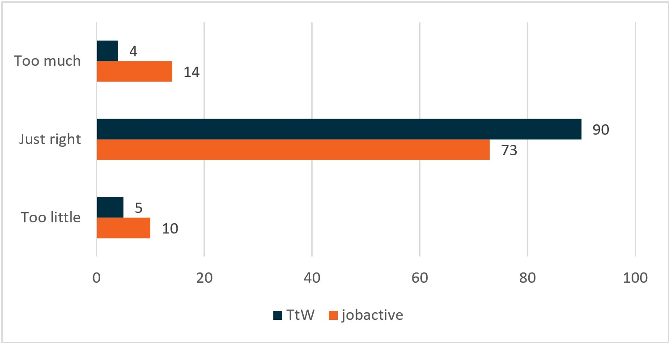

Base: all respondents (TtW: n=600, jobactive: n=3,000)

QTJA4 – And would you say the frequency of contact with [participant’s provider site] is …

Source: 2017 JSEES Survey

Moreover, TtW participants were more likely to state that their providers treated them with respect. As **Figure 8.4** shows, almost **98%** of TtW JSEES respondents either strongly agreed or agreed that their providers treated them with respect, compared with just over **88%** of jobactive respondents.

Figure 8.4: TtW and jobactive participants’ level of agreement with statement that their provider treats them with respect (per cent)

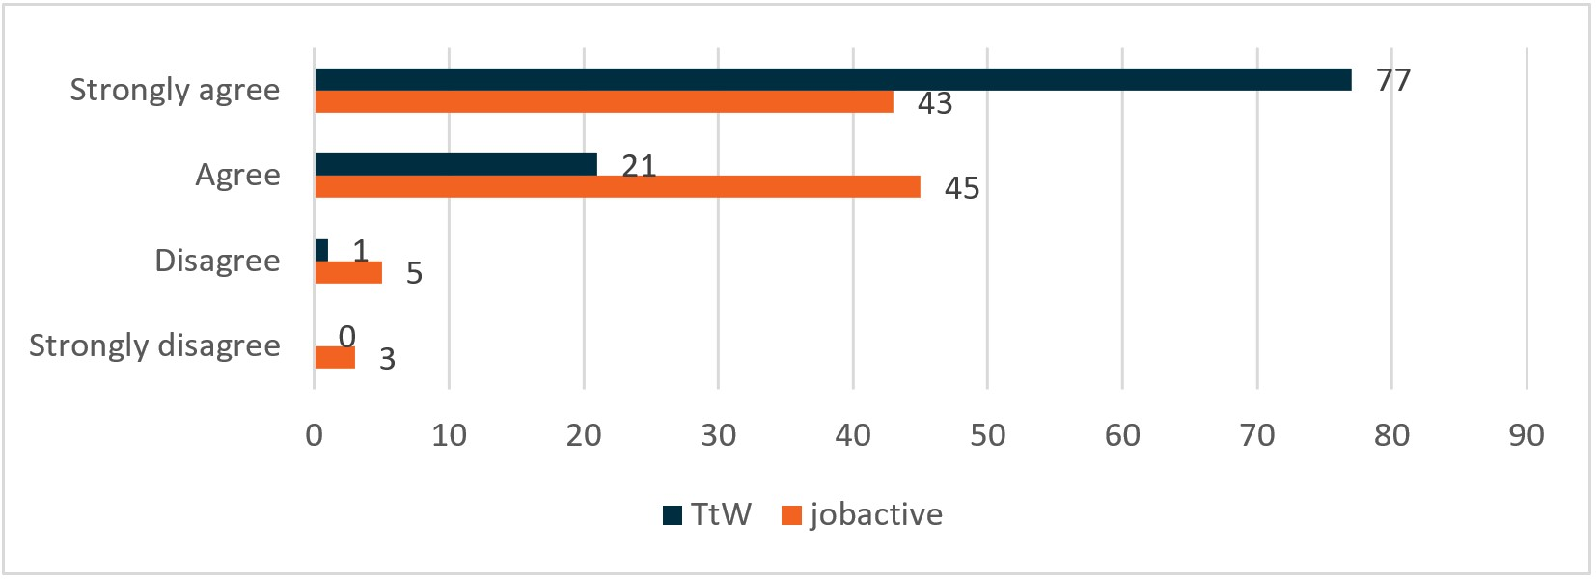

Base: all respondents (TtW: n=600, jobactive: n=3,000)

QTTA6 – Do you agree or disagree that [participant’s provider site] treats you with respect?

Source: 2017 JSEES Survey

## 8.4 Post-placement support

When asked if their provider had given them any support while they were working, **79%** of TtW participants who were currently working or had worked in the last six months responded with an affirmative answer. As can be seen in **Figure 8.5**, just over one in five (**21%**) participants surveyed indicated they had not received any form of work placement support from their TtW provider.

For those who did, the four most common types of support provided were:

* a telephone call to them (**55%**)
* talking to employers or other staff members on the participant’s behalf (**30%**)
* organising suitable workplace clothing (**29%**)
* organising or paying for training to support the work being undertaken by the participant (**24%**).

Figure 8.5: Support received from TtW provider following a work placement (per cent)

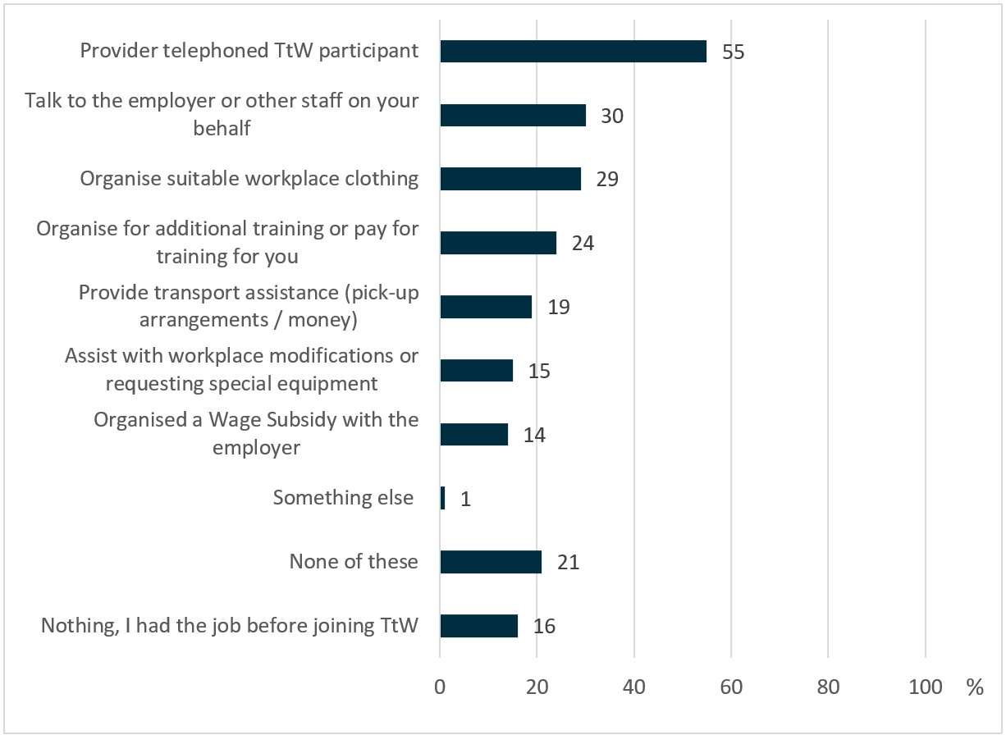

Base: currently working or has had a job in the last six months (n=396)

QTTC4 – Thinking about your most recent job, did provider provide support by doing any of the following: …

Source: 2017 TtW JSEES Survey

Other types of post-placement support provided included the provision of transport assistance (**19%**), assistance with workplace modifications (**15%**) and wage subsidies (**14%**).

## 8.5 Link between provider performance and participant satisfaction

Results from the 2017 TtW JSEES Survey highlighted the differences between participants’ overall satisfaction with providers who met or exceeded their Outcome Performance Targets compared with providers who did not. The significant differences are in **Table 8.2**.

Table 8.2: Differences between participants with providers that met or exceeded their Outcome Performance Targets and those that did not

| Characteristic | Provider outcome performance measure of less than 100% (%) | Provider outcome performance measure of 100% or more (%) |
| --- | --- | --- |
| Overall satisfaction with provider | 93* | 87 |
| Frequency of SMS contact – receiving a text on at least a fortnightly basis | 79 | 86* |
| Type of support from provider: signed a job plan | 67 | 76* |
| Type of support from provider: discussed the best ways to find a job | 90* | 82 |
| Attitude to work: Willing to take any job | 76 | 81* |
| Attitude to work: I already know how to look for a job | 82 | 91* |
| Completed study or training | 23 | 31* |

* Significantly higher than participants in the corresponding provider outcome performance measure (*p* < 0.05)

Source: 2017 TtW JSEES Survey

It is interesting to note that participants were more likely to be satisfied with the overall performance and support given by those providers who did not achieve their Outcome Performance Targets than those who did. It is possible that the providers who did not achieve their Outcome Performance Targets spent more time assisting participants in addressing their non-vocational barriers, therefore attracting higher satisfaction ratings from participants. Alternatively, they may have had a larger caseload of participants with personal barriers.

We were getting the other outcomes, not the employment and education outcomes – but we were getting people into housing, we were getting young people off the street, we were getting people drug and alcohol help that they need. So lots of big stuff that's not recorded at all by TtW. You think well, there’s no richness in what we can report to you, because you’re only interested in whether they’ve got the job or whether they’re in education. (Provider 2 Interview 1, Wave 1)

Providers who achieved their targets appeared to have a stronger focus on job plans, training and nudging (SMS contact). These providers may have had higher proportions of participants who wanted to work immediately, were knowledgeable about how to obtain a job, or had completed more study or training. Alternatively, it could be that they adopted more work-first strategies.

Following the changes in eligibility requirements for Indigenous participants at the beginning of 2018, there was an initial drop in the number of contracts meeting their targets. Following a quick recovery, annual targets increased by 10% in 2017–18 compared to the previous financial year. During the qualitative research, some providers reported an increase in the number of young Indigenous people on their caseloads.

We’ve seen a big jump in Indigenous referrals since the guidelines changed at the start of the year, which is great ... it was so easier for Indigenous clients to access TtW which we thought was great and it was a good shift. (Area 11 Provider 11, Wave 2)

Historically we’ve had a very low number of participants to the point where you could count them on one hand. Since the changes in January this year with Indigenous youth we have seen an increase. (Area 12 Provider 12, Wave 2)

## 8.6 Provider satisfaction

As noted earlier, when discussed during the 2017 TtW Provider Survey, there was a consensus among providers that TtW improved work readiness and helped participants get work and keep a job. Nearly two-thirds of them (**63%**) strongly agreed, and a further one-third (**33%**) agreed that TtW was appropriate for its target group.

Responding to whether there was sufficient time to contact and engage with participants, slightly under one-third (**30%**) of respondents strongly agreed that there was enough time, and a further **42%** agreed. There was a mixed response from providers when asked whether there was sufficient time in the program for participants to improve their work readiness. Around half (**51%**) of respondents agreed or strongly agreed that it was sufficient. However, **40%** of respondents disagreed or strongly disagreed.

Providers’ opinions suggested that TtW benefited ESLs (Group One participants) the most, and referrals from jobactive Stream C (Group Three participants) the least (see **Figure 8.6**).

Figure 8.6: Benefits to each of the three participant groups

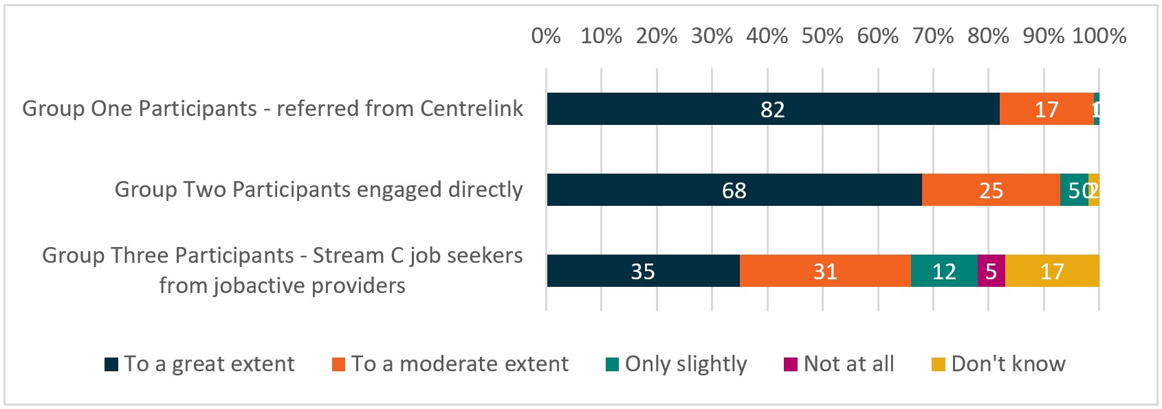

Base: all respondents (n=214)

QE2: Based on the experiences of the [site name] site, to what extent do you think that TtW benefits …

Source: 2017 TtW Provider Survey

Overall, there was a very positive view of the effectiveness of TtW among providers surveyed. Three-quarters (**76%**) of the providers interviewed during the Wave 1 qualitative research viewed TtW as doing what it should do. The remaining quarter (**23%**) thought it had the potential for improvement. None of the providers believed TtW was not delivering what it was supposed to do.

### 8.6.1 Satisfaction with departmental support

Results in the Interim Report indicated that providers’ satisfaction with the operational information they had received about TtW and with the department’s information systems (including the provider portal and question manager) was generally positive.

When asked about the service guidelines and the Learning Centre in the 2017 TtW Provider Survey, providers’ attitudes towards department resources were similar to the results in the Interim Report (**Figure 8.7**):

* most(2017: **87%**,2016: **85%**) respondents agreed or strongly agreed that the service guidelines were comprehensive and met their requirements
* three-quarters (2017: **76%**, 2016: **74%**) of respondents agreed or strongly agreed that the Learning Centre content was relevant and helpful.

Results varied regarding whether providers thought there was too much information to digest in the online departmental resources (this question was not asked in 2016). Most respondents neither agreed nor disagreed and one-quarter (**25%**) thought there was too much information to digest. However, **36%** did not agree there was too much information – that is, they believed there was the right amount of information or there was too little information.

Figure 8.7: Attitudes to online departmental resources

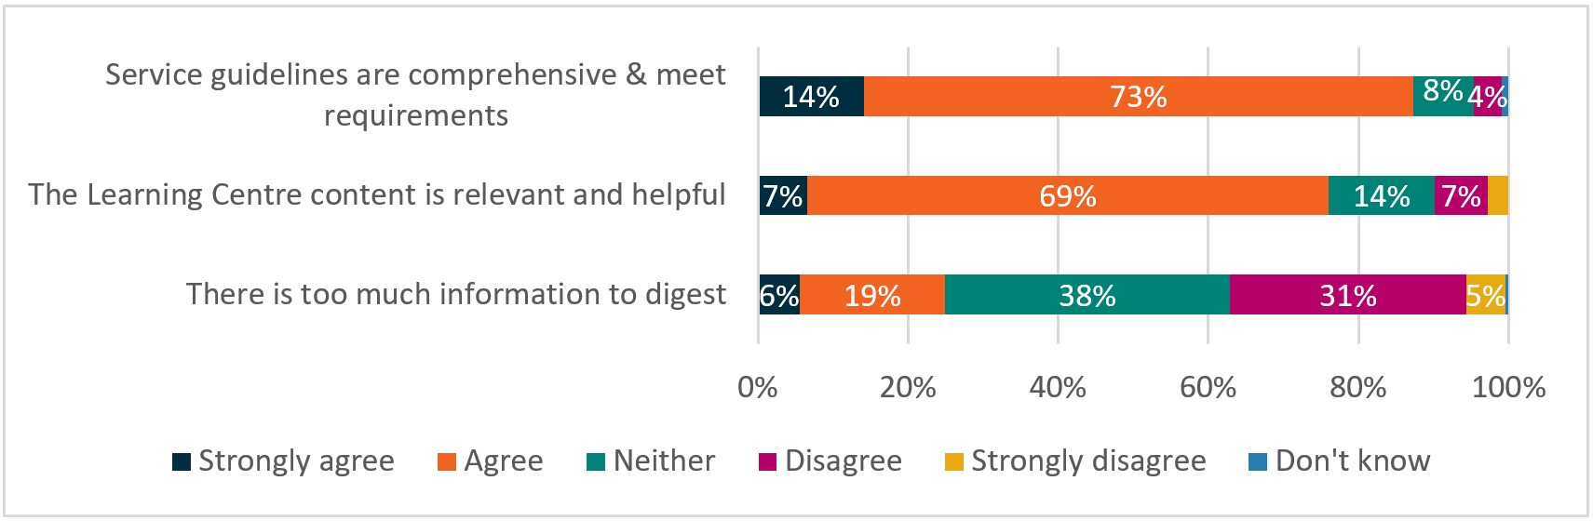

Base: all respondents (n=213)

QF3 – Thinking about the resources provided by the department, to what extent do you agree or disagree that …?

Source: 2017 TtW Provider Survey

## 8.7 Employer views

### 8.7.1 Awareness of TtW

Providers reported using a variety of strategies to connect TtW participants with potential employers and training providers. These included inviting employers and training providers to speak to participants, mock interviews, organising job placements, networking with employers and training providers and scanning job notices in newspapers and online job sites. As one provider explained during the qualitative research:

We do a lot of employer visits, we do a lot of employers coming to site to talk to the young people about different roles and industries, understanding jobs, what are the duties of the jobs. It’s a lot of explaining we do. They actually physically get to see that. We have group training organisations come in. We’ve always got presenters coming in to talk about what they really want to know. Things that they’re a bit scared of. A lot of people are a bit scared of the apprenticeships and traineeships. ‘Study – oh, my god, it takes years’ – we sort of break that down and take the stigma away. (Area 4 Provider 2, manager, Wave 2)

A survey of employers was conducted in 2017 to gauge their awareness of, and satisfaction with, TtW. Although the department’s administrative system recorded all employers sampled for the 2017 Employer Survey as having placed a TtW participant in work in the six months prior to the survey, their awareness of, and familiarity with, all aspects of TtW services canvassed was modest (**Figure 8.8**). A greater proportion of employers who reported contact with TtW providers, regardless of whether they claimed they used them to hire staff (**71%**) or whether they did not (**49%**), stated that they had heard of TtW, in comparison with employers whose self-reported contact was undetermined and who claimed that they did not use a provider to assist in recruitment (**45%**).

Figure 8.8: Unprompted awareness of TtW (per cent)

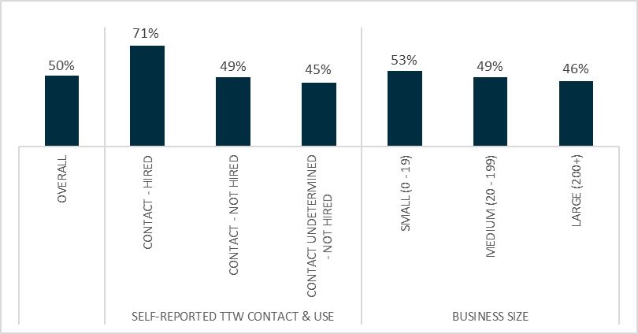

Base: all respondents (351)

B1 – Before today, have you heard of the government program called TtW?

Source: 2017 Employer Survey

Unprompted awareness of TtW decreased linearly by business size, with a greater proportion of respondents working in a small organisation (**53%**) reporting that they had heard of TtW, in comparison to employers from large organisations (**46%**). This differed from jobactive, where recognition of the program name ‘jobactive’ was most frequent among large businesses (**55%**), decreasing with the size of the business (**46%** of medium businesses and **45%** of small businesses) (**Figure 8.9**).

Figure 8.9: Unprompted awareness of jobactive (per cent)

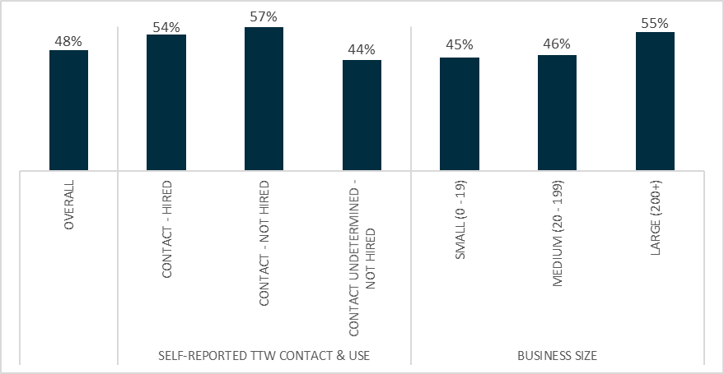

Base: all respondents (n=351)

B2 – Before today, have you heard of the government program called jobactive? % Yes

Source: 2017 Employer Survey

When employers overall were asked about jobactive, the results did not differ much compared to the TtW unprompted questions, with around half (**48%**) reporting that they had heard of the program and half (**50%**) reporting that they had heard of TtW (**Figure 8.9**).

I hear transition to work and I think getting her (staff) to work and back, helping her with vehicles to get – I don’t even know what this is. (Employer 3, Wave 2)

Most employers were aware their organisation had placed or hired a young person but, more often than not, did not realise that the individual was a TtW participant.

I don’t know what you mean really (when asked if the respondent had heard about TtW). I’ve had people that have been transitioned back into the workforce, whether they’d be young, or old, or people with disabilities. (Employer 12, Wave 2)

Most employers in the Wave 2 research reported screening TtW participants prior to employing them. Either the provider or the employer undertook the screening process, depending on the specific arrangements made and the existing relationship with the provider. For example, if the employer had worked with the provider previously, the provider often screened the job seekers to ensure they captured the most appropriate job seekers for the role.

I think because they pretty much know the people. It gives me a bit of a head start. What they’ll do is they’ll send me the résumés and the local [Provider] who I used to deal with, which the persons left, she knew exactly what we were looking for. So she would screen her people and know them already, so she would send them along saying, ‘Look [Name] these ones I think are going to fit the criteria that you’re after’. (Employer 9)

Some employers who had recruited through a TtW provider indicated that they preferred the provider to send only candidates who met their specifications, helping to save time in the recruitment process. Other employers explained that they interviewed and screened the résumés of participants. Employers belonging to this latter group indicated a preference for assessing applicants on a case-by-case basis.

Some employers interviewed were not interested in learning about TtW or wage subsidies because government initiatives were too confusing for them to understand.

And I hadn’t heard of the TtW program. And I guess that’s kind of my own fault that we were focused more on getting the right candidate rather than the subsidy or whatever it might be. And I guess the issue that a lot of employers have, including ourselves, is that we’re a small business, we don’t have a HR team that looks at what programs are out there, what grants are out there and all that sort of stuff. And it’s confusing out there. (Employer 10, Wave 2)

### 8.7.2 Appropriateness of TtW linked to employer satisfaction

Almost all employers who responded to the 2017 Employer Survey (**95%**) considered that the job seeker(s) they hired met their business needs at least to some extent. There was a large difference in the perceptions as to whether a job seeker ‘fully met’ the employer’s needs between employers who had not hired a job seeker (**30%**) previously and those who had hired a job seeker through a TtW provider (**45%**) or whose contact was undetermined (**48%**).

Of the employers surveyed, **74%** overall confirmed that they would be ‘likely’ or ‘very likely’ to use a TtW provider again (**Figure 8.10**). Unsurprisingly, findings differed between employers who reported contact with a TtW provider (**84%**) and using them for hiring and employers who recalled contact with a TtW provider (**58%**) but said they had not used them in hiring staff.

Figure 8.10: Likelihood of employers using a TtW provider for future recruitment needs (per cent)

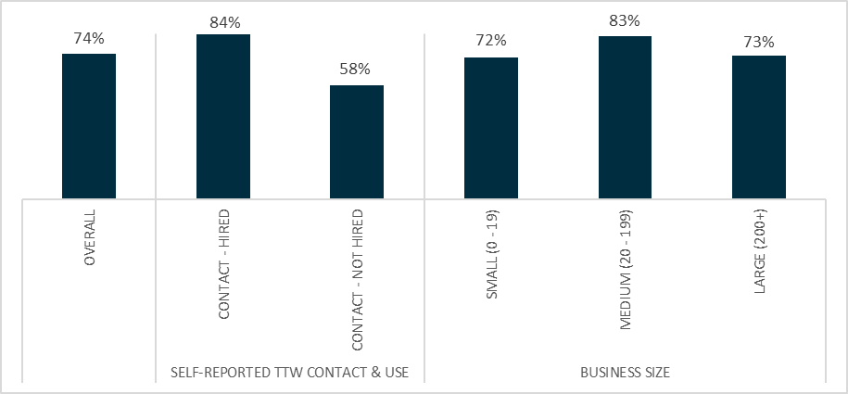

Base: respondents who self-reported contact with TtW provider (n=103)

E3: For any future recruitment needs do you think your business is likely or unlikely to use a <jobactive / Transition to Work> provider as part of the recruitment process?

Source: 2017 Employer Survey

The Wave 2 qualitative research confirmed that TtW participants were placed in a range of positions, largely dependent on the particular employer. Generally, participants took on entry-level roles, including general labouring positions, operating machinery, administrative roles, customer service and retail roles, kitchenhand positions, and traineeships/apprenticeships.

We put them into the yard of the company to do labouring and … To get experience with the company … If they’re reliable and they’re working well, that’s when they go out onsite to work on the building sites … they’ve just got to do what they need to do. (Employer 1)

We pay the award level two and level four. So, you’re not going to get rich working here. But it is a secure job, five days a week, and two shifts: a morning shift and an afternoon shift. If that’s what people want to do, well, we’ve got the job for them … (Employer 2)

Most employers praised TtW for trying to address the issue of youth unemployment. Employers were supportive of the overarching principles of the program and some noted that TtW had been effective in fostering a sense of self-confidence in the participants.

I think it will give them a little bit more confidence … Some people are scared that they don’t have those skills to talk to kind of strangers or people that don’t really know at all. So, I think yeah, [TtW is] building their confidence and how to communicate as well. (Employer 6)

During the qualitative research, employers confirmed the findings of the 2017 TtW Employer Survey that they valued job seekers with the right mix of technical vocational skills and personal ‘softer’ skills. Personal attributes were reported as the most important characteristic of a job seeker, with ‘relevant work skills or experience’ ranking third in the list.

Among employers who used the program, their satisfaction with TtW participants varied depending on whether their expectations of a job candidate were satisfied. During the qualitative research, some employers expressed dissatisfaction. They cited a poor attitude and limited work ethic as a major problem among participants.

She’s had no skills. She hasn’t – and the entire time she worked with us she had no – she didn’t want to develop her skills at all and that’s why she no longer works with us … Maybe if the attitude was right to begin with the skills would then follow. I mean if you’ve got an attitude that you want to learn what are you going to do? You’re going to go and learn, aren’t you? (Employer 3, Wave 2)

Despite the challenges, most employers interviewed expressed a strong commitment to supporting young people to make the transition to employment. Employers who had had a good experience with a TtW participant were more impressed with their soft skills than their technical skills, especially participants who displayed a genuine interest and were proactive about getting a job. Presentation and initiative were important factors to employers.

[TtW participant] did make the effort to contact me. The person that is here in this position, she took the initiative to contact me and see if I was interested. And she also in doing so took the time to explain to me how it worked, she printed out the information that I needed and made sure that I was well briefed on it … She organised an appointment for us with [Provider], which is the provider that she goes through so that I could ask the questions and understand what was needed. So it wouldn’t have happened, I don’t think, if she hadn’t put as much effort into it as she did to create the opportunity. (Employer 8, Wave 2)

When asked if they would use TtW again, almost all employers said that it would depend on a few factors such as business needs, work readiness of participants and post-placement support from the providers.

I would only employ them if I was assured that they were going to be looked after along the way, instead of just dumped there and left there. I’m quite angry with them, because I think the program’s a good one … just throwing them in the deep end doesn’t work. (Employer 12, Wave 2)

Employers surveyed during the 2017 TtW Employer Survey had a reasonably high rate of satisfaction with TtW providers (**81%**), compared with employers in the jobactive program, whose rate of satisfaction was around two-thirds (**65%**). Almost all employers (**95%**) considered that the TtW job seeker(s) hired met their business needs at least to some extent.

### 8.7.3 Wage subsidies

Analysis of wage subsidies conducted for the jobactive evaluation indicates that subsidies have a positive impact on job sustainability. However, the take-up of wage subsidies in TtW was modest. More than half of the employers interviewed for the 2017 TtW Employer Survey who had been offered a wage subsidy said this only happened after the TtW participant started work with them, suggesting the wage subsidy did not serve as a stimulus at all and could be considered a ‘dead weight cost’.

While wage subsidies may cover some of the costs of employing a TtW participant, employers did not regard them as the sole determining factor when hiring. As discovered during the qualitative research, employers valued job and business fit more than subsidies, including a participant’s self-motivation and reliability.

I suppose when it all boils down to it, it depends on who’s going to be better for our business as well and who’s skilled more. But then again I suppose there would be a lot of training as well. I suppose we want someone who’s got basic skills and then you can mould them into what you want as you go along and they can be taught different things. But those who are really not interested and not forthcoming with asking questions, then that makes it a bit difficult. (Employer 7, Wave 2)

### 8.7.4 Unpaid work experience

The low take-up of internships and similar initiatives has complex and varied explanations, none of which are simple or tidy. As noted during the 2017 TtW Employer Survey, only a minority of employers offered unpaid work experience, because many felt it was somewhat exploitative. When it was offered, it often took the form of an unpaid work trial and was offered to help young people gain skills and experience.

Of the three in 10 employers who offered work experience, a ‘work trial’ (**32%**) was the most commonly mentioned type. Overwhelmingly, employers explained that they offered work experience placements ‘to help young people gain skills and experience’ (**55%**). A fifth of employers (**20%**) indicated that work experience placements allowed them to ‘try someone out prior to recruiting’.

Over half of employers (**54%**) indicated that they would consider offering an unpaid work experience placement in the future. Those employers who suggested that they would not offer a work experience placement in the future cited exploitation as the reason.

## 8.8 Conclusion

The satisfaction of providers, participants and employers with the TtW service is a useful measure of how targeted and appropriate the service had proven to be. Well over 90% of participants thought providers had their interests at heart, understood their needs and wanted to find them a job. More than three-quarters of providers believed that they were equipped to provide the specific support required by participants.

Employers’ awareness of the TtW program was moderate but those who had experience of using the services of a TtW participant considered that those hired met their business needs at least to some extent. A substantial majority of employers surveyed during the evaluation thought that TtW was an appropriate program and indicated that they would be ‘likely’ or ‘very likely’ to use a TtW provider again.

# Chapter 9 The impact of TtW

## 9.1 Introduction

Making young people work ready, with skills that enable them to compete successfully for job opportunities, is a key indicator of success for TtW. Engagement in some paid work and/or participation in approved activities to improve work readiness and skills are important steps in obtaining sustainable employment and reducing dependence on income support in the longer term.

Various characteristics – such as gender, Indigeneity, CALD, residential location, disability, access to transport, and homelessness – may impact on TtW participants’ ability to engage in activities. Some young people are job ready, despite their lack of qualifications, and their transition to work is faster, although their workforce participation is not necessarily sustainable. The acquisition of basic vocational skills is a requirement for others if they are to achieve the successful attainment of outcomes.

The capacity of providers to refer participants to specialist external organisations, especially for assistance in overcoming non-vocational barriers such as mental health, homelessness and general counselling needs, increased participants’ work readiness and confidence. The TtW service was effective at helping women to access education and training but less so at encouraging study among Indigenous youth, possibly because they had more recent education experience due to changed eligibility requirements.

Positive short-term outcomes for participants, such as practical skills to become job ready and personal improvement skills to reduce levels of anxiety, also increased their social connectedness and improved their communication skills. Positive long-term impacts on participants included increased self-confidence and motivation to find and retain employment.

## 9.2 Effectiveness of TtW

Providers delivered or referred participants to a wide range of activities essential to addressing their non-vocational barriers and improving their wellbeing and human capabilities. Many were time consuming and often difficult, such as developing a mental health plan. Providers reported that poor mental health and substance abuse were among the most common non-vocational barriers that they addressed.

Mentoring and coaching sessions, job search assistance and advice about undertaking interviews helped participants to achieve education, training and employment outcomes and an improvement in their motivation and work readiness.

Around three-quarters of participants who responded to the 2017–2018 PPM Survey reported that their level of work readiness improved because of working with their TtW provider. Almost all providers (**97%**) surveyed in the 2017 TtW Provider Survey thought participants’ work readiness had improved.

TtW has a strong focus on improving participants’ vocational capability. Of the TtW inflow population, **49%** engaged in in at least one recorded activity, and education and training represented the vast majority of the activities (**46%** of the inflow population). Similar proportions of participants were placed in accredited (**30%**) and non-accredited (**29%**) education and training respectively. Around a quarter of participants (**26%**) engaged in a course that was eligible for an education outcome.

Work experience organised by providers correlated positively with LMA. Unsurprisingly perhaps, most providers preferred courses that incorporated an element of work experience. Accredited training/education correlated positively with LMA.

Those participants who engaged in work experience were **11 percentage points** more likely to experience LMA – that is, some form of employment – than those who did not. Allowing for an initial 28-day settlement period, the LMA rate of the study population increased by **21 percentage points** after six months. The rate then slowed, recording an overall increase of **30 percentage points** over 12 months.

Overall, TtW meets its objectives. At the program level, providers achieved above the outcome target for nearly all quarters over the two financial years July 2016 to June 2018. The proportion of annual performance targets achieved increased from 110% of the target in 2016–17 to 125% in 2017–18.

## 9.3 Efficiency of TtW and cost-effectiveness of TtW

More than three-quarters of all young people (**77%**) referred to the service commenced and the proportion of referrals that led to commencements increased over time. The average commencement rate increased from **70%** in February 2016 to **85%** in June 2019. Participants commenced in TtW more quickly than did participants in jobactive, with **92%** of TtW referrals commencing within 30 days, compared with **81%** of jobactive referrals. In spite of the voluntary nature of TtW, its referral and commencement process is more efficient.

A little over half of TtW participants exited to jobactive at the end of the study period. Of those who did so, around three-quarters commenced in jobactive within 91 days of exiting TtW.

Perhaps not surprisingly, given the intervention-intensive and capability-building nature of TtW, a majority (**64%**) of participants who had a recorded outcome achieved their first outcomes six months or more after commencing in TtW.

TtW was found to be more expensive than jobactive. In fact, the unit cost for a TtW participant over a 12-month period was 2.8 times as much as that of a jobactive participant. Similarly, TtW positive outcomes cost 2.9 times as much as jobactive positive outcomes.

The emerging evidence from this evaluation indicates that TtW program settings enabled participants to develop their confidence, wellbeing, motivation, work readiness and community connectedness within a capability framework. In addition, the human capital generated by TtW, as equated to the number of productive years in which participants can contribute the skills they develop through the program to the economy, develops over time.

For some participants these skills take longer to grow than for others. As a result, the return on investment (ROI) of such a program may take many years to be realised and is unlikely to be apparent within the study period of this evaluation.

## 9.4 Appropriateness of TtW

Consensus among providers that TtW was suitable for young people at risk of long-term unemployment supported the view of participants that the tailored and intensive support in TtW was appropriate for them and contributed to their achievement of work readiness, education and employment outcomes. The flexibility of the service delivery model allowed participants to engage with their consultants via various means, including individual appointments or group sessions, and enabled the delivery of a mix of vocational and non-vocational support, including from staff with specialised cultural and linguistic skills. Participants described providers as nurturing them along the pathway to their end goal and being supportive of that goal.

Providers felt that TtW’s assistance with early detection of and early intervention to address the needs of their participants, some of whom faced multiple non-vocational barriers, was crucial to achieving longer term educational or employment outcomes.

Smaller caseloads and collaboration, not competition, between providers enabled them to service participants with specific barriers at least most of the time in 50% of provider sites in 2017. Upfront funding enabled the payment of specialised support services, accredited training for participants, clothing purchases for interviews, and payments for transport and work-related licences.

The satisfaction of providers, participants and employers with the TtW service is a useful measure of how targeted and appropriate the service had proven to be. Well over 90% of participants thought providers had their interests at heart, understood their needs and wanted to find them a job. More than three-quarters of providers believed that they were equipped to provide the specific support required by participants.

Employers’ awareness of the TtW program was moderate but those who had experience of using the services of a TtW participant considered that those hired met their business needs at least to some extent. A substantial majority of employers surveyed during the evaluation thought that TtW was an appropriate program and indicated that they would be ‘likely’ or ‘very likely’ to use a TtW provider again.

## 9.5 TtW compared with jobactive

An overwhelming number of TtW participants (**90%**) in the 2017 JSEES Survey were satisfied or very satisfied with the service their TtW provider gave them, compared with **64%** of jobactive respondents. Compared with jobactive participants, TtW participants reported a greater willingness to work and were more positive about their job prospects. Almost **98%** of TtW participants surveyed either strongly agreed or agreed that their providers treated them with respect, compared with just over **88%** of jobactive respondents. (Note these were not matched samples.)

Employers also indicated a high level of satisfaction, with four in five employers using TtW satisfied with the service (**81%**) compared with two in three employers using the jobactive program (**65%**).

During the 12 months following referral, TtW participants achieved slightly lower LMA (**47%**) than similar jobactive participants (**52%**), largely due to the difference in LMA achieved at an early stage of program participation (at six weeks post-referral or earlier). This is unlikely due to jobactive’s program effect but more a ‘deterrence effect’ of the strong compliance framework.

TtW participants were less likely to exit income support than were jobactive participants. A higher proportion of jobactive participants (**73%**) exited income support during the two years from commencement than TtW participants (**68%**) and this was largely due to a higher proportion of jobactive participants exiting early. TtW had a higher proportion of participants exiting income support during the second year than jobactive. This delayed effect of TtW confirms that due to the intensity of the program TtW had a larger lock-in effect.

TtW had higher rates of study outcomes than jobactive. In fact, it achieved almost double the number of study outcomes for its participants than did jobactive over 12 months and was more effective than jobactive at encouraging female participants to study.

TtW was also more effective than jobactive at helping participants avoid renewed contact with the criminal justice system. In the matched samples, **3%** of TtW participants who left prison claimed crisis payments up to two years after referral, compared with over **4%** of jobactive participants. Participants in the matched samples were more likely to go to prison two or more times if they were in jobactive (around **2%**) than if they were in TtW (**1%**).

These findings reaffirm that TtW has a strong effect on building participants’ vocational and other human capabilities. This approach inevitably led to a stronger lock-in effect and delayed outcomes.

## 9.6 What were the gaps?

Despite their upfront payments, given the voluntary nature of TtW, providers needed to work hard to maintain their caseloads. Around **23%** of participants referred to TtW did not commence. It is possible that the thought of spending 12 months undertaking 25 hours a week of study, training or work experience drove some young people back to school, into VET, into work, into jobactive or into the world of disengaged NEET young people.

While their participation in TtW was voluntary, the majority of potential TtW participants arrived at an appointment with their provider with little or no understanding of the program they were about to enter. Once there, many wanted to stay.

Some Group Two TtW participants were ineligible for income support because their parents’ income was above the threshold or they had decided they did not want to register with Centrelink. Providers felt that without TtW a number of these young people would have been further disadvantaged because of the lack of supports available to assist them to improve their work readiness.

Providers reported facing considerable challenges in accessing appropriate support services for their participants. For example, providers reported that there was a strong demand for mental health services among their participants but that a shortage of youth mental health places meant that some participants did not receive the support they needed. This problem was particularly severe in regional locations where the limited local services were often oversubscribed.

Having a dedicated case manager was not always possible due to the high staff turnover in TtW provider organisations; this was a source of frustration for participants, who disliked having to provide the same information on multiple occasions and build relationships with new staff members. To minimise the disruption to participants, some providers assigned two case managers to each participant. While this helped lessen disruption for participants, staff turnover continued to be a problem for participants and TtW providers alike.

Some providers indicated that they did not find the prescriptive job plan format useful because the tailored approach to servicing TtW participants individually demanded more flexibility. Many providers felt the job plan was administratively burdensome and suggested a change to the format to make it more practical and useful.

## 9.7 What are the trade-offs?

The human capital investment associated with the program may have increased with the program’s duration; however, the potential for a ‘lock-in’ effect on participants the longer they continued in their education and training activities appeared evident. As the post-program future approached, it may have been more attractive for participants to complete the program by undertaking a study option than to search for a job. This had the potential to magnify the lock-in effect. Providers who did not achieve their outcomes were excluded from bonuses despite actively building the human capital of participants, many of whom preferred their servicing model.

The individualised pathway for young people that combined education and training with paid work was likely to result in some attachment effect for TtW participants in the shorter term. Unfortunately, the lock-in effect could have had a significant impact on the cost-effectiveness of TtW in the early stages of the service. If TtW’s potential to enable participants to achieve ‘sustained transition’ is realised, however, the investment may be proven worthwhile.

Whether some form of compliance incentive associated with initial appointments, as suggested by some providers, might have enabled providers to spend more time with participants explaining the objectives and benefits of TtW in order to encourage them to stick with the program is unknown.

What is clear is that the greater flexibility to undertake education and training in TtW is likely to be a contributing factor in participants’ reliance on income support in the short term, as young people combined work and study but did not earn enough to sustain themselves. Participants tracking towards an educational outcome or engaged in prerequisite courses would not have been able to earn enough to move off income support over the study period.

## 9.8 Longer term effects

Having presented evidence in addressing the question of what works in TtW, we require a deeper dive into the question of why/how programs such as TtW are likely to succeed.

Positive short-term outcomes for TtW participants, such as practical skills to become job ready and personal improvement skills that reduced levels of anxiety, increased their human capital and social connectedness and improved their communication skills. The achievement of study outcomes likely had positive long-term impacts for participants including increased self-confidence and motivation to find and retain employment.

In addition, in the context of the development of human capability, there were indications that TtW had a broader public benefit, at least in reducing recidivism among some ex-offender participants. It will be up to further research and evaluation, however, to focus on assessing whether the proposed human capability gain and ‘sustained transition’ are realised in the longer term.

# Appendix A: Interim Report key findings

### Early implementation and operation of the TtW service

The qualitative research found that, with the rapid rollout of TtW, a number of providers reported that it was challenging to find sites and train staff by their contract start date. Providers also reported problems with initial referrals, particularly with participant contact details and the suitability for TtW of early transfers from jobactive. Providers, DHS staff and employers all reported that low initial awareness of TtW had contributed to early issues with the service.

A survey of providers by the department during October to November 2016 found that, while start-up issues were challenging, most had been largely resolved. Providers also reported that the service and support provided by the department during the rollout and early stages of TtW were of a high quality.

Most providers and participants reported that they were satisfied with the flexibility of the TtW service, which enabled a strong focus on participant engagement in activities and more time with individual participants to increase their work readiness and chances of finding a job. Providers also regarded the TtW funding structure as sustainable, and the KPIs and Outcome Performance Targets as achievable.

### Engagement and retention of participants in TtW

Utilisation of TtW places (i.e. Occupancy of Annual Funded Places) increased over time, with the TtW caseload (pending, commenced and suspended participants) at 78% of Annual Funded Places at the end of July 2016 and rising to 117% six months later. The median time to commence a participant fell during the study period, from 16 days in the provider’s first month in TtW to four days by the provider’s sixth month. Analysis of referrals to both TtW and jobactive in the matched inflow population showed that TtW providers achieved a higher commencement rate during the first 30 days after the participant’s referral to them (93%, excluding Group Three transfers from jobactive) than jobactive providers (83%).

The attendance rate at the first initial appointment was higher for TtW participants (77%) than for young people in the jobactive comparison group (69%), while the attendance at contact appointments was slightly lower (60% for TtW, compared with 63% for the jobactive comparison group). It is worth noting that there is a different compliance arrangement relating to individual appointments and attendance at activities in TtW. TtW does not have sanctions of suspending/cancelling income support payments in relation to non-attendance at appointments or activities (as in jobactive). Instead, TtW providers assess the participant’s overall participation and exit them if they do not meet participation requirements.

During the early months, providers reported that they had difficulties in attracting disengaged young people (Group Two) but, once they were engaged, these participants had a high level of commitment to, and retention in, the TtW service. Providers and peak bodies both noted that recruitment of this group improved over time, attributing this to innovative strategies and word of mouth. Referrals of suitable young people from jobactive Stream C were well below the targeted 10% of Annual Funded Places during the first 12 months of operation.

TtW participants were required to undertake 25 hours per week of pre-employment activities, which included placements in a wider range of education and training activities than young people in jobactive. TtW participants typically undertook more pre-employment activities, reflecting the employment preparation focus of the program. By contrast, the jobactive focus on employment outcomes meant that jobactive participants who were ESLs were more likely to receive a range of work-related services and support from their providers. This included job search, part-time or casual employment, participation in other government programs, and certain education and training activities depending on their needs and job seeker classification. Consequently, the proportion of young people participating in activities was higher in TtW (46%, compared to 19% for the jobactive comparison group) over their first six months in the service. For participants who were undertaking activities, TtW participants were also placed in activities more quickly (55% in the first 30 days after referral, compared with 46% for the jobactive comparison group).

The commencement processes between TtW and jobactive are similar, but the non-commencement patterns for referrals are different. TtW providers generally recorded young people as a non-commencement from the second month after referral following numerous attempts to engage them. The main recorded reason for non-commencement was ‘young person was not contactable’. Non-commencements from the comparison group in jobactive during the first month were more likely due to many other reasons such as failing to attend an initial appointment with their providers, having their income support claims cancelled or withdrawn, or finding a job. Therefore, recorded reasons in jobactive tend to be ‘referral to other service’ or ‘no longer fully eligible’.

### Early education, employment and LMA outcomes

Approved outcomes in TtW include education, employment or a combination of education and employment outcomes, depending on the participant’s income status and MORs. At the end of March 2017, employment outcomes achieved through TtW comprised 79% of all TtW outcomes, and the March 2017 quarterly Outcome Performance Targets were met for 50% of all provider contracts.

The high contribution of employment outcomes probably reflects the provider focus, where possible, to get young people in a job to achieve an employment outcome. Qualitative research found placing young people in education in order to obtain an education outcome was considered to be the secondary focus for providers after all avenues of employment were already exhausted. A Certificate III was the main type of study undertaken by TtW participants qualifying for an education outcome.

Young people were less likely to report earnings early in their TtW participation period compared to the matched sample of jobactive participants. However, similar proportions of participants reported earnings by the sixth month of service, with the rate of increase slightly faster for TtW.

The LMA rate, which measures engagement in some paid employment, was higher over the study period for TtW participants (33%) than for the jobactive comparison group participants (28%). Employment indicators used for this measure included earnings reported to DHS, reduction in income support payment, participation in casual or part-time employment, and confirmed job placements.

The positive outcome measure for this report, which includes study in education courses qualifying for a TtW outcome payment[53] as well as the employment indicators, was higher for TtW participants (42%) than for the jobactive comparison group participants (33%). This result is consistent with the higher proportion of TtW participants placed in these education courses compared with the matched cohort of young people in jobactive.

### Conclusion

Overall, TtW is an appropriate and well received service for young people. It delivers high-quality services to the identified target groups in a flexible and effective manner. Despite some initial issues with the implementation of TtW, the service’s operational processes appear sound. The strong evidence-based design underpinning TtW, together with funding arrangements that support intensive servicing, presumably contributed to the positive outcomes achieved over the six-month follow-up period from commencement in services.

Providers and participants suggested a number of changes to expand eligibility for and participation in the TtW service. These included:

* extending the service delivery time beyond 12 months
* extending the upper age limit from 21 to 25 years
* increasing compliance requirements for participants during the early weeks of engagement
* reducing the waiting times for disengaged youth (Group Two)
* increasing incentives to encourage more Stream C referrals from jobactive (Group Three).

Providers also recommended that the department could improve the delivery of TtW by:

* offering providers more training on the use of the department’s IT system
* providing more regular feedback to providers on their performance
* encouraging greater interaction between the department, providers and DHS.

The next stage of the evaluation will provide an assessment of the overall performance of the TtW service, addressing questions of service quality, effectiveness, efficiency and good practice. With more data available for analysis covering the full 12 months of services offered to eligible young people, the final (stage two) report will offer more robust assessments of outcomes, including improvement of participant work readiness, cost and time-effectiveness, and service quality. The final report will also assess the impact of specific service elements on employment and education outcomes.

# Appendix B: Exit and suspension reasons

## Compliance exit reasons

Two new Compliance Exit reasons became available from 29 June 2019. The new exit reasons are ‘Compliance Exit due to Work Refusal Failure’ and ‘Compliance Exit due to Unemployment Failure’.

**A work refusal failure** is committed when a participant who has MORs refuses or fails to accept an offer of suitable employment. There is now a specific exit reason when exiting a participant due to a work refusal failure.

**An unemployment failure** is committed when a participant who has MORs becomes unemployed as a direct or indirect result of a voluntary act or as a result of their misconduct as an employee. There is now a specific exit reason when exiting a participant due to an unemployment failure.

In addition to providing documentary evidence directly to the jobactive provider, TtW providers must report the participant to DHS for further investigation and provide details of the circumstances of the failure.

Once a failure is reported to DHS for a decision, DHS determines compliance action in accordance with Social Security Law. If DHS determines that the participant has committed a work refusal failure or unemployment failure, DHS cancels the participant’s payment and the participant is subject to a four-week payment preclusion period.

If DHS determines that a failure did not occur, or that the participant has a reasonable excuse for a work refusal failure, then DHS rejects the work refusal or unemployment failure report. The participant does not have their payment cancelled or serve a preclusion period and they continue to receive jobactive services.

## Participants may exit from TtW for a range of reasons

### Exits happen automatically (effective exit)

Participants can be exited automatically from TtW, ending the participant’s service period. This is called an effective exit. An effective exit will be triggered in the system for participants who have:

* stopped receiving an income support payment
* commenced in another employment service such as Disability Employment Services or the Community Development Programme
* changed allowance type from Youth Allowance (Other) to Youth Allowance (Student) or Youth Allowance (Australian Apprenticeship)
* reached the end of the 12-month TtW service period (Group Two participants who are not in receipt of an activity-tested income support payment only).

An effective exit will also occur on advice from DHS that a participant:

* is deceased
* has been imprisoned
* has moved permanently overseas.

### Some exits can be actioned by providers (provider exit)

Providers can action a manual exit for a participant who is in TtW services or who has been referred and does not commence in TtW services.

A provider must action a provider exit for any participant who:

* is referred to and does not commence in TtW
* advises they no longer wish to participate in TtW
* is not participating in line with requirements set out in the Participant Requirements Guideline
* they determine has a work refusal failure or an unemployment failure (see the Participant Requirements Guideline for more details on how to exit and refer participants in these circumstances)
* is not tracking towards an outcome at the end of the 12-month TtW service period (activity-tested participants only).

Providers must refer an activity-tested participant to a jobactive provider in line with requirements set out in the Eligibility, Referral, Commencement and Caseload Guideline prior to exiting them. The Eligibility, Referral, Commencement and Caseload Guideline also provides guidance in relation to the handover of participants who have completed their 12 months of TtW services.

Participants who engage in challenging behaviours may be exited upon consultation with the relevant contract manager. For more information refer to the Servicing Participants with Challenging Behaviours Guideline. Participants in receipt of an activity-tested income support payment who participate for six months or more in TtW will commence in the Work for the Dole phase of jobactive upon exit from TtW.

A participant does not need to be exited from TtW once a provider claims an outcome if the participant is still within their service period.

### ParentsNext participants

Providers must exit a ParentsNext volunteer if they assess the participant as unsuitable for TtW. Where a provider exits a ParentsNext participant, the provider must notify the participant’s ParentsNext provider as soon as practicable.

### Providers should inform participants requesting to exit of implications

If a participant advises their provider they wish to exit TtW, the provider should ensure the participant understands:

* in the case of activity-tested participants, they must be referred to jobactive (see [Eligibility, Referral, Commencement and Caseload Guideline](https://ecsnaccess.gov.au/sites/SecureSitePortal/TTW/Guidelines/Operational-Servicing/Pages/default.aspx)) for more details)
* they may not be able to access TtW services in the future; Group One – Stream B jobactive participants cannot be referred back from jobactive to Transition to Work.

Source: TtW Guidelines – Participant Service Period, Suspensions and Exits

## A suspension affects services to participants

Providers must not deliver services to suspended participants unless the suspended participant advises that they want to voluntarily participate in services.

A provider must resume delivery of services to a participant once the suspension period has ended.

(Deed reference: Clause 87)

## Participants may be suspended for a range of reasons

### Group One, Group Three and activity-tested Group Two participants

Participants who are in receipt of an activity-tested income support payment are suspended from services when an exemption is applied by DHS.

Details of any exemptions applied by DHS can be viewed on the suspensions screen in ESS Web.

### Non-activity-tested Group Two participants

Group Two participants who are not in receipt of an activity-tested income support payment may be suspended from services if the provider determines that the participant is unable to participate for a specified time due to their circumstances. The suspension period will end when the provider determines that the participant is able to participate.

### ParentsNext participants

A ParentsNext participant in TtW may be suspended if:

* the participant has an exemption recorded by the ParentsNext provider, or
* the provider identifies that the participant has experienced circumstances which prevent them from participating in services for a specified period of time, in accordance with any guidelines, and the participant’s ParentsNext provider agrees to their suspension.

The ParentsNext participant will remain suspended until:

* the exemption has reached its end date and the participant’s ParentsNext provider lifts the suspension, or
* the provider determines that the participant is able to participate in the services and the participant’s ParentsNext provider agrees to their suspension ending.

(Deed references: Clause 86, Annexure A1)

## Who applies a suspension

### Group One, Group Three and activity-tested Group Two participants

Suspensions can be applied by DHS for participants with MORs.

The provider should direct a participant to DHS to test their eligibility for an exemption where the provider determines that an activity-tested participant is experiencing circumstances that prevent them from participating in services for a period. Participant circumstances that may warrant an exemption include:

* major personal crisis such as domestic violence, death of an immediate family member, family dislocation or physical, emotional and/or sexual abuse
* housing instability or homelessness
* declared natural disaster such as bushfire, flood or cyclone.

### Non-activity-tested Group Two participants

Suspensions can be applied by providers when a Group Two participant who is not in receipt of an activity-tested income support payment is experiencing a situation that affects their ability to participate for a specified period.

A suspension period can be recorded for up to 13 weeks. The provider should consider if the participant will continue to benefit from services if the suspension period is likely to continue beyond 13 weeks.

### ParentsNext participants

Suspensions can be applied by providers when the participant is a ParentsNext volunteer and the ParentsNext provider agrees to the suspension if:

* the ParentsNext provider notifies the TtW provider that the ParentsNext volunteer has an exemption, or
* the TtW provider identifies that the ParentsNext volunteer has experienced circumstances which prevent them from participating in services for a specified period of time.

(Deed reference: Clause 86)

# Appendix C: Employment regions

The Transition to Work program operates across all 51 employment regions in Australia.

Figure C.1: Employment regions in Australia

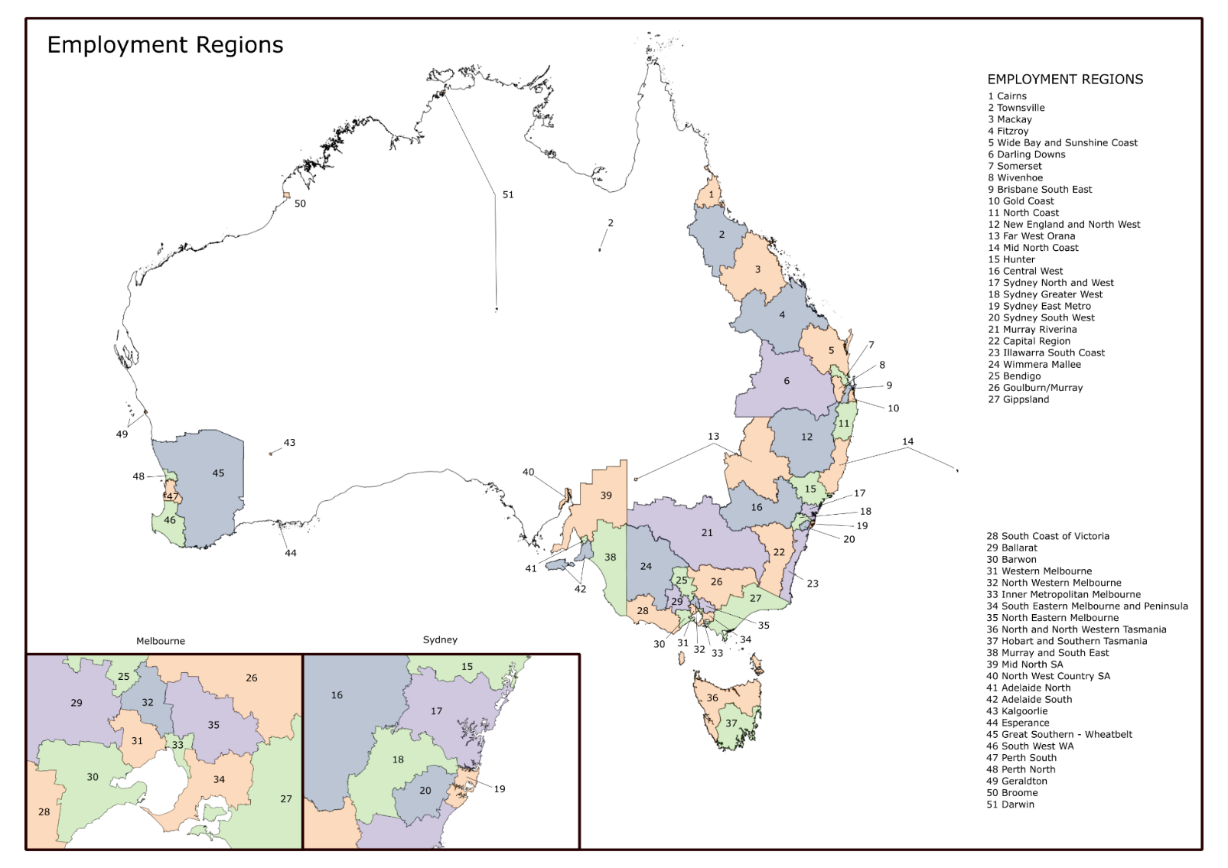

# Appendix D: TtW outcomes and definitions of outcome types

There are two ways to achieve an **approved education outcome**:

* 26 consecutive weeks of full-time participation in, or attainment of:
  + a Certificate III course or higher (this includes a Certificate IV, diploma, advanced diploma, associate degree or bachelor degree; it does not include university bridging or preparation courses), **or**
  + secondary education leading to Year 12 (participation outcomes can be claimed for, for example, Year 10, Year 11 or Year 12, but attainment can only be claimed for completing Year 12), **or**
* 26 **consecutive** weeks of full-time participation in SEE and AMEP can only track towards a participation outcome, not an attainment outcome.

Providers can claim an education participation outcome or an education attainment outcome, but not both, for a qualifying course of study.

An **employment outcome** consists of 12 **cumulative** weeks[54] of employment (which includes apprenticeships, traineeships and unsubsidised self-employment) during a participant’s time in the service. The 12 cumulative weeks can comprise multiple periods of at least four weeks.

A hybrid outcome is 12 consecutive weeks combining education and employment.

TtW providers can claim a sustainability outcome where a 12-week outcome (employment or hybrid) is followed by an additional consecutive 14 weeks of employment or combined employment and education. A 12-week employment outcome can lead to a hybrid sustainability outcome, and a 12-week hybrid outcome can lead to an employment sustainability outcome. It is important to note that sustainability outcomes are always paid outcomes and do not count towards the Outcome Performance Target. The requirements for achieving each outcome type vary depending on the income support status and MORs of the participant, as summarised in **Table D.1**.

Table D.1: TtW outcome types

| Income support status | Participant characteristics | 12-week employment outcome or sustainability outcome (employment) | Education outcome: participation (26 weeks) | Education outcome: attainment | 12-week hybrid outcome or sustainability outcome (hybrid) |
| --- | --- | --- | --- | --- | --- |
| Receiving income support payment |  | Work which reduces income support payment by 60%  Work in pre-existing employment which reduces income support payment by 100% | Study full time while the course is running | Achieve:  Year 12  Certificate III or higher | Study and work 25 hours on average per week |
| Receiving income support payment | Part-time MORs of 30 hours each fortnight | Work an average of 10 hours per week  Work in pre-existing employment for at least an average of 15 hours per week | Study an average of 15 hours per week while the course is running | Achieve:  Year 12  Certificate III or higher | Study and work 15 hours on average per week |
| Receiving income support payment | Partial capacity to work | Work an average 70% of the minimum number of hours per week but not less than an average of 8 hours per week  Work in pre-existing employment for 100% of the minimum number of hours per week but not less than an average of 8 hours per week | Study 100% of the minimum number of hours per week while the course is running | Achieve:  Year 12  Certificate III or higher | Study and work 100% of the minimum number of hours per week |
| Receiving income support payment | Receiving Parenting Payment (Partnered or Single) without MORs and chooses to work reduced hours | Work an average of 10 hours per week  Work in pre-existing employment for at least an average of 15 hours per week | Study an average of 10 hours per week while the course is running | Achieve:  Year 12  Certificate III or higher | Study and work 10 hours on average per week |
| Receiving income support payment | Receiving a Carer Payment and chooses to work reduced hours | Work an average of 10 hours per week  Work in pre-existing employment for at least an average of 15 hours per week | Study an average of 10 hours per week while the course is running | Achieve:  Year 12  Certificate III or higher | Study and work 10 hours on average per week |
| Not receiving income support payment | Volunteer | Work an average of 15 hours per week  Work in pre-existing employment for at least an average of 20 hours per week | Study full time while the course is running | Achieve:  Year 12  Certificate III or higher | Study and work 25 hours on average per week |

# Appendix E: Data sources

### Data Source 1: Departmental administrative data

The Department’s administrative data collection includes information on participant demographics, referrals, commencements and paid outcomes. Providers interact with the ESS to record program data such as participant job plans, job placements and activities. Administrative data was the source for the extraction of the TtW inflow population, as well as the matched TtW and jobactive participant samples.

### Data Source 2: Research and Evaluation Database (RED)

The RED, maintained by the department and constructed from DHS administrative data, includes information relating to periods of income support assistance such as income support types, base rates and reported earnings. The RED was the source for several indicators used in the construction of the LMA and positive outcome measures.

### Data Source 3: 2016 TtW Provider Survey

#### Purpose

To collect providers’ feedback on the initial service implementation process, operational parameters and participant engagement.

#### Sample

The 2016 TtW Provider Survey enumerated all TtW service providers. Staff from all TtW provider sites operating at either full-time or part-time capacity were invited to participate, including outreach sites. The respondent sample comprised 242 completed survey questionnaires from the 264 TtW provider sites invited to participate, for an overall response rate of 92%.

#### Data collection

The surveys were delivered using the Qualtrics online platform for self-enumeration by provider staff. Round One data collection was conducted over October and November 2016. Providers’ views were canvassed on:

* implementation of TtW service
* caseload management
* assessing and servicing participants
* servicing employers.

#### Profile

The majority of states and territories had response rates over 90%, with three achieving 100% completion (**Table E.1**). The distribution of respondents by organisational role for the 2016 and 2017 TtW Provider Surveys is shown in **Figure E.1**. For both surveys, the most common respondent role was Site Manager, followed by Employment Consultant / Case Manager.

Table E.1: 2016 TtW Provider Survey response rates

| State/Territory | Sample (n=) | Completions (n=) | Response rate (%) |
| --- | --- | --- | --- |
| NSW/ACT | 88 | 81 | 92.0 |
| VIC | 69 | 57 | 82.6 |
| QLD | 54 | 51 | 94.4 |
| SA/NT | 23 | 23 | 100.0 |
| WA | 22 | 22 | 100.0 |
| TAS | 8 | 8 | 100.0 |
| Total | 264 | 242 | 91.7 |

Source: 2016 TtW Provider Survey

Figure E.1: 2016 and 2017 TtW Provider Survey respondent roles

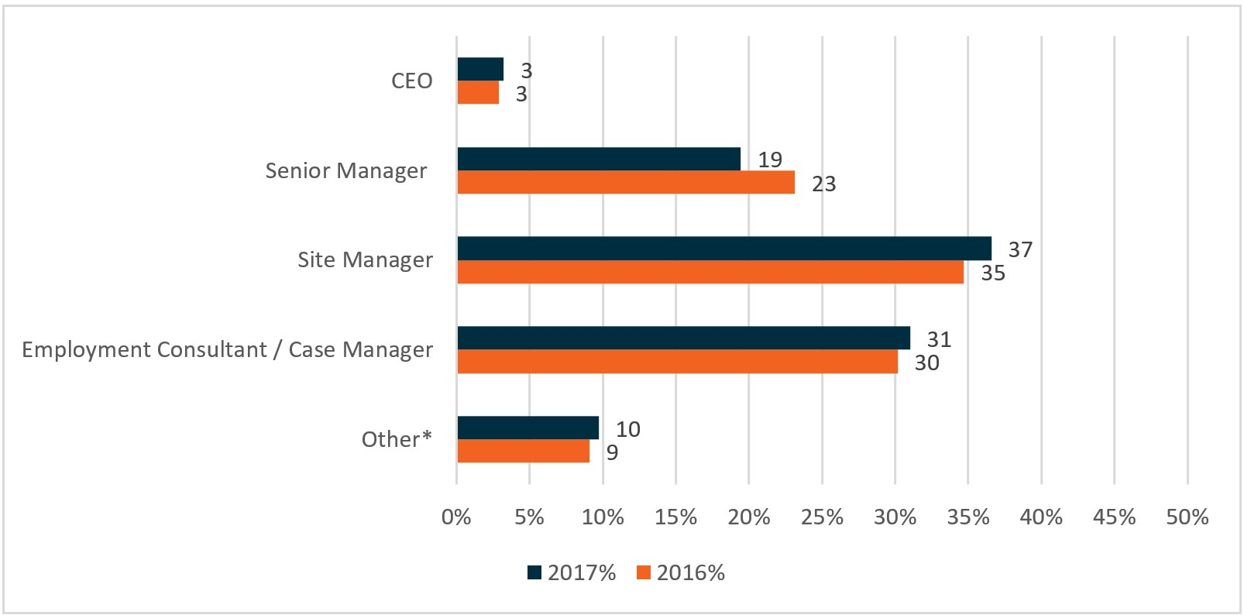

Base: all respondents (2017: n=216, 2016: n=242)

2016/2017 QA2 – Which of the following best reflects your current role (if you have multiple roles, please select the one that takes up most of your time)?

* Other includes Job Broker / Employer Account Manager, Post-Placement Support Officer, Administrator / Office Manager / Reception, and Other (please specify)

### Data Source 4: 2017 TtW Provider Survey

#### Purpose

To collect providers’ feedback on service effectiveness, efficiency and quality and to facilitate the identification of good practice.

#### Sample

Like the 2016 equivalent, the 2017 TtW Provider Survey enumerated all TtW service provider sites, including full-time, part-time and outreach sites. The respondent sample comprised 216 responses from 277 invitations to TtW provider sites, giving a response rate of 78%.

#### Data collection

The surveys were delivered using the Qualtrics online platform for self-enumeration by provider staff. Data collection was conducted from November to December 2017. Providers’ views were canvassed on:

* attitudes towards TtW
* caseload management
* assessing and servicing participants
* servicing employers.

#### Profile

Response rates were variable across states and territories, ranging from 50% in Western Australia to 100% in Tasmania, delivering the overall response rate of 77% (**Table E.2**). Survey respondents tended to have more experience in employment services than youth services. Half of the respondents reported that they had been working in employment services for five or more years (**Figure E.2**).

Table E.2: 2017 TtW Provider Survey response rates

| State/Territory | Sample (n=) | Completions (n=) | Response rate (%) |
| --- | --- | --- | --- |
| NSW/ACT | 96 | 78 | 81 |
| VIC | 71 | 54 | 76 |
| QLD | 57 | 53 | 93 |
| SA/NT | 23 | 12 | 52 |
| WA | 22 | 11 | 50 |
| TAS | 8 | 8 | 100 |
| Total | 277 | 216 | 78.0 |

Source: 2017 TtW Provider Survey

Figure E.2: Respondent experience in employment and youth services

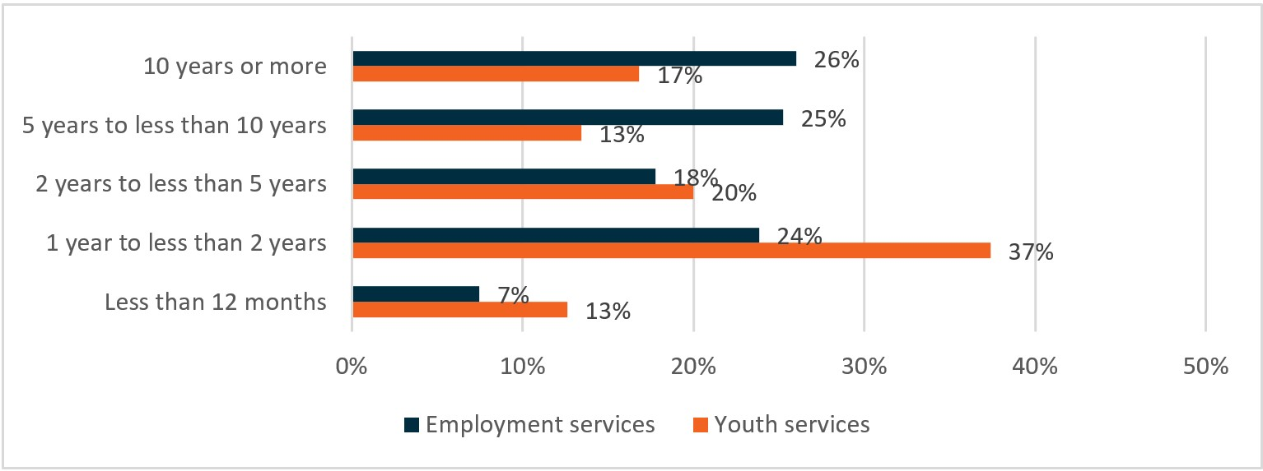

Base: all respondents (n=216)

QA3 – How long have you worked in the employment services/youth sector?

Source: 2017 TtW Provider Survey

### Data Source 5: 2017 JSEES Survey

#### Purpose

In order to explore the views and experiences of TtW and jobactive participants, a survey was developed. This survey focused on referrals to TtW, barriers to finding and maintaining work, and the assistance participants received from providers. In addition, the jobactive component of the JSEES Survey examined job seekers’ views on the labour market and their views on other pre-employment programs.

#### Sample

The participant sample was stratified into two sub-groups based on whether a participant’s TtW provider met their Outcome Performance Target. The cooperation rate (defined as the number of completed interviews as a proportion of refusals plus completed interviews) was 81.2%. An interview was conducted with 34.4% of the ‘initiated sample’ (n=1,745). The initiated sample consists of sample members who had at least one attempted call placed to them during the survey fieldwork period.

The jobactive sample was a stratified random sample of active jobactive participants (excluding volunteers) receiving Newstart Allowance, Youth Allowance (Other), Parenting Payment (Single) or Parenting Payment (Partnered). The sample was stratified on age, stream and Indigenous status. The cooperation rate was 69.5%. Of the initiated sample, 29.1% (n=10,306) completed an interview.

#### Data collection

SRC was commissioned to undertake the 2017 JSEES Survey research and the department collaborated with SRC throughout the survey development and design stages. The survey design involved the conduct of interviews by Computer Assisted Telephone Interviewing (CATI) in August and September 2017. Up to eight calls were made to establish contact with a survey member. The average survey length was 14.9 minutes for TtW participants and 16.9 minutes for jobactive participants.

#### Profile

The achieved interview profile for the TtW sample was consistent with the population, with the largest variations occurring in the distribution of age groups and TtW groups (**Table E.3**). Three-quarters (76.3%) of interviews were completed by respondents aged 18 to 22 years, and 68.8% were with Group One participants. A weighting method was used to correct for differences between the achieved interviews and population.

Table E.3: 2017 JSEES respondent profile

| Characteristic | Interviews (n=600) % | Sample file (n=2,000) % | Population (n=9,973) % |
| --- | --- | --- | --- |
| **Gender** | – | – | – |
| Male | 58.2 | 57.8 | 58.2 |
| Female | 41.8 | 42.2 | 41.8 |
| **Age** | – | – | – |
| Less than 18 years | 15.7 | 18.6 | 18.2 |
| 18 to 22 years | 76.3 | 75.4 | 63.7 |
| 22+ years | 8.0 | 6.1 | 18.0 |
| **TtW group** | – | – | – |
| Group One | 68.8 | 65.3 | 86.6 |
| Group Two | 25.2 | 28.6 | 9.8 |
| Group Three | 6.0 | 6.2 | 1.5 |
| **Market** | – | – | – |
| TtW outcome performance < 100 | 46.0 | 46.0 | 46.6 |
| TtW outcome performance >100 | 54.0 | 54.0 | 53.5 |

Source: 2017 JSEES Survey

The characteristics of the jobactive interviewees were also similar to the population (**Table E.4**). Smaller groups and groups expected to have lower response rates were deliberately over-sampled. As a result, the interview sample slightly over-represents job seekers aged under 22 or over 50, Indigenous job seekers and job seekers who live in regional or remote areas. As with the TtW sample, responses to the jobactive survey were weighted to reflect differences between the interview sample and the population.

Table E.4: 2017 jobactive interviewee characteristics

| Characteristic | Interviews  (n=3,000) % | Sample file (n=14,565) % | Population (n=591,509) % |
| --- | --- | --- | --- |
| **Gender** | – | – | – |
| Male | 54.5 | 53.3 | 51.8 |
| Female | 45.5 | 46.7 | 48.2 |
| **Age** | – | – | – |
| Under 22 years | 14.7 | 14.5 | 10.5 |
| 22 to 29 years | 21.3 | 21.5 | 24.6 |
| 30 to 49 years | 39.3 | 39.2 | 43.7 |
| 50+ years | 24.7 | 24.9 | 21.2 |
| **Unemployment length** | – | – | – |
| 12+ months | 66.2 | 66.2 | 65.4 |
| Under 12 months | 33.8 | 33.8 | 34.6 |
| **Location** | – | – | – |
| Inner regional | 26.7 | 25.3 | 23.1 |
| Major cities | 55.3 | 57.2 | 61.6 |
| Outer regional / Remote / Very remote | 16.6 | 15.8 | 13.8 |
| **Employment stream** | – | – | – |
| Stream A | 42.0 | 42.4 | 43.2 |
| Stream B | 39.0 | 39.1 | 38.9 |
| Stream C | 19.0 | 18.6 | 18.0 |
| **Indigenous** | – | – | – |
| Yes | 15.0 | 14.3 | 10.7 |
| No | 85.0 | 85.7 | 89.3 |
| **Work status\*** | – | – | – |
| Working full time | 8.9 | n/a | n/a |
| Working part time | 26.5 | n/a | n/a |
| Not currently working | 62.9 | n/a | n/a |
| **Could not determine work status | 1.8 | n/a | n/a |

* Data not available for sample file/population as this is a survey derived variable.

** Established that the respondent was in paid employment but could not determine the total number of hours worked to be allocated to ‘full time’ or ‘part time’.

Source: 2017 JSEES Survey

### Data Source 6: 2017 Employer Survey

#### Purpose

The purpose of this second survey was to better understand and monitor employers’ experiences in recruiting and hiring job seekers under TtW. This section refers to the quantitative component of the Employer Survey. The qualitative component is included in Data Source 8.

#### Sample

Employers identified by the department as having hired a young person who was on the TtW caseload were approached to take part in the Employer Survey. The sample was based on employers that were recorded as having employed a TtW participant to fill an employment vacancy in the six months prior to the survey. Employers may not have necessarily been aware that the employee was previously on the TtW caseload, as some participants source their own employment opportunities. A total of 351 interviews were completed with employers, resulting in a response rate (interviews as a proportion of refusals plus completed interviews) of 66.5%.

#### Data collection

The survey was conducted by the SRC on behalf of the department in March and April 2017. It was delivered via CATI, with up to six call attempts made to establish contact with the selected business, and up to four further attempts made to achieve an interview with the selected respondent. The average interview length was 18.2 minutes.

#### Profile

A variety of businesses responded to the survey (**Table E.5**). Employers that recruited five or fewer staff in the six months prior to the survey made up 56% of all respondents, and slightly over half (52%) of businesses reported that they had multiple workplaces across Australia. A small proportion of respondents were recruitment agencies or labour hire companies, and 15% of all businesses had an Indigenous employment strategy.

Table E.5: 2017 Employer Survey respondent profile

| Business characteristic | Interviews (n=351) % |
| --- | --- |
| Number of staff hired in the last 6 months | – |
| 1 | 13 |
| 2–5 | 43 |
| 6–10 | 16 |
| 10–20 | 14 |
| 20 or more | 14 |
| Number of staff (total business) | – |
| Self-employed | 1 |
| 1–4 employees | 14 |
| 5–19 employees | 31 |
| 20–99 employees | 23 |
| 100–199 employees | 4 |
| 200 or more employees | 24 |
| Do not know / Refused | 3 |
| Does business have multiple workplaces | – |
| Yes | 52 |
| Company type | – |
| Recruitment agency | 1 |
| Labour hire company | 3 |
| Both recruitment agency and labour hire company | 1 |
| Not a labour hire or a recruitment agency | 93 |
| Indigenous employment focus | – |
| Indigenous employment strategy | 15 |
| Indigenous employment target | 5 |
| Total interviews | 351 |

Source: 2017 Employer Survey

### Data Source 7: 2017–2018 PPM Survey

#### Purpose

This survey aimed to monitor the education and employment participation status of participants while, or after, participating in TtW, as well as improvement in soft skills such as communication skills, organisational skills and work readiness.

#### Sample

The PPM Survey was conducted on TtW participants who either had exited TtW or were on the TtW caseload between 1 July 2017 and 30 June 2018. Over a quarter (28.0%) of all surveyed participants (23,319) responded. This provided the department with a statistically representative sample of all young people who participated in TtW during the 12-month period, and all reported results were within a maximum confidence interval of +/- 5%.

#### Data collection

The survey was conducted by the department across 2017 and 2018. A variety of methods were used to contact participants, and multiple follow-up contacts were made for non-respondents. Initial contact was via email, if available, or a letter if there was no recorded email address. Non-respondents with a recorded mobile phone number were sent an SMS, followed by contact from the department’s call centre for remaining non-respondents. Participants could respond via an online survey, paper survey (mail contact only) or telephone interview (phone contact only).

### Data Source 8: Qualitative research ­– Wave 1

#### Purpose

This section examined the implementation and early utilisation of TtW from the perspective of key stakeholder groups. Key themes explored include model establishment, participant engagement and service quality, efficiency and effectiveness. This section refers to the first wave of qualitative research, which occurred in 2016. The second wave was conducted in 2018 and is described in Data Source 9.

#### Sample

Qualitative discussions were held with TtW participants, providers and DHS staff in 12 areas across six ERs. A total of 67 participants, 45 provider staff and 19 DHS staff were spoken to. Discussions were also held with representatives from the two peak bodies for providers: Jobs Australia and NESA. Interviews were also conducted with seven employers who had recently hired TtW participants.

#### Data collection

The qualitative fieldwork was undertaken in late 2016 by the SRC on behalf of the department. Focus groups were held with TtW participants, with the number of participants in each ranging from four to 12. Interviews with provider staff and DHS staff were largely face-to-face, with some additional interviews conducted via telephone. Telephone in-depth interviews were held with employers.

#### Profile

**Table E.6** summarises the number of research participants in each area. Interviews with providers were conducted with regional and site managers, as well as frontline staff. A mix of for-profit and not-for-profit providers were included, as well as providers that only delivered TtW and those that also delivered other employment services. Interviews with DHS staff were held with site managers and call centre staff.

Table E.6: Qualitative research – Wave 1 participants

| Area | Employment region | TtW participants in focus group (no) | Provider staff (no) | DHS staff (no) |
| --- | --- | --- | --- | --- |
| Area 1 | Melbourne (Western) | 6 | 1 | – |
| Area 2 | Melbourne (Western) | 8 | 4 | 2 |
| Area 3 | Melbourne (South Eastern) | 6 | 7 |  |
| Area 4 | Melbourne (South Eastern) | 6 | 3 | 3 |
| Area 5(a) | New England and Northwest | 12 | 4 | 1 |
| Area 6 | Adelaide (North) | 6 | 4 |  |
| Area 7 | Adelaide (North) | 5 | 5 | – |
| Area 8 | Adelaide (North) | – | 3 | 3 |
| Area 9 | Mid-North Coast | 4 | 3 | 2 |
| Area 9 | Mid-North Coast | 5 | 2 | 3 |
| Area 10 | Mid-North Coast | – | 3 | – |
| Area 11(a) | Mid-North Coast | 9 | 2 | 5 |
| Area 12 | Wide Bay and Sunshine Coast | – | 4 | – |
| Total | – | 67 | 45 | 19 |

(a) Two focus groups were held in these areas.

Source: Qualitative research – Wave 1

### Data Source 9: Qualitative research – Wave 2

#### Purpose

This section examined the implementation, ongoing utilisation and impact and outcomes of TtW from the perspective of different stakeholder groups. This wave followed Wave 1 and was conducted between March and May 2018.

#### Sample

Six ERs and five key stakeholder groups were selected for inclusion in this research: The stakeholders were:

* TtW participants
* TtW provider staff
* jobactive providers who had been involved in the transition of TtW participants after 12 months in the service
* employers who had recently employed TtW participants
* peak body organisations.

Six focus groups were held with a total of 31 participants, and a total of 29 TtW and jobactive staff were interviewed. Five additional TtW providers were interviewed after opting to participate in the research, representing four additional ERs. There were 13 in-depth telephone interviews with employers. Discussions were held with representatives from the two peak body organisations for providers: Jobs Australia and NESA.

#### Data collection

The SRC undertook this wave of qualitative fieldwork, on behalf of the department, between March and May 2018. As in Wave 1, a combination of focus groups and in-depth face-to-face and telephone interviews were conducted.

#### Profile

**Table E.7** summarises the number of participants involved in each focus group, which occurred in four of the six ERs. Interviews with provider staff included national and regional managers and frontline consultants, across 11 ERs (**Table E.8**).

Table E.7: Qualitative research – Wave 2 focus groups

| Focus group number | Employment region | Number of participants |
| --- | --- | --- |
| Focus Group 1(a) | Melbourne (South Eastern) | 9 |
| Focus Group 2 | Melbourne (South Eastern) | 4 |
| Focus Group 3 | Sydney Greater Western | 3 |
| Focus Group 4 | Illawarra South | 2 |
| Focus Group 5 | Adelaide North | 7 |
| Focus Group 6 | Adelaide North | 6 |
| Total | – | 31 |

(a) One TtW focus group was held in this area as well as a separate focus group with jobactive job seekers who had transitioned from TtW (non-participation or completed 12 months in TtW).

Source: Qualitative research – Wave 2

Table E.8: Qualitative research – Wave 2 provider participants

| Region | Area | Employment region | Provider staff |
| --- | --- | --- | --- |
| Region 1(a) | Area 1 | Melbourne (South Eastern) | 3 |
| Region 1 | Area 2 | Melbourne (South Eastern) | 3 |
| Region 2 | Area 3 | Sydney Greater Western | 2 |
| Region 2 | Area 4 | Sydney Greater Western | 1 |
| Region 3(a) | Area 5 | Illawarra South | 3 |
| Region 4 | Area 6 | Adelaide North | 2 |
| Region 4 | Area 7 | Adelaide North | 2 |
| Region 5(a) | Area 8 | Perth South | 6 |
| Region 6 | Area 9 | Hobart | 1 |
| Additional TtW providers | – | – | – |
| Region 7 | Area 10 | Mid-North Coast | 1 |
| Region 8 | Area 11 | North Western Melbourne | 1 |
| Region 9 | Area 12 | Ballarat | 1 |
| Region 10 | Area 13 | Goulburn/Murray | 2 |
| Region 11 | Area 14 | Murray Riverina | 1 |
| Total | ­ | 31 | 29 |

(a) Interview with jobactive provider in this region.

Source: Qualitative research – Wave 2

# Appendix F: The study population methodology and demographics

### Construction of study population

The primary inflow population included participants referred to the TtW service during the inflow period between 1 April 2016 and 31 March 2017. It excludes any initial caseload referrals from jobactive. This study population consisted of new applicants for Youth Allowance (Other) (Group One), disengaged young people recruited by providers and other eligible young people receiving non-activity-tested income support payments (Group Two) and suitable Stream C participants referred from jobactive (Group Three). Population members were identified from departmental administrative data.

The study population consisted of participants who commenced in the service. The evaluation followed participants for various time periods for different types of analyses, with most participants observed for at least 18 calendar months following referral to TtW.

An inflow population of jobactive participants was constructed for the same period as the TtW inflow population (between 1 April 2016 and 31 March 2017). This population was restricted to Stream B participants aged under 22 years at referral who had not been in TtW in the 91 days prior to referral. The primary use for this inflow population was to provide the matched jobactive sample, described below.

### Matched TtW and jobactive samples construction

Matched samples of TtW and jobactive participants were constructed for the purpose of impact analysis of the effects of the TtW service model on labour market and educational outcomes for TtW participants, compared to similar jobactive participants. The base populations used for the matching process were the TtW and jobactive inflow populations. Unless otherwise stated the matched populations were followed for 12 months from referral.

To ensure that the TtW and jobactive participant groups had similar levels of disadvantage, a number of different sets of characteristics were investigated for use as matching variables. While all have shortcomings, the final comparison populations selected for analysis consisted of commenced participants from both programs matched on their education attainment (under Year 12 or Year 12 and above) and JSCI score group (JSCI scores were distributed into four groups). Although the final matched TtW sample was found to be statistically different to the broader TtW inflow population, having the matched TtW and jobactive samples constructed with similar levels of disadvantage based on JSCI score range minimises the characteristics that need to be controlled for in analyses between these two groups.

It was important to note that participants in one service may still have been different in some ways from those in the other. For instance, young people who are less motivated or face greater barriers to workforce participation, such as poor language skills, mental illness or homelessness, may opt to go or be referred to jobactive rather than participate in the 12 months of activity-intensive services offered in TtW. The logistic regression analysis (described in Appendix H) aims to mitigate differences between the TtW and jobactive participant samples by including a range of control factors (independent variables).

### Demographics

Table F.1: Demographic characteristics of TtW inflow population and matched TtW and jobactive samples (1 April 2016 to 31 March 2017)

| Factor/Level | TtW inflow population n=27,241  (no) | TtW inflow population n=27,241  (%) | TtW matched sample n=12,105  (no) | TtW matched sample n=12,105  (%) | jobactive matched sample n=12,105  (no) | jobactive matched sample n=12,105  (%) |
| --- | --- | --- | --- | --- | --- | --- |
| **Age** | – | – | – | – | – | – |
| 15 | 357 | 1.3 | 153 | 1.3 | 15 | 0.1 |
| 16 | 2,950 | 10.8 | 1,314 | 10.9 | 930 | 7.7 |
| 17 | 5,824 | 21.4 | 2,611 | 21.6 | 2,087 | 17.2 |
| 18 | 7,079 | 26.0 | 3,025 | 25.0 | 3,184 | 26.3 |
| 19 | 4,413 | 16.2 | 1,999 | 16.5 | 2,163 | 17.9 |
| 20 | 3,583 | 13.2 | 1,614 | 13.3 | 1,888 | 15.6 |
| 21 | 3,034 | 11.1 | 1,388 | 11.5 | 1,838 | 15.2 |
| 22 | 0 | 0.0 | 0 | 0.0 | 0 | 0.0 |
| 23 | 1 | 0.0 | 1 | 0.0 | 0 | 0.0 |
| **Education** | – | – | – | – | – | – |
| Special school or support unit | 19 | 0.1 | 10 | 0.1 | 13 | 0.1 |
| Less than Year 10 | 3,382 | 12.4 | 1,531 | 12.6 | 1,697 | 14.0 |
| Did not go to school | 27 | 0.1 | 12 | 0.1 | 32 | 0.3 |
| Year 10/11 | 18,900 | 69.4 | 6,039 | 49.9 | 5,850 | 48.3 |
| Year 12/13 | 259 | 1.0 | 259 | 2.1 | 1,873 | 15.5 |
| Diploma or equivalent | 18 | 0.1 | 18 | 0.1 | 318 | 2.6 |
| Trades qualification | 29 | 0.1 | 29 | 0.2 | 86 | 0.7 |
| Non-trade vocational education | 3,791 | 13.9 | 3,791 | 31.3 | 1,467 | 12.1 |
| Graduate Certificate / Graduate Diploma or equivalent | 15 | 0.1 | 15 | 0.1 | 52 | 0.4 |
| Bachelor degree | 4 | 0.0 | 4 | 0.0 | 316 | 2.6 |
| Other postgraduate | 0 | 0.0 | 0 | 0.0 | 4 | 0.0 |
| Unknown | 797 | 2.9 | 397 | 3.3 | 397 | 3.3 |
| Gender | – | – | – | – | – | – |
| Female | 10,963 | 40.2 | 5,374 | 44.4 | 5,631 | 46.5 |
| Male | 16,277 | 59.8 | 6,730 | 55.6 | 6,474 | 53.5 |
| Unknown | 1 | 0.0 | 1 | 0.0 | 0 | 0.0 |
| **Indigenous status** | – | – | – | – | – | – |
| Does not identify as Indigenous | 21,148 | 77.6 | 8,832 | 73.0 | 9,022 | 74.5 |
| Declined to answer | 558 | 2.0 | 258 | 2.1 | 365 | 3.0 |
| Identifies as Indigenous | 4,739 | 17.4 | 2,619 | 21.6 | 2,322 | 19.2 |
| Unknown | 796 | 2.9 | 396 | 3.3 | 396 | 3.3 |
| **Transport** | – | – | – | – | – | – |
| Own transport | 6,005 | 22.0 | 2,387 | 19.7 | 3,024 | 25.0 |
| Other private transport | 4,047 | 14.9 | 1829 | 15.1 | 1678 | 13.9 |
| Public transport | 14,878 | 54.6 | 6,739 | 55.7 | 6,122 | 50.6 |
| No transport | 1,515 | 5.6 | 754 | 6.2 | 885 | 7.3 |
| Unknown | 796 | 2.9 | 396 | 3.3 | 396 | 3.3 |
| **English** | – | – | – | – | – | – |
| Good | 25,129 | 92.2 | 10,971 | 90.6 | 10,480 | 86.6 |
| Combination of good and poor | 888 | 3.3 | 504 | 4.2 | 645 | 5.3 |
| Poor | 428 | 1.6 | 234 | 1.9 | 584 | 4.8 |
| Unknown | 796 | 2.9 | 396 | 3.3 | 396 | 3.3 |
| **Offender status** |  |  |  |  |  |  |
| Not an ex-offender | 23,741 | 87.2 | 10,364 | 85.6 | 10,271 | 84.8 |
| Declined to answer | 487 | 1.8 | 232 | 1.9 | 356 | 2.9 |
| Ex-offender | 2,217 | 8.1 | 1,113 | 9.2 | 1,082 | 8.9 |
| Unknown | 796 | 2.9 | 396 | 3.3 | 396 | 3.3 |
| **Disability** | – | – | – | – | – | – |
| No disabilities | 24,831 | 91.2 | 10,681 | 88.2 | 10,630 | 87.8 |
| Declined to answer | 172 | 0.6 | 86 | 0.7 | 176 | 1.5 |
| Has one disability | 539 | 2.0 | 290 | 2.4 | 374 | 3.1 |
| Has multiple disabilities | 347 | 1.3 | 229 | 1.9 | 257 | 2.1 |
| 23 to 29 hours work capacity | 69 | 0.3 | 49 | 0.4 | 34 | 0.3 |
| 15 to 22 hours work capacity | 332 | 1.2 | 248 | 2.0 | 138 | 1.1 |
| Less than 15 hours work capacity | 154 | 0.6 | 125 | 1.0 | 99 | 0.8 |
| Less than 8 hours work capacity | 1 | 0.0 | 1 | 0.0 | 1 | 0.0 |
| Unknown | 796 | 2.9 | 396 | 3.3 | 396 | 3.3 |
| **Income support history: duration(a)** | – | – | – | – | – | – |
| Less than 12 months | 4,282 | 15.7 | 2,003 | 16.5 | 2,972 | 24.6 |
| 12 to 23 months | 1,312 | 4.8 | 736 | 6.1 | 1,190 | 9.8 |
| 24 to 35 months | 616 | 2.3 | 390 | 3.2 | 628 | 5.2 |
| 36 to 47 months | 309 | 1.1 | 207 | 1.7 | 332 | 2.7 |
| 48 year to 59 months | 161 | 0.6 | 124 | 1.0 | 130 | 1.1 |
| 60 months or more | 197 | 0.7 | 132 | 1.1 | 257 | 2.1 |
| Not on income support | 19,568 | 71.8 | 8,117 | 67.1 | 6200 | 51.2 |
| Unknown | 796 | 2.9 | 396 | 3.3 | 396 | 3.3 |
| **Income support history: frequency and crisis payment** | – | – | – | – | – | – |
| More than once on income support | 4,834 | 17.7 | 2,375 | 19.6 | 2,428 | 20.1 |
| Received crisis payment | 231 | 0.8 | 144 | 1.2 | 276 | 2.3 |
| Received crisis payment + multiple spells on income support | 162 | 0.6 | 97 | 0.8 | 197 | 1.6 |
| All others | 21,218 | 77.9 | 9,093 | 75.1 | 8,808 | 72.8 |
| Unknown | 796 | 2.9 | 396 | 3.3 | 396 | 3.3 |
| **Work experience** |  |  |  |  |  |  |
| Paid full-time work (35 hours+) | 3,979 | 14.6 | 1,509 | 12.5 | 1,247 | 10.3 |
| Paid regular part-time work (8 to 30 hours) | 3,113 | 11.4 | 1,123 | 9.3 | 990 | 8.2 |
| Paid regular part-time work (less than 8 hours) | 196 | 0.7 | 68 | 0.6 | 57 | 0.5 |
| Paid seasonal or irregular work | 179 | 0.7 | 62 | 0.5 | 73 | 0.6 |
| Unpaid work (inc voluntary work) | 173 | 0.6 | 93 | 0.8 | 112 | 0.9 |
| Not in the labour force (e.g. caring or studying) | 14,537 | 53.4 | 6,816 | 56.3 | 7,746 | 64.0 |
| Not working but looking for work | 4,268 | 15.7 | 2,038 | 16.8 | 1,484 | 12.3 |
| Unknown | 796 | 2.9 | 396 | 3.3 | 396 | 3.3 |
| **Personal factors** | – | – | – | – | – | – |
| No impact | 24,280 | 89.1 | 10,231 | 84.5 | 10,785 | 89.1 |
| Some impact | 2,165 | 7.9 | 1,478 | 12.2 | 918 | 7.6 |
| Unknown | 796 | 2.9 | 396 | 3.3 | 402 | 3.3 |
| **Multiple disadvantage** | – | – | – | – | – | – |
| No | 26,445 | 97.1 | 11,709 | 96.7 | 11,079 | 96.7 |
| Yes | 0 | 0.0 | 0.0 | 0.0 | 0 | 0.0 |
| Unknown | 796 | 2.9 | 396 | 3.3 | 396 | 3.3 |
| **Housing** |  |  |  |  |  |  |
| Stable residence | 23,859 | 87.6 | 10,278 | 84.9 | 10,093 | 83.4 |
| Primary unstable residence | 121 | 0.4 | 62 | 0.5 | 87 | 0.7 |
| Secondary unstable residence | 2,465 | 9.0 | 1,369 | 11.3 | 1529 | 12.6 |
| Unknown | 796 | 2.9 | 396 | 3.3 | 396 | 3.3 |
| **TtW group** | – | – | – | – | – | – |
| Group One | 24,041 | 88.3 | 10,282 | 84.9 | n/a | n/a |
| Group Two | 2,439 | 9.0 | 1,271 | 10.5 | n/a | n/a |
| Group Three | 759 | 2.8 | 551 | 4.6 | n/a | n/a |
| Unknown | 2 | 0.0 | 1 | 0.0 | n/a | n/a |

Base: study populations (TtW inflow population: n=27,241, TtW matched sample: n=12,105, jobactive matched sample: n=12,105)

* One participant was aged 23 years.

Note: Demographics are as at a participant’s JSCI assessment date, using the JSCI assessment that was closest to their TtW commencement date. Some participants may have been yet to start on income support at this date.

Source: Department of Education, Skills and Employment administrative data

### JSCI score distribution

**Figure F.1** shows the comparative distributions of JSCI scores at commencement for the TtW inflow population and the TtW and jobactive matched samples. JSCI scores were placed into five discrete quintiles, using the JSCI score distribution of the combined TtW and jobactive inflows (n=49,607) to select the JSCI scores to define the quintile boundaries.

Figure F.1: JSCI score distribution of TtW inflow and TtW and jobactive matched samples

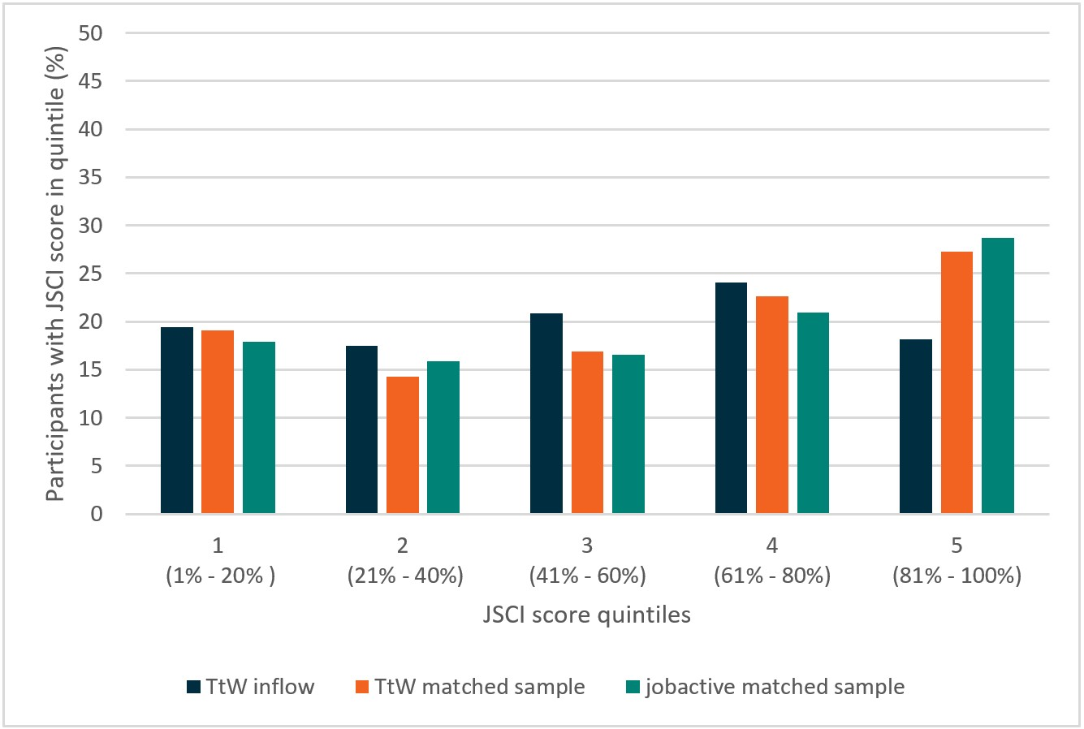

Base: TtW inflow population: n=26,451, TtW matched sample: n=11,714, jobactive matched sample: n=11,719

Note: Some participants did not have a JSCI score around their commencement date.

Source: Department of Education, Skills and Employment administrative data

# Appendix G: Range of activity types in TtW

The TtW service model seeks to improve the skills base of young people and improve their work readiness through participation in education and employment activities.

Table G.1: TtW activity types and sub-types

| Activity type | Activity sub-type |
| --- | --- |
| Part-time/casual paid employment | None |
| Voluntary work in community/non-profit sector | None |
| National Work Experience Programme | NWEP placement |
| Work experience (other) | None |
| Defence Force Reserves | None |
| Other government programs | AMEP  SEE  Vocational, training and employment centres  Australian Apprenticeship Support Network  Innovative Community Action Networks – Flexible  Skilling Queenslanders – Community Work Skills  Empowering YOUth Initiatives  Other government programs |
|  | Bachelor Degree  Associate Degree  Advanced Diploma  Diploma  Certificate I  Certificate II  Certificate III  Certificate IV  Primary school  Secondary school  Accredited units (incl. training for tickets or licences)  Accredited skill set  Accredited units – language, literacy and numeracy (LLN)  Certificate I – LLN  Certificate II – LLN  Certificate III – LLN  Certificate IV – LLN  Pre-employment training |
| Non-accredited education and training (vocational) | Employability skills  Other  Other LLN (non-accredited)  Careers counselling |
| Non-vocational assistance | Cultural services  Interpersonal skills (non-vocational)  Parenting course  Personal development  Addictions intervention |
| Interventions | Counselling services  Disability intervention  Homelessness intervention  Mental health interventions  Medical/health related services  Drug or alcohol detox/rehabilitation |

Source: Department of Education, Skills and Employment administrative data

# Appendix H: Detailed discussion of impact analysis

This appendix contains a detailed discussion of the impact analysis in Chapter 6, including the methodology underlying the logistic regression analyses and the regression model results. It also presents a profile of the total inflow population from which the matched samples were drawn and the impact analysis conducted.

To evaluate the impact of TtW, the analysis measured whether TtW participants were more likely than similar jobactive participants to increase their LMA, study or reduce their reliance on income support. The analysis included several outcome measures for comparing the outcomes of TtW and jobactive participants, namely:

* LMA, which occurs when the income support and job placement information on the department’s IT system suggests a participant has secured some form of employment
* study outcomes, which occur when a participant engages in an education or training activity that could qualify for an outcome payment
* positive outcomes, which occur when a participant achieves either LMA or a study outcome.

**Section 2.9** describes these measures in detail.

This analysis used logistic regression models to identify good practice among TtW providers. Specifically, it examined whether TtW participants with providers that used certain servicing practices had better outcomes than other TtW participants. The outcome measures include the LMA measure, education outcomes and 12- and 26-week employment outcomes. These analyses informed the discussion in Section 4.10.

To supplement the main impact analyses, the evaluation investigated whether TtW helps participants to reduce their reliance on income support. **Section 6.4** discusses the findings of this investigation. This appendix provides detailed outputs from the regression models used to examine whether TtW participants who exited income support were less likely to return to income support than their jobactive counterparts were. It also reports further analysis of whether TtW was effective in helping participants reduce their income support payments, even if it did not help them exit income support entirely. The analysis defines a participant as having achieved an ‘income support reduction’ when their average income support payment over a period is lower than the maximum rate of income support they could have received in the month after referral.

## The impact of TtW on labour market attachment, sustainability and income support reductions

### Methodology

To compare the effectiveness of TtW with jobactive, the evaluation isolated the impact of TtW from the impact of participants’ personal characteristics. The evaluation achieved this using two methods. First, to compare the performance of TtW with jobactive, the evaluation used a matched case-control sampling design to take matched samples of TtW and jobactive participants from the inflow population. This means that the analysis included two groups of TtW and jobactive participants with similar characteristics.

Second, the analysis used logistic regression models that controlled for any remaining differences between the TtW and jobactive matched samples. This means that, rather than just comparing the outcomes of the matched TtW and jobactive participants, the analysis adjusted for the personal characteristics of participants when making the comparisons. **Table H.1** describes the explanatory variables used in these analyses, including the controls.

Table H.1: Explanatory variables used in impact analyses

| Variable | Description |
| --- | --- |
| TtW | Participant is in TtW rather than jobactive |
| Age | Age at referral in years |
| Female | Participant is female rather than male |
| Non-Indigenous | Participant does not identify as Aboriginal or as Torres Strait Islander |
| Year 12 completer | Participant has completed Year 12 |
| Transport | Whether participant has no transport, private transport or public transport for travel to and from work |
| Stable residence | Participant has a stable residence |
| Work history | Whether participant spent most of the previous two years in paid work, unpaid work or not working |
| Income support history | Whether participant spent less than 12 months on income support, spent more than 12 months on income support, or was not on income support before commencing services |
| Good English skills | Participant reports having good English reading and writing skills |
| Personal factors | Participant reports personal barriers to finding work not otherwise recorded in JSCI |
| Disability | Participant has a disability or medical condition |
| Income support and crisis payment | Whether participant has been on income support more than once and/or has received a Crisis Payment |
| Ex-offender | Participant is an ex-offender |
| Geographic location | Whether participant lives in Statistical Area Level 2 (SA2) with Accessibility/Remoteness Index of Australia code ‘Major Cities of Australia’, ‘Inner Regional Australia’, ‘Outer Regional Australia’ or ‘Remote or Very Remote Australia’. |
| Strength of local economy | Internet Vacancy Index (IVI) score for Skill Level 5 (i.e. low-skill) jobs in the participant’s SA2 |

Source: Department of Employment, Skills, Small and Family Business regression analysis

To control for participants’ economic environments, three options were examined:

* IVI score for Skill Level 5 (i.e. low-skill) jobs in a participant’s SA2. This variable indicates the number of online Skill Level 5 job vacancies in the job seeker’s local area
* the proportion of working age people on income support in a participant’s SA2
* the unemployment rate in a participant’s SA2.

The IVI measure was the preferred option with the highest reduction in the models’ Akaike Information Criterion and Schwarz Criterion scores.

To ensure that variables with the strongest impact were included in each model, a stepwise selection was conducted to screen out those that had no statistically significant relationship to outcome variables. The stepwise selection procedure evaluates the significance of the entire categorical variable using a chi-square test. It does not separately evaluate the significance of each individual category within the categorical variable.

To illustrate how the stepwise selection procedure treats categorical variables, consider the residential location variable. Residential location is often included in the final model. However, the individual residential location categories were usually statistically insignificant. This means that, while residential location appears to have some relationship with the outcome variables, it cannot said with confidence that, participants living in major cities for example have better outcomes than do other participants.

### Interpreting the logistic regression tables

The logistic regression tables use odds ratios to represent the relationship between the explanatory or independent variables and the outcome or dependent variable. If a variable has an odds ratio greater than 1, then the variable has a positive relationship with the outcome of interest. Likewise, variables with odds ratios that are lower than 1 have a negative relationship with the outcome. This means that if, for a given outcome variable, TtW servicing has an odds ratio of 1 or more, it is concluded that the TtW has a positive impact on that outcome. Statistically significant effects are identified with an asterisk (*).

The odds ratios associated with the control variables require careful interpretation. Control variables are included in the models to adjust the impact estimates for factors that may influence both outcome achievement and the probability of a participant commencing in TtW. The models do not isolate the impact of each control variable from any other confounding influences. The odds ratios for the control variables are therefore difficult to interpret. They reflect the associations between the control variables and outcome achievement, adjusted for some, but not all, potentially important variables. It is advisable to focus on the odds ratios associated with TtW servicing when reading the logistic regression tables.

The odds ratios for variables with more than two categories also need to be interpreted cautiously. An example is the variable ‘income support history’, which contains three categories: ‘more than 12 months on income support’, ‘less than 12 months on income support’ and ‘no income support history’. The odds ratio for a variable category does not compare the outcomes of participants in that category with those of participants in all other categories. It instead compares the outcomes of participants in that category with participants in a single ‘reference category’. For example, the odds ratio for participants who spent more than 12 months on income support does not compare participants who spent more than a year on income support with all participants who did not. Rather, it compares these participants with young people who had no income support history (the ‘reference group’). In each table, the reference category for each variable is indicated to the right of the forward slash (/).

### Labour market attachment

TtW participants in the inflow population were less likely to achieve LMA compared with the jobactive participants in the inflow population. **Figure H.1** shows the proportion of inflow TtW and jobactive participants achieving LMA at different stages in their service periods. Over half (57.2%) of the jobactive participants in the inflow population achieved LMA outcomes four to 52 weeks after referral, compared with just under half (48.4%) of TtW participants.

Figure H.1: Cumulative percentage of TtW and jobactive participants achieving LMA*, inflow population

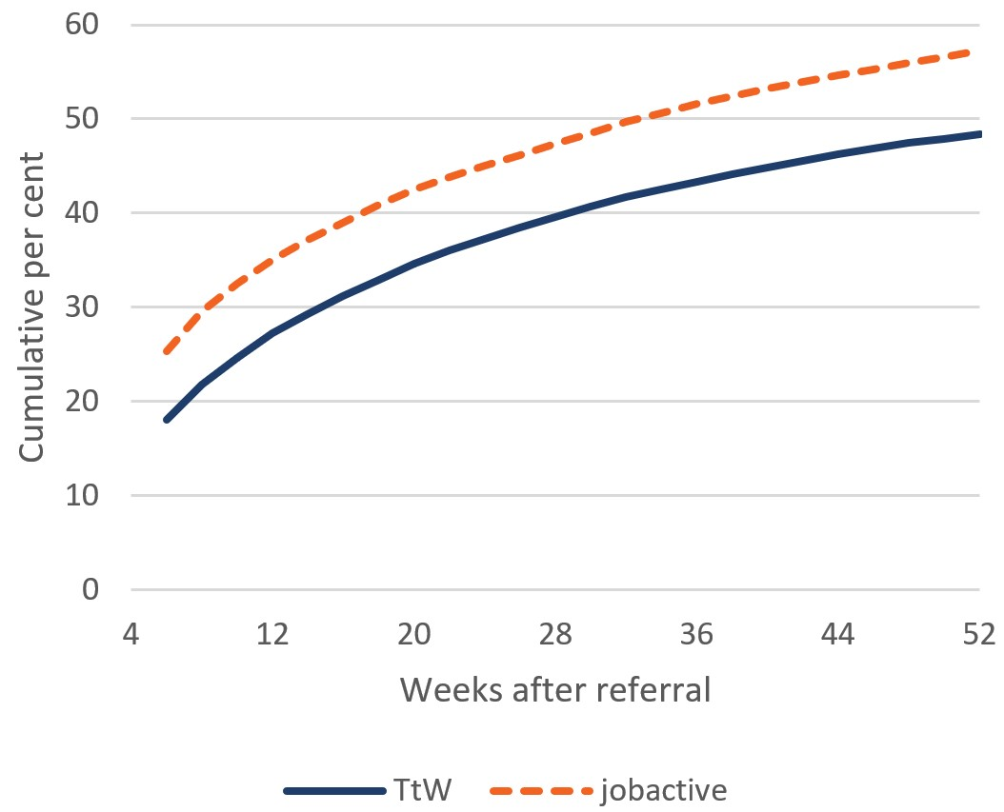

Base: TtW inflow population (n=27,241) and jobactive inflow population (n=24,032)

* A participant achieves LMA when the department’s income support and job placement information indicates they have secured employment. LMA outcomes achieved within four weeks of referral are excluded, as it is unlikely these outcomes resulted from TtW or jobactive servicing.

Source: Department of Education, Skills and Employment administrative data

Even after controlling for participant characteristics, TtW servicing is associated positively with achievements in LMA. However, TtW participants are less likely to achieve LMA in their first year after referral than are jobactive participants; odds ratios are less than 1 for the TtW variable in **Tables H.2**, **H.3** and **H.4**. The difference between TtW and jobactive participants with respect to LMA is largest for participants who have spent longer in services.

Table H.2: Logistic regression model – impact of TtW on probability of achieving LMA1 four to 26 weeks after referral

| Variable | Odds ratio2 | Lower 95% confidence limit | Upper 95% confidence limit |
| --- | --- | --- | --- |
| TtW / jobactive | 0.935* | 0.883 | 0.990 |
| Female / Male | 1.067* | 1.007 | 1.129 |
| Non-Indigenous / Indigenous | 1.670* | 1.551 | 1.798 |
| Year 12 completer / Non-Year 12 completer | 1.572* | 1.481 | 1.669 |
| No transport / Public transport | 0.863* | 0.761 | 0.978 |
| Private transport / Public transport | 1.472* | 1.387 | 1.563 |
| Stable residence / Unstable residence | 1.401* | 1.275 | 1.540 |
| History of paid work / Was not working | 1.710* | 1.596 | 1.831 |
| History of unpaid work / Was not working | 0.704 | 0.491 | 1.011 |
| Less than 12 months on income support / Not on income support | 1.172* | 1.089 | 1.261 |
| More than 12 months on income support / Not on income support | 1.285* | 1.186 | 1.391 |
| Ex-offender / Non-ex-offender or Did not answer | 0.637* | 0.569 | 0.714 |
| Disability / No disability or Did not answer | 0.792* | 0.711 | 0.883 |
| Good English skills / Poor or Combination of good and poor | 1.895* | 1.677 | 2.140 |
| More than once on income support / Other3 | 1.364* | 1.220 | 1.524 |
| Strength of local economy (increased IVI score by 1) | 1.006* | 1.004 | 1.009 |

Base: n (excluding missing) = 23,035

1. A participant achieves LMA when the department’s income support and job placement information indicates they have secured employment. LMA outcomes achieved within four weeks of referral are excluded, as it is unlikely these outcomes resulted from TtW servicing.

2. * variable has statistically significant coefficient: *p* < 0.05

3. ‘Other’ includes the following categories: ‘Received Crisis Payment’, ‘Received Crisis Payment + Multiple spells on income support’, ‘All others’.

Source: Department of Education, Skills and Employment administrative data – matched samples

English proficiency, Year 12 completion, having a history of paid work, stable residence and the strength of the local economy were significantly associated with the probability of achieving LMA. In contrast, Indigenous participants, ex-offenders and participants with disabilities were significantly less likely to achieve LMA. Women were slightly more likely to achieve LMA in the six months after referral than men were, but the association between gender and LMA was statistically insignificant thereafter.

Table H.3: Logistic regression model – impact of TtW on probability of achieving LMA1 four to 38 weeks after referral

| Variable | Odds ratio2 | Lower  95% confidence limit | Upper  95% confidence limit |
| --- | --- | --- | --- |
| TtW / jobactive | 0.899* | 0.850 | 0.951 |
| Non-Indigenous / Indigenous | 1.697* | 1.581 | 1.821 |
| Year 12 completer / Non-Year 12 completer | 1.493* | 1.407 | 1.584 |
| No transport / Public transport | 0.879* | 0.781 | 0.990 |
| Private transport / Public transport | 1.447* | 1.365 | 1.535 |
| Stable residence / Unstable residence | 1.455* | 1.330 | 1.592 |
| History of paid work / Was not working | 1.713* | 1.600 | 1.835 |
| History of unpaid work / Was not working | 0.676* | 0.481 | 0.950 |
| Less than 12 months on income support / Not on income support | 1.154* | 1.074 | 1.239 |
| More than once on income support / Not on income support | 1.247* | 1.154 | 1.348 |
| Ex-offender / Non-ex-offender or Did not answer | 0.617* | 0.555 | 0.685 |
| Disability / No disability or Did not answer | 0.807* | 0.727 | 0.896 |
| Good English skills / Poor or Combination of good and poor | 1.964* | 1.753 | 2.201 |
| Personal factors – No impact / Some impact | 1.245* | 1.121 | 1.383 |
| Strength of local economy (increased IVI score by 1) | 1.007* | 1.004 | 1.009 |

Base: n (excluding missing) = 23,035

1. A participant achieves LMA when the department’s income support and job placement information indicates they have secured employment. LMA outcomes achieved within four weeks of referral are excluded, as it is unlikely these outcomes resulted from TtW servicing.

2. * variable has statistically significant coefficient: *p* < 0.05

Source: Department of Education, Skills and Employment administrative data – matched samples

Table H.4: Logistic regression model – impact of TtW on probability of achieving LMA1 four to 52 weeks after referral

|  |  |  |  |
| --- | --- | --- | --- |
| Variable | Odds ratio2 | Lower 95% confidence limit | Upper 95% confidence limit |
| TtW / jobactive | 0.860* | 0.814 | 0.910 |
| Non-Indigenous / Indigenous | 1.665* | 1.549 | 1.791 |
| Year 12 completer / Non-Year 12 completer | 1.458* | 1.374 | 1.547 |
| No transport / Public transport | 0.865* | 0.772 | 0.970 |
| Private transport / Public transport | 1.411* | 1.330 | 1.496 |
| Stable residence / Unstable residence | 1.401* | 1.285 | 1.528 |
| History of paid work / Was not working | 1.726 | 1.609* | 1.851 |
| History of unpaid work / Was not working | 0.709 | 0.514* | 0.978 |
| Less than 12 months on income support / Not on income support | 1.158 | 1.078* | 1.244 |
| More than 12 months on income support / Not on income support | 1.273 | 1.179* | 1.376 |
| Ex-offender / Non-ex-offender or Did not answer | 0.642 | 0.580* | 0.710 |
| Disability / No disability or Did not answer | 0.817 | 0.738* | 0.904 |
| Good English skills / Poor or Combination of good and poor | 1.910 | 1.714* | 2.128 |
| More than once on income support / Other3 | 0.929 | 0.864* | 0.999 |
| Personal factors – No impact / Some impact | 1.174 | 1.060* | 1.299 |
| Strength of local economy (increased IVI score by 1) | 1.007 | 1.004* | 1.009 |

Base: n (excluding missing) = 23,035

1. A participant achieves LMA when the department’s income support and job placement information indicates they have secured employment. LMA outcomes achieved within four weeks of referral are excluded, as it is unlikely these outcomes resulted from TtW or jobactive servicing.

2. * variable has statistically significant coefficient: *p* < 0.05

3. ‘Other’ includes the following categories: ‘Received Crisis Payment’, ‘Received Crisis Payment + Multiple spells on income support’, ‘All others’.

Source: Department of Education, Skills and Employment administrative data – matched samples

### Study outcomes

TtW participants in the inflow population were more likely to achieve study outcomes than the jobactive participants were, consistent with results from the matched samples analysis. **Figure H.2** shows the cumulative proportion of TtW and jobactive participants in the inflow population achieving study outcomes. Around a fifth of TtW participants (21%) achieved study outcomes in their first year of services, compared with only 10% of jobactive participants.

Figure H.2: Cumulative percentage of TtW and jobactive participants achieving study outcomes*, inflow population

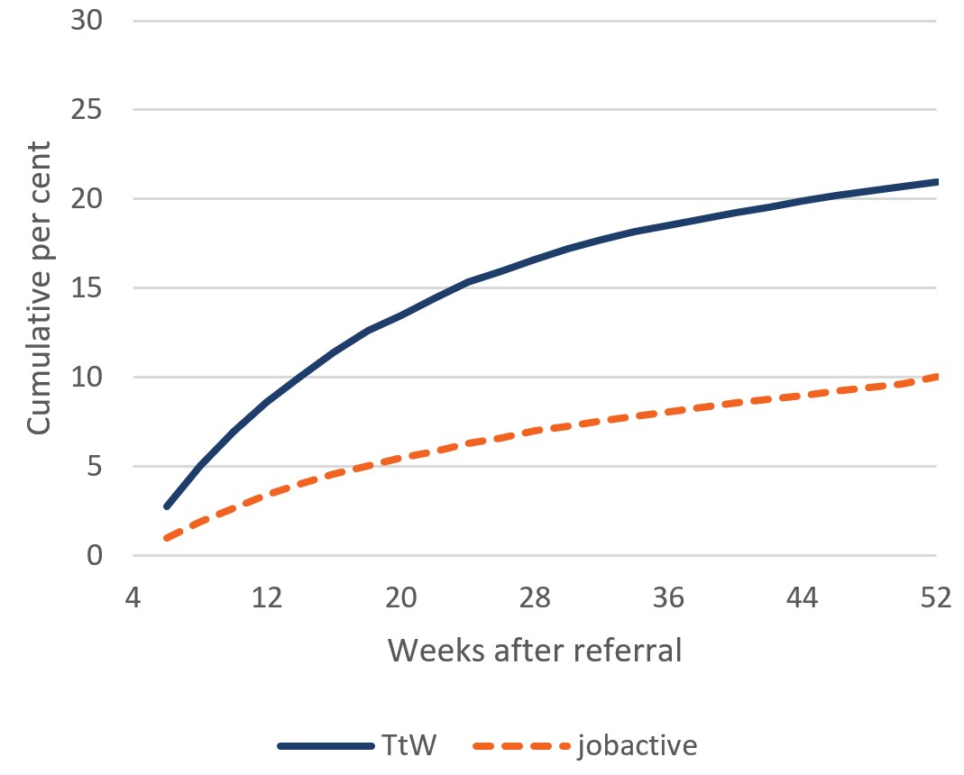

Base: TtW inflow population (n=27,241) and jobactive inflow population (n=24,032)

* A participant achieves study outcomes when they participate in an education or training activity that could qualify for an outcome payment. Study outcomes achieved within four weeks of referral are excluded, as it is unlikely these outcomes resulted from TtW or jobactive servicing.

Source: Department of Education, Skills and Employment administrative data

Logistic regression analysis confirms that TtW is more effective than jobactive at helping participants achieve study outcomes. As **Tables H.5**, **H.6** and **H.7** show, TtW participants are more likely to study over their service periods than are jobactive participants. The impact of TtW on the probability of participants achieving study outcomes in their first six months of servicing is similar to the impact of TtW over the first nine and 12 months of servicing.

Female participants and participants living in stronger local economies were significantly more likely to achieve study outcomes than other participants were. Participant groups that were significantly less likely to achieve study outcomes included older participants, Indigenous participants, Year 12 completers, ex-offenders, and participants with good English proficiency.

Table H.5: Logistic regression model – impact of TtW on probability of achieving study outcomes1 four to 26 weeks after referral

| Variable | Odds ratio2 | Lower 95% confidence limit | Upper 95% confidence limit |
| --- | --- | --- | --- |
| TtW / jobactive | 2.274* | 2.090 | 2.475 |
| Age (increased by one year) | 0.914* | 0.888 | 0.941 |
| Female / Male | 1.439* | 1.326 | 1.561 |
| Non-Indigenous / Indigenous | 1.200* | 1.074 | 1.341 |
| Year 12 completer / Non-Year 12 completer | 0.811* | 0.739 | 0.889 |
| No transport / Public transport | 0.995 | 0.844 | 1.173 |
| Private transport / Public transport | 0.833* | 0.761 | 0.912 |
| Stable residence / Unstable residence | 1.260* | 1.108 | 1.433 |
| Ex-offender / Non-ex-offender or Did not answer | 0.729* | 0.620 | 0.856 |
| Good English skills / Poor or Combination of good and poor | 0.736* | 0.638 | 0.850 |
| More than once on income support / Other3 | 0.874* | 0.777 | 0.983 |
| Lives in inner regional Australia / Remote or very remote Australia | 1.169 | 0.837 | 1.632 |
| Lives in major cities / Remote or very remote Australia | 0.978 | 0.700 | 1.366 |
| Lives in outer regional Australia / Remote or very remote Australia | 1.315 | 0.940 | 1.838 |
| Strength of local economy (increased IVI score by 1) | 1.008* | 1.005 | 1.011 |

Base: n (excluding missing) = 23,035

1. A participant achieves study outcomes when they participate in an education or training activity that could qualify for an outcome payment. Study outcomes achieved within four weeks of referral are excluded, as it is unlikely these outcomes resulted from TtW or jobactive servicing.

2. * variable has statistically significant coefficient: *p* < 0.05

3. ‘Other’ includes the following categories: ‘Received Crisis Payment’, ‘Received Crisis Payment + Multiple spells on income support’’, ‘All others’.

Source: Department of Education, Skills and Employment administrative data – matched samples

Table H.6: Logistic regression model – impact of TtW on probability of achieving study outcomes1 four to 38 weeks after referral

| Variable | Odds ratio2 | Lower 95% confidence limit | Upper 95% confidence limit |
| --- | --- | --- | --- |
| TtW / jobactive | 2.220* | 2.054 | 2.400 |
| Age (increased by one year) | 0.915* | 0.891 | 0.940 |
| Female / Male | 1.462* | 1.355 | 1.577 |
| Non-Indigenous / Indigenous | 1.196* | 1.079 | 1.326 |
| Year 12 completer / Non-Year 12 completer | 0.772* | 0.708 | 0.841 |
| No transport / Public transport | 0.983 | 0.843 | 1.146 |
| Private transport / Public transport | 0.840* | 0.772 | 0.914 |
| Stable residence / Unstable residence | 1.190* | 1.058 | 1.338 |
| Ex-offender / Non-ex-offender or Did not answer | 0.737* | 0.636 | 0.854 |
| Good English skills / Poor or Combination of good and poor | 0.752* | 0.658 | 0.859 |
| More than once on income support / Other3 | 0.865* | 0.776 | 0.965 |
| Lives in inner regional Australia / Remote or very remote Australia | 1.256 | 0.917 | 1.722 |
| Lives in major cities / Remote or very remote Australia | 1.053 | 0.768 | 1.445 |
| Lives in outer regional Australia / Remote or very remote Australia | 1.358 | 0.989 | 1.865 |
| Strength of local economy (increased IVI score by 1) | 1.008* | 1.005 | 1.011 |

Base: n (excluding missing) = 23,035

* A participant achieves study outcomes when they participate in an education or training activity that could qualify for an outcome payment. Study outcomes achieved within four weeks of referral are excluded, as it is unlikely these outcomes resulted from TtW or jobactive servicing.

2. * variable has statistically significant coefficient: *p* < 0.05

3. ‘Other’ includes the following categories: ‘Received Crisis Payment’, ‘Received Crisis Payment + Multiple spells on income support’, ‘All others’.

Source: Department of Education, Skills and Employment administrative data – matched samples

Table H.7: Logistic regression model – impact of TtW on probability of achieving study outcomes1 four to 52 weeks after referral

| Variable | Odds ratio2 | Lower 95% confidence limit | Upper 95% confidence limit |
| --- | --- | --- | --- |
| TtW / jobactive | 2.125* | 1.975 | 2.287 |
| Age (increased by one year) | 0.925* | 0.901 | 0.950 |
| Female / Male | 1.428* | 1.329 | 1.535 |
| Non-Indigenous / Indigenous | 1.176* | 1.067 | 1.296 |
| Year 12 completer / Non-Year 12 completer | 0.755* | 0.695 | 0.819 |
| No transport / Public transport | 0.988 | 0.855 | 1.142 |
| Private transport / Public transport | 0.844* | 0.779 | 0.915 |
| Stable residence / Unstable residence | 1.202* | 1.076 | 1.343 |
| History of paid work / Was not working | 0.847* | 0.769 | 0.932 |
| History of unpaid work / Was not working | 0.927 | 0.601 | 1.430 |
| Ex-offender / Non-ex-offender or Did not answer | 0.700* | 0.607 | 0.806 |
| Good English skills / Poor or Combination of good and poor | 0.757* | 0.667 | 0.859 |
| More than once on income support / Other3 | 0.848* | 0.765 | 0.941 |
| Lives in inner regional Australia / Remote or very remote Australia | 1.208 | 0.902 | 1.616 |
| Lives in major cities of Australia / Remote or very remote Australia | 0.974 | 0.727 | 1.304 |
| Lives in outer regional Australia / Remote or very remote Australia | 1.305 | 0.973 | 1.749 |
| Strength of local economy (increased IVI score by 1) | 1.008* | 1.005 | 1.011 |

Base: n (excluding missing) = 23,035

* A participant achieves study outcomes when they participate in an education or training activity that could qualify for an outcome payment. Study outcomes achieved within four weeks of referral are excluded, as it is unlikely these outcomes resulted from TtW or jobactive servicing.

2. * variable has statistically significant coefficient: *p* < 0.05

3. ‘Other’ includes the following categories: ‘Received Crisis Payment’, ‘Received Crisis Payment + Multiple spells on income support’, ‘All others’.

Source: Department of Education, Skills and Employment administrative data – matched samples

### Positive outcomes

As in the matched samples, the logistic regression analysis found that the TtW and jobactive participants in the inflow population had similar positive outcome rates. As **Figure H.3** shows, 58.2% of TtW participants achieved positive outcomes four to 52 weeks after referral, compared with 62.3% of jobactive participants.

Figure H.3: Cumulative percentage of TtW and jobactive participants achieving positive outcomes*, inflow population

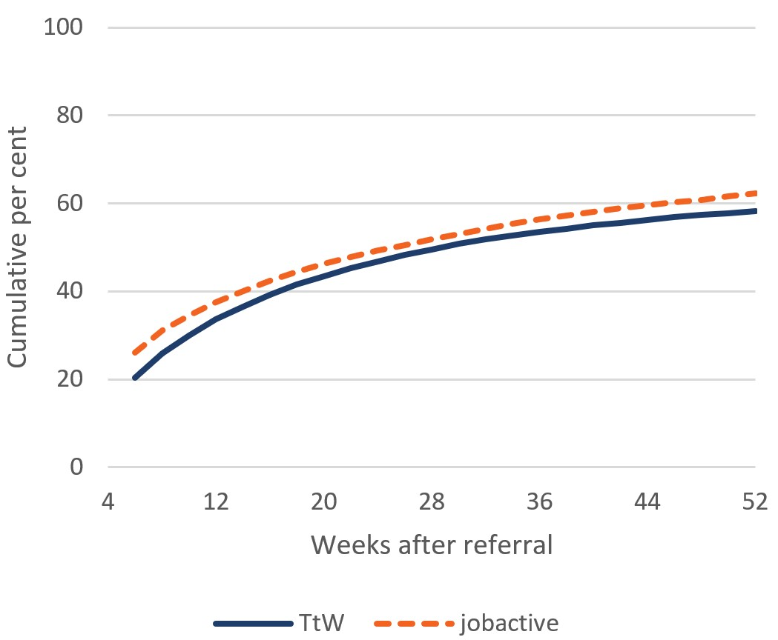

Base: TtW inflow population (n=27,241) and jobactive inflow population (n=24,032)

*A participant achieves a ‘positive outcome’ when they achieve either LMA or a study outcome. Positive outcomes achieved within four weeks of referral are excluded, as it is unlikely these outcomes resulted from any TtW or jobactive servicing.

Source: Department of Education, Skills and Employment administrative data

Controlling for participant characteristics confirms the finding that TtW had little impact on positive outcome rates. **Tables H.8**, **H.9** and **H.10** show parameter estimates from the positive outcome models. There is almost no relationship between TtW servicing and achieving positive outcomes one to six and one to nine months after referral. Receiving TtW services has no statistically significant effect on positive outcome rates over participants’ first 12 months of services.

Table H.8: Logistic regression model – impact of TtW on probability of achieving positive outcomes1 four to 26 weeks after referral

| Variable | Odds ratio2 | Lower 95% confidence limit | Upper 95% confidence limit |
| --- | --- | --- | --- |
| TtW / jobactive | 1.148* | 1.086 | 1.213 |
| Age (increased by one year) | 0.977* | 0.958 | 0.998 |
| Female / Male | 1.158* | 1.096 | 1.224 |
| Non-Indigenous / Indigenous | 1.549* | 1.439 | 1.668 |
| Year 12 completer / Non-Year 12 completer | 1.404* | 1.322 | 1.490 |
| No transport / Public transport | 0.918 | 0.819 | 1.029 |
| Private transport / Public transport | 1.340* | 1.264 | 1.421 |
| Stable residence / Unstable residence | 1.442* | 1.322 | 1.574 |
| History of paid work / Was not working | 1.565* | 1.458 | 1.680 |
| History of unpaid work / Was not working | 0.690* | 0.495 | 0.963 |
| Less than 12 months on income support / Not on income support | 1.200* | 1.117 | 1.289 |
| More than 12 months on income support / Not on income support | 1.291* | 1.193 | 1.397 |
| Ex-offender / Non-ex-offender or Did not answer | 0.626* | 0.564 | 0.694 |
| Disability / No disability or Did not answer | 0.797* | 0.719 | 0.882 |
| Good English skills / Poor or Combination of good and poor | 1.442* | 1.295 | 1.605 |
| More than once on income support / Other3 | 0.894* | 0.829 | 0.965 |
| Personal factors – No impact / Some impact | 1.265* | 1.143 | 1.401 |
| Strength of local economy (increased IVI score by 1) | 1.007* | 1.005 | 1.009 |

Base: n (excluding missing) = 23,035; matched samples

1. A participant achieves a ‘positive outcome’ when they achieve either LMA or a study outcome. Positive outcomes achieved within four weeks of referral are excluded, as it is unlikely these outcomes resulted from any TtW or jobactive servicing.

2. * variable has statistically significant coefficient: *p* < 0.05

3. ‘Other’ includes the following categories: ‘Received Crisis Payment’, ‘Received Crisis Payment + Multiple spells on income support’, ‘All others’.

Source: Department of Education, Skills and Employment administrative data

Table H.9: Logistic regression model estimating impact of TtW on probability of achieving positive outcomes1 one to nine months after referral

| Variable | Odds ratio2 | Lower 95% confidence limit | Upper 95% confidence limit |
| --- | --- | --- | --- |
| TtW / jobactive | 1.092* | 1.034 | 1.155 |
| Age (increased by one year) | 0.973* | 0.953 | 0.993 |
| Female / Male | 1.141* | 1.080 | 1.206 |
| Non-Indigenous / Indigenous | 1.603* | 1.491 | 1.723 |
| Year 12 completer / Non-Year 12 completer | 1.326* | 1.249 | 1.409 |
| No transport / Public transport | 0.935 | 0.837 | 1.045 |
| Private transport / Public transport | 1.335* | 1.258 | 1.416 |
| Stable residence / Unstable residence | 1.451* | 1.334 | 1.579 |
| History of paid work / Was not working | 1.550* | 1.442 | 1.666 |
| History of unpaid work / Was not working | 0.656* | 0.477 | 0.902 |
| Less than 12 months on income support / Not on income support | 1.183* | 1.101 | 1.271 |
| More than 12 months on income support / Not on income support | 1.292* | 1.194 | 1.399 |
| Ex-offender / Non-ex-offender or Did not answer | 0.620* | 0.561 | 0.685 |
| Disability / No disability or Did not answer | 0.784* | 0.710 | 0.867 |
| Good English skills / Poor or Combination of good and poor | 1.500* | 1.352 | 1.663 |
| More than once on income support / Other3 | 0.911* | 0.845 | 0.982 |
| Personal factors – No impact / Some impact | 1.179* | 1.067 | 1.302 |
| Strength of local economy (increased IVI score by 1) | 1.007* | 1.005 | 1.009 |

Base: n (excluding missing) = 23,035; matched samples

1. A participant achieves a ‘positive outcome’ when they achieve either LMA or a study outcome. Positive outcomes achieved within four weeks of referral are excluded, as it is unlikely these outcomes resulted from any TtW or jobactive servicing.

2. * variable has statistically significant coefficient: *p* < 0.05

3. ‘Other’ includes the following categories: ‘Received Crisis Payment’, ‘Received Crisis Payment + Multiple spells on income support’, ‘All others’.

Source: Department of Education, Skills and Employment administrative data

Table H.10: Logistic regression model estimating impact of TtW on probability of achieving positive outcomes1 one to 12 months after referral

| Variable | Odds ratio2 | Lower 95% confidence limit | Upper 95% confidence limit |
| --- | --- | --- | --- |
| Age (increased by one year) | 0.977* | 0.957 | 0.997 |
| Female / Male | 1.120* | 1.059 | 1.184 |
| Non-Indigenous / Indigenous | 1.576* | 1.465 | 1.696 |
| Year 12 completer / Non-Year 12 completer | 1.282* | 1.205 | 1.364 |
| No transport / Public transport | 0.880* | 0.786 | 0.986 |
| Private transport / Public transport | 1.280* | 1.204 | 1.361 |
| Stable residence / Unstable residence | 1.415* | 1.301 | 1.538 |
| History of paid work / Was not working | 1.514* | 1.406 | 1.630 |
| History of unpaid work / Was not working | 0.696* | 0.513 | 0.944 |
| Less than 12 months on income support / Not on income support | 1.189* | 1.107 | 1.277 |
| More than 12 months on income support / Not on income support | 1.306* | 1.206 | 1.413 |
| Ex-offender / Non-ex-offender or Did not answer | 0.615* | 0.558 | 0.678 |
| Disability / No disability or Did not answer | 0.806* | 0.729 | 0.890 |
| Good English skills / Poor or Combination of good and poor | 1.457* | 1.316 | 1.612 |
| More than once on income support / Other3 | 0.883* | 0.819 | 0.953 |
| Lives in inner regional Australia / Remote or very remote Australia | 1.184 | 0.955 | 1.468 |
| Lives in major cities of Australia / Remote or very remote Australia | 1.102 | 0.889 | 1.366 |
| Lives in outer regional Australia / Remote or very remote Australia | 1.214 | 0.978 | 1.508 |
| Personal factors – No impact / Some impact | 1.130 | 1.025 | 1.246 |
| Strength of local economy (increased IVI score by 1) | 1.006* | 1.004 | 1.009 |

Base: n (excluding missing) = 23,035; matched samples

1. A participant achieves a ‘positive outcome’ when they achieve either LMA or a study outcome. Positive outcomes achieved within four weeks of referral are excluded, as it is unlikely these outcomes resulted from any TtW or jobactive servicing.

2. * variable has statistically significant coefficient: *p* < 0.05

3. ‘Other’ includes the following categories: ‘Received Crisis Payment’, ‘Received Crisis Payment + Multiple spells on income support’, ‘All others’.

Source: Department of Education, Skills and Employment administrative data

### How the impact of TtW varied by gender

While the impact of TtW on LMA was similar for men and women, TtW was more effective at encouraging women to study than it was for men. **Tables H.11** to **H.14** show the logistic regression results of LMA and study outcomes, by gender. While the odds ratios associated with TtW are similar for the LMA models, it was larger among women than it was among men, suggesting a greater impact from TtW for female study outcomes.

Additional modelling confirmed this finding through inclusion of a gender interaction term. The interaction between gender and TtW servicing was significant for the study outcome model and insignificant for the LMA model. For reasons of space, this appendix does not show full parameter estimates for these additional interaction models.

Table H.11: Logistic regression model estimating impact of TtW on probability of achieving LMA1 one to 12 months after referral, among women

| Variable | Odds ratio2 | Lower 95% confidence limit | Upper 95% confidence limit |
| --- | --- | --- | --- |
| TtW / jobactive | 0.897* | 0.825 | 0.975 |
| Non-Indigenous / Indigenous | 1.663* | 1.492 | 1.854 |
| Good English skills / Poor or Combination of good and poor | 3.005* | 2.462 | 3.669 |
| Lives in inner regional Australia / Remote or very remote Australia | 1.583* | 1.121 | 2.236 |
| Lives in major cities of Australia / Remote or very remote Australia | 1.460* | 1.034 | 2.062 |
| Lives in outer regional Australia / Remote or very remote Australia | 1.505* | 1.061 | 2.134 |
| Year 12 completer / Non-Year 12 completer | 1.633* | 1.491 | 1.789 |
| No transport / Public transport | 0.926 | 0.774 | 1.107 |
| Private transport / Public transport | 1.322* | 1.207 | 1.448 |
| Stable residence / Unstable residence | 1.565* | 1.375 | 1.780 |
| History of paid work / Was not working | 1.737* | 1.551 | 1.946 |
| History of unpaid work / Was not working | 0.987 | 0.526 | 1.849 |
| Less than 12 months on income support / Not on income support | 1.148* | 1.031 | 1.278 |
| More than 12 months on income support / Not on income support | 1.247* | 1.119 | 1.390 |
| Ex-offender / Non-ex-offender or Did not answer | 0.457* | 0.362 | 0.577 |
| Disability / No disability or Did not answer | 0.832* | 0.718 | 0.965 |
| More than once on income support / Other3 | 0.883* | 0.788 | 0.989 |
| Personal factors – No impact / Some impact | 1.225* | 1.050 | 1.429 |
| Strength of local economy (increased IVI score by 1) | 1.007* | 1.004 | 1.010 |

Base: female participants, n (excluding missing) = 10,510; matched samples

1. A participant achieves LMA when the department’s income support and job placement information indicates they have secured employment. LMA outcomes achieved within four weeks of referral are excluded, as it is unlikely these outcomes resulted from TtW or jobactive servicing.

2. * variable has statistically significant coefficient: *p* < 0.05

3. ‘Other’ includes the following categories: ‘Received Crisis Payment’, ‘Received Crisis Payment + Multiple spells on income support’, ‘All others’.

Source: Department of Education, Skills and Employment administrative data

Table H.12: Logistic regression model estimating impact of TtW on probability of achieving LMA1 one to 12 months after referral, among men

| Variable | Odds ratio2 | Lower 95% confidence limit | Upper 95% confidence limit |
| --- | --- | --- | --- |
| TtW / jobactive | 0.835* | 0.775 | 0.900 |
| Non-Indigenous / Indigenous | 1.684* | 1.531 | 1.853 |
| Good English skills / Poor or Combination of good and poor | 1.561* | 1.369 | 1.779 |
| Year 12 completer / Non-Year 12 completer | 1.356* | 1.252 | 1.468 |
| No transport / Public transport | 0.803* | 0.689 | 0.936 |
| Private transport / Public transport | 1.467* | 1.356 | 1.588 |
| Stable residence / Unstable residence | 1.285* | 1.143 | 1.444 |
| History of paid work / Was not working | 1.692* | 1.549 | 1.849 |
| History of unpaid work / Was not working | 0.607* | 0.416 | 0.885 |
| Less than 12 months on income support / Not on income support | 1.158* | 1.052 | 1.275 |
| More than 12 months on income support / Not on income support | 1.260* | 1.128 | 1.406 |
| Ex-offender / Non-ex-offender or Did not answer | 0.686* | 0.611 | 0.769 |
| Disability / No disability or Did not answer | 0.758* | 0.663 | 0.867 |
| Strength of local economy (increased IVI score by 1) | 1.006* | 1.003 | 1.009 |

Base: male participants, n (excluding missing) = 12,543; matched samples

1. A participant achieves LMA when the department’s income support and job placement information indicates they have secured employment. LMA outcomes achieved within four weeks of referral are excluded, as it is unlikely these outcomes resulted from TtW or jobactive servicing.

2. * variable has statistically significant coefficient: *p* < 0.05

Source: Department of Education, Skills and Employment administrative data

Table H.13: Logistic regression model estimating impact of TtW on probability of achieving study outcomes1 one to 12 months after referral, among women

| Variable | Odds ratio2 | Lower 95% confidence limit | Upper 95% confidence limit |
| --- | --- | --- | --- |
| TtW / jobactive | 2.416* | 2.181 | 2.676 |
| Non-Indigenous / Indigenous | 1.172* | 1.026 | 1.340 |
| Good English skills / Poor or Combination of good and poor | 0.651* | 0.536 | 0.790 |
| Lives in inner regional Australia / Remote or very remote Australia | 1.726* | 1.116 | 2.670 |
| Lives in major cities / Remote or very remote Australia | 1.429 | 0.926 | 2.207 |
| Lives in outer regional Australia / Remote or very remote Australia | 1.705* | 1.097 | 2.652 |
| Age (increased by one year) | 0.903* | 0.871 | 0.936 |
| Year 12 completer / Non-Year 12 completer | 0.714* | 0.636 | 0.802 |
| Stable residence / Unstable residence | 1.205* | 1.035 | 1.401 |
| Ex-offender / Non-ex-offender or Did not answer | 0.612* | 0.462 | 0.810 |
| More than once on income support / Other3 | 0.846* | 0.730 | 0.981 |
| Strength of local economy (increased IVI score by 1) | 1.009* | 1.005 | 1.013 |

Base: female participants, n (excluding missing) = 10,510; matched samples

1. A participant achieves a ‘study outcome’ when they participate in an education or training activity that qualifies for an outcome payment. Study outcomes achieved within one month of referral are excluded, as it is unlikely these outcomes resulted from TtW or jobactive servicing.

2. * variable has statistically significant coefficient: *p* < 0.05

3. ‘Other’ includes the following categories: ‘Received Crisis Payment’, ‘Received Crisis Payment + Multiple spells on income support’, ‘All others’.

Source: Department of Education, Skills and Employment administrative data

Table H.14: Logistic regression model estimating impact of TtW on probability of achieving study outcomes1 one to 12 months after referral, among men

| Variable | Odds ratio2 | Lower 95% confidence limit | Upper 95% confidence limit |
| --- | --- | --- | --- |
| TtW / jobactive | 1.851* | 1.668 | 2.055 |
| Age (increased by one year) | 0.943* | 0.909 | 0.978 |
| Year 12 completer / Non-Year 12 completer | 0.770* | 0.688 | 0.861 |
| No transport / Public transport | 1.041 | 0.859 | 1.262 |
| Private transport / Public transport | 0.868* | 0.776 | 0.971 |
| History of paid work / Was not working | 0.739* | 0.647 | 0.844 |
| History of unpaid work / Was not working | 0.683 | 0.389 | 1.198 |
| Ex-offender / Non-ex-offender or Did not answer | 0.729* | 0.620 | 0.858 |
| More than once on income support / Other3 | 0.843* | 0.736 | 0.965 |
| Strength of local economy (increased IVI score by 1) | 1.006* | 1.002 | 1.010 |

Base: male participants, n (excluding missing) = 12,569; matched samples

1. A participant achieves a ‘study outcome’ when they participate in an education or training activity that qualifies for an outcome payment. Study outcomes achieved within one month of referral are excluded, as it is unlikely these outcomes resulted from TtW or jobactive servicing.

2. * variable has statistically significant coefficient: *p* < 0.05

3. ‘Other’ includes the following categories: ‘Received Crisis Payment’, ‘Received Crisis Payment + Multiple spells on income support’, ‘All others’.

Source: Department of Education, Skills and Employment administrative data

### How the impact of TtW varied by Indigenous status

The TtW service was less effective at encouraging Indigenous participants to study than it was for non-Indigenous participants, although it was equally effective at helping Indigenous and non-Indigenous participants to achieve LMA. **Tables H.15** to **H.18** present results from logistic regressions estimating the impact of TtW on LMA and study outcomes for Indigenous and non-Indigenous participants.

Additional modelling confirmed that the interaction between Indigenous status and TtW servicing is also statistically insignificant. However, TtW has a larger impact on study outcomes for non-Indigenous participants than it does for Indigenous participants. For reasons of space, this appendix does not show full parameter estimates for these additional interaction models.

Table H.15: Logistic regression model estimating impact of TtW on probability of achieving LMA1 one to 12 months after referral, among Indigenous participants

| Variable | Odds ratio2 | Lower 95% confidence limit | Upper 95% confidence limit |
| --- | --- | --- | --- |
| TtW / jobactive | 0.830* | 0.733 | 0.939 |
| Good English skills / Poor or Combination of good and poor | 1.618* | 1.277 | 2.050 |
| Lives in inner regional Australia / Remote or very remote Australia | 1.356 | 0.997 | 1.843 |
| Lives in major cities / Remote or very remote Australia | 1.527* | 1.122 | 2.079 |
| Lives in outer regional Australia / Remote or very remote Australia | 1.321 | 0.975 | 1.789 |
| Year 12 completer / Non-Year 12 completer | 1.844* | 1.589 | 2.141 |
| No transport / Public transport | 0.832 | 0.682 | 1.016 |
| Private transport / Public transport | 1.452* | 1.261 | 1.672 |
| Stable residence / Unstable residence | 1.312* | 1.095 | 1.572 |
| History of paid work / Was not working | 2.770* | 2.323 | 3.303 |
| History of unpaid work / Was not working | 1.080 | 0.627 | 1.860 |
| Ex-offender / Non-ex-offender or Did not answer | 0.627* | 0.525 | 0.749 |
| Disability / No disability or Did not answer | 0.756* | 0.598 | 0.957 |
| More than once on income support / Other3 | 0.866* | 0.765 | 0.980 |
| Strength of local economy (increased IVI score by 1) | 1.006* | 1.001 | 1.011 |

Base: Indigenous participants, n (excluding missing) = 4,988; matched samples

1. A participant achieves LMA when the department’s income support and job placement information indicates they have secured employment. LMA outcomes achieved within four weeks of referral are excluded, as it is unlikely these outcomes resulted from TtW or jobactive servicing.

2. * variable has statistically significant coefficient: *p* < 0.05

3. ‘Other’ includes the following categories: ‘Received Crisis Payment’, ‘Received Crisis Payment + Multiple spells on income support’, ‘All others’.

Source: Department of Education, Skills and Employment administrative data

Table H.16: Logistic regression model estimating impact of TtW on probability of achieving LMA1 one to 12 months after referral, among non-Indigenous participants

| Variable | Odds ratio2 | Lower 95% confidence limit | Upper 95% confidence limit |
| --- | --- | --- | --- |
| TtW / jobactive | 0.867* | 0.815 | 0.923 |
| Good English skills / Poor or Combination of good and poor | 1.985* | 1.757 | 2.242 |
| Year 12 completer / Non-Year 12 completer | 1.384* | 1.297 | 1.477 |
| No transport / Public transport | 0.966 | 0.833 | 1.119 |
| Private transport / Public transport | 1.417* | 1.327 | 1.513 |
| Stable residence / Unstable residence | 1.443* | 1.306 | 1.593 |
| History of paid work / Was not working | 1.569* | 1.455 | 1.692 |
| History of unpaid work / Was not working | 0.582* | 0.393 | 0.860 |
| Less than 12 months on income support / Not on income support | 1.192* | 1.101 | 1.291 |
| More than 12 months on income support / Not on income support | 1.334* | 1.223 | 1.455 |
| Ex-offender / Non-ex-offender or Did not answer | 0.650* | 0.574 | 0.736 |
| Disability / No disability or Did not answer | 0.820* | 0.732 | 0.918 |
| Personal factors – No impact / Some impact | 1.237* | 1.101 | 1.390 |
| Strength of local economy (increased IVI score by 1) | 1.007* | 1.004 | 1.009 |

Base: non-Indigenous participants, n (excluding missing) = 18,065; matched samples

1. A participant achieves LMA when the department’s income support and job placement information indicates they have secured employment. LMA outcomes achieved within four weeks of referral are excluded, as it is unlikely these outcomes resulted from TtW or jobactive servicing.

2. * variable has statistically significant coefficient: *p* < 0.05

Source: Department of Education, Skills and Employment administrative data

Table H.17: Logistic regression model estimating impact of TtW on probability of achieving study outcomes1 one to 12 months after referral, among Indigenous participants

| Variable | Odds ratio2 | Lower 95% confidence Limit | Upper 95% confidence Limit |
| --- | --- | --- | --- |
| TtW / jobactive | 1.526* | 1.307 | 1.781 |
| Female / Male | 1.351* | 1.153 | 1.583 |
| Lives in inner regional Australia / Remote or very remote Australia | 1.247 | 0.877 | 1.773 |
| Lives in major cities / Remote or very remote Australia | 0.845 | 0.594 | 1.202 |
| Lives in outer regional Australia / Remote or very remote Australia | 1.253 | 0.883 | 1.777 |
| Age (increased by one year) | 0.896* | 0.851 | 0.944 |
| Ex-offender / Non-ex-offender or Did not answer | 0.759* | 0.605 | 0.952 |
| Disability / No disability or Did not answer | 0.707* | 0.517 | 0.967 |
| Strength of local economy (increased IVI score by 1) | 1.006* | 1.000 | 1.013 |

Base: Indigenous participants, n (excluding missing) = 4,988; matched samples

1. A participant achieves a ‘study outcome’ when they participate in an education or training activity that qualifies for an outcome payment. Study outcomes achieved within one month of referral are excluded, as it is unlikely these outcomes resulted from TtW or jobactive servicing.

2. * variable has statistically significant coefficient: *p* < 0.05

Source: Department of Education, Skills and Employment administrative data

Table H.18: Logistic regression model estimating impact of TtW on probability of achieving study outcomes1 one to 12 months after referral, among non-Indigenous participants

| Variable | Odds ratio2 | Lower 95% confidence limit | Upper 95% confidence limit |
| --- | --- | --- | --- |
| TtW / jobactive | 2.345* | 2.156 | 2.551 |
| Female / Male | 1.444* | 1.332 | 1.566 |
| Good English skills / Poor or Combination of good and poor | 0.714* | 0.618 | 0.825 |
| Age (increased by one year) | 0.907* | 0.881 | 0.935 |
| Year 12 completer / Non-Year 12 completer | 0.720* | 0.658 | 0.787 |
| No transport / Public transport | 1.019 | 0.846 | 1.228 |
| Private transport / Public transport | 0.877* | 0.805 | 0.957 |
| Stable residence / Unstable residence | 1.253* | 1.101 | 1.427 |
| Less than 12 months on income support / Not on income support | 1.173* | 1.059 | 1.299 |
| More than 12 months on income support / Not on income support | 1.160* | 1.037 | 1.298 |
| Ex-offender / Non-ex-offender or Did not answer | 0.691* | 0.578 | 0.826 |
| More than once on income support / Other3 | 0.823* | 0.718 | 0.943 |
| Strength of local economy (increased IVI score by 1) | 1.008* | 1.005 | 1.011 |

Base: non-Indigenous participants, n (excluding missing) = 18,078; matched samples

1. A participant achieves a ‘study outcome’ when they participate in an education or training activity that qualifies for an outcome payment. Study outcomes achieved within one month of referral are excluded, as it is unlikely these outcomes resulted from TtW or jobactive servicing.

2. * variable has statistically significant coefficient: *p* < 0.05

3. ‘Other’ includes the following categories: ‘Received Crisis Payment’, ‘Received Crisis Payment + Multiple spells on income support’, ‘All others’.

Source: Department of Education, Skills and Employment administrative data

### How the impact of TtW varied by English proficiency

The impacts of TtW on LMA and study outcomes were similar for participants with different levels of English proficiency. As **Tables H.19** to **H.22** show, whether a participant had good, poor or mixed English skills had little or no impact on how effective TtW was for them. While the effect of TtW on LMA was not statistically significant for participants with poor or mixed English proficiency, as **Table H.20** shows, this is because the sample size for this regression was comparatively small, not because there was genuinely a null effect.

Additional analysis confirmed that the interaction terms in the LMA and study outcome models between English proficiency and TtW servicing were not statistically significant. For reasons of space, this appendix does not show full parameter estimates for these additional interaction models.

Table H.19: Logistic regression model estimating impact of TtW on probability of achieving LMA1 one to 12 months after referral, among participants with good English skills

| Variable | Odds ratio2 | Lower 95% confidence limit | Upper 95% confidence limit |
| --- | --- | --- | --- |
| TtW / jobactive | 0.859* | 0.811 | 0.910 |
| Non-Indigenous / Indigenous | 1.666* | 1.545 | 1.795 |
| Year 12 completer / Non-Year 12 completer | 1.458* | 1.372 | 1.549 |
| No transport / Public transport | 0.851* | 0.753 | 0.961 |
| Private transport / Public transport | 1.399* | 1.316 | 1.486 |
| Stable residence / Unstable residence | 1.395* | 1.271 | 1.532 |
| History of paid work / Was not working | 1.703* | 1.586 | 1.830 |
| History of unpaid work / Was not working | 0.784 | 0.562 | 1.094 |
| Less than 12 months on income support / Not on income support | 1.191* | 1.104 | 1.284 |
| More than 12 months on income support / Not on income support | 1.277* | 1.178 | 1.384 |
| Ex-offender / Non-ex-offender or Did not answer | 0.621* | 0.558 | 0.691 |
| Disability / No disability or Did not answer | 0.792* | 0.711 | 0.883 |
| More than once on income support / Other3 | 0.911* | 0.845 | 0.982 |
| Personal factors – No impact / Some impact | 1.173* | 1.049 | 1.311 |
| Strength of local economy (increased IVI score by 1) | 1.007* | 1.005 | 1.009 |

Base: participants reporting that they have good English skills, n (excluding missing) = 21,125; matched samples

1. A participant achieves LMA when the department’s income support and job placement information indicates they have secured employment. LMA outcomes achieved within four weeks of referral are excluded, as it is unlikely these outcomes resulted from TtW or jobactive servicing.

2. * variable has statistically significant coefficient: *p* < 0.05

3. ‘Other’ includes the following categories: ‘Received Crisis Payment’, ‘Received Crisis Payment + Multiple spells on income support’, ‘All others’.

Source: Department of Education, Skills and Employment administrative data

Table H.20: Logistic regression model estimating impact of TtW on probability of achieving LMA1 one to 12 months after referral, among participants with poor or mixed English skills

| Variable | Odds ratio2 | Lower 95% confidence limit | Upper 95% confidence limit |
| --- | --- | --- | --- |
| Female / Male | 0.523* | 0.416 | 0.658 |
| Non-Indigenous / Indigenous | 1.567* | 1.197 | 2.051 |
| Age (increased by one year) | 1.082* | 1.012 | 1.157 |
| No transport / Public transport | 0.864 | 0.615 | 1.213 |
| Private transport / Public transport | 1.489* | 1.155 | 1.920 |
| Stable residence / Unstable residence | 1.380* | 1.096 | 1.738 |
| History of paid work / Was not working | 2.223* | 1.598 | 3.092 |
| History of unpaid work / Was not working | 0.104* | 0.014 | 0.776 |
| Ex-offender / Non-ex-offender or Did not answer | 0.690* | 0.505 | 0.944 |

Base: participants reporting that they have poor or mixed English skills, n (excluding missing) = 1,928; matched samples

1. A participant achieves LMA when the department’s income support and job placement information indicates they have secured employment. LMA outcomes achieved within four weeks of referral are excluded, as it is unlikely these outcomes resulted from TtW or jobactive servicing.

2. * variable has statistically significant coefficient: *p* < 0.05

Source: Department of Education, Skills and Employment administrative data

Table H.21: Logistic regression model estimating impact of TtW on probability of achieving study outcomes1 one to 12 months after referral, among participants with good English skills

| Variable | Odds ratio2 | Lower 95% confidence limit | Upper 95% confidence limit |
| --- | --- | --- | --- |
| TtW / jobactive | 2.157* | 1.997 | 2.330 |
| Female / Male | 1.407* | 1.305 | 1.517 |
| Non-Indigenous / Indigenous | 1.150* | 1.039 | 1.273 |
| Lives in inner regional Australia / Remote or very remote Australia | 1.244 | 0.913 | 1.696 |
| Lives in major cities / Remote or very remote Australia | 0.991 | 0.727 | 1.351 |
| Lives in outer regional Australia / Remote or very remote Australia | 1.289 | 0.944 | 1.760 |
| Age (increased by one year) | 0.916* | 0.891 | 0.942 |
| Year 12 completer / Non-Year 12 completer | 0.760* | 0.699 | 0.827 |
| No transport / Public transport | 1.058 | 0.906 | 1.234 |
| Private transport / Public transport | 0.854* | 0.785 | 0.928 |
| Stable residence / Unstable residence | 1.132* | 1.003 | 1.278 |
| History of paid work / Was not working | 0.846* | 0.767 | 0.934 |
| History of unpaid work / Was not working | 0.906 | 0.566 | 1.452 |
| Ex-offender / Non-ex-offender or Did not answer | 0.705* | 0.605 | 0.821 |
| More than once on income support / Other3 | 0.869* | 0.781 | 0.968 |
| Strength of local economy (increased IVI score by 1) | 1.009* | 1.006 | 1.012 |

Base: participants reporting that they have good English skills, n (excluding missing) = 21,125; matched samples

1. A participant achieves a ‘study outcome’ when they participate in an education or training activity that qualifies for an outcome payment. Study outcomes achieved within one month of referral are excluded, as it is unlikely these outcomes resulted from TtW or jobactive servicing.

2. * variable has statistically significant coefficient: *p* < 0.05

3. ‘Other’ includes the following categories: ‘Received Crisis Payment’, ‘Received Crisis Payment + Multiple spells on income support’, ‘All others’.

Source: Department of Education, Skills and Employment administrative data

Table H.22: Logistic regression model estimating impact of TtW on probability of achieving study outcomes one to 12 months after referral, among participants with poor or mixed English skills

| Variable | Odds ratio | Lower 95% confidence limit | Upper 95% confidence limit |
| --- | --- | --- | --- |
| TtW / jobactive | 1.936* | 1.528 | 2.453 |
| Female / Male | 1.704* | 1.340 | 2.167 |
| Non-Indigenous / Indigenous | 1.534* | 1.097 | 2.144 |
| Lives in inner regional Australia / Remote or very remote Australia | 0.975 | 0.410 | 2.320 |
| Lives in major cities / Remote or very remote Australia | 1.009 | 0.430 | 2.367 |
| Lives in outer regional Australia / Remote or very remote Australia | 1.658 | 0.699 | 3.934 |
| Stable residence / Unstable residence | 1.633* | 1.250 | 2.134 |
| Disability / No disability or Did not answer | 0.684* | 0.480 | 0.975 |
| More than once on income support / Other3 | 0.643* | 0.447 | 0.926 |

Base: participants reporting that they have poor or mixed English skills, n (excluding missing) = 1,928; matched samples

1. A participant achieves a ‘study outcome’ when they participate in an education or training activity that qualifies for an outcome payment. Study outcomes achieved within one month of referral are excluded, as it is unlikely these outcomes resulted from TtW or jobactive servicing.

2. * variable has statistically significant coefficient: *p* < 0.05

3. ‘Other’ includes the following categories: ‘Received Crisis Payment’, ‘Received Crisis Payment + Multiple spells on income support’, ‘All others’.

Source: Department of Education, Skills and Employment administrative data

### How the impact of TtW varied by residential location

There is no evidence that the impact of TtW varied depending on whether participants lived in urban, regional or remote areas. **Tables H.23** to **H.30** show the impact of TtW on LMA and study outcomes for participants living in different residential locations.

Additional analysis confirmed that the relationship between TtW servicing and outcomes was weaker for participants in outer regional areas and was not statistically significant for remote participants. The interaction between living in an outer regional or remote area and TtW participation was not statistically significant. There were not enough young people living in outer regional and remote areas to say confidently whether TtW was less effective for them. For reasons of space, this appendix does not show full parameter estimates for these additional interaction models.

Table H.23: Logistic regression model estimating impact of TtW on probability of achieving LMA1 one to 12 months after referral, among participants in major cities

| Variable | Odds ratio2 | Lower 95% confidence limit | Upper 95% confidence limit |
| --- | --- | --- | --- |
| TtW / jobactive | 0.845* | 0.783 | 0.911 |
| Non-Indigenous / Indigenous | 1.524* | 1.369 | 1.698 |
| Good English skills / Poor or Combination of good and poor | 2.124* | 1.844 | 2.446 |
| Year 12 completer / Non-Year 12 completer | 1.334* | 1.232 | 1.443 |
| No transport / Public transport | 0.822 | 0.629 | 1.075 |
| Private transport / Public transport | 1.435* | 1.321 | 1.559 |
| Stable residence / Unstable residence | 1.428* | 1.269 | 1.608 |
| History of paid work / Was not working | 1.567* | 1.424 | 1.723 |
| History of unpaid work / Was not working | 0.586* | 0.377 | 0.911 |
| Less than 12 months on income support / Not on income support | 1.147* | 1.043 | 1.262 |
| More than 12 months on income support / Not on income support | 1.394* | 1.257 | 1.545 |
| Ex-offender / Non-ex-offender or Did not answer | 0.642* | 0.555 | 0.742 |
| Disability / No disability or Did not answer | 0.798* | 0.696 | 0.915 |
| Personal factors – No impact / Some impact | 1.184* | 1.032 | 1.357 |
| Strength of local economy (increased IVI score by 1) | 1.007* | 1.004 | 1.010 |

Base: participants reporting they live in a major cities location, n (excluding missing) = 12,541; matched samples

1. A participant achieves LMA when the department’s income support and job placement information indicates they have secured employment. LMA outcomes achieved within four weeks of referral are excluded, as it is unlikely these outcomes resulted from TtW or jobactive servicing.

2. * variable has statistically significant coefficient: *p* < 0.05

Source: Department of Education, Skills and Employment administrative data

Table H.24: Logistic regression model estimating impact of TtW on probability of achieving LMA1 one to 12 months after referral, among participants in inner regional Australia

| Variable | Odds ratio2 | Lower 95% confidence limit | Upper 95% confidence limit |
| --- | --- | --- | --- |
| TtW / jobactive | 0.901* | 0.813 | 0.998 |
| Female / Male | 1.136* | 1.023 | 1.262 |
| Non-Indigenous / Indigenous | 1.753* | 1.545 | 1.988 |
| Good English skills / Poor or Combination of good and poor | 1.560* | 1.246 | 1.952 |
| Year 12 completer / Non-Year 12 completer | 1.662* | 1.484 | 1.862 |
| No transport / Public transport | 0.918 | 0.759 | 1.110 |
| Private transport / Public transport | 1.367* | 1.224 | 1.525 |
| Stable residence / Unstable residence | 1.517* | 1.291 | 1.783 |
| History of paid work / Was not working | 1.723* | 1.517 | 1.957 |
| History of unpaid work / Was not working | 0.725 | 0.377 | 1.395 |
| Less than 12 months on income support / Not on income support | 1.186* | 1.038 | 1.354 |
| More than 12 months on income support / Not on income support | 1.104 | 0.955 | 1.275 |
| Ex-offender / Non-ex-offender or Did not answer | 0.578* | 0.480 | 0.697 |
| Disability / No disability or Did not answer | 0.812* | 0.683 | 0.965 |
| Strength of local economy (increased IVI score by 1) | 1.007* | 1.003 | 1.012 |

Base: participants reporting they live in an inner regional location, n (excluding missing) = 6,558; matched samples

1. A participant achieves LMA when the department’s income support and job placement information indicates they have secured employment. LMA outcomes achieved within four weeks of referral are excluded, as it is unlikely these outcomes resulted from TtW or jobactive servicing.

2. * variable has statistically significant coefficient: *p* < 0.05

Source: Department of Education, Skills and Employment administrative data

Table H.25: Logistic regression model estimating impact of TtW on probability of achieving LMA1 one to 12 months after referral, among participants in outer regional Australia.

| Variable | Odds ratio2 | Lower 95% confidence limit | Upper 95% confidence limit |
| --- | --- | --- | --- |
| TtW / jobactive | 0.791* | 0.686 | 0.912 |
| Non-Indigenous / Indigenous | 1.865* | 1.606 | 2.165 |
| Good English skills / Poor or Combination of good and poor | 1.777* | 1.339 | 2.357 |
| Year 12 completer / Not on income support | 1.547* | 1.315 | 1.820 |
| No transport / Public transport | 0.847 | 0.684 | 1.050 |
| Private transport / Public transport | 1.452* | 1.241 | 1.699 |
| History of paid work / Was not working | 2.317* | 1.938 | 2.770 |
| History of unpaid work / Was not working | 1.224 | 0.603 | 2.484 |
| Ex-offender / Non-ex-offender or Did not answer | 0.641* | 0.507 | 0.811 |
| Disability / No disability or Did not answer | 0.736* | 0.560 | 0.967 |

Base: participants reporting they live in an outer regional location, n (excluding missing) = 3,548; matched samples

1. A participant achieves LMA when the department’s income support and job placement information indicates they have secured employment. LMA outcomes achieved within four weeks of referral are excluded, as it is unlikely these outcomes resulted from TtW or jobactive servicing.

2. * variable has statistically significant coefficient: *p* < 0.05

Source: Department of Education, Skills and Employment administrative data

Table H.26: Logistic regression model estimating impact of TtW on probability of achieving LMA1 one to 12 months after referral, among participants in remote Australia

| Variable | Odds ratio2 | Lower 95% confidence limit | Upper 95% confidence limit |
| --- | --- | --- | --- |
| Non-Indigenous / Indigenous | 3.607* | 2.262 | 5.753 |
| Year 12 completer / Non-Year 12 completer | 3.165* | 1.873 | 5.348 |

Base: participants reporting they live in a remote location, n (excluding missing) = 406; matched samples

1. A participant achieves LMA when the department’s income support and job placement information indicates they have secured employment. LMA outcomes achieved within four weeks of referral are excluded, as it is unlikely these outcomes resulted from TtW or jobactive servicing.

2. * variable has statistically significant coefficient: *p* < 0.05

Source: Department of Education, Skills and Employment administrative data

Table H.27: Logistic regression model estimating impact of TtW on probability of achieving study outcomes1 one to 12 months after referral, among participants in major cities

| Variable | Odds ratio2 | Lower 95% confidence limit | Upper 95% confidence limit |
| --- | --- | --- | --- |
| TtW / jobactive | 2.666* | 2.398 | 2.964 |
| Female / Male | 1.516* | 1.371 | 1.676 |
| Non-Indigenous / Indigenous | 1.303* | 1.111 | 1.527 |
| Good English skills / Poor or Combination of good and poor | 0.657* | 0.555 | 0.777 |
| Age (increased by one year) | 0.947* | 0.913 | 0.981 |
| Year 12 completer / Non-Year 12 completer | 0.789* | 0.707 | 0.881 |
| No transport / Public transport | 1.023 | 0.725 | 1.442 |
| Private transport / Public transport | 0.766* | 0.680 | 0.862 |
| Stable residence / Unstable residence | 1.411* | 1.199 | 1.661 |
| History of paid work / Was not working | 0.839* | 0.733 | 0.961 |
| History of unpaid work / Was not working | 1.143 | 0.636 | 2.056 |
| Ex-offender / Non-ex-offender or Did not answer | 0.634* | 0.509 | 0.790 |
| More than once on income support / Other3 | 0.836* | 0.717 | 0.976 |

Base: participants reporting they live in a major cities location, n (excluding missing) = 12,541; matched samples

1. A participant achieves a ‘study outcome’ when they participate in an education or training activity that qualifies for an outcome payment. Study outcomes achieved within one month of referral are excluded, as it is unlikely these outcomes resulted from TtW or jobactive servicing.

2. * variable has statistically significant coefficient: *p* < 0.05

3. ‘Other’ includes the following categories: ‘Received Crisis Payment’, ‘Received Crisis Payment + Multiple spells on income support’, ‘All others’.

Source: Department of Education, Skills and Employment administrative data

Table H.28: Logistic regression model estimating impact of TtW on probability of achieving study outcomes1 one to 12 months after referral, among participants in inner regional Australia

| Variable | Odds ratio2 | Lower 95% confidence limit | Upper 95% confidence limit |
| --- | --- | --- | --- |
| TtW / jobactive | 1.960* | 1.718 | 2.236 |
| Female / Male | 1.462* | 1.283 | 1.666 |
| Age (increased by one year) | 0.911* | 0.870 | 0.955 |
| Year 12 completer / Non-Year 12 completer | 0.731* | 0.630 | 0.849 |
| Less than 12 months on income support / Not on income support | 1.202* | 1.023 | 1.411 |
| More than 12 months on income support / Not on income support | 1.236* | 1.035 | 1.475 |
| Ex-offender / Non-ex-offender or Did not answer | 0.583* | 0.451 | 0.755 |
| Strength of local economy (increased IVI score by 1) | 1.025* | 1.019 | 1.030 |

Base: participants reporting they live in an inner regional location, n (excluding missing) = 6,558; matched samples

1. A participant achieves a ‘study outcome’ when they participate in an education or training activity that qualifies for an outcome payment. Study outcomes achieved within one month of referral are excluded, as it is unlikely these outcomes resulted from TtW or jobactive servicing.

2. * variable has statistically significant coefficient: *p* < 0.05

Source: Department of Education, Skills and Employment administrative data

Table H.29: Logistic regression model estimating impact of TtW on probability of achieving study outcomes1 one to 12 months after referral, among participants in outer regional Australia

| Variable | Odds ratio2 | Lower 95% confidence limit | Upper 95% confidence limit |
| --- | --- | --- | --- |
| TtW / jobactive | 1.370* | 1.152 | 1.629 |
| Female / Male | 1.232* | 1.036 | 1.466 |
| Age (increased by one year) | 0.854* | 0.805 | 0.906 |
| Year 12 completer / Non-Year 12 completer | 0.673* | 0.545 | 0.830 |

Base: participants reporting they live in an outer regional location, n (excluding missing) = 3,548; matched samples

1. A participant achieves a ‘study outcome’ when they participate in an education or training activity that qualifies for an outcome payment. Study outcomes achieved within one month of referral are excluded, as it is unlikely these outcomes resulted from TtW or jobactive servicing.

2. * variable has statistically significant coefficient: *p* < 0.05

Source: Department of Education, Skills and Employment administrative data

Table H.30: Logistic regression model estimating impact of TtW on probability of achieving study outcomes1 one to 12 months after referral, among participants in remote Australia

| Variable | Odds ratio2 | Lower 95% confidence limit | Upper 95% confidence limit |
| --- | --- | --- | --- |
| History of paid work / Was not working | 0.224* | 0.068 | 0.739 |
| History of unpaid work / Was not working | 6.216 | 0.830 | 46.577 |
| More than once on income support / Other3 | 0.535* | 0.297 | 0.964 |

Base: participants reporting they live in a remote location, n (excluding missing) = 406; matched samples

1. A participant achieves a ‘study outcome’ when they participate in an education or training activity that qualifies for an outcome payment. Study outcomes achieved within one month of referral are excluded, as it is unlikely these outcomes resulted from TtW or jobactive servicing.

2. * variable has statistically significant coefficient: *p* < 0.05

3. ‘Other’ includes the following categories: ‘Received Crisis Payment’, ‘Received Crisis Payment + Multiple spells on income support’, ‘All others’.

Source: Department of Education, Skills and Employment administrative data Provider Good Practice

In 2017, the department invited each TtW site with an active caseload to participate in a survey about the TtW service (described in **Appendix E**). Responses from the survey were linked with administrative data to analyse the relationships between provider practices and achievement of participant outcomes.

The focus of the analysis was on self-reported practices, recorded face-to-face appointments and placements in activities. The analysis controlled for statistically significant participant characteristics.

The analysis grouped the provider responses on the following service elements:

* engagement with participants
* addressing barriers to employment
* helping young people find work
* supporting young people with further education and training
* provider engagement with employers and other community organisations
* caseload management.

The service elements and activities were analysed for each of the measures using a stepwise logistic regression to determine features that positively attribute to participants’ LMA, education and employment outcomes (good practice). In addition, the analysis also examined whether the educational activities of participants play a significant role in their achieving 12- and 26-week employment outcomes.

The analysis dataset used is the 12-month TtW inflow population between 1 April 2016 and 31 March 2017. The dependent variables used binary variables (0, 1) created for each participant representing their LMA, achievement of TtW education outcomes, and 12- and 26-week employment outcomes. Linkage of the participant’s record with the 2017 TtW Provider Survey responses used the participant’s site of referral and the survey site as the linkage variables.

The regression analysis excluded observations with missing values for any of the variables (i.e. they use listwise deletion). As some of these variables rely on provider survey questions with varying response rates, regression sample sizes are reduced compared to the full TtW inflow population. This introduces a limitation to the analysis as it is unknown whether the servicing practices of sites included in the analysis differ systematically from the practices of sites excluded due to missing information.

**Table H.31** shows all the indicators used to measure providers’ servicing practices. The logistic regression models also included all the control variables described in **Table H.1**.

Table H.31: Servicing variables used in good practice analysis

| Variable | Description |
| --- | --- |
| Face-to-face appointments per fortnight | Participant’s average number of face-to-face appointments with their provider per fortnight. |
| Survey respondent in youth services longer than 5 years | Provider survey respondent has worked in youth services for over 5 years. |
| Indigenous staff present at site | Indigenous staff are present at site. |
| Site keeps unsuitable participants on caseload | Site usually keeps participants found to be unsuitable for TtW on its caseload. |
| Site uses assessment tools | Site uses assessment tools to assess participants needs. |
| Site takes individualised approach using same consultant each time | Site mainly services participants one on one using the same consultant each time. |
| Site takes individualised approach using specialist consultants | Site mainly services participants one on one using specialist consultants. |
| Sites takes group-based approach | Site mainly services participants in groups. |
| Site helps participants with job preparation | Site assists participants with job preparation – for example, reviewing their résumé or referring them to a job. |
| Site helps participants to find education | Site assists participants to find educational opportunities. |
| Most participants at site need support from upfront payments | More than half of participants at site need support from upfront payments. |
| Site has contact with employers every day | Site contacts employers or other business organisations every day – ‘0’ if they contact employers or other business organisations a few times a day, once per week, once per fortnight or less often (or if respondent does not know). |
| Survey respondent believes TtW improves work readiness | Provider survey respondent believes TtW improves participants’ work readiness. |
| Survey respondent believes TtW is effective | Provider survey respondent believes TtW is effective at doing what it is designed to do. |
| Staff at site spend over 40% of time on administration | Staff at site spent 40% or more of their time on administration. |
| FTE staff | Number of full-time equivalent staff at site. |
| Site caseload | Number of participants on site caseload. |
| Participant undertook accredited training | Participant undertook accredited training. |
| Participant undertook non-accredited training | Participant undertook non-accredited training. |
| Participant undertook paid work experience activity | Participant undertook paid work experience as an activity. |

Source: Department of Employment, Skills, Small and Family Business regression analysis

### Provider practices and achieving LMA

**Table H.32** shows which provider servicing practices were associated with the greatest improvements in LMA for TtW participants. Participants who undertook education, training and work experience activities were more likely to achieve LMA than participants who did not. Participants who achieved LMA also had more frequent face-to-face provider appointments, on average.

Sites that used specialist consultants were also slightly more likely to have serviced participants who achieved LMA, as were sites that assisted participants with job preparation, contacted employers more often, employed more staff or serviced smaller caseloads.

Interestingly, sites with staff in youth services less than five years and sites with Indigenous staff had participants with reduced LMA achievement.

Table H.32: Logistic regression model estimating impact of servicing practices on probability of TtW participants achieving LMA1 one to 12 months after referral

| Variable | Odds ratio2 | Lower 95% confidence limit | Upper 95% confidence limit |
| --- | --- | --- | --- |
| Non-Indigenous / Indigenous | 1.685* | 1.540 | 1.844 |
| Year 12 completer / Non-Year 12 completer | 1.315* | 1.201 | 1.440 |
| No transport / Public transport | 0.856* | 0.736 | 0.995 |
| Private transport / Public transport | 1.405* | 1.311 | 1.506 |
| Stable residence / Unstable residence | 1.471* | 1.309 | 1.654 |
| History of paid work / Was not working | 1.880* | 1.743 | 2.028 |
| History of unpaid work / Was not working | 0.618* | 0.389 | 0.983 |
| Less than 12 months on income support / Not on income support | 1.174* | 1.071 | 1.286 |
| More than 12 months on income support / Not on income support | 1.132* | 1.008 | 1.271 |
| Ex-offender / Non-ex-offender or Did not answer | 0.680* | 0.599 | 0.771 |
| Good English skills / Poor or Combination of good and poor | 1.785* | 1.516 | 2.103 |
| Personal factors – No impact / Some impact | 1.203* | 1.060 | 1.365 |
| Survey respondent been in youth services longer than 5 years / Less than 5 years | 0.912* | 0.849 | 0.980 |
| Indigenous staff present at site / None | 0.921 | 0.848 | 1.000 |
| Site takes individualised approach using specialist consultants – Most of the time / Less frequently, Never or Don’t know | 1.119* | 1.043 | 1.201 |
| Site helps participants with job preparation / Does not help with job preparation | 1.154* | 1.037 | 1.285 |
| Site has contact with employers every day / Less frequently or No response | 1.091* | 1.017 | 1.170 |
| FTE staff (increased by one) | 1.037* | 1.007 | 1.067 |
| Site caseload (increased by one) | 0.998* | 0.997 | 0.999 |
| Face-to-face appointments per fortnight (increased by one) | 1.258* | 1.175 | 1.346 |
| Participant undertook accredited training / Did not undertake accredited training | 1.369* | 1.268 | 1.478 |
| Participant undertook non-accredited training / Did not undertake non-accredited training | 1.307* | 1.171 | 1.460 |
| Participant undertook paid work experience activity / Did not undertake paid work experience activity | 1.643* | 1.229 | 2.197 |

Base: participants in TtW inflow population n (excluding missing) = 15,935; matched using site (of referral) to the 2017 TtW Provider Survey

1. A participant achieves LMA when the department’s income support and job placement information indicates they have secured employment. LMA outcomes achieved within four weeks of referral are excluded, as it is unlikely these outcomes resulted from TtW or jobactive servicing.

2. * variable has statistically significant coefficient: *p* < 0.05

Source: Department of Education, Skills and Employment administrative data

### Provider practices and achieving study outcomes

**Table H.33** explores which servicing practices were most effective in helping participants convert education and training activities into education outcomes. This analysisis restricted to participants who undertook accredited education and training activities during their service periods. Therefore, the analysis examined which servicing characteristics affected the probability of participants converting their education and training activities into paid outcomes.

Unsurprisingly, sites that reported helping participants to find education were more likely to have participants who achieved education outcomes. Conversely, sites that helped participants with job preparation were less effective at encouraging participants to achieve education outcomes. Participants who converted their education activities to paid outcomes also tended to meet their providers more often and tended to be with providers who spent more time on administration.

Table H.33: Logistic regression model estimating impact of servicing practices on probability of TtW participants achieving education outcomes1 one to 12 months after referral, among participants who undertook education and training

| Variable | Odds ratio2 | Lower 95% confidence limit | Upper 95% confidence limit |
| --- | --- | --- | --- |
| Non-Indigenous / Indigenous | 1.363* | 1.137 | 1.635 |
| Year 12 completer / Non-Year 12 completer | 1.210* | 1.025 | 1.428 |
| Lives in inner regional Australia / Remote or very remote Australia | 1.748 | 0.832 | 3.675 |
| Lives in major cities / Remote or very remote Australia | 1.704 | 0.807 | 3.597 |
| Lives in outer regional Australia / Remote or very remote Australia | 1.296 | 0.609 | 2.756 |
| Less than 12 months on income support / Not on income support | 0.783* | 0.666 | 0.921 |
| More than 12 months on income support / Not on income support | 0.935 | 0.768 | 1.138 |
| Site takes individualised approach using same consultant – Most of the time / Less frequently, Never or Don’t know | 0.628* | 0.510 | 0.774 |
| Site helps participants with job preparation / Does not help with job preparation | 0.740* | 0.612 | 0.895 |
| Site helps participants to find education / Does not help with finding education | 1.408* | 1.216 | 1.632 |
| Site has contact with employers every day / Less frequently or No response | 1.183* | 1.039 | 1.347 |
| Staff at site spend over 40% of time on administration / Less than 40% of time | 1.166* | 1.019 | 1.334 |
| Site caseload (increased by one) | 0.998* | 0.997 | 0.999 |
| Face-to-face appointments per fortnight (increased by one) | 1.388* | 1.221 | 1.578 |

Base: participants who undertook accredited education and training in TtW inflow population n (excluding missing) = 4,989; matched using site (of referral) to the 2017 TtW Provider Survey

1. The analysis examined the impact of servicing characteristics on education outcomes for TtW participants who participated in accredited education and training activities (and never participated in non-accredited education and training or paid work experience activities). This means the analysis only examined which servicing characteristics affected the probability of participants converting their education and training activities into outcomes. It did not examine which servicing characteristics affected the probability of participants undertaking education and training in the first instance. The model therefore did not include non-accredited education and training or paid work experience since none of the participants under analysis undertook these types of activities.

2. * variable has statistically significant coefficient: *p* < 0.05

Source: Department of Education, Skills and Employment administrative data

### Provider practices and achieving employment outcomes

The analysis also examined which provider practices were more effective in helping participants to achieve employment outcomes; see **Tables H.35** and **H.36** for results.

Table H.34: Logistic regression model estimating impact of servicing practices on probability of TtW participants achieving 12-week employment outcomes one to 12 months after referral

| Variable | Odds ratio1 | Lower 95% confidence limit | Upper 95% confidence limit |
| --- | --- | --- | --- |
| Age (increased by one year) | 1.047* | 1.020 | 1.075 |
| Female / Male | 0.768* | 0.712 | 0.828 |
| Non-Indigenous / Indigenous | 1.652* | 1.478 | 1.846 |
| Year 12 completer / Non-Year 12 completer | 1.395* | 1.268 | 1.533 |
| No transport / Public transport | 0.802* | 0.662 | 0.973 |
| Private transport / Public transport | 1.601* | 1.484 | 1.727 |
| Stable residence / Unstable residence | 1.538* | 1.327 | 1.783 |
| History of paid work / Was not working | 1.692* | 1.558 | 1.839 |
| History of unpaid work / Was not working | 0.686 | 0.381 | 1.236 |
| Ex-offender / Non-ex-offender or Did not answer | 0.573* | 0.487 | 0.673 |
| Disability / No disability or Did not answer | 0.754* | 0.641 | 0.886 |
| Good English skills / Poor or Combination of good and poor | 1.812* | 1.464 | 2.241 |
| Indigenous staff present at site / None | 0.901* | 0.823 | 0.986 |
| Site keeps unsuitable participants on caseload / Does not keep | 1.211* | 1.122 | 1.308 |
| Site uses assessment tools / Does not use assessment tools or Don’t know | 0.875* | 0.787 | 0.972 |
| Most of participants at site need support from upfront payments / Up to half of participants at site need support from upfront payments | 1.182* | 1.095 | 1.276 |
| Survey respondent believes TtW is effective / Not effective | 1.114* | 1.023 | 1.214 |
| Site caseload (increased by one) | 0.998* | 0.998 | 0.999 |
| Participant undertook accredited training / Did not undertake accredited training | 1.325* | 1.220 | 1.439 |
| Participant undertook non-accredited training / Did not undertake non-accredited training | 1.442* | 1.286 | 1.618 |
| Participant undertook paid work experience activity / Did not undertake paid work experience | 1.567* | 1.187 | 2.068 |

Base: participants in TtW inflow population n (excluding missing) = 16,298; matched using site (of referral) to the 2017 TtW Provider Survey

1. * variable has statistically significant coefficient: *p* < 0.05

Source: Department of Education, Skills and Employment administrative data

Participants who undertook paid work experience, non-accredited training and (to a lesser extent) accredited training were more likely to achieve 12- and 26-week employment outcomes. Participants who achieved employment outcomes were also more likely to be at sites that kept unsuitable participants on their caseloads, used assessment tools and had smaller caseloads.

Table H.35: Logistic regression model estimating impact of servicing practices on probability of TtW participants achieving 26-week employment outcomes one to 12 months after referral

| Variable | Odds ratio | Lower 95% confidence limit | Upper 95% confidence limit |
| --- | --- | --- | --- |
| Age (increased by one year) | 1.078* | 1.046 | 1.110 |
| Female / Male | 0.754* | 0.691 | 0.822 |
| Non-Indigenous / Indigenous | 1.690* | 1.481 | 1.928 |
| Year 12 completer / Non-Year 12 completer | 1.392* | 1.253 | 1.546 |
| No transport / Public transport | 0.859 | 0.684 | 1.079 |
| Private transport / Public transport | 1.594* | 1.462 | 1.738 |
| Stable residence / Unstable residence | 1.670* | 1.392 | 2.005 |
| History of paid work / Was not working | 1.645* | 1.499 | 1.806 |
| History of unpaid work / Was not working | 0.838 | 0.438 | 1.604 |
| Ex-offender / Non-ex-offender or Did not answer | 0.576* | 0.475 | 0.698 |
| Disability / No disability or Did not answer | 0.812* | 0.663 | 0.994 |
| Good English skills / Poor or Combination of good and poor | 1.827* | 1.408 | 2.369 |
| Personal factors – No impact / Some impact | 1.302* | 1.074 | 1.578 |
| Site keeps unsuitable participants on caseload / Does not keep | 1.171* | 1.072 | 1.279 |
| Site uses assessment tools / Does not use assessment tools or Don’t know | 0.853* | 0.753 | 0.965 |
| Most of participants at site need support from upfront payments / Up to half of participants at site need support from upfront payments | 1.169* | 1.072 | 1.274 |
| Survey respondent believes TtW is effective / Not effective | 1.185* | 1.072 | 1.309 |
| Staff at site spend over 40% of time on administration / Less than 40% of time | 1.110* | 1.015 | 1.213 |
| Site caseload (increased by one) | 0.999* | 0.998 | 0.999 |
| Participant undertook accredited training / Did not undertake accredited training | 1.173* | 1.067 | 1.290 |
| Participant undertook non-accredited training / Did not undertake non-accredited training | 1.357* | 1.191 | 1.548 |
| Participant undertook paid work experience activity / Did not undertake paid work experience | 1.478* | 1.083 | 2.016 |

Base: participants in TtW inflow population n (excluding missing) = 16,016; matched using site (of referral) to the 2017 TtW Provider Survey

1. * variable has statistically significant coefficient: *p* < 0.05

Source: Department of Education, Skills and Employment administrative data

## Income support exits and reductions

The evaluation explored whether TtW helped participants to exit income support in the long term, even if it was less effective in the short term. **Section 6.4** includes discussion of this analysis. Results from the logistic and Cox proportional hazards regression modelling are presented below.

As **Section 6.4.1** discusses (and shown in **Table H.36**), matched TtW participants were less likely to exit income support during the two-year analysis period and this was largely due to a higher proportion of jobactive participants exiting early (at six weeks). It could also be that TtW participants were more likely to reduce their average income support payments, even if they were less likely to go off payments entirely.

Table H.36: Income support exit analysis – sample size and exit rate

| **Program** | **Matched sample total**  **(no)** | **Matched sample subset**  **(no)** | **Exited income support at week 6**  **(no)** | **Exited income support at week 6**  **(% of matched sample subset)** | **Exited income support within 2 years**  **(no)** | **Exited income support within 2 years**  **(% of matched sample subset)** |
| --- | --- | --- | --- | --- | --- | --- |
| **TtW** | 12,105 | 9,513 | 403 | 4.2 | 6,466 | 68.0 |
| **jobactive** | 12,105 | 11,007 | 894 | 8.1 | 7,993 | 72.6 |
| **Total** | **24,210** | **20,520** | **1,297** | **–** | **14,459** | **–** |

Base: n=24,210; matched samples. The matched sample subsets are limited to participants who received income support within six weeks of their commencement in services and had two years of observation time available since their commencement date.

Source: Department of Education, Skills and Employment administrative data

To explore this possibility, this analysis uses the ‘income support reduction’ measure, defined previously in this appendix. **Table H.37** shows outputs from a logistic regression model estimating the impact of TtW on the probability of participants reducing their income support reliance up to a year after referral. The TtW service had a negative impact on income support reductions, as discussed in **Section 6.4.1**.

Table H.37: Logistic regression model estimating impact of TtW on probability of achieving income support reductions1

| Variable | Odds ratio2 | Lower 95% confidence limit | Upper 95% confidence limit |
| --- | --- | --- | --- |
| TtW / jobactive | 0.698* | 0.661 | 0.737 |
| Age (increased by one year) | 1.071* | 1.049 | 1.093 |
| Female / Male | 0.780* | 0.738 | 0.824 |
| Non-Indigenous / Indigenous | 1.145* | 1.064 | 1.233 |
| Year 12 completer / Non-Year 12 completer | 1.109* | 1.045 | 1.177 |
| Lives in inner regional Australia / Remote or very remote Australia | 0.789* | 0.639 | 0.975 |
| Lives in major cities / Remote or very remote Australia | 0.860 | 0.696 | 1.063 |
| Lives in outer regional Australia / Remote or very remote Australia | 0.819 | 0.661 | 1.013 |
| No transport / Public transport | 0.887* | 0.791 | 0.995 |
| Private transport / Public transport | 1.158* | 1.091 | 1.229 |
| Stable residence / Unstable residence | 1.220* | 1.121 | 1.328 |
| History of paid work / Was not working | 1.258* | 1.173 | 1.349 |
| History of unpaid work / Was not working | 1.650* | 1.229 | 2.213 |
| Less than 12 months on income support / Not on income support | 1.236* | 1.152 | 1.327 |
| More than 12 months on income support / Not on income support | 1.063 | 0.983 | 1.149 |
| Ex-offender / Non-ex-offender or Did not answer | 1.232* | 1.119 | 1.357 |
| Disability / No disability or Did not answer | 0.812* | 0.734 | 0.898 |
| Good English skills / Poor or Combination of good and poor | 1.629* | 1.468 | 1.808 |
| More than once on income support / Other3 | 1.132* | 1.051 | 1.220 |
| Personal factors – No impact / Some impact | 1.146* | 1.037 | 1.265 |
| Strength of local economy (increased IVI score by 1) | 1.004* | 1.002 | 1.006 |

Base: n (excluding missing) = 23,053; matched samples

1. An ‘income support reduction’ occurs when a participant’s average income support payment over a period is lower than the maximum rate of income support they could have received in the month after referral.

2. * variable has statistically significant coefficient: *p* < 0.05

3. ‘Other’ includes the following categories: ‘Received Crisis Payment’, ‘Received Crisis Payment + Multiple spells on income support’, ‘All others’.

Source: Department of Education, Skills and Employment administrative data

**Section 6.4** also discusses whether TtW participants who left income support were more likely to return to income support than jobactive participants. This discussion used results from the Cox proportional hazards regression modelling which estimated the probability of TtW and jobactive participants remaining off income support after exiting for the first time.

The impact of TtW on income support returns in this analysis uses ‘hazard ratios.’ The hazard ratio is the ratio of the hazard rates of two groups of interest. The hazard rate is the probability of an event occurring at a point in time. In this case, the event is returning to income support and our points in time occur during either the first year after referral or the second year after referral. A hazard ratio greater than 1 indicates that one group has an increased hazard rate compared to the other group while a ratio below 1 indicates the opposite. That is, for this analysis, if the hazard ratio is greater than 1 then it is understood that one group is more likely to stay off income support than the other group.

Unlike the logistic regression models, all variables are included in the final Cox regression model, rather than just the statistically significant variables. They are all included because the impact of TtW on income support returns may be small and it is important to report these impacts whether they are statistically significant or not.

**Table H.38** reports hazard ratios from the Cox regression model estimating the probability that participants who exited income support in their first year of services would remain off income support in the year after first exiting. Other things being equal, TtW participants were less likely to remain off income support than jobactive participants.

Table H.38: Cox proportional hazards regression model estimating impact of TtW on probability of participants remaining off income support in the year after their first income support exit in their first year after referral

| Variable | Hazard ratio1 | Lower 95% confidence limit | Upper 95% confidence limit |
| --- | --- | --- | --- |
| TtW / jobactive | 0.910* | 0.862 | 0.960 |
| Non-Indigenous / Indigenous | 0.877* | 0.818 | 0.941 |
| Year 12 completer / Non-Year 12 completer | 0.880* | 0.831 | 0.932 |
| No transport / Public transport | 1.115 | 0.998 | 1.246 |
| Private transport / Public transport | 0.913* | 0.862 | 0.967 |
| Stable residence / Unstable residence | 1.101* | 1.012 | 1.199 |
| History of paid work / Was not working | 0.898* | 0.843 | 0.957 |
| History of unpaid work / Was not working | 0.886 | 0.705 | 1.112 |
| Less than 12 months on income support / Not on income support | 0.992 | 0.928 | 1.062 |
| More than 12 months on income support / Not on income support | 1.098* | 1.020 | 1.182 |
| Good English skills / Poor or Combination of good and poor | 0.989 | 0.891 | 1.098 |
| Personal factors – No impact / Some impact | 1.087 | 0.986 | 1.199 |
| Disability / No disability or Did not answer | 1.227* | 1.112 | 1.353 |
| More than once on income support / Other2 | 1.033 | 0.969 | 1.102 |
| Ex-offender / Non-ex-offender or Did not answer | 1.080 | 0.992 | 1.176 |
| Strength of local economy (increased IVI score by 1) | 0.997* | 0.995 | 0.999 |
| Lives in inner regional Australia / Remote or very remote Australia | 0.901 | 0.752 | 1.079 |
| Lives in outer regional Australia / Remote or very remote Australia | 0.914 | 0.763 | 1.096 |

Base: participants who exited income support for the first time within a year of referral, n (excluding missing) = 9,791; matched samples

1. * variable has statistically significant coefficient: *p* < 0.05

2. ‘Other’ includes the following categories: ‘Received Crisis Payment’, ‘Received Crisis Payment + Multiple spells on income support’, ‘All others’.

Source: Department of Education, Skills and Employment administrative data

**Table H.39** shows outputs from another Cox proportional hazards regression model estimating the probability of participants remaining off income support after exiting. This model differs from the previous model in that it estimates the probability that participants who exited income support for the first time 12 to 24 months after referral would remain off income support in the year after they first exited. Results from this modelling showed that the impact of TtW on the probability of participants remaining off income support was small and not statistically significant.

Table H.39: Cox proportional hazards regression model estimating impact of TtW on probability of participants remaining off income support for a year after their first income support exit in their second year after referral

| Variable | Hazard ratio1 | Lower 95% confidence limit | Upper 95% confidence limit |
| --- | --- | --- | --- |
| TtW / jobactive | 1.041 | 0.955 | 1.135 |
| Non-Indigenous / Indigenous | 0.913 | 0.817 | 1.019 |
| Year 12 completer / Non-Year 12 completer | 0.888* | 0.805 | 0.979 |
| No transport / Public transport | 1.018 | 0.866 | 1.198 |
| Private transport / Public transport | 0.968 | 0.879 | 1.067 |
| Stable residence / Unstable residence | 1.121 | 0.998 | 1.259 |
| History of paid work / Was not working | 0.929 | 0.825 | 1.046 |
| History of unpaid work / Was not working | 0.875 | 0.452 | 1.692 |
| Less than 12 months on income support / Not on income support | 1.128* | 1.014 | 1.254 |
| More than 12 months on income support / Not on income support | 1.278* | 1.145 | 1.428 |
| Good English skills / Poor or Combination of good and poor | 0.999 | 0.862 | 1.157 |
| Personal factors – No impact / Some impact | 1.123 | 0.983 | 1.283 |
| Disability / No disability or Did not answer | 1.113 | 0.964 | 1.286 |
| More than once on income support / Other2 | 1.055 | 0.945 | 1.179 |
| Ex-offender / Non-ex-offender or Did not answer | 1.120 | 0.977 | 1.283 |
| Strength of local economy (increased IVI score by 1) | 0.994* | 0.991 | 0.998 |
| Lives in inner regional Australia / Remote or very remote Australia | 0.978 | 0.701 | 1.365 |
| Lives in outer regional Australia / Remote or very remote Australia | 1.009 | 0.721 | 1.410 |

Base: participants who exited income support for the first time in second year after referral, n (excluding missing) = 4,153; matched samples

* variable has statistically significant coefficient: *p* < 0.05

2. ‘Other’ includes the following categories: ‘Received Crisis Payment’, ‘Received Crisis Payment + Multiple spells on income support’, ‘All others’.

Source: Department of Education, Skills and Employment administrative data

# Bibliography

Australian Bureau of Statistics (ABS) (2011). Prisoners in Australia, 2011 (Cat. no. 4517.0). <https://www.abs.gov.au/ausstats/abs@.nsf/0/B1BDF0A59F16AB85CA25795F000DB327?opendocument>

ABS (2016). 2016 Census. <https://www.abs.gov.au/ausstats/abs@.nsf/Lookup/by%20Subject/2008.0~2016~Main%20Features~Topic%20release%20schedule~140>

ABS (2018). Employment and Unemployment, Labour Force, Australia, released 13 December 2018. <https://www.abs.gov.au/Employment-and-Unemployment>

ABS (February 2019). Labour Force, Australia, Detailed – Electronic Delivery, February 2019 (Cat. no. 6291.0.55.001) (data are 12-month averages of original estimates). <https://www.abs.gov.au/AUSSTATS/abs@.nsf/MF/6291.0.55.001>

ABS (March 2019). Labour Force, Australia, Detailed – Electronic delivery, March 2019 (Cat. no. 691.0.55.001). <https://www.abs.gov.au/AUSSTATS/abs@.nsf/allprimarymainfeatures/E35947BB22B1568CCA2584410018B3DE?opendocument>

ABS (April 2019). Labour Force, Australia, April 2019 (Cat. no. 6202.0) (data are in *trend* terms). <https://www.abs.gov.au/ausstats/abs@.nsf/mf/6202.0>

ABS (May 2019). Labour Force, Australia, Detailed – Electronic Delivery, May 2019 (Cat. no. 6291.0.55.001). <https://www.abs.gov.au/AUSSTATS/abs@.nsf/Lookup/6291.0.55.001Main+Features1May%202019?OpenDocument=>

Australian National Audit Office (2009). Evaluation of the Indigenous Youth Mobility Program: Final Report. Department of Finance and Deregulation: Canberra. <https://apo.org.au/node/152166>

Bell, D (2012). Labour Market Attachment: Defining the Spectrum between the Employed and the Inactive. Canadian Career Development Foundation: Ottawa. [https://www.worldcat.org/title/labour-market-attachment-defining-the-spectrum-between-the-employed-and-the-inactive/oclc/852804346](https://www.worldcat.org/title/labour-market-attachment-defining-the-spectrum-between-the-employed-and-the-inactive/oclc/852804346:%20)

Borland, J and Tseng, YP (2004). Does ‘Work for the Dole’ Work? Melbourne Institute Working Paper No. 14/04.

<https://minerva-access.unimelb.edu.au/bitstream/handle/11343/33797/66032_00000576_01_wp2004n14.pdf?sequence=1&isAllowed=y>

Borland, J (2014A). Work for the Dole does not work – but here is what does. The Conversation, 30 January 2014. <http://theconversation.com/work-for-the-dole-doesnt-work-but-here-is-what-does-22492>

Borland, J (2014B). Dealing with unemployment: What should be the role of labour market programs? Evidence Base 4, pp. 1–26. <https://apo.org.au/node/54014>

Caldwell, LL and Smith, EA (2006). Leisure as a context for youth development and delinquency prevention. Australian and New Zealand Journal of Criminology 39(3): 398–418. <https://journals.sagepub.com/doi/10.1375/acri.39.3.398>

Carcillo, S, Fernandez, R, Konigs, S and Minea, A (2015). NEET Youth in the Aftermath of the Crisis: Challenges and Policies. OECD Social, Employment and Migration Working Papers, No. 164. OECD Publishing: Paris. <https://www.oecd-ilibrary.org/social-issues-migration-health/neet-youth-in-the-aftermath-of-the-crisis_5js6363503f6-en>

Churchill, B (2020). COVID‐19 and the immediate impact on young people and employment in Australia: a gendered analysis. Gender, Work and Organization, Feminist Frontiers. Wiley Online Library. <https://onlinelibrary.wiley.com/doi/abs/10.1111/gwao.12563>

Considine, G, Watson, I and Hall, R (2015). Who’s Missing Out? Access and Equity in Vocational Education and Training. Research Report. National Centre for Vocational Education Research: Adelaide. <https://www.ncver.edu.au/research-and-statistics/publications/all-publications/whos-missing-out-access-and-equity-in-vocational-education-and-training>

dandolopartners (2012). Interim Evaluation of the National Partnership on Youth Attainment and Transitions: A Report for the Department of Education, Employment and Workplace Relations. dandolopartners: Melbourne. <https://annualreport2014.education.gov.au/programme-27-youth-support>

Department of Education, Skills and Employment. Youth Jobs PaTH. <https://www.employment.gov.au/youth>, accessed 24 June 2019.

Department of Education, Skills and Employment (2020). Empowering YOUth Initiatives Consolidated Learnings Report. Unpublished.

Department of Employment (2015). Exposure Draft of a Request for Proposal for Transition to Work 2016–2020. Commonwealth of Australia. <https://www.nds.org.au/news/department-of-employment-releases-transition-to-work-2016-2020-exposure-draft>

Department of Employment (2017A). Managing PaTH Internships Guideline. <https://docs.employment.gov.au/documents/managing-path-internships-guideline>

Department of Employment (2017B). Transition to Work Evaluation Strategy. Commonwealth of Australia. <https://docs.jobs.gov.au/system/files/doc/other/d17_934352_ttw_evaluation_strategy_final_29may17.2docx2.pdf>

Department of Employment, Skills, Small and Family Business (2016). Transition to Work Deed 2016–20. <https://docs.employment.gov.au/system/files/doc/other/transition_to_work_deed_2016-2020_incorporating_gdv_7_0.pdf>

Department of Employment, Skills, Small and Family Business (2018A). Transition to Work Interim Evaluation Report. <https://docs.employment.gov.au/system/files/doc/other/ttw_interim_evaluation_report.pdf>

Department of Employment, Skills, Small and Family Business (2018B). Transition to Work Interim Evaluation Report: Departmental Response to Findings. <https://docs.employment.gov.au/system/files/doc/other/ttw_interim_evaluation_departmental_response.pdf>

Department of Jobs and Small Business (2019).Eligibility, Referral, Commencement and Caseload Guideline.<https://docs.jobs.gov.au/documents/eligibility-referral-commencement-and-caseload-guideline>

Department of Employment, Skills, Small and Family Business (2020). Work Readiness Assessment Guideline. <https://docs.employment.gov.au/documents/work-readiness-assessment-guideline>

Holzer, H (2002). Can Work Experience Programs Work for Welfare Recipients? Brookings. [https://www.brookings.edu/research/can-work-experience-programs-work-for-welfare-recipients](https://www.brookings.edu/research/can-work-experience-programs-work-for-welfare-recipients/)

Insights MSD (2014). Youth Service Evaluation Report. Ministry of Social Development: Wellington. <https://www.msd.govt.nz/about-msd-and-our-work/publications-resources/evaluation/youth-service/evaluation-report.html>

Kluve, J (2014). A review of the effectiveness of Active Labour Market Programmes with a Focus on Latin America and the Caribbean. Working Paper No. 9. International Labour Office. <http://www.ilo.org/wcmsp5/groups/public/@dgreports/@inst/documents/publication/wcms_459117.pdf>

Lewis, PET (2003). The Australian Labour Market: Some Social and Economic Consequences. Centre for Labour Market Research, University of Canberra. <http://archive.hrnicholls.com.au/archives/vol24/lewis2003.pdf>

Liu, S-H and Nguyen, N (2011). Successful Youth Transitions. Longitudinal Surveys of Australian Youth: Briefing Paper 25. National Centre for Vocational Education Research: Adelaide. <https://files.eric.ed.gov/fulltext/ED524663.pdf>

Mourshed, M., Farrell, D., & Barton, D. (2013). Education to employment: Designing a system that works. McKinsey and Company: Chicago. https://www.mckinsey.com/industries/public-and-social-sector/our-insights/education-to-employment-designing-a-system-that-works#

National Youth Affairs Research Scheme (1996). Young People and Self-Employment in Australia. Report prepared by P Kenyon and S White. National Clearinghouse for Youth Studies: Hobart. <https://www.worldcat.org/title/young-people-and-self-employment-in-australia/oclc/37079650>

NSW Commission for Children and Young People (2013). Report on Public Consultations on Strengthening Advocacy for Children and Young People in New South Wales. <https://cdn2.hubspot.net/hubfs/522228/publications/advocacy/Speakup_report_full.pdf>

NSW Family and Community Services (2011). Barriers to Participation: The Experiences of Disadvantaged Young Children, Their Families and Professionals in Engaging with Early Childhood Services. NSW Government. [https://www.facs.nsw.gov.au/download?file=321583](https://www.facs.nsw.gov.au/download?file=321583%20)

Organisation for Economic Co-operation and Development (OECD) and International Labour Office (2014). Promoting Better Labour Market Outcomes for Youth. Background paper for the G20 Labour and Employment Ministerial Meeting, Melbourne, 10–11 September 2014. <https://www.oecd.org/g20/topics/employment-and-social-policy/OECD-ILO-Youth-Apprenticeships-G20.pdf>

OECD (2016A). Society at a Glance 2016: OECD Social Indicators. OECD Publishing: Paris. <http://dx.doi.org/10.1787/9789264261488-en>

OECD (2016B). Investing in Youth: Australia.OECD Publishing: Paris. <https://read.oecd-ilibrary.org/social-issues-migration-health/investing-in-youth-australia_9789264257498-en#page1>

OECD (2017). Connecting People with Jobs: Key Issues for Raising Labour Market Participation in Australia. ­­OECD Publishing: Paris. <https://read.oecd-ilibrary.org/employment/connecting-people-with-jobs-key-issues-for-raising-labour-market-participation-in-australia_9789264269637-en#page1>

Parker, PD, Jerrim, J and Anders, J (2016). What Effect Did the Global Financial Crisis Have upon Youth Wellbeing? Evidence from Four Australian Cohorts. Development Psychology 52(4):640–651. <https://pubmed.ncbi.nlm.nih.gov/26854968/>

Perales, F, Higginson, A, Baxter, J, Western, M, Zubrick, SR and Mitrou, F (2018). Intergenerational Welfare Dependency in Australia: A Review of the Literature. lifecoursecentre, University of Queensland. <https://www.lifecoursecentre.org.au/research/journal-articles/working-paper-series/intergenerational-welfare-dependency-in-australia-a-review-of-the-literature/>

Ranasinghe, R, Chew, E, Knight, G and Siekmann, G (2019). School-to-Work Pathways. Research report. National Centre for Vocational Education Research: Adelaide. <https://www.ncver.edu.au/research-and-statistics/publications/all-publications/school-to-work-pathways>

Sanders, M, Kristal, A, Sabri, F and Tupper, A (2013). Aspiration & Inspiration – A Pilot Study of Mentoring in Schools. Centre for Market and Public Organisation Working Paper No. 13/314. Centre for Market and Public Organisation: Bristol. <https://www.academia.edu/4861461/Aspiration_and_Inspiration_A_Small_Field_Experiment_on_Mentoring_in_Schools>

Social Ventures Australia (2016). Fundamental Principles for Youth Employment. <https://cica.org.au/wp-content/uploads/Fundamental-principles-for-youth-employment-report-FINAL.pdf>, accessed 11 September 2018.

The Treasury (2015). Budget 2015: Growing Jobs and Small Business. Commonwealth of Australia. <https://archive.budget.gov.au/2015-16/overview/Budget-2015-Overview.pdf>

Valentine, JC, Hirschy, AS, Bremer, CD, Novillo, A, Castellano, M and Banister, A (2009). Systematic Reviews of Research: Postsecondary Transitions – Identifying Effective Models and Practices. National Research Center for Career and Technical Education: Louisville. <https://eric.ed.gov/?id=ED507727>

Wunsch, C (2016). How to Minimize Lock-in Effects of Programs for Unemployed Workers. IZA World of Labor. <https://wol.iza.org/uploads/articles/288/pdfs/how-to-minimize-lock-in-effects-of-programs-for-unemployed-workers.pdf>

# List of tables

Table 1.1: TtW target groups before 1 January 2018 – eligibility, referral process and caseload profile 33

Table 2.1: Pathways from school to employment – mixed and repeatedly disengaged or mostly working part time 42

Table 2.2: Pathways from school to employment – early entry to full-time work and a mix of higher education and VET 44

Table 2.3: Demographic characteristics of TtW inflow population and matched samples 49

Table 2.4: Non-vocational barriers of TtW inflow population and matched samples 52

Table 2.5: Vocational barriers of TtW inflow population and matched samples 54

Table 3.1: Referral paths of the three target groups 58

Table 3.2: Time taken from referral to commencement, inflow population and matched samples (cumulative per cent) 67

Table 4.1: Type of participant assessments used by TtW providers 76

Table 4.2: Impact of servicing characteristics on the probability of the typical TtW participant achieving labour market outcomes: percentage points 83

Table 5.1: Participation in education and training by young people in the TtW inflow population over a 12-month period* 93

Table 5.2: Outcomes achieved in TtW, 2016–17 and 2017–18 (whole TtW population) 95

Table 6.1: Average change1 in probability of achieving LMA2 in TtW compared to jobactive, by period after referral 108

Table 6.2: Average change1 in probability of achieving study outcomes2 in TtW compared to jobactive, by period after referral 110

Table 6.3: Average change1 in probability of positive outcomes2 in TtW compared to jobactive, by period after referral 111

Table 6.4: Percentage of TtW and jobactive participants achieving LMA1 and study outcomes2 112

Table 6.5: Average change1 in probability of achieving LMA2 and study outcomes3 in TtW compared to jobactive, by gender 115

Table 6.6: Average change1 in probability of achieving LMA2 and study outcomes3 in TtW compared to jobactive, by Indigenous status 118

Table 6.7: Average change1 in probability of achieving LMA2 and study outcomes3 in TtW compared to jobactive, by English proficiency 121

Table 6.8: Average change1 in probability of achieving LMA2 and study outcomes3 in TtW compared to jobactive, by residential location4 123

Table 7.1: Time taken for TtW participants to achieve their first outcome 133

Table 7.2: Breakdown of TtW expenditure from July 2016 to June 2018 139

Table 7.3: Percentage of year spent in different employment service programs 139

Table 7.4: Average program costs for jobactive and TtW participants 140

Table 7.5: Average cost per labour market attachment, study outcome and positive outcome for TtW and jobactive 140

Table 8.1: Support wanted by TtW participants compared with support provided 143

Table 8.2: Differences between participants with providers that met or exceeded their Outcome Performance Targets and those that did not 147

Table D.1: TtW outcome types 173

Table E.1: 2016 TtW Provider Survey response rates 176

Table E.2: 2017 TtW Provider Survey response rates 177

Table E.3: 2017 JSEES respondent profile 179

Table E.4: 2017 jobactive interviewee characteristics 180

Table E.5: 2017 Employer Survey respondent profile 181

Table E.6: Qualitative research – Wave 1 participants 184

Table E.7: Qualitative research – Wave 2 focus groups 186

Table E.8: Qualitative research – Wave 2 provider participants 187

Table F.1: Demographic characteristics of TtW inflow population and matched TtW and jobactive samples (1 April 2016 to 31 March 2017) 189

Table G.1: TtW activity types and sub-types 195

Table H.1: Explanatory variables used in impact analyses 198

Table H.2: Logistic regression model – impact of TtW on probability of achieving LMA1 four to 26 weeks after referral 201

Table H.3: Logistic regression model – impact of TtW on probability of achieving LMA1 four to 38 weeks after referral 202

Table H.4: Logistic regression model – impact of TtW on probability of achieving LMA1 four to 52 weeks after referral 203

Table H.5: Logistic regression model – impact of TtW on probability of achieving study outcomes1 four to 26 weeks after referral 205

Table H.6: Logistic regression model – impact of TtW on probability of achieving study outcomes1 four to 38 weeks after referral 205

Table H.7: Logistic regression model – impact of TtW on probability of achieving study outcomes1 four to 52 weeks after referral 206

Table H.8: Logistic regression model – impact of TtW on probability of achieving positive outcomes1 four to 26 weeks after referral 208

Table H.9: Logistic regression model estimating impact of TtW on probability of achieving positive outcomes1 one to nine months after referral 209

Table H.10: Logistic regression model estimating impact of TtW on probability of achieving positive outcomes1 one to 12 months after referral 209

Table H.11: Logistic regression model estimating impact of TtW on probability of achieving LMA1 one to 12 months after referral, among women 211

Table H.12: Logistic regression model estimating impact of TtW on probability of achieving LMA1 one to 12 months after referral, among men 211

Table H.13: Logistic regression model estimating impact of TtW on probability of achieving study outcomes1 one to 12 months after referral, among women 212

Table H.14: Logistic regression model estimating impact of TtW on probability of achieving study outcomes1 one to 12 months after referral, among men 213

Table H.15: Logistic regression model estimating impact of TtW on probability of achieving LMA1 one to 12 months after referral, among Indigenous participants 214

Table H.16: Logistic regression model estimating impact of TtW on probability of achieving LMA1 one to 12 months after referral, among non-Indigenous participants 214

Table H.17: Logistic regression model estimating impact of TtW on probability of achieving study outcomes1 one to 12 months after referral, among Indigenous participants 215

Table H.18: Logistic regression model estimating impact of TtW on probability of achieving study outcomes1 one to 12 months after referral, among non-Indigenous participants 216

Table H.19: Logistic regression model estimating impact of TtW on probability of achieving LMA1 one to 12 months after referral, among participants with good English skills 217

Table H.20: Logistic regression model estimating impact of TtW on probability of achieving LMA1 one to 12 months after referral, among participants with poor or mixed English skills 217

Table H.21: Logistic regression model estimating impact of TtW on probability of achieving study outcomes1 one to 12 months after referral, among participants with good English skills 218

Table H.22: Logistic regression model estimating impact of TtW on probability of achieving study outcomes one to 12 months after referral, among participants with poor or mixed English skills 219

Table H.23: Logistic regression model estimating impact of TtW on probability of achieving LMA1 one to 12 months after referral, among participants in major cities 219

Table H.24: Logistic regression model estimating impact of TtW on probability of achieving LMA1 one to 12 months after referral, among participants in inner regional Australia 220

Table H.25: Logistic regression model estimating impact of TtW on probability of achieving LMA1 one to 12 months after referral, among participants in outer regional Australia. 221

Table H.26: Logistic regression model estimating impact of TtW on probability of achieving LMA1 one to 12 months after referral, among participants in remote Australia 221

Table H.27: Logistic regression model estimating impact of TtW on probability of achieving study outcomes1 one to 12 months after referral, among participants in major cities 222

Table H.28: Logistic regression model estimating impact of TtW on probability of achieving study outcomes1 one to 12 months after referral, among participants in inner regional Australia 222

Table H.29: Logistic regression model estimating impact of TtW on probability of achieving study outcomes1 one to 12 months after referral, among participants in outer regional Australia 223

Table H.30: Logistic regression model estimating impact of TtW on probability of achieving study outcomes1 one to 12 months after referral, among participants in remote Australia 223

Table H.31: Servicing variables used in good practice analysis 224

Table H.32: Logistic regression model estimating impact of servicing practices on probability of TtW participants achieving LMA1 one to 12 months after referral 226

Table H.33: Logistic regression model estimating impact of servicing practices on probability of TtW participants achieving education outcomes1 one to 12 months after referral, among participants who undertook education and training 227

Table H.34: Logistic regression model estimating impact of servicing practices on probability of TtW participants achieving 12-week employment outcomes one to 12 months after referral 228

Table H.35: Logistic regression model estimating impact of servicing practices on probability of TtW participants achieving 26-week employment outcomes one to 12 months after referral 229

Table H.36: Income support exit analysis – sample size and exit rate 231

Table H.37: Logistic regression model estimating impact of TtW on probability of achieving income support reductions1 231

Table H.38: Cox proportional hazards regression model estimating impact of TtW on probability of participants remaining off income support in the year after their first income support exit in their first year after referral 233

Table H.39: Cox proportional hazards regression model estimating impact of TtW on probability of participants remaining off income support for a year after their first income support exit in their second year after referral 234

# List of figures

Figure 1.1: Unemployment rate – persons aged 15–24 years, Australia, 1978 to 2018 27

Figure 1.2: Changes to the TtW program between February 2016 and January 2020 32

Figure 2.1: Participants’ capability development 43

Figure 2.2: Perceived barriers to ongoing and sustainable work identified by TtW participants 50

Figure 2.3: TtW inflow study population, mode of transport by age 53

Figure 3.1: Reasons why Group One and Group Three referrals were unsuitable 61

Figure 3.2: Referrals who are suitable for TtW 62

Figure 3.3: TtW pathway to commencement for Group One 63

Figure 3.4: Referrals to TtW by commencement status (per cent) 63

Figure 3.5: Referrals to and commencements in TtW by month, February 2016 to June 2019 64

Figure 3.6: TtW referrals who commenced in TtW between February 2016 and June 2019 (per cent) 65

Figure 3.7: Time taken for commenced TtW and jobactive participants to commence in services, inflow population and matched samples (cumulative per cent) 66

Figure 4.1: The range of service activities within the TtW service model 69

Figure 4.2: TtW commenced caseload compared with unemployment rate for 15–24 year olds 73

Figure 4.3: Types of support discussed with TtW provider 77

Figure 4.4: Servicing approaches using consultants 79

Figure 4.5: Employment services and youth services sector experience 80

Figure 4.6: Specialist staff roles among providers increased between 2016 and 2017 81

Figure 4.7: Employment of Indigenous staff 82

Figure 4.8: Employment of multilingual staff 82

Figure 5.1: Types of vocational support activities undertaken by TtW participants 87

Figure 5.2: Forms of non-vocational assistance provided to participants 88

Figure 5.3: Other types of non-vocational support given by providers 90

Figure 5.4: Use of upfront payments 90

Figure 5.5: Reasons for being unable to refer participants to training courses 92

Figure 5.6: Forms of assistance provided to participants 94

Figure 5.7: TtW employment and education outcome achievement, raw data, July 2016 to June 2018 95

Figure 5.8: TtW outcomes achieved compared to targets, quarterly 98

Figure 5.9: Perceived impact on soft skills from study and training 99

Figure 5.10: TtW and jobactive participants’ attitudes to work (per cent) 100

Figure 5.11: Proportion of TtW participants stating their participation in TtW improved selected soft skills ‘a little’ or ‘a lot’ three months after exiting 101

Figure 5.12: Attitudes towards PaTH 103

Figure 6.1: Cumulative percentage of TtW and jobactive participants achieving LMA* 107

Figure 6.2: Cumulative percentage of TtW and jobactive participants achieving study outcome* 109

Figure 6.3: Cumulative percentage of TtW and jobactive participants achieving positive outcomes* 111

Figure 6.4: Cumulative percentage of TtW and jobactive participants achieving LMA*, by gender 113

Figure 6.5: Cumulative percentage of TtW and jobactive participants achieving study outcomes*, by gender 114

Figure 6.6: Cumulative percentage of TtW and jobactive participants achieving LMA*, by Indigenous status 116

Figure 6.7: Cumulative percentage of TtW and jobactive participants achieving study outcomes*, by Indigenous status 117

Figure 6.8: Cumulative percentage of TtW and jobactive participants achieving LMA*, by English proficiency 119

Figure 6.9: Cumulative percentage of TtW and jobactive participants achieving study outcomes*, by English proficiency 120

Figure 6.10: Cumulative percentage of TtW and jobactive participants achieving LMA*, by residential location 122

Figure 6.11: Cumulative percentage of TtW and jobactive participants achieving study outcomes*, by residential location 124

Figure 6.12: Cumulative percentage of TtW and jobactive participants exiting income support for the first time, in the year after commencement 126

Figure 6.13: Cumulative percentage of TtW and jobactive participants exiting income support for the first time, in the second year after commencement 126

Figure 6.14: Estimated probability of remaining off income support after first income support exit occurs in the first year from commencement 127

Figure 6.15: Estimated probability of remaining off income support after first income support exit occurs in the second year from commencement 128

Figure 6.16: Type of income support of participants who returned to income support 129

Figure 6.17: Cumulative percentage of matched TtW and jobactive participants leaving prison and claiming crisis payments, by number of weeks between referral and first prison exit 130

Figure 6.18: Number of times matched TtW and jobactive participants left prison and claimed crisis payments up to two years after referral 131

Figure 7.1: Time taken for TtW participants who achieved outcomes to have their first outcomes approved, by type of first outcome 135

Figure 7.2: TtW inflow population (including referrals) by status in TtW (as at 11 October 2018) 136

Figure 7.3: Outcome performance across all TtW contracts for 2016–17 and 2017–18 137

Figure 8.1: TtW participants’ perceptions of their providers (per cent) 144

Figure 8.2: TtW and jobactive participants’ overall satisfaction with their providers 144

Figure 8.3: TtW and jobactive participants’ attitudes towards frequency of contact with their providers (per cent) 145

Figure 8.4: TtW and jobactive participants’ level of agreement with statement that their provider treats them with respect (per cent) 145

Figure 8.5: Support received from TtW provider following a work placement (per cent) 146

Figure 8.6: Benefits to each of the three participant groups 148

Figure 8.7: Attitudes to online departmental resources 149

Figure 8.8: Unprompted awareness of TtW (per cent) 150

Figure 8.9: Unprompted awareness of jobactive (per cent) 151

Figure 8.10: Likelihood of employers using a TtW provider for future recruitment needs (per cent) 153

Figure C.1: Employment regions in Australia 171

Figure E.1: 2016 and 2017 TtW Provider Survey respondent roles 176

Figure E.2: Respondent experience in employment and youth services 178

Figure F.1: JSCI score distribution of TtW inflow and TtW and jobactive matched samples 194

Figure H.1: Cumulative percentage of TtW and jobactive participants achieving LMA*, inflow population 200

Figure H.2: Cumulative percentage of TtW and jobactive participants achieving study outcomes*, inflow population 204

Figure H.3: Cumulative percentage of TtW and jobactive participants achieving positive outcomes*, inflow population 207

# List of short forms

|  |  |
| --- | --- |
| Short form | In full |
| ABS | Australian Bureau of Statistics |
| AMEP | Adult Migrant English Program |
| CALD | Culturally and linguistically diverse |
| department | Department of Education, Skills and Employment |
| DHS | Department of Human Services (now Services Australia) |
| ESAt | Employment Services Assessment |
| ESL | Early school leaver |
| ESS | Employment Services System |
| ER | Employment region |
| JSEES | Job Seeker Experiences in Employment Services |
| JSCI | Job Seeker Classification Instrument |
| KPI | Key Performance Indicator |
| LMA | Labour market attachment |
| MOR | Mutual Obligation Requirement |
| NCVER | National Centre for Vocational Education Research |
| NEET | Neither in employment nor in education or training |
| NESA | National Employment Services Association |
| NWEP | National Work Experience Programme |
| OECD | Organisation for Economic Co-operation and Development |
| PPM | Post Program Monitoring |
| RED | Research and Evaluation Database |
| SDP | Service Delivery Plan |
| SEE | Skills for Education and Employment |
| SRC | Social Research Centre |
| TtW | Transition to Work |
| TtW Deed | Transition to Work Deed 2016–2022 |
| VET | Vocational education and training |

# Glossary

|  |  |
| --- | --- |
| Term | Description |
| Annual Funded Places | Transition to Work (TtW) providers are contracted for an agreed number of funded places per annum per employment region, with each funded place expected to allow participation for approximately two young people on average per annum. |
| Caseload | Caseload refers to the number of participants in services and information about this group captured at a point in time. |
| Contract | In this report, a contract is an agreement between a provider and the Australian Government to deliver TtW services in a particular employment region. Some providers have more than one contract because they deliver TtW in more than one region. |
| Employment Fund | The Employment Fund General Account (Employment Fund) is a flexible pool of funds available to jobactive providers. Each jobactive provider receives credits providers may use to claim reimbursement for goods and services that genuinely support and assist job seekers to gain the tools, skills and experience they need to get and keep a job. TtW does not provide access to the Employment Fund, as providers are to use upfront payments to support young people to get and keep a job. |
| ESAt | An Employment Services Assessment (ESAt) provides a comprehensive work capacity assessment for people with disability and/or other potentially serious barriers to work. An ESAt is required before a participant can be referred to jobactive Stream C or Disability Employment Services. |
| ESS Web | This is the Employment Services System (ESS) secure web interface where providers enter servicing information about participant transactions that stimulate payments consistent with the contractual arrangement with the department. |
| Exit | In this report, an exit occurs when a participant is removed from the caseload of a TtW or jobactive provider. Most exits are automatic (effective exit) for reasons such as stopping or changing income support payments, changing to another employment service, death or imprisonment. Providers can initiate a manual exit (provider exit) and they must record reasons for exits. |
| Group One | Young people aged under 22 years referred to TtW through DHS who meet the following eligibility criteria:   * have not been awarded a Year 12 certificate or a Certificate III or higher * are receiving Youth Allowance (Other) or any other activity-tested income support payment * are eligible for Stream B in jobactive but do not have a pending ESAt, or * are an Indigenous young person with Year 12 or a Certificate III or higher. |
| Group Two | Disengaged young people who are directly registered with a TtW provider and who meet the following eligibility criteria:   * have not been awarded a Year 12 certificate or a Certificate III or higher * are not already participating in employment services * for the last 13 weeks have not been working an average of 8 hours or more per week * have not attended secondary education for 13 weeks, are not enrolled in secondary education and have an approved exemption from legal requirements to attend school (if compulsory school age) * are not receiving income support or are receiving non-activity-tested income support such as Parenting Payment. |
| Group Three | Young people referred from a jobactive provider who meet the following eligibility criteria:   * are in Stream C in jobactive * are identified by their jobactive provider as having capacity to benefit from TtW (e.g. young people with one or more particular types of disadvantage, such as unstable housing). |
| Inflow population | The TtW inflow population is the primary study population used in this report. It contains participants who commenced TtW periods of assistance starting from 1 April 2016 to 31 March 2017. It excludes participants referred from jobactive as part of the TtW initial start-up caseload. A jobactive inflow population from the same time period as the TtW inflow was also constructed, to derive the jobactive matched sample. |
| Inflow period | The inflow population comprises young people who were referred to TtW and jobactive in the period between 1 April 2016 and 31 March 2017 and who commenced in TtW or jobactive. |
| Initial phase | In this report, the initial phase is the 28 days immediately after a participant commences with TtW; this is also referred to as the ‘initial commencement phase’. |
| Job plan | A job plan is an agreement that a jobactive or TtW participant must make with their employment services provider and comply with in return for receiving income support payments and services. It covers things they need to do to meet their mutual obligations, for example applying for jobs, attending appointments with the provider and participating in approved activities. |
| jobactive | jobactive is the Australian Government’s mainstream employment service. |
| Labour market attachment | A participant achieves labour market attachment when the income support and job placement information on the department’s IT system suggests they have secured some form of employment. |
| Learning Centre | The Learning Centre is an online learning site on the Department of Education, Skills and Employment website. |
| Lock-in effect | Where a program causes a path dependency that results in participants spending less time and effort on job search activities than non-participants and reducing the likelihood of exiting income support. |
| Matched samples | Samples of TtW and jobactive participants taken from the inflow populations. The samples contain an equal number of TtW and jobactive participants selected so that the TtW and jobactive participants have similar labour market characteristics (using case-control matching). |
| Mutual Obligation Requirements | Mutual Obligation Requirements are actions that people on activity-tested income support must complete in return for receiving payments. These include requirements for job seekers to attend employment service provider appointments and interviews, undertake activities to improve their job prospects, and look for and accept suitable paid work. |
| Outcome Performance Targets | Outcome Performance Targets are the benchmarks for provider performance in TtW. TtW providers are required to meet them in order to achieve paid bonus outcomes in a certain quarter. Over a year this is known as the Provider’s Annual Outcome Performance Target. |
| Participant | In this report, a participant is a young person who has commenced with the TtW service (or, in some cases, with jobactive). |
| Period of assistance | A period of assistance, defined for evaluation purposes, is an extended period of time over which a TtW or jobactive participant has received servicing. A period of assistance for a TtW or jobactive participant begins when the participant is referred to TtW or jobactive. It ends when the participant has exited TtW or jobactive for more than 91 days. |
| Positive outcome | A participant achieves a ‘positive outcome’ when they achieve either labour market attachment or a study outcome. |
| Provider | In this report, a provider is an organisation that has a contract (or contracts) to deliver TtW (or, where specified, jobactive) services. |
| Provider Portal | The Provider Portal is a secure website for providers of Australian Government employment services and departmental staff to access policy and program information and advice. |
| Question Manager | Question Manager is a knowledge-based system that supports the lodgement and resolution of policy and operational questions. |
| RapidConnect | RapidConnect is the commencement timeline for most young people who contact DHS to claim or transfer to Youth Allowance as a job seeker. RapidConnect typically requires attendance at an initial appointment with an employment services provider within two working days of initial contact with DHS.[55] |
| Referrals | In this report, referrals are people who have been referred by DHS and TtW providers to the TtW service (or, in some cases, to jobactive). |
| Service guidelines | Service guidelines provide information on administering employment service programs. |
| Stream A (jobactive) | Stream A participants are the most job ready. They receive services to help them understand what employers want and how to navigate the local labour market, build résumés and look for jobs. |
| Stream B (jobactive) | Stream B participants are those who require more assistance from their jobactive provider. They may have barriers such as housing instability or poor language, literacy and numeracy skills that make them less competitive in the job market. |
| Stream C (jobactive) | Stream C participants are the most disadvantaged group in jobactive. They have a combination of serious issues that require attention before they are work ready. |
| Study period | Participants in the main study populations were observed for at least 12 months following their referral to TtW or jobactive. Various study periods were used for different types of analyses. These are noted in the report. |
| Study outcome | The study outcome measure used in this report is distinct from education outcomes in TtW and jobactive. Here ‘achieving a study outcome’ is defined as a TtW or jobactive participant recording an education activity that could qualify for an education outcome payment in the department’s IT system. |
| TtW Deed | Providers are contracted under this legal agreement to deliver TtW services. |
| Work readiness | Work readiness in the TtW Deed is defined as possessing the core skills and behaviours required by employers, including teamwork skills; communication skills; and a positive attitude and work ethic, including motivation, reliability and a willingness to work. It is sometimes assessed according to seven key attributes: job skills and experience; aspiration and motivation; job search skills; stability; basic skills; workplace and social skills; and health and wellbeing (Department of Employment, Skills, Small and Family Business, 2020). |
| Youth Jobs PaTH | Youth Jobs PaTH (Prepare–Trial–Hire) is an employment initiative announced as part of the Youth Employment Package in the 2016–17 Budget. |

1. Effective 1 January 2018, eligibility requirements were expanded to include Aboriginal or Torres Strait Islander young people irrespective of whether they have completed Year 12 or a Certificate III or higher. Effective 1 January 2020, eligibility requirements were expanded to include 22–24 year olds.
2. These factors include limited educational opportunities, chronic illness, poor mental health, housing insecurity, parenting, family structure, risky behaviour, food insecurity, experience of domestic or family violence, gendered attitudes and parental employment.
3. Research following the global financial crisis (GFC) suggested that the GFC had a significant negative impact on the wellbeing of young people in Australia (Parker et al, 2016). This evaluation was conducted prior to the 2020 bushfires and the COVID-19 pandemic; however, recent research indicates that COVID-19 is likely to have a long-term effect on young people’s, especially young women’s, employment in Australia (Churchill, 2020).
4. PaTH is designed to provide a pathway to work by giving young people employability skills, creating opportunities for work experience through PaTH Internships, and supporting employment opportunities with the Youth Bonus Wage Subsidy.
5. Persons unemployed for 2 years or more.
6. From 1 July 2020, young job seekers are able to access TtW services for up to 12 months to up to 18 months.
7. In line with the findings of the Interim Report an expansion of the eligibility age from 15–21 years to 15–24 years was announced on 14 April 2019 by the Australian Government, to be introduced from 1 January 2020. <https://www.liberal.org.au/latest-news/2019/04/14/coalition-helps-more-young-people-transition-work>
8. Increasing employment and education outcomes for Indigenous participants is a key government objective. For TtW there is no formal Indigenous outcome target to achieve; however, the department will monitor Indigenous outcomes. In particular, data will be available to monitor the new cohort of Indigenous young people who have completed Year 12 or a Certificate III.

   The TtW Team monitors Indigenous outcomes through the six-monthly Outcome Performance Target reviews. Account and contract managers will monitor any strategies providers have set out in their Service Delivery Plan or included in an Indigenous employment strategy as outlined in the TtW Deed at clause 59.
9. Prior to 1 July 2018 this figure was $5,300 per annum.
10. In accordance with clause 108.1 of the Deed, the amounts of the upfront payment, outcome payment and PaTH Internship outcome payment increased by 3.4% from the financial quarter commencing on 1 July 2018.
11. jobactive replaced Job Services Australia on 1 July 2015 as the main employment service program.
12. The Norfolk Island employment region has no TtW services operating.
13. The Youth Bonus wage subsidy for a TtW participant is up to $10,000 (previously up to $6,500) from 1 January 2017 onwards. From 1 January 2018, eligible Indigenous participants can access up to $10,000 through any of the wage subsidies.
14. <https://docs.employment.gov.au/documents/service-guarantee-transition-work>
15. The Trial element offered a Youth Jobs PaTH internship placement of 4 to 12 weeks. The Hire element offered employers incentives such as a Youth Bonus Wage Subsidy of up to $10,000 when they employ a young person. The department has evaluated Youth Jobs PaTH independently.
16. From 1 July 2019, young people participating in TtW who are looking for employment have immediate access to PaTH Internships.
17. Through NWEP, employers can trial a TtW participant for up to 25 hours a week over a maximum four-week period. They may be eligible for a wage subsidy if they offer ongoing employment to the participant after the placement.
18. Around 5% of participants in Group Three may have these qualifications; however, they have other significant barriers that affect their workforce participation. Also Indigenous participants are eligible even with a Year 12 certificate.
19. The government announced on 19 April 2019 the expansion of the eligibility age for TtW to disadvantaged young people aged 22 to 24 years to commence from 1 January 2020: <https://www.liberal.org.au/latest-news/2019/04/14/coalition-helps-more-young-people-transition-work>
20. From 1 January 2018 if a TtW Group One referral subject to RapidConnect fails to comply with the requirement to attend the initial interview and does not have a reasonable excuse, as determined by DHS, commencement of their income support payment will be delayed until the participant attends an initial interview. When a participant does not attend the RapidConnect initial interview, the TtW provider must record an attendance result of Did Not Attend – Valid (DNAV).
21. The phrase ’91 day rule’ is used to denote the period in which a TtW or jobactive participant who exits servicing may return to services without entering a new period of service.
22. Such as jobless family background, anger issues/temper/violence, caring responsibilities, domestic violence, criminal court action pending or in drug treatment program as measured by the JSCI.
23. Note that for some participants not all demographic and social characteristics were available. If participants were missing variables used in a regression model, they were excluded from that model. For the number of participants included in each model see **Appendix H**.
24. A limitation of the LMA indicator is that it treats cases where a participant exits income support or reduces their income support payments as evidence that the participant has found employment. A participant may, however, exit or reduce their income support payments without finding a job – for example, by disengaging from the labour market or changing payment type. The LMA indicator nonetheless includes income support indicators on the assumption that income support reductions generally indicate that a participant has found paid work, even if this is not always the case.
25. Note that, as participants are not linked to a funded place, a caseload can be more or less than the number of Annual Funded Places at any time.
26. Possibly because of a slow-down in the number of young people entering Youth Allowance (Other) employment services.
27. Note that there is a significant drop in the proportion of TtW referrals that had commenced in services in June 2019 when the analyses were conducted (see **Figure 5.4**). This is because the analyses use data on TtW participants who were referred to TtW on or before 30 June 2019. Many TtW participants who were referred in June 2019 would commence in later months.
28. [https://jobsearch.gov.au/service-providers/provider/download-service-delivery-plan...](https://jobsearch.gov.au/service-providers/provider/download-service-delivery-plan... )
29. In TtW, if the young person did not attend their initial appointment, the provider, who may have attempted to contact the participant on numerous occasions, ultimately had no option other than to exit them to jobactive.
30. <https://esherhouse.org/>
31. <https://www.careerexplorer.com/>
32. <http://www.handsandvoices.org/pdf/PARC_2011_ReadinessChecklists.pdf> and Esherhouse
33. <https://docs.employment.gov.au/documents/job-plans-guideline-0>
34. It is interesting to note that the 2017 jobactive Provider Survey gave a breakdown of specialist staff. ‘The most common response reported by sites was that their site did not have any specialist staff roles, of 40%, a decrease from the 47% recorded in the 2016 Provider Survey. Of those respondents that did report having specialist roles at their site, over a quarter (27%) reported an Allied Health / Mental Health or Psychologist role. Other specialist roles as reported included Indigenous Mentor (20%), Multilingual staff (19%), Disability Specialist (15%), Youth Specialist (14%) and Pre-release or Ex-Offender Support (2%).’
35. This is in line with international research. Evaluations of work experience programs ‘suggest that carefully structured work experience programs can have a positive impact on the employment rates of disadvantaged groups and can generate socially valued goods and services. When poorly designed however, they can be wasteful and have small net impacts on employment’ (Holzer, 2002). However, evaluations of work experience programs have found lock-in effects for work experience programs to be common internationally (Borland, 2004).
36. Such as jobless family background, anger issues/temper/violence, caring responsibilities, domestic violence, criminal court action pending or in drug treatment program as measured by the JSCI.
37. The difference between the two years may have been the result of any one of a number of factors, such as different providers’ responses to the two surveys, fewer Stream C participants amongst the caseload or changes in providers’ approaches as the program matured.
38. <https://headspace.org.au/>
39. Note that the program setting allowed TtW providers to continue servicing participants post 12 months if they were tracking for an outcome.
40. With the exception of ESLs, as they do not have a Work for the Dole phase requirement.
41. The concept of work readiness is relatively contentious. Work readiness typically refers to soft skills or behaviours required by employers, such as personal characteristics, organisational acumen, work competence and social intelligence. There appears to be a lack of clarity and consensus about how to measure work readiness, with various types of tools available and used by providers to assess a job seeker’s employability skills.
42. This includes the expanded eligibility for Indigenous young people on 1 January 2018.
43. From July 2019 TtW participants were able to access PaTH Internships from day one without serving the six-month waiting period.
44. <https://www.employment.gov.au/national-work-experience-programme>
45. From 1 July 2018, 17 year olds became eligible for NWEP.
46. Note that TtW did not commence until February 2016.
47. The term human capability comes from economics and extends the notion of human capital beyond a narrow focus on human economic productivity to include contributions that individuals make to community and society through their social, civic and economic participation across the life course (Perales et al., 2018).
48. Crisis Payment Prison Release is a one-off payment to assist those in financial hardship and recently released from prison or psychiatric confinement.
49. If a TtW or jobactive participant leaves prison and claims a crisis payment (which most people who leave prison are entitled to), it is recorded in DHS data, along with the date on which the participant left prison. If a DHS customer attempts to claim a post-prison crisis payment, then clearly they must have been in prison previously. If TtW participants are more (or less) likely to leave prison and claim a crisis payment over a period compared with jobactive participants, this suggests that they are more (or less) likely to have gone to prison over that period.
50. The finding that many participants spend more than a year in TtW before they achieve an outcome may seem to conflict with the requirement that job seekers spend no more than one year in TtW servicing. There are 2 reasons why participants may spend longer than a year in TtW. The first reason is that participants’ service periods in TtW pause while job seekers are in servicing suspensions or allowable breaks. The second reason is that participants who are tracking towards outcomes when their TtW service periods reach one year may stay in servicing until their outcome periods end.
51. In accordance with clause 108.1 of the Deed, the amounts of the upfront payment, outcome payment and PaTH Internship outcome payment increased by 3.4% from the financial quarter commencing on 1 July 2018.
52. Note that the analysis was based on the matched cohorts for a specific time period. The results should not be interpreted as representing total program unit cost, especially for jobactive. The outcome measures used in the evaluation are specific evaluation constructs and the cost associated with these outcomes should not be compared with other cost per outcome measures.
53. Other measures of positive outcomes compiled by the department have broader criteria for education course inclusion and are not strictly comparable.
54. The 12 cumulative weeks are not required to be consecutive, but the department’s IT system requires that employment outcomes satisfy the criteria for at least two DHS fortnights at a time. Multiple job placements with different employers can count towards one employment outcome.
55. At 2 June 2019, 37% of TtW participants had an exemption from RapidConnect.